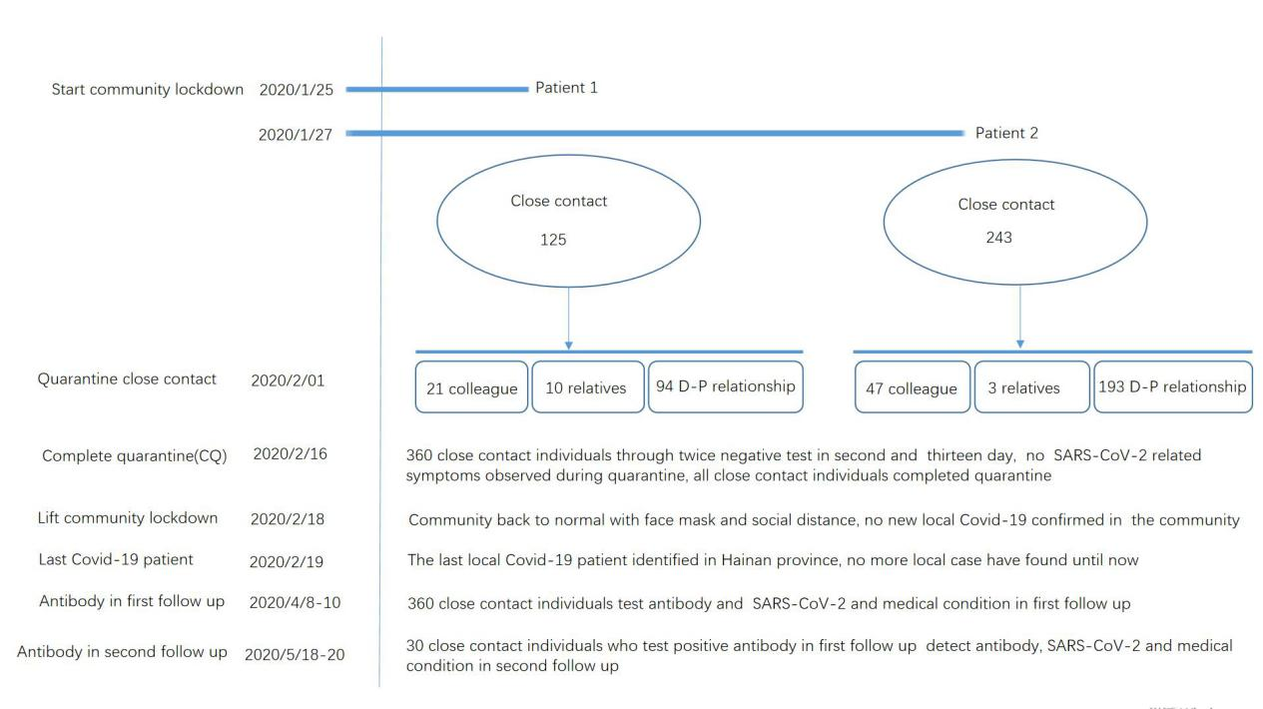

Supplementary Figure 1.Timeline of two Covid-19 infection reported in Qiongzhong community and close contacts follow up. D-P relationship: Doctor-patient relationship

