Supplement figure 1 Flowchart showing the final selection process
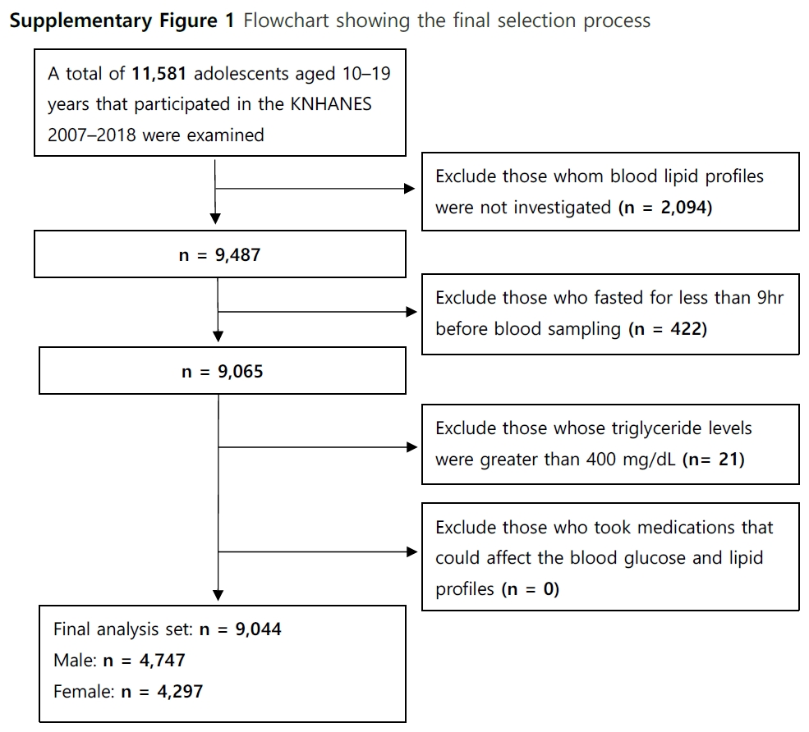
Supplement table 1 General characteristics of participants from the nationwide survey data from 2007–2018 (N=9,044)
 | Boys | Study year |  |  |  | P-for-trend | Girls | Study year |  |  |  | P-for-trend
 | Boys | 2007-2009 | 2010-2012 | 2013-2015 | 2016-2018 | P-for-trend | Girls | 2007-2009 | 2010-2012 | 2013-2015 | 2016-2018 | P-for-trend
Nomber |  | 1,379 | 1,308 | 1,047 | 1,013 |  |  | 1,266 | 1,181 | 930 | 920
Age (years) |  | 14.4 ± 0.1 | 14.6 ± 0.1 | 14.9 ± 0.1 | 14.9 ± 0.1 | <0.001 |  | 14.4 ± 0.1 | 14.8 ± 0.1 | 14.9 ± 0.1 | 14.9 ± 0.1 | <0.001
BMI (kg/m2) |  | 21.1 ± 0.1 | 21.0 ± 0.1 | 21.7 ± 0.2 | 21.5 ± 0.1 | <0.001 |  | 20.1 ± 0.1 | 20.5 ± 0.1 | 20.9 ± 0.1 | 20.6 ± 0.1 | 0.004
Waist circumference (cm) |  | 72.3 ± 0.3 | 71.7 ± 0.4 | 73.8 ± 0.4 | 73.8 ± 0.4 | <0.001 |  | 67.3 ± 0.3 | 67.7 ± 0.3 | 68.8 ± 0.3 | 67.7 ± 0.3 | 0.101
Age group
10-11 years |  | 19.6% | 16.7% | 16.5% | 15.7% | 0.019 |  | 20.2% | 17.1% | 15.0% | 16.8% | 0.019
12-15 years |  | 42.5% | 43.1% | 38.3% | 37.9% | 0.008 |  | 42.4% | 37.5% | 38.4% | 38.3% | 0.155
16-19 years |  | 37.9% | 40.2% | 45.2% | 46.5% | <0.001 |  | 37.4% | 45.4% | 46.6% | 44.9% | 0.004
Overweight
10-11 years |  | 15.5% | 8.1% | 14.1% | 15.8% | 0.611 |  | 8.1% | 5.0% | 9.6% | 8.3% | 0.570
12-15 years |  | 11.8% | 11.6% | 10.0% | 9.1% | 0.163 |  | 9.7% | 10.5% | 9.3% | 10.1% | 0.984
16-19 years |  | 11.9% | 9.7% | 13.7% | 10.8% | 0.913 |  | 10.7% | 8.2% | 11.4% | 10.3% | 0.719
Obesity
10-11 years |  | 11.6% | 12.6% | 14.0% | 14.5% | 0.347 |  | 6.9% | 10.2% | 10.4% | 6.4% | 0.921
12-15 years |  | 9.1% | 10.9% | 11.4% | 13.8% | 0.059 |  | 8.2% | 8.5% | 8.9% | 10.1% | 0.441
16-19 years |  | 14.1% | 12.3% | 16.7% | 15.7% | 0.292 |  | 9.2% | 13.0% | 15.7% | 13.3% | 0.065
Central obesity
10-11 years |  | 10.3% | 8.7% | 10.3% | 11.8% | 0.561 |  | 8.6% | 9.9% | 9.5% | 6.6% | 0.501
12-15 years |  | 6.1% | 7.4% | 9.0% | 10.1% | 0.040 |  | 7.6% | 9.0% | 10.5% | 9.3% | 0.313
16-19 years |  | 9.5% | 6.7% | 12.7% | 14.9% | 0.006 |  | 9.0% | 12.1% | 11.3% | 11.8% | 0.396
Notes: Values are presented as mean ± SE, number, or prevalence (%). The reference data were obtained from the 2007–2009 nationwide survey.
Supplement table 2 Trends in the mean serum lipid profiles by age in Korean boys from the nationwide survey data from 2007–2018 (N=4,747)
Boys | Study year |  |  |  | P-for-trendª | P-for-trend^{b}
Boys | 2007-2009 | 2010-2012 | 2013-2015 | 2016-2018 | P-for-trendª | P-for-trend^{b}
Total cholesterol (mg/dL)
10-19 years | 157.3 ± 0.9 | 156.2 ± 1.0 | 158.0 ± 0.9 | 164.3 ± 1.0 | <0.001 | <0.001
10-11 years | 166.2 ± 1.5 | 165.6 ± 2.1 | 166.2 ± 1.7 | 172.9 ± 1.7 | 0.007 | 0.011
12-15 years | 152.8 ± 1.5 | 150.4 ± 1.3 | 150.9 ± 1.5 | 157.1 ± 1.5 | 0.051 | 0.071
16-19 years | 152.8 ± 1.4 | 152.8 ± 2.0 | 156.4 ± 1.4 | 162.6 ± 1.7 | <0.001 | <0.001
HDL-cholesterol (mg/dL)
10-19 years | 49.1 ± 0.3 | 50.1 ± 0.4 | 51.9 ± 0.4 | 51.1 ± 0.3 | <0.001 | <0.001
10-11 years | 52.1 ± 0.6 | 54.3 ± 0.8 | 56.0 ± 0.8 | 54.3 ± 0.8 | 0.006 | 0.001
12-15 years | 48.1 ± 0.4 | 48.7 ± 0.5 | 50.3 ± 0.5 | 49.7 ± 0.5 | 0.001 | <0.001
16-19 years | 46.8 ± 0.4 | 47.7 ± 0.6 | 49.7 ± 0.5 | 49.0 ± 0.5 | <0.001 | <0.001
Non-HDL-cholesterol (mg/dL)
10-19 years | 108.2 ± 0.9 | 106.0 ± 1.0 | 106.1 ± 0.9 | 113.2 ± 1.0 | <0.001 | 0.002
10-11 years | 114.1 ± 1.4 | 111.3 ± 1.8 | 110.1 ± 1.6 | 118.6 ± 1.7 | 0.137 | 0.263
12-15 years | 104.7 ± 1.4 | 101.7 ± 1.2 | 100.7 ± 1.4 | 107.3 ± 1.5 | 0.363 | 0.703
16-19 years | 106.0 ± 1.4 | 105.0 ± 1.9 | 106.7 ± 1.4 | 113.6 ± 1.6 | <0.001 | 0.001
Triglycerides (mg/dL)
10-19 years | 75.4 ± 1.0 | 70.8 ± 1.0 | 73.5 ± 1.0 | 73.1 ± 1.0 | 0.514 | 0.102
10-11 years | 73.1 ± 1.0 | 65.6 ± 1.0 | 64 ± 1.0 | 70.3 ± 1.0 | 0.284 | 0.108
12-15 years | 74.5 ± 1.0 | 70.6 ± 1.0 | 73.2 ± 1.0 | 71.3 ± 1.0 | 0.426 | 0.062
16-19 years | 80.2 ± 1.0 | 76.3 ± 1.0 | 81.3 ± 1.0 | 79.3 ± 1.0 | 0.739 | 0.905
LDL-cholesterol (mg/dL)
10-19 years | 90.9 ± 0.8 | 90.7 ± 0.9 | 90.6 ± 0.8 | 97.0 ± 0.9 | <0.001 | <0.001
10-11 years | 97.1 ± 1.2 | 96.6 ± 1.7 | 95.6 ± 1.5 | 102.7 ± 1.5 | 0.022 | 0.042
12-15 years | 87.7 ± 1.3 | 86.5 ± 1.1 | 85.0 ± 1.3 | 91.5 ± 1.3 | 0.111 | 0.209
16-19 years | 88.0 ± 1.2 | 89.2 ± 1.7 | 90.7 ± 1.3 | 96.5 ± 1.5 | <0.001 | <0.001
Notes: Values are presented as mean (±SE). Lipid profiles were adjusted for age. ªAdjusted for age. ^{b}Adjusted for age, BMI, and waist circumference.
Abbreviations: HDL, high-density lipoprotein; LDL, low-density lipoprotein.
Supplement table 3 Trends in the mean serum lipid profiles by age in Korean girls from the nationwide survey data from 2007–2018 (N=4,297)
Girls | Study year |  |  |  | P-for-trendª | P-for-trend^{b}
Girls | 2007-2009 | 2010-2012 | 2013-2015 | 2016-2018 | P-for-trendª | P-for-trend^{b}
Total cholesterol (mg/dL)
10-19 years | 162.3 ± 0.8 | 164.1 ± 1.0 | 164.8 ± 1.0 | 168.9 ± 1.0 | <0.001 | <0.001
10-11 years | 162.9 ± 1.6 | 168.2 ± 2.0 | 165.5 ± 2.3 | 169.7 ± 1.8 | 0.020 | 0.028
12-15 years | 159.6 ± 1.2 | 161.6 ± 1.3 | 162.9 ± 1.6 | 165.8 ± 1.7 | 0.003 | 0.003
16-19 years | 163.9 ± 1.4 | 164.1 ± 1.7 | 165.4 ± 1.5 | 170.6 ± 1.6 | 0.002 | 0.005
HDL-cholesterol (mg/dL)
10-19 years | 51.0 ± 0.3 | 52.8 ± 0.4 | 53.5 ± 0.4 | 53.5 ± 0.4 | <0.001 | <0.001
10-11 years | 50.7 ± 0.6 | 52.4 ± 0.7 | 52.6 ± 0.8 | 53.3 ± 0.8 | 0.007 | 0.002
12-15 years | 50.2 ± 0.5 | 51.8 ± 0.6 | 52.6 ± 0.5 | 52.6 ± 0.5 | 0.001 | <0.001
16-19 years | 52.0 ± 0.5 | 54.2 ± 0.7 | 55.1 ± 0.6 | 54.8 ± 0.6 | 0.001 | 0.001
Non-HDL-cholesterol (mg/dL)
10-19 years | 111.3 ± 0.8 | 111.3 ± 1.0 | 111.2 ± 0.9 | 115.4 ± 1.0 | 0.004 | 0.010
10-11 years | 112.2 ± 1.5 | 115.8 ± 1.8 | 113.0 ± 2.3 | 116.3 ± 1.7 | 0.193 | 0.283
12-15 years | 109.4 ± 1.2 | 109.8 ± 1.2 | 110.3 ± 1.5 | 113.3 ± 1.7 | 0.062 | 0.075
16-19 years | 111.9 ± 1.4 | 109.8 ± 1.6 | 110.3 ± 1.3 | 115.7 ± 1.7 | 0.060 | 0.120
Triglycerides (mg/dL)
10-19 years | 80.7 ± 1.0 | 76.4 ± 1.0 | 76.9 ± 1.0 | 79.3 ± 1.0 | 0.529 | 0.388
10-11 years | 85.2 ± 1.0 | 84.6 ± 1.0 | 83.8 ± 1.0 | 80.6 ± 1.0 | 0.650 | 0.476
12-15 years | 83.7 ± 1.0 | 75.1 ± 1.0 | 76.6 ± 1.0 | 80.6 ± 1.0 | 0.380 | 0.319
16-19 years | 72.9 ± 1.0 | 71.1 ± 1.0 | 71.3 ± 1.0 | 73.2 ± 1.0 | 0.845 | 0.969
LDL-cholesterol (mg/dL)
10-19 years | 93.3 ± 0.7 | 95.1 ± 0.9 | 95.1 ± 0.9 | 98.1 ± 0.9 | <0.001 | <0.001
10-11 years | 93.1 ± 1.4 | 97.9 ± 1.6 | 95.9 ± 2.1 | 97.9 ± 1.5 | 0.048 | 0.260
12-15 years | 90.6 ± 1.0 | 94.0 ± 1.2 | 94.6 ± 1.4 | 95.9 ± 1.5 | 0.003 | 0.037
16-19 years | 95.8 ± 1.3 | 94.7 ± 1.5 | 95.0 ± 1.2 | 99.9 ± 1.6 | 0.038 | 0.552
Notes: Values are presented as mean (±SE). Lipid profiles were adjusted for age. ªAdjusted for age. ^{b}Adjusted for age, BMI, and waist circumference.
Abbreviations: HDL, high-density lipoprotein; LDL, low-density lipoprotein.

