ONLINE APPENDIX

Supplementary Materials on Method, Results and Discussions
To characterize an epidemic wave of having at least an upward and/or downward periods for a sustained period of time in a country, we employ R_{t}, a time series estimates of the reproduction number. If the average reproduction rate in the last n days is above 1, there is evidence of a sustained upward period. Similarly, if the average reproduction rate in the last n days is below 1, there is evidence of a sustained downward period. Formally, we test the null hypothesis 1 and alternative hypothesis 2, where 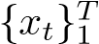 denotes the daily estimates of R_{t} at any moment T in the last n number of days, i.e. t = 1,...,n. Equation 3 refers to the sample average of R_{t} estimates during the past n days.
H₀ 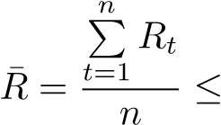1 (1)
H₁ 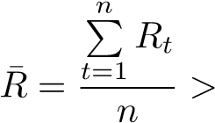1 (2)
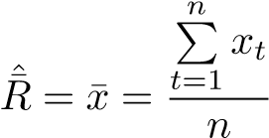 (3)

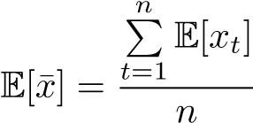 (4)
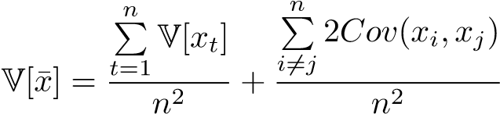 (5)
Equations 4 and 5 show the formula for the expectations and variance for any simple average estimators, in this case, the simple average of R_{t} estimates of the past n days. The expectation of average R¯_{t} is calculated by taking the average of the estimate of the mean or median of the posterior distribution of each daily estimation. Because the estimates of R_{t} use a Kalman filter estimation, where both the transition and state equations have normally distributed error terms, the posterior distribution of each of the estimates will rapidly converge to a normal distribution, and the weighted sum of normally distributed variables, ¯x, is also normally distributed. The variance, however, depends on whether the estimates were completely independent between themselves. If so, the second term in equation 5 would be zero and calculation of V[¯x] would be the sum of the variance of each estimate in the sample, divided by n². However, the covariance among some estimates may not be zero, as it is likely to have positive covariance in adjacent dates in a time series. Since it is impossible to know the value of these covariance terms in real-time in reality, we use an upper bound for the covariance of adjacent variables in the second term based on the statistical property that the covariance between two variables can never be bigger than the biggest variance of both variables as the upper bound for the variance, described in equation 5.
As an illustration of a working definition of epidemic waves of COVID-19 based on the COVID-19 contexts, we provide an example of a potential calibration especially considering the temporality of transmission and the cyclicity of infection case reporting. An individual can exhibit symptoms 11 days after the initial infection, with a confidence interval of 8 to 15 days. That is, the reporting of Covid-19 cases of people infected on day t will appear between day t + 8 to day t + 15. This variance in the temporal lag implies a potential covariance among R_{t} estimates within 7 days from each other. Therefore, it is a reasonable calibration to set J=7. Having J = 7 implies that at n must be at least 7. The choice of n should capture consecutive days to allow at least a two-chain transmission process to occur to model the sequential propagation of the epidemics in a region. The serial interval of one sequential propagation is estimated to be between 4 and 6 days, and we take 6 days, the upper limit, for prudence, and therefore n needs to be at least 7+6 = 13 days to capture a two-chain propagation in epidemic transmissions. Another critical consideration is the weekly cyclicity in COVID-19 infection cases seasonality (e.g., fewer cases on Sundays in many countries). To account for the weekly cyclicity, we try to set n = 14. An upward (downward) period refers to a period of at least n (=14) consecutive days when R_{t} is bigger (smaller) than 1.
The pandemic data used are the daily estimations of R_{t} that can be downloaded freely. We have incorporated results up to January 26th, 2020. The serial interval option used is the default option at 5 (the public R data contains several option intervals).

A wave of COVID-19 cannot be declared arbitrarily by any individuals without a common definition. The first questions we need to understand are: ‘what do we mean by epidemic waves, then where do waves occur and not occur, and what can we learn from this?’ We hope our working definition and operationalization offers a stepping stone towards a common understanding of what constitutes an epidemic wave and enables us to be more effective in combating the continued pandemic.

