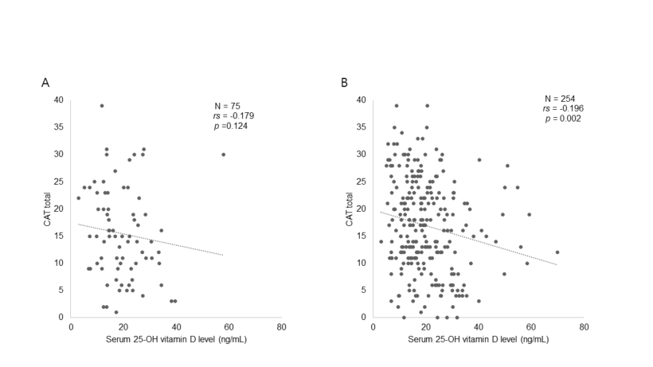
Figure E1 Correlation between serum 25-OH vitamin D level and total CAT score (A) in patients aged <65 years and (B) those aged ≥65 years. 25-OH vitamin D, 25-hydroxyvitamin D; CAT, COPD assessment test.

Supplementary Table E1 Baseline Characteristics of COPD patients stratified by vitamin D level
 | Vitamin D level |  |  | P-value
 | < 20 ng/mL  (N=193) | 20-29 ng/mL  (N=88) | ≥ 30 ng/mL  (N=48) | P-value
Age, year | 70.55 (8.40) | 71.10 (9.12) | 71.83 (7.68) | 0.623
Sex
Male | 180 (93.3%) | 78 (88.6%) | 46 (95.8%) | 0.248
Female | 13 (6.7%) | 10 (11.4%) | 2 (4.2%)
BMI, kg/m² | 23.58 (3.13) | 23.90 (3.41) | 23.54 (3.12) | 0.719
Smoking status |  |  |  | 0.632
Current smoker | 36 (18.7%) | 12 (13.6%) | 7 (14.6%)
Ex-smoker | 141 (73.1%) | 65 (73.9%) | 35 (72.9%)
Never smoker | 16 (8.3%) | 11 (12.5%) | 6 (12.5%)
Smoking pack-year | 38.28 (24.09) | 35.00 (26.10) | 33.26 (22.77) | 0.338
Comorbidity
Coronary arterial disease | 29 (15.0%) | 12 (13.6%) | 4 (8.3%) | 0.482
Cerebrovascular disease | 16 (8.3%) | 6 (6.8%) | 2 (4.2%) | 0.690
Heart failure | 12 (6.2%) | 6 (6.8%) | 4 (8.3%) | 0.781
Peripheral arterial disease | 8 (4.1%) | 1 (1.1%) | 4 (8.3%) | 0.106
Diabetes mellitus | 29 (15.0%) | 13 (14.8%) | 9 (18.8%) | 0.796
Chronic kidney disease | 11 (5.7%) | 2 (2.3%) | 2 (4.2%) | 0.438
Liver disease | 4 (2.1%) | 4 (4.5%) | 1 (2.1%) | 0.394
Dementia | 1 (0.5%) | 2 (2.3%) | 1 (2.1%) | 0.237
Connective tissue disease | 2 (1.0%) | 0 (0.0%) | 3 (6.3%) | 0.032
Peptic ulcer disease | 6 (3.1%) | 4 (4.5%) | 0 (0.0%) | 0.393
CCI | 5.03 (2.16) | 5.09 (2.07) | 5.65 (2.24) | 0.202
Inhaler
None | 4 (2.1) | 5 (5.7) | 3 (6.3) | 0.135
LABA or LAMA | 11 (5.7) | 2 (2.3) | 4 (8.3) | 0.270
LABA+LAMA | 79 (40.9) | 28 (31.8) | 18 (37.5) | 0.344
LABD+ICS | 31 (16.1) | 19 (21.6) | 9 (18.8) | 0.527
LABA+LAMA+ICS | 68 (35.2) | 34 (38.6) | 14 (29.2) | 0.543
Vitamin D level | 13.45 (4.13) | 24.61 (2.72) | 38.90 (9.79) | <0.001
Previous Exacerbation, any |  |  |  | 0.399
0 | 86 (44.6) | 38 (43.2) | 24 (50.0)
1 | 69 (35.8) | 27 (30.7) | 11 (22.9)
2≤ | 38 (19.7) | 23 (26.1) | 13 (27.1)
Previous Exacerbation, severe |  |  |  | 0.093
0 | 182 (94.3) | 79 (89.8) | 41 (85.4)
1 | 9 (4.7) | 5 (5.7) | 4 (8.3)
2≤ | 2 (1.0) | 4 (4.5) | 3 (6.3)
Notes: Data are mean (standard deviation) or number (%).
Abbreviations: BMI, body mass index; CCI, Charlson comorbidity index; LABA, long-acting beta2-agonist; LAMA, long-acting muscarinic antagonist; ICS, inhaled corticosteroids

Supplementary Table E2 Baseline Pulmonary Function Parameters of COPD patients stratified by vitamin D level
 | Vitamin D level |  |  | P-value
 | < 20 ng/mL  (N=193) | 20-29 ng/mL  (N=88) | ≥ 30 ng/mL  (N=48) | P-value
Pulmonary function test after bronchodilator
FVC, L | 3.43 (0.80) | 3.37 (0.82) | 3.63 (0.81) | 0.176
FVC, % pred | 81.70 (15.65) | 80.94 (14.40) | 85.69 (13.17) | 0.183
FEV₁, L | 1.85 (0.60) | 1.82 (0.66) | 1.98 (0.63) | 0.304
FEV₁, % pred | 62.81 (17.53) | 63.07 (19.41) | 67.94 (18.57) | 0.207
≥ 50, n(%) | 155 (80.3) | 67 (76.1) | 37 (77.1) | 0.698
FEV₁/FVC | 53.44 (11.89) | 53.80 (13.70) | 54.31 (11.37) | 0.902
RV/TLC, % | 41.82 (10.17) | 43.63 (11.34) | 41.56 (9.99) | 0.446
DLco, % pred | 66.15 (19.78) | 64.87 (23.06) | 69.09 (20.83) | 0.538
GOLD grade |  |  |  | 0.129
1 | 23 (11.9) | 17 (19.3) | 13 (27.1)
2 | 119 (61.7) | 49 (55.7) | 23 (47.9)
3 | 39 (20.2) | 15 (17.0) | 11 (22.9)
4 | 12 (6.2) | 7 (8.0) | 1 (2.1)
CAT
Cough frequency | 1.96 (1.33) | 1.78 (1.35) | 1.52 (1.34) | 0.112
Amount of phlegm | 2.41 (1.36) | 2.19 (1.51) | 1.77 (1.21) | 0.015
Chest tightness | 1.97 (1.40) | 1.84 (1.36) | 1.44 (1.26) | 0.053
Breathlessness  walking upstairs | 3.28 (1.40) | 3.13 (1.53) | 2.46 (1.43) | 0.002
Home activities  limitation | 1.76 (1.53) | 1.55 (1.49) | 1.08 (1.25) | 0.017
Not confident  leaving home | 1.76 (1.53) | 1.56 (1.46) | 1.33 (1.29) | 0.172
Sleep disturbance | 1.95 (1.44) | 1.83 (1.40) | 1.77 (1.33) | 0.641
Lack of energy | 2.52 (1.34) | 2.24 (1.30) | 1.94 (1.26) | 0.015
CAT, total | 17.61 (8.42) | 16.11 (8.83) | 13.31 (8.08) | 0.006
CAT score ≥ 10 | 162 (83.9) | 64 (72.7) | 31 (64.6) | 0.005
mMRC, total | 1.39 (0.66) | 1.44 (0.79) | 1.19 (0.49) | 0.099
mMRC ≥ 2 | 72 (37.3) | 33 (37.5) | 11 (22.9) | 0.130
Notes: Data are mean (standard deviation) or number (%).
Abbreviations: FVC, forced vital capacity; FEV₁, forced expiratory volume in 1 second; RV, Residual volume; TLC, Total lung capacity; DLco, Diffusing capacity of the lung for carbon monoxide; GOLD, global initiative for chronic obstructive lung disease; CAT, COPD assessment test; mMRC, modified Medical Research Council.

Supplementary Table E3 Baseline Characteristics of COPD patients stratified by age subgroups (< 65 vs. ≥ 65 years)
 | Total  (N=329) | < 65 years old  (N=75) | ≥ 65 years old  (N=254) | P-value
Age, year | 70.89 (8.49) | 59.28 (4.31) | 74.31 (6.02) | <0.001
Sex
Male | 304 (92.4) | 64 (85.3) | 240 (94.5) | 0.009
Female | 25 (7.6) | 11 (14.7) | 14 (5.5) | 0.009
BMI, kg/m² | 23.66 (3.20) | 23.32 (3.22) | 23.76 (3.19) | 0.295
Vitamin D level | 20.15 (10.44) | 19.53 (9.26) | 20.33 (10.77) | 0.560
Post-bronchodilator spirometry
FEV₁/FVC | 53.66 (12.29) | 55.95 (12.31) | 52.99 (12.23) | 0.067
FVC, L | 3.44 (0.81) | 3.84 (0.91) | 3.32 (0.74) | <0.001
FVC, % pred | 82.08 (15.02) | 86.56 (13.94) | 80.76 (15.10) | 0.003
FEV₁, L | 1.86 (0.62) | 2.17 (0.67) | 1.77 (0.58) | <0.001
FEV₁, % pred | 63.63 (18.23) | 63.51 (15.69) | 63.66 (18.94) | 0.949
FEV₁, % pred ≥ 50% | 259 (78.7) | 62 (82.7) | 197 (77.6) | 0.342
RV/TLC, % | 42.25 (10.45) | 38.92 (10.78) | 43.31 (10.14) | 0.003
DLco, % pred | 66.25 (20.80) | 68.93 (23.40) | 65.44 (19.93) | 0.206
CAT score, total | 16.58 (8.59) | 15.48 (8.51) | 16.91 (8.61) | 0.206
CAT score ≥ 10 | 257 (78.1) | 55 (73.3) | 202 (79.5) | 0.254
mMRC, total | 1.37 (0.68) | 1.20 (0.62) | 1.43 (0.69) | 0.011
mMRC ≥ 2 | 116 (35.3) | 19 (25.3%) | 97 (38.2%) | 0.041
Notes: Data are mean (standard deviation) or number (%).
Abbreviations: BMI, body mass index; FVC, forced vital capacity; FEV₁, forced expiratory volume in 1 second; RV, Residual volume; TLC, Total lung capacity; DLco, Diffusing capacity of the lung for carbon monoxide; GOLD, global initiative for chronic obstructive lung disease; CAT, COPD assessment test; mMRC, modified Medical Research Council.

Supplementary Table E4. The association between total CAT score ≥ 10 and vitamin D level < 30ng/mL by age subgroups (< 65 vs. ≥ 65 years)
Total CAT ≥ 10 | Unadjusted |  | Adjusted
Total CAT ≥ 10 | OR (95% CI) | P-value | OR (95% CI) | P-value
Age < 65 (N = 75)
Vitamin D ≥ 30 ng/mL (N = 9) | Reference |  | Reference
Vitamin D < 30 ng/mL (N= 66) | 1.44 (0.32 – 6.41) | 0.631 | 1.56 (0.33 – 7.40) | 0.574
Age ≥ 65 (N = 254)
Vitamin D ≥ 30 ng/mL (N = 39) | Reference |  | Reference
Vitamin D < 30 ng/mL (N= 215) | 2.61 (1.24 – 5.48) | 0.011 | 2.78 (1.24 – 6.27) | 0.013
P for interaction |  | 0.485 |  | 0.450
Notes: Adjusted for age, sex, body mass index and smoking history (never vs. ever), charlson comorbidity index, post bronchodilator FEV₁ (≥ 50% vs. < 50% pred), and season of blood draw (spring/fall vs. summer vs. winter).
Abbreviations: OR, odds ratio; CI, confidence interval.

