Supplementary Materials
Multifarious biological applications and toxic Hg²⁺ sensing potentiality of biogenic silver nanoparticles based on securidaca inappendiculata Hassk stem extract

Figure S1 Base peak chromatogram of elute from S. inappendiculata stem bark extract analysed in negative electrospray ionization mode.

Table S1 Putative identities of chemical components present in S. inappendiculata stem bark extract obtained by LC-ESI-QTOF analysis
S/N | Rt  (min) | m/z | Accurate mass (Da) | Mass Diff (ppm) | Calculated mass (Da) | Predicted Formula | Score (DB) | Tentative identity of compound
1 | 6.201 | 537.1846 | 478.1707 | -4.34 | 478.1686 | C₂₀ H₃₀ O₁₃ | 90.29 | Kelampayoside A
2 | 6.452 | 259.0829 | 260.0902 | -2.36 | 260.0896 | C₁₁ H₁₆ O₇ | 97.99 | 3-Furanmethanol glucoside
3 | 6.602 | 517.1564 | 472.1583 | -0.53 | 472.1581 | C₂₁ H₂₈ O₁₂ | 98.74 | 1-O-Cinnamoyl-beta-D-gentiobiose
4 | 6.866 | 585.2195 | 540.2211 | -0.79 | 540.2207 | C₂₆ H₃₆ O₁₂ | 98.59 | Sambacin
5 | 6.929 | 313.0933 | 314.1005 | -1.1 | 314.1002 | C₁₄ H₁₈ O₈ | 98.82 | 2-O-Acetylarbutin
6 | 7.255 | 783.235 | 784.2425 | 0.06 | 784.2426 | C₃₅ H₄₄ O₂₀ | 99.12 | Rhamnazin 3-isorhamninoside
7 | 7.707 | 567.2088 | 568.2146 | 1.67 | 568.2156 | C₂₇ H₃₆ O₁₃ | 80.55 | Citrusin B
8 | 7.732 | 339.1092 | 340.1164 | -1.71 | 340.1158 | C₁₆ H₂₀ O₈ | 82.99 | Oenanthoside A
9 | 7.908 | 435.0951 | 436.1023 | -3.96 | 436.1006 | C₂₀ H₂₀ O₁₁ | 92.66 | Irisxanthone
10 | 7.958 | 741.2637 | 742.2708 | -3.25 | 742.2684 | C₃₄ H₄₆ O₁₈ | 92.74 | Acanthoside D
11 | 8.071 | 569.1878 | 570.1951 | -0.35 | 570.1949 | C₂₆ H₃₄ O₁₄ | 99.59 | 2''-Methoxy-(S)-oleuropein
12 | 8.234 | 683.2228 | 684.2302 | 2.49 | 684.2319 | C₃₇ H₃₆ N₂O₁₁ | 87 | Citbismine C
13 | 8.31 | 723.2172 | 724.2238 | -3.26 | 724.2215 | C₃₃ H₄₀ O₁₈ | 90.24 | Natsudaidain 3-(4-O-3-hydroxy-3-methylglutaroylglucoside)
14 | 8.46 | 693.2044 | 694.2114 | -0.67 | 694.2109 | C₃₂ H₃₈ O₁₇ | 98.76 | Neocuscutoside C
15 | 8.535 | 593.1506 | 594.1588 | -0.5 | 594.1585 | C₂₇ H₃₀ O₁₅ | 82.94 | Vitexin 4'-O-galactoside
16 | 8.711 | 621.1831 | 622.1905 | -1.23 | 622.1898 | C₂₉ H₃₄ O₁₅ | 98.28 | Pectolinarin
17 | 8.837 | 697.2365 | 652.2384 | -2.54 | 652.2367 | C₃₁ H₄₀ O₁₅ | 95.71 | (-)-Matairesinol 4'-[apiosyl-(1->2)-glucoside]
18 | 8.937 | 521.1318 | 522.1391 | -3.31 | 522.1373 | C₂₄ H₂₆ O₁₃ | 93.86 | Centaurein
19 | 8.987 | 597.1828 | 598.1908 | -1.73 | 598.1898 | C₂₇ H₃₄ O₁₅ | 84.78 | 10-Acetoxyoleuropein
20 | 9.389 | 355.1046 | 356.1118 | -3.05 | 356.1107 | C₁₆ H₂₀ O₉ | 95.27 | 1-O-2'-Hydroxy-4'-methoxycinnamoyl-b-D-glucose
21 | 9.59 | 411.1304 | 412.1375 | -1.39 | 412.1369 | C₁₉ H₂₄ O₁₀ | 98.58 | Methylpicraquassioside A
22 | 9.716 | 547.1455 | 548.1529 | 0.21 | 548.153 | C₂₆ H₂₈ O₁₃ | 98.88 | Mirificin
23 | 9.929 | 365.0881 | 366.0954 | -0.82 | 366.0951 | C₁₇ H₁₈ O₉ | 99.39 | Furocoumarinic acid glucoside
24 | 10.64 | 303.0502 | 304.0574 | 2.95 | 304.0583 | C₁₅ H₁₂ O₇ | 95.61 | Pratenol B
25 | 10.77 | 329.234 | 330.2412 | -1.73 | 330.2406 | C₁₈ H₃₄ O₅ | 98.67 | 11,12,13-trihydroxy-9-octadecenoic acid
27 | 11.12 | 303.0512 | 304.0584 | -0.38 | 304.0583 | C₁₅ H₁₂ O₇ | 99.62 | Alphitonin
28 | 11.6 | 287.0569 | 288.0642 | -2.73 | 288.0634 | C₁₅ H₁₂ O₆ | 96.81 | Eriodictyol
29 | 12.28 | 307.1911 | 308.1987 | 0.19 | 308.1988 | C₁₈ H₂₈ O₄ | 91.32 | 5-O-Methylembelin
30 | 12.38 | 227.035 | 228.0423 | -0.32 | 228.0423 | C₁₃ H₈ O₄ | 99.21 | Euxanthone
31 | 13.16 | 293.1763 | 294.1836 | -1.52 | 294.1831 | C₁₇ H₂₆ O₄ | 98.79 | Embelin
32 | 17.7 | 563.3443 | 518.3459 | -0.84 | 518.3455 | C₂₇ H₅₀ O₉ | 97.29 | 3-O-L-rhamnosyl-3-hydroxydecanoyl-3-hydroxydecanoic acid
Rt: retention time

a
b
c
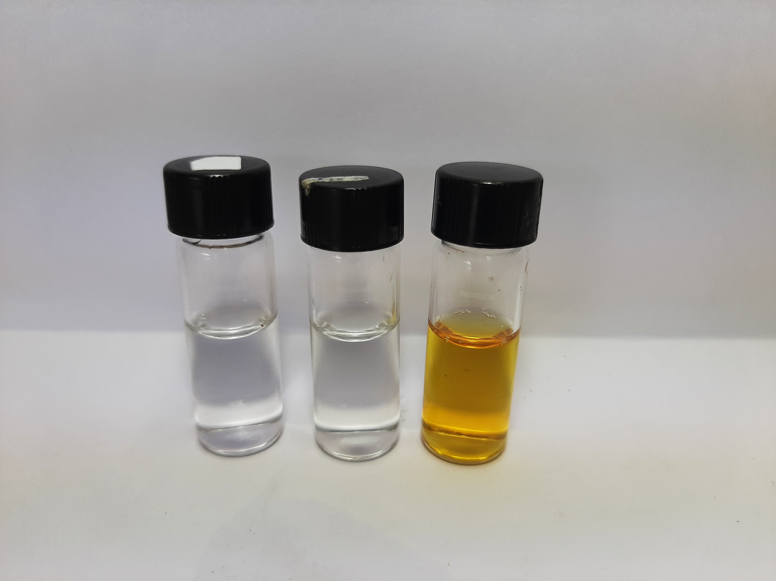

b
a
c

Figure S2 UV-vis absorption spectra of (a) AgNO₃ salt (b) AgNO₃ and NaOH mixture (c) SISE, AgNO₃ and NaOH mixture

Figure S3 UV-Vis absorption spectra of SISE AgNPs synthesis at optimal conditions

Figure S4 Plot of Absorbance at 423 nm of SISE AgNPs vs synthesis time (min)

Figure S5 Histogram showing the distribution of particles sizes of SISE AgNPs acquired on an Image J software

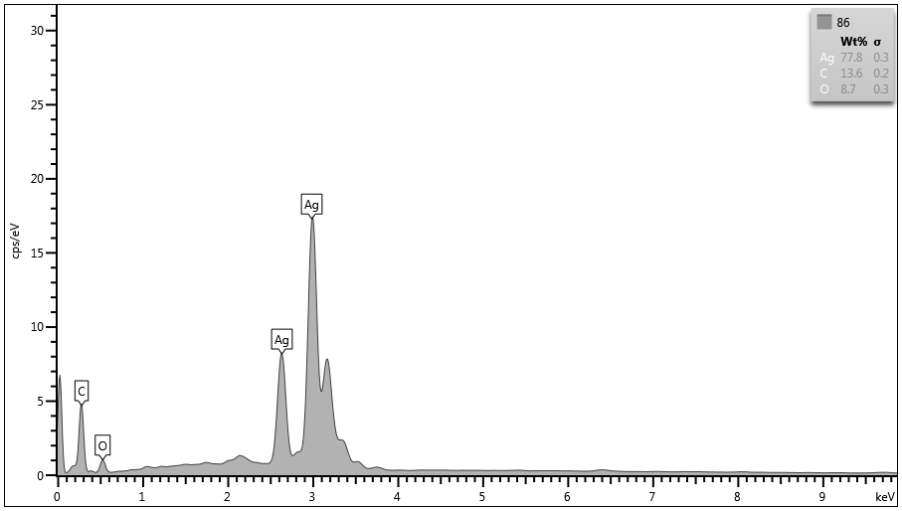

Figure S6 EDS spectrum of as-synthesized SISE AgNPs

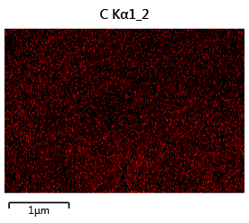
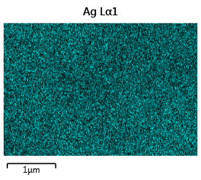

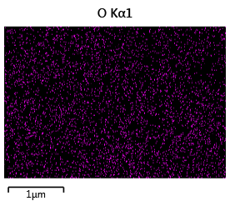

Figure S7 Elemental mapping of SISE AgNPs showing, the presence of Ag, C and O

A
B

Fig.S6: A. Thermogravimetric analysis plot and B. Differential thermogravimetric plot of SISE

Figure S8 (A) Thermogravimetric analysis plot and (B) Differential thermogravimetric plot of SISE AgNPs

Table S2: TGA data of SISE AgNPs
Sample | Stages | Onset Temperature (°C) | Temperature ranges (°C) | IDT (°C) | IPDT (°C) | Mass loss (%) | Ash (%)
SISE AgNPs | I | 41.75 | 41.75-169.81 | 41.75 | 1010.00 | Y = 0.71 | 59.5
 | II | 169.71 | 169.71-662.22 |  |  | Y = 13.06+18.95
 | III | 662.22 | 662.22-1010.00 |  |  | Y = 4.93+2.85
 |  |  |  |  |  | Total = 40.50
IDT = Initial decomposition temperature; IPDT = Integral procedural decomposition temperature.

Blank Hg²⁺

A
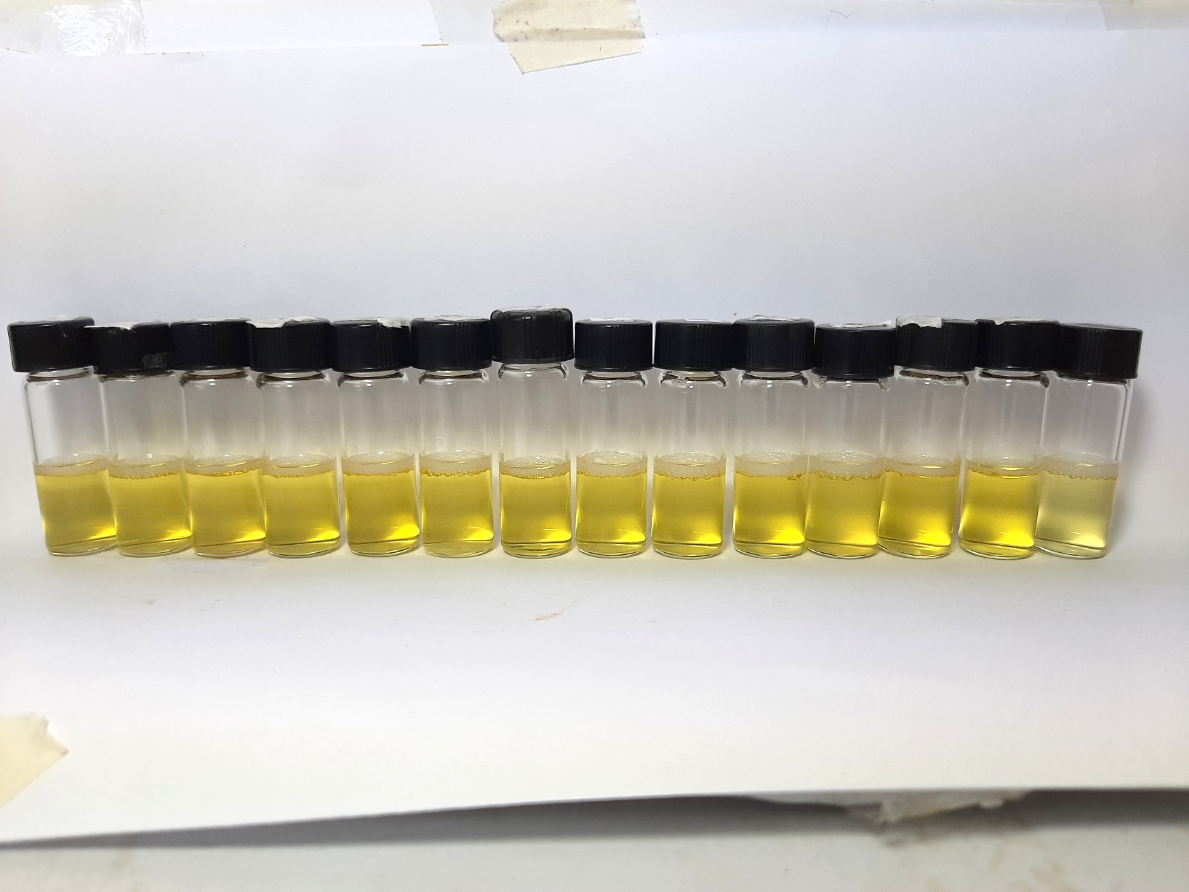

B

Figure S9 (A) UV-Vis absorption spectra of SISE AgNPs in the presence of metal ions; Blank, K⁺, Fe³⁺, Ca²⁺, Fe²⁺, Co²⁺, Cd²⁺, Cu²⁺, Ni²⁺, Mg²⁺, Pb²⁺, Zn²⁺, Ba²⁺, Al³⁺, Hg²⁺, inset shows the photo images of the corresponding plots, and (B) Plot of A₃₈₅/A₄₂₃ vs metal ions, Concentration of Hg²⁺ =20.0 μM, while other metal ions were 50.0 μM.
Table S3: Comparison of SISE AgNPs probe with reported methods for Hg²⁺ detection.
Detection probe | LOD (nM) | Linear range (µM) | References
Electrochemical (DPV) | 0.009 | 0.001 – 0.5 | [1]
Colorimetry (β-CD-AgNPs) | 37.5 | 0.2 – 2.6 | [2]
Colorimetry (AuNPs) | 0.275 | 0.1 – 0.5 | [3]
Colorimetry (CMC-AgNPs) | 5.0 | 0.0025 – 0.25 | [4]
Colorimetry (SA-AgNPs) | 5.29 | 0.025 – 60.0 | [5]
Colorimetry (AuNPs-MBT) | 6.0 | 0.05 – 1.0 | [6]
Colorimetry (Chlorophyll-AgNPs) | 2700 | 0.10 - 200 | [7]
Fluorescence | 33.0 | 0.05 – 5.8 | [8]
Fluorescence | 14.0 | 0.0 – 100.0 | [9]
SISE AgNPs | 26.5 | 0.10 – 10.0 | This work
DPV = Differential pulse voltammetry; β-CD = Beta cyclodextrin; CMC = Carboxymethyl cellulose; SA= Sodium alginate.

References
1. Mahmoudian MR, Basirun WJ, Alias Y, et al. Investigating the effectiveness of g-C3N4 on Pt/g-C3N4/polythiophene nanocomposites performance as an electrochemical sensor for Hg²⁺ detection. J Environ Chem Eng. 2020;8(5):104204. Doi:10.1016/j.jece.2020.104204
2. Rajamanikandan R, Ilanchelian M. β-cyclodextrin functionalised silver nanoparticles as a duel colorimetric probe for ultrasensitive detection of Hg2+ and S2− ions in environmental water samples. Mater Today Commun. 2018;15:61-69. Doi:10.1016/j.mtcomm.2018.02.024
3. Amanulla B, Perumal KN, Ramaraj SK. Chitosan functionalized gold nanoparticles assembled on sulphur doped graphitic carbon nitride as a new platform for colorimetric detection of trace Hg2+. Sens Actuators B: Chem. 2019;281:281-287. Doi:10.1016/j.snb.2018.10.039
4. Sakly N, Marzouk W, Ouada HB, et al. Enhancing performances of colorimetric response of carboxymethylcellulose-stabilized silver nanoparticles: a fully eco-friendly assay for Hg2+ detection. Sens Actuators B: Chem. 2017;253:918-927. Doi:10.1016/j.snb.2017.07.035
5. Faghiri F, Ghorbani F. Colorimetric and naked eye detection of trace Hg2+ ions in the environmental water samples based on plasmonic response of sodium alginate impregnated by silver nanoparticles. J Hazard Mater. 2019;374:329-340. Doi:10.1016/j.jhazmat.2019.04.052
6. Jin W, Huang P, Wei G, et al. Visualization and quantification of Hg2+ based on anti-aggregation of label-free gold nanoparticles in the presence of 2-mercaptobenzothiazole. Sens Actuators B: Chem. 233 (2016) 223-229. Doi:10.1016/j.snb.2016.04.071
7. Yılmaz DD, Demirezen DA, Mıhçıokur H. Colorimetric detection of mercury ion using chlorophyll functionalized green silver nanoparticles in aqueous medium. Surf Interfaces. 2021;22:100840. Doi:10.1016/j.surfin.2020.100840
8. Wang S, Chen H, Xie H, et al. A novel thioctic acid-carbon dots fluorescence sensor for the detection of Hg2+ and thiophanate methyl via S-Hg affinity. Food Chem. 2021;346:128923. Doi:10.1016/j.foodchem.2020.128923
9. Wang P, Yan Y, Zhang Y, et al. An Improved Synthesis of Water-Soluble Dual Fluorescence Emission Carbon Dots from Holly Leaves for Accurate Detection of Mercury Ions in Living Cells. Int J Nanomed. 2021;16:2045. Doi: 10.2147/IJN.S298152

