NUDT15 c.415C>T polymorphism predicts 6-MP induced early myelotoxicity in ALL patients undergoing maintenance therapy

Aswin Anand Pai¹, Ajith Mohan¹, Esther Sathya Bama Benjamin R¹, Raveen Stephen Stallon Illangeswaran¹, Infencia Xavier Raj¹, Nancy Beryl Janet¹, Arun Kumar Arunachalam¹, Kavitha ML¹, Uday Kulkarni¹, Anup J Devasia¹, Fouzia NA¹, Aby Abraham¹, Alok Srivastava¹, Biju George¹, Vikram Mathews¹, Anu Korula¹, Poonkuzhali Balasubramanian¹

¹Department of Haematology, Christian Medical College, Vellore

Correspondence:
Poonkuzhali Balasubramanian
Professor
Department of Haematology
Christian Medical College- Vellore
Email: bpoonkuzhali@cmcvellore.ac.in
ORCID ID : 0000-0002-9443-439X

Keywords: Leukemia, Mercaptopurine, Myelotoxicity, Pharmacogenomics

Table S1: Comparison of baseline characteristics between patients enrolled in study (cohort-2) with total patients on maintenance therapy diagnosed at the centre but not enrolled due to inclusion criteria.

Baseline characteristics | Patients not enrolled  (n=107) | Prospective cohort (n=133) | P-value
Age at Diagnosis | 13 (1-61) | 17 (1-63) | 0.729
BSA (m²) | 1.28 (0.49-2.03) | 1.5 (0.4-2.1) | 0.309
Sex  Male  Female | 73 (68.2)  34 (31.8) | 88 (66.2)  45 (33.8) | 0.783
Immunophenotype  B cell  T cell  BP-ALL  MP-ALL  ETP-ALL  NA | 78 (72.9)  22 (20.6)  1 (0.9)  -  2 (1.9)  4 (3.7) | 111 (83.6)  20 (15)  -  1 (0.8)  -  1 (0.8) | 0.135
Cytogenetics Risk  Favourable  Intermediate  Poor  NA | 17 (15.9)  63 (58.9)  22 (20.6)  05 (4.6) | 25 (18.8)  81 (60.9)  7 (5.3)  20 (15) | 0.389
ALL Risk  Standard Risk  Intermediate Risk  High Risk  NA | 12 (11.2)  61 (57)  12 (11.2)  22 (20.6) | 20 (15)  70 (52.6)  5 (3.8)  38 (28.6) | 0.246

Table S2: Allele and genotype frequencies screened in the present study (cohort-2; N=133)
S. No | Gene Polymorphisms | Allele frequency (%) | Genotype frequency (%)
1 | NUDT15 c.415C>T, rs116855232 | C-93 & T-7 | CC-86.5 & CT-13.5
2 | TPMT c.719A>G, rs1142345 | A-98 & T-2 | AA-96.9 & AT-3.1
3 | ITPA c.94 C>A, rs1127354 | C-87 & T-13 | CC-76.4, CA-22.0 & AA-1.6
4 | MRP4 c.2269 C>T, rs3765534 | C-93 & T-7 | CC-87.6 CT-10.7 & TT-1.7

Table S3: Distribution of variant allele frequencies of NUDT15, MRP4, ITPA and TPMT genes across different studies in different ethnicities
S.no | Ethnicity (n) | NUDT15 c.415C>T  rs116855232 | TPMT c.719A>G  rs1142345 | ITPA  c.94 C>A  rs1127354 | MRP4  c.2269 C>T  rs3765534 | Reference
1. | Guatemala(159) | 5% | - | - | - | [5]
1. | Singapore (79) | 12% | - | - | - | [5]
1. | Japan (32) | 17% | - | - | - | [5]
2 | Middle East (210) | 0.4% | 1% | 3% | - | [22]
3 | China (105) | 16% | 3% | 18% | - | [25]
4 | Japan (95) | 16% | 2% | 16% | 13% | [40]
5 | Denmark (132) | - | 5% | 3% | - | [41]
6 | Serbia (68) | 3% | - | - | - | [42]
7 | Thailand (110) | 12% | - | - | - | [43]
8 | Taiwan (294) | 13% | 2% | 19% | 4% | [44]
9 | India (73) | 9% | 1% | - | - | [14]
10 | India (63) | 5% | 2% | - | - | [15]
11 | MedGenome Labs Pvt Ltd, India | 7% | 2% | 10% | 6% | *
12 | NIBMG, India | 6% | 2% | 9% | 6% | *
13 | Present study (133) | 7% | 2% | 10% | 7% | Present study  (Cohort-2)
*- Variant allelic frequency in Indian Population provided by Dr. Partha Majumdar (NIBMG, Kalyani) and Dr. Ram Prasad (MedGenome Laboratories, Bengaluru)- Personal communication.

Figure S1: Associations between Myelotoxicity and TPMT*3C (A), ITPA 94C > A (B) polymorphisms

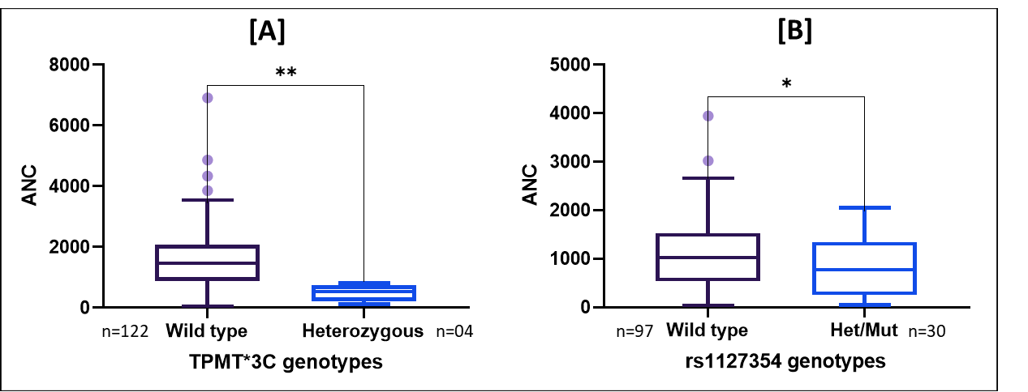

Figure S2: Kaplan-Meier survival curves showing associations between NUDT15 c.415C>T (A) and TPMT*3C polymorphism (B) with Relapse free survival

