The potential synergistic activity of Zolmitriptan combined in new self-nano-emulsifying drug delivery systems: ATR-FTIR real-time fast dissolution monitoring and Pharmacodynamic Assessment

Supplementary materials

Instruments
All measurements were done using FTIR (IRaffinity-1 Spectrometer, Shimadzu, Kyoto, Japan) fitted with ATR-8200HA (Attenuated Total Reflectance Unit) accessory (PIKE Tech, Madison, Wisconsin, USA) mounted with Zinc Selenide crystal (ZnSe) which is trapezoid shape yellow crystal 4 mm thick, 10 mm wide, 80 mm long, relatively hard, durable and has high mid-infrared throughput and a wide spectral range. It is worth to mention that the calculated, infrared light angle of incidence is 45, crystal refractive index is 2.43, penetration depth is 2.0 μm, effective pathlength is 12.12 μm and number of reflections is 12.34. Low Flow Pulsation HPLC pump “LC-20-AD” (Shimadzu, Kyoto, Japan). Malvern Zetasizer (Malvern, Worcestershire, UK). USP dissolution (type I, DISTEK Dissolution System, Model 2500i, NJ, USA). Transmission Electron Microscopy (TEM, JEOL, JEM-1230, Japan). HPLC (LC-20AD liquid chromatograph, Shimadzu, Japan) consisting of two LC-10ADvp pumps, a DGU-20A continuous degassing unit equipped with an SIL-20A autosampler and an SPD-20A UV–vis detector. Chromatographic separations were achieved by a Pronto SIL® RP-C18 (150 × 4.6 mm, 5 μm) column (type SC-150, Bischoff Chromatography, Berlin, Germany). HPLC data was acquired and processed using LC solution Software, version 1.25 SP4 (Shimadzu, Kyoto, Japan). UV spectrophotometer (Thermos Fisher Scientific evolution 600, Modison, WI, USA). shaking water bath (Precision Scientific, Model 25, Chicago, USA). Grid floor activity cage (7430; Ugo-Basile, Italy), Hotplate (7280; Ugo Basile, Italy) and CCD digital camera Olympus DP-12 attached to the Olympus CX41 research microscope for slide tissue microphotography.

Chemicals
Zolmitriptan (Glopal Napi Pharmaceuticals, Egypt); Nitroglycerin (Angised®) (GlaxoSmithKline, Egypt); Selective serotonin agonist (Amoun Pharmaceutical Company, Egypt); (Phosphoric acid, Methanol and deionized water HPLC grades), diethyl ether, formaldehyde, propylene glycol, Brij® L4, Brij® 93, ginger, lavender and peppermint essential oils (Sigma-Aldrich, St. Louis, MO, USA); Cremophor® EL [Polyoxyl 35 Hydrogenated Castor Oil (P35HCO), (BASF, Ludwigshafen, Germany)]; Transcutol® HP, Lauroglycol™ 90 and Labrasol® (Gattefosse, France); Biotinylated anti-mouse secondary antibody (1,200, Vector Labs, Burlingame, CA, USA) and Peroxidase (ABC Kit, Vector Labs, and Burlingame, CA, USA).

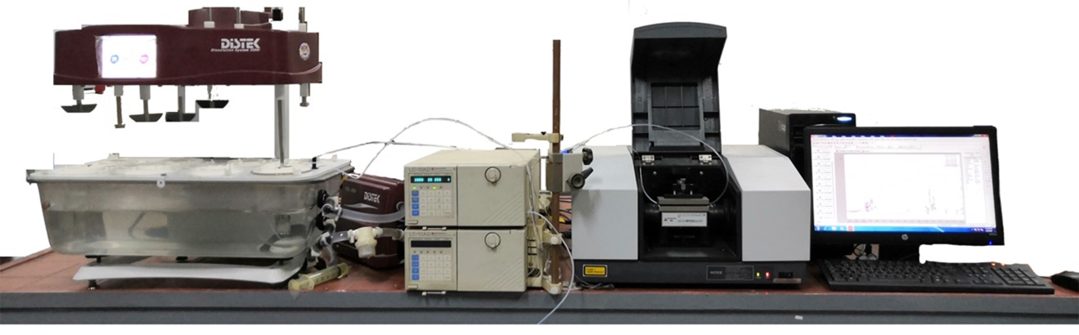
Figure S1 Setup of continuous flow monitoring ATR-FTIR device.
A
B)
P35HCO

Figure S2 The percentage of water incorporated into A) mixtures of different surfactants with Lavender oil at oil:surfactant ratio (O:S) of 1:1 by weight & B) mixtures of Lavender oil, P35HCO and different cosurfactants (CoS) at O:S:CoS ratio of 2:1:1 by weight.

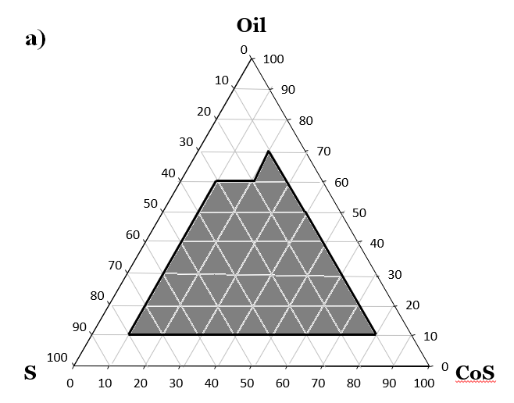
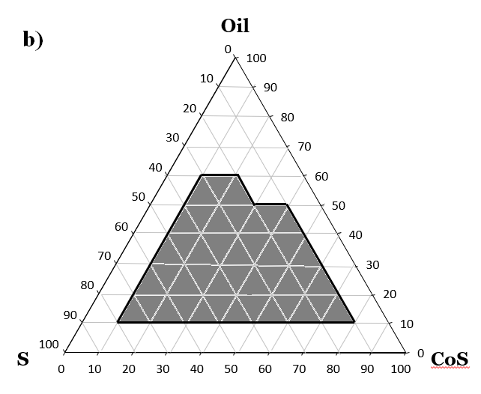
A
B)
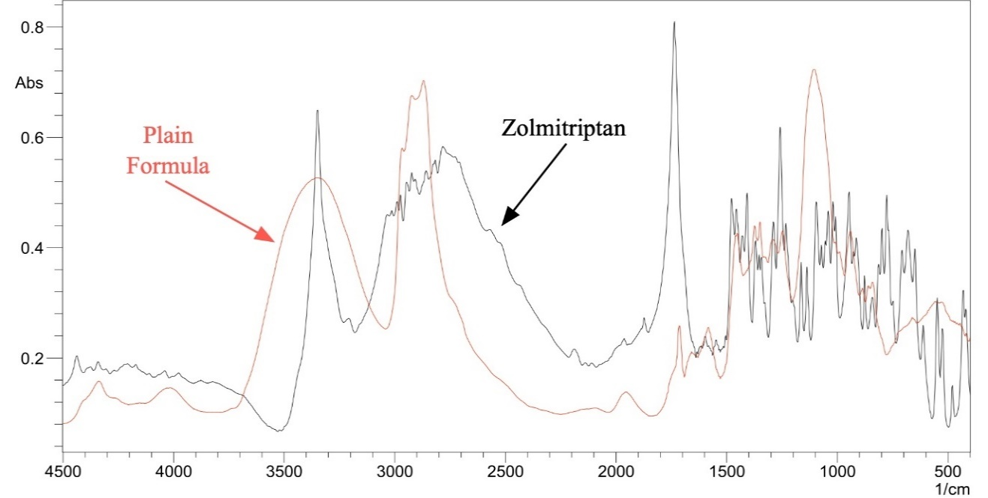
Figure S3 Phase diagram of a) Plain SNEDDS and b) ZMT loaded SNEDDS prepared with lavender (Oil), P35HCO (S; Surfactant) and Transcutol® HP (CoS; Cosurfactant) upon dilution 100 times.

Figure S4 Overlay plot of plain SNEDDS and zolmitriptan pure drug.

Figure S5 Ex-vivo permeation of optimized ZMT loaded SNEDDS F5 compared to ZMT solution across rat intestine.

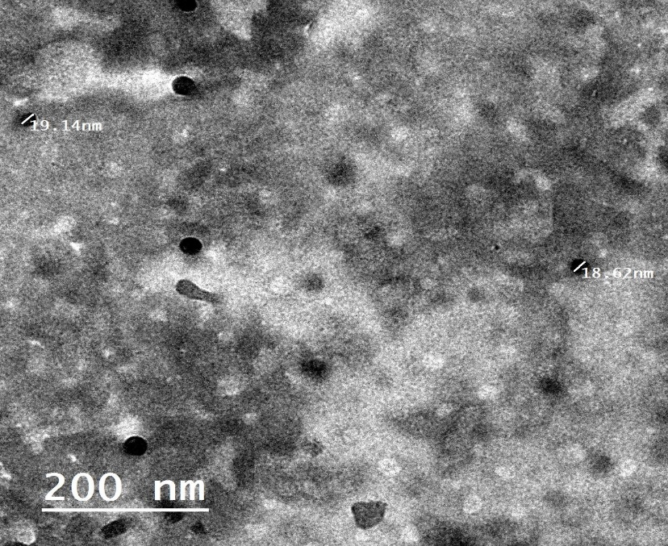
Figure S6 Transmission electron microscopic (TEM) image of the optimized formula F5.

Histopathology Photomicrographs
Acute Toxicity Study
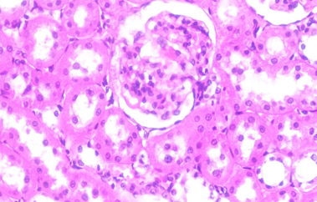 | 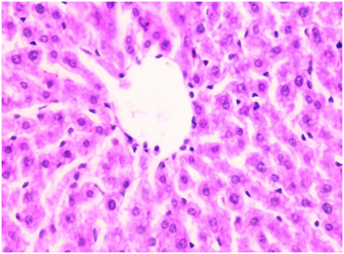
Figure S7A Photomicrograph of kidney showing normal histological structure of glomerulus with intact tubular epithelial lining arrow (X200). | Figure S7B Photomicrograph of liver showing normal histological structure of hepatic lobule arrow (X200).
Efficacy Study
Negative Control group
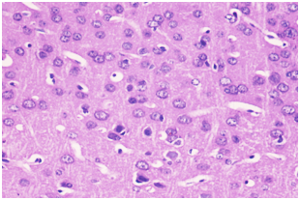 |  |  | 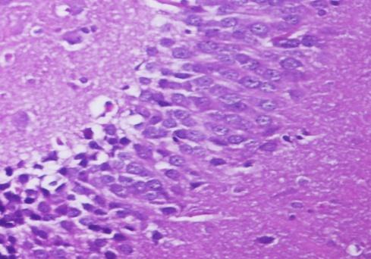
Figure S8A Photomicrograph of cerebral cortex showing normal arrangement of neuronal cells in association small blood vessels in between arrow (X200). |  |  | Figure S8B Photomicrograph of hippocampus showing normal histological structure of compact granular cells with dark nuclei arrow (X200).
Positive Control group
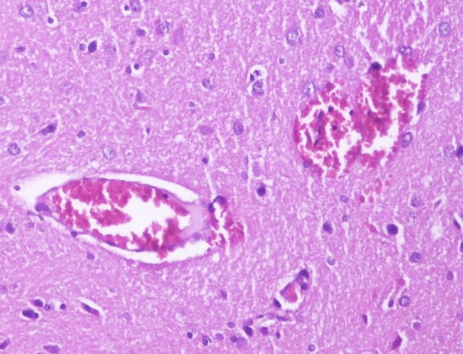 |  |  | 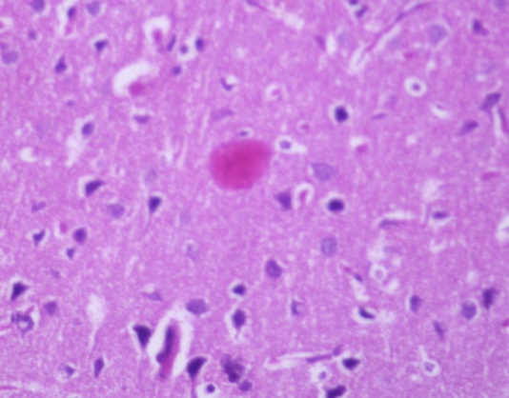
Figure S9A Photomicrograph of cerebral cortex showing apoptosis of neuronal cells and dilatation of cerebral capillaries arrow (X200). |  |  | Figure S9B Photomicrograph of cerebral cortex showing eosinophilic neurofibrillary tangles arrow (X200).
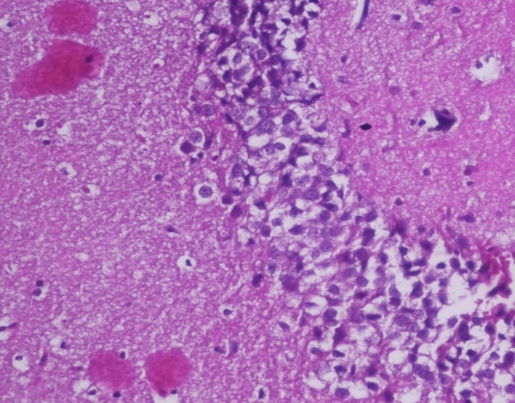 |  |  | 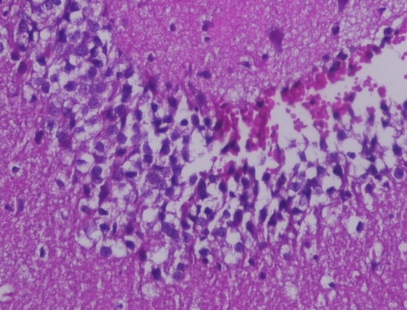
Figure S9C Photomicrograph of hippocampus showing eosinophilic neurofibrillary tangles arrow (X200). |  |  | Figure S9D Photomicrograph of hippocampus showing cellular disorganization and focal hemorrhagic area arrow (X200).
Zolmitriptan solution 0.225 mg/kg
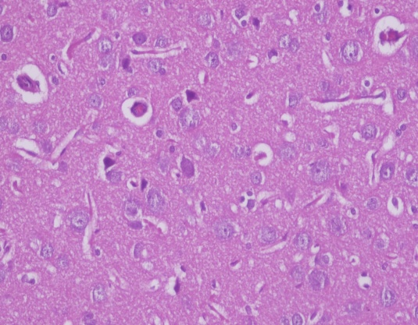 |  | 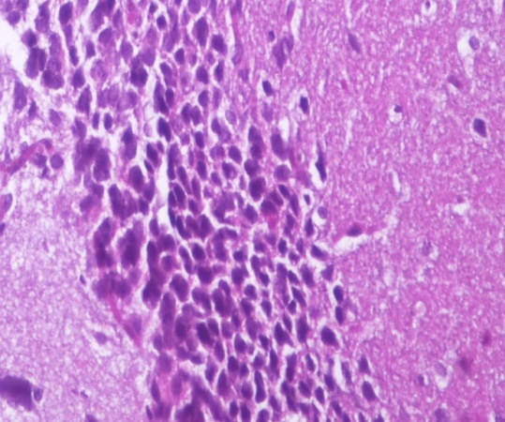
Figure S10A Photomicrograph of cerebral cortex showing nuclear pyknosis surrounded by glial cells arrow (X200). |  | Figure S10B Photomicrograph of hippocampus showing cellular disorganization with nuclear pyknosis of pyramidal cells arrow (X200).
Zolmitriptan solution 0.45 mg/kg
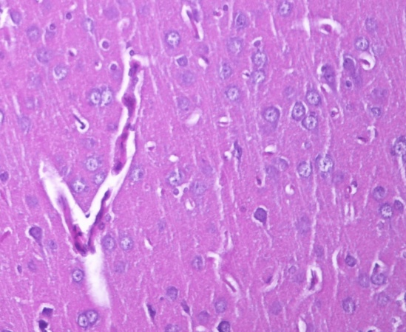 |  | 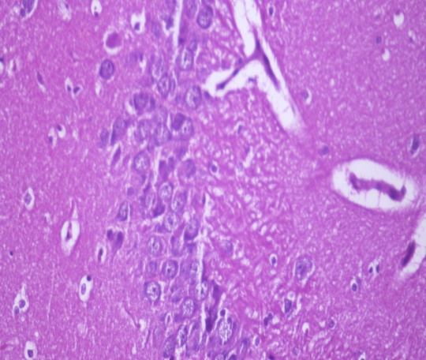
Figure S11A Photomicrograph of cerebral cortex showing mild swelling of neuronal cells. Dilatation of cerebral capillaries arrow (X200). |  | Figure S11B Photomicrograph of hippocampus showing cellular disorganization and vacuolations of granular cell layers arrow (X200).
ZMT-SNEDDS 0.022 mg/kg
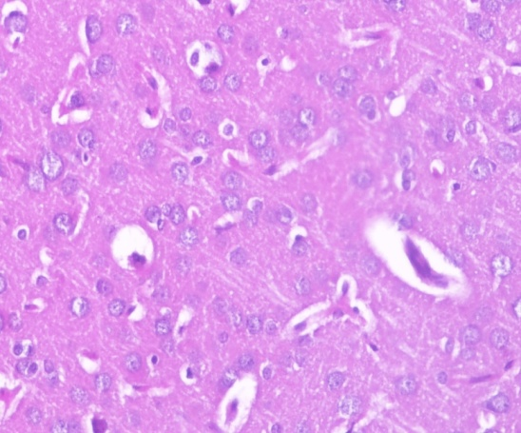 |  |  |  | 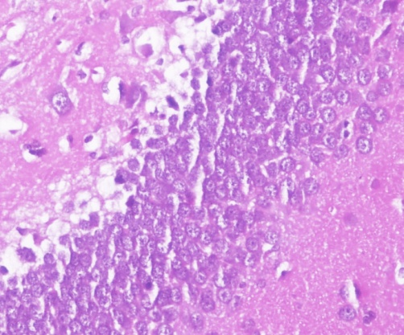
Figure S12A Photomicrograph of cerebral cortex showing mild swelling of neuronal cells perivascular oedema arrow (X200). |  |  |  | Figure S12B Photomicrograph of hippocampus showing cellular disorganization and vacuolations of granular cell layers arrow (X200).
ZMT-SNEDDS 0.045 mg/kg
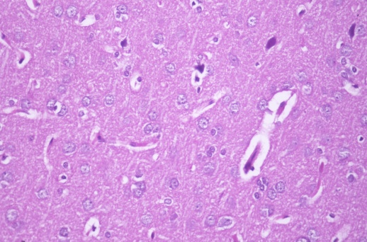 |  |  |  | 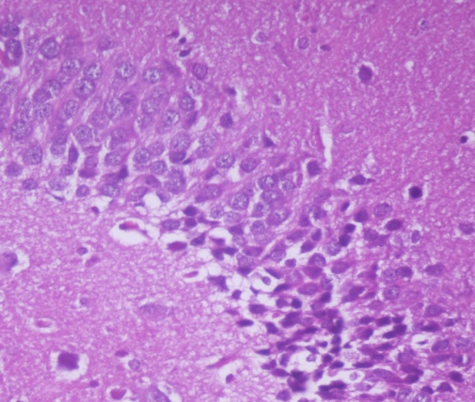
Figure S13A Photomicrograph of cerebral cortex showing normal histological architecture of cerebral cortex with normal arrangement of cells arrow (X200). |  |  |  | Figure S13B Photomicrograph of hippocampus showing normal layers of compact granular cells arrow (X200).
Plain SNEDDS 0.25 ml
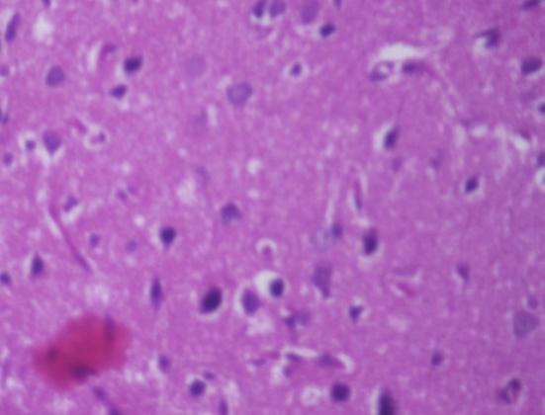 | 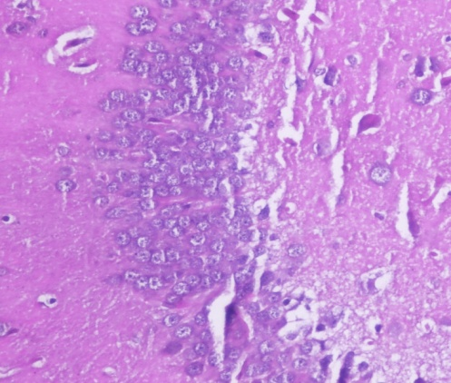
Figure S14A Photomicrograph of cerebral cortex showing Eosinophilic neurofibrillary tangles, focal gliosis and apoptosis of neuronal cells arrow (X200). | Figure S14B Photomicrograph of hippocampus showing cellular disorganization and marked shrinkage in size of large pyramidal cells arrow (X200).
Plain SNEDDS 0.5 ml
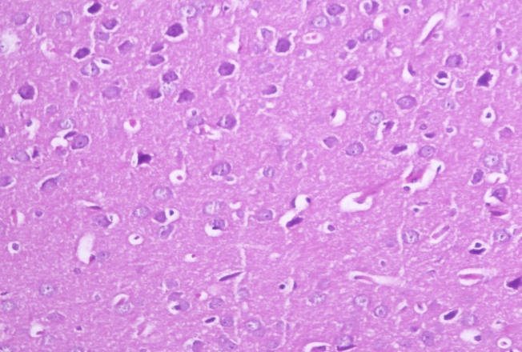 | 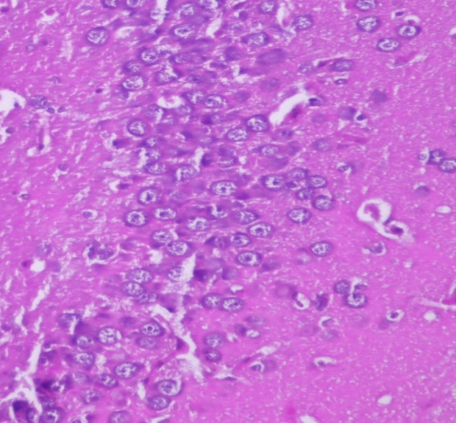
Figure S15A Photomicrograph of cerebral cortex showing focal gliosis and apoptosis of neuronal cells arrow (X200). | Figure S15B Photomicrograph of hippocampus showing revealed cellular disorganization and marked shrinkage in size of large pyramidal cells, with darkened nuclei arrow (X200).

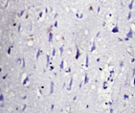  Figure S16 | 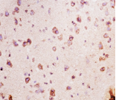  Figure S17 | 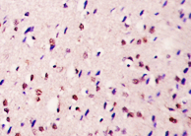  Figure S18 | 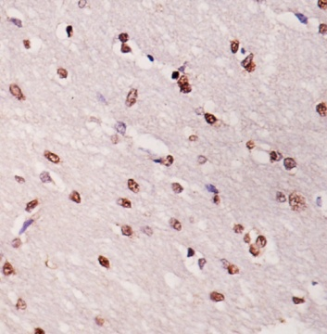  Figure S19
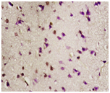  Figure S20 | 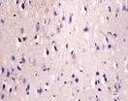  Figure S21 | 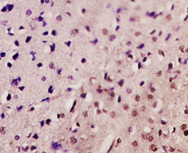  Figure S22 | 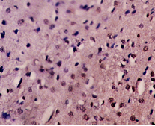  Figure S23
Photomicrograph of cerebral cortex (NSE) immune-staining section showing: Figure S16 “score 0” for absolutely no staining (negativity), Figure S17 “score 3” with a percentage of intensely brown neurons >30% of the counted cells (strong positivity), Figure S18 “score 2” with a percentage of intense immunopositive neurons between 10 and 30% (moderate positivity), Figures S19 & S20 “score 1” when the index was >10% slightly immunopositive cells (weak positivity), Figure S21 “score 0” for absolutely no staining (negativity) and Figures S22 & S23 score 3” with a percentage of intensely brown neurons >30% of the counted cells (strong positivity), (x200).

