Supplemental Methods
Lentivirus-based shRNA and expression vector
Wild type TP53 fragment was amplified from the cDNAs of normal lung tissue with primers containing XbaI and BamHI cutting sites and tagged with FLAG at C-terminus. TCTAGAGCCACCATGGAGGAGCCGCAGTCAGATCC and GGATCCTCACTTATCGTCGTCATCCTTGTAATCGTCTGAGTCAGGCCCTTCTGTC. The fragment was then ligated into pGEM-T easy (Promega) to generate pGEM-T-TP53. TP53 Mutant p53 G245S were generated by site-directed mutagenesis according to Agilent QuikChange® protocol. In brief, mutagenic primers were designed using Agilent QuikChange on-line tool, PCR was performed with pGEM-T-TP53 as a template using mutagenic primers. Cctccggttcatgctgcccatgcaggaac and gttcctgcatgggcagcatgaaccggagg to generate a lentiviral expression vector, pGEM-T-TP53 and pGEM-T-TP53 mutant were digested with XbaI and BamHI, The purified fragments of WT and TP53 mutant were inserted into lentiviral expression vector pCDH-CMV-MCS-EF1-GFP-Puro (System Biosciences). The sequence of each construct was confirmed by Sanger sequencing.

Lentivirus particle packaging and transduction
To generate the lentiviral particles, lentiviral-based expression vector, along with packaging vectors psPAX2 and pMD2.G, were transiently transfected into human embryonic kidney cell 293T using the lipofectamine 2000 transfection reagent (Life techonlogies, USA). The lentiviruses were transduced into H3122 cells in the presence of polybrene (8μg/ml).

Supplemental Figures
Figure S1. KEGG pathway mapping.
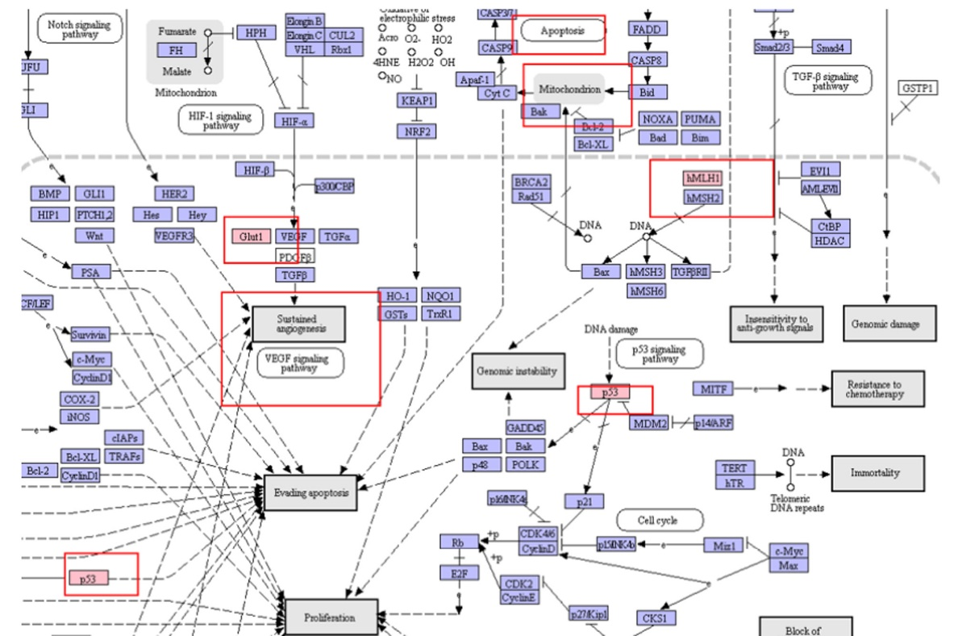

Figure S2. Protein analysis in the STRING database.
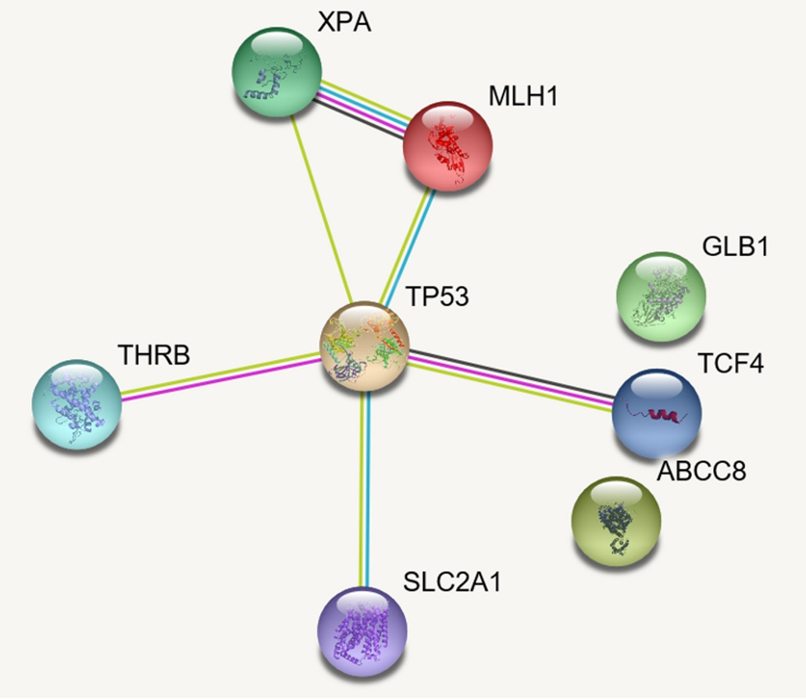

Supplemental Tables

Table S1. Clinical characteristics of enrolled patients for WES (n=10)
Patient | extreme strong response to crizotinib |  |  |  |  | extreme poor response to crizotinib
number | 1 | 2 | 3 | 4 | 5 | 6 | 7 | 8 | 9 | 10
sex | M | F | F | F | F | M | M | F | M | M
age (years) | 61 | 59 | 39 | 52 | 46 | 56 | 81 | 46 | 32 | 62
pathology | AD | AD | AD | AD | AD | AD | AD | AD | AD | AD
BM | no | yes | no | no | no | yes | no | no | no | no
ORR | PR | PR | PR | PR | PR | PD | SD | SD | PD | SD
PFS (months) | 53 | 26ª | 48 | 30ª | 36 | 1 | 2 | 5 | 3 | 3
OS (months) | 53 | 37^{b} | 48 | 52 | 36 | 3 | 2 | 11 | 4 | 7
TMB | 6 | 7 | 10 | 9 | 8 | 11 | 23 | 17 | 18 | 22
F: female; M: male; AD: adenocarcinoma; BM: brain metastasis; ORR: overall response; PR: partial response; SD: stable disease; PD: progression disease; PFS: progression-free survival; OS: overall survival; a: crizotinib resistance occurred in number 2 and 4patient; b: only death in number 2 patient who didn’t receive any treatment after crizotinib resistance; TMB: tumor mutation burden

Table S2. Related 43 gene variations in tumor growth or drug responsiveness.

Chr | Start | End | Ref | Alt | Func | Gene | ExonicFunc.ref Gene
chr1 | 12062090 | 12062090 | C | T | exonic | MFN2 | nonsynonymous SNV
chr1 | 43394913 | 43394913 | C | T | exonic | SLC2A1 | nonsynonymous SNV
chr1 | 55318019 | 55318019 | C | T | exonic | DHCR24 | nonsynonymous SNV
chr2 | 27589697 | 27589697 | G | A | exonic | EIF2B4 | nonsynonymous SNV
chr3 | 24185030 | 24185030 | C | T | exonic | THRB | nonsynonymous SNV
chr3 | 33114079 | 33114079 | G | A | exonic | GLB1 | nonsynonymous SNV
chr3 | 37035043 | 37035043 | C | T | exonic | MLH1 | nonsynonymous SNV
chr3 | 37067281 | 37067281 | C | T | exonic | MLH1 | stopgain
chr3 | 38647549 | 38647549 | C | T | exonic | SCN5A | nonsynonymous SNV
chr3 | 98299553 | 98299553 | G | A | exonic | CPOX | nonsynonymous SNV
chr3 | 129247749 | 129247749 | C | T | exonic | RHO | nonsynonymous SNV
chr3 | 148896379 | 148896379 | G | A | exonic | CP | stopgain
chr4 | 6304112 | 6304112 | G | A | exonic | WFS1 | nonsynonymous SNV
chr5 | 112399807 | 112399807 | C | T | exonic | MCC | nonsynonymous SNV
chr6 | 6266848 | 6266848 | G | A | exonic | F13A1 | stopgain
chr6 | 49426902 | 49426902 | C | T | exonic | MUT | nonsynonymous SNV
chr6 | 74354306 | 74354306 | G | A | exonic | SLC17A5 | nonsynonymous SNV
chr7 | 100228596 | 100228596 | G | A | exonic | TFR2 | stopgain
chr7 | 107350571 | 107350571 | C | T | exonic | SLC26A4 | nonsynonymous SNV
chr7 | 150671915 | 150671915 | C | T | exonic | KCNH2 | nonsynonymous SNV
chr8 | 38003586 | 38003586 | C | T | exonic | STAR | nonsynonymous SNV
chr9 | 95481404 | 95481404 | T | G | exonic | BICD2 | nonsynonymous SNV
chr9 | 100447259 | 100447259 | G | A | exonic | XPA | stopgain
chr9 | 116151801 | 116151801 | G | A | exonic | ALAD | nonsynonymous SNV
chr11 | 17417206 | 17417206 | G | A | exonic | ABCC8 | nonsynonymous SNV
chr11 | 46898045 | 46898045 | G | A | exonic | LRP4 | nonsynonymous SNV
chr11 | 68171075 | 68171075 | G | A | exonic | LRP5 | nonsynonymous SNV
chr11 | 76885871 | 76885871 | C | T | exonic | MYO7A | stopgain
chr14 | 23885871 | 23885871 | C | T | exonic | MYH7 | nonsynonymous SNV
chr14 | 23887522 | 23887522 | C | T | exonic | MYH7 | nonsynonymous SNV
chr14 | 69346747 | 69346747 | G | A | exonic | ACTN1 | nonsynonymous SNV
chr15 | 80472526 | 80472526 | C | T | exonic | FAH | nonsynonymous SNV
chr17 | 7577548 | 7577548 | C | T | exonic | TP53 | nonsynonymous SNV
chr18 | 52896219 | 52896219 | G | A | exonic | TCF4 | nonsynonymous SNV
chr21 | 35821910 | 35821910 | G | A | exonic | KCNE1 | nonsynonymous SNV
chr22 | 40760969 | 40760969 | G | A | exonic | ADSL | nonsynonymous SNV
chr22 | 42525035 | 42525035 | C | T | exonic | CYP2D6 | nonsynonymous SNV
chrX | 153001686 | 153001686 | G | A | exonic | ABCD1 | nonsynonymous SNV
chrX | 154001427 | 154001427 | C | T | exonic | DKC1 | nonsynonymous SNV
chr2 | 47703631 | 47703631 | C | T | exonic | MSH2 | stopgain
chr2 | 47635629 | 47635629 | G | T | exonic | MSH2 | stopgain
chr2 | 47641557 | 47641557 | G | A | exonic | MSH2 | nonsynonymous SNV
chr2 | 47657020 | 47657020 | C | T | exonic | MSH2 | stopgain

