SUPPLEMENTARY DATA
Supplementary 1: Infographic Protocol for the Online Mock ISCE
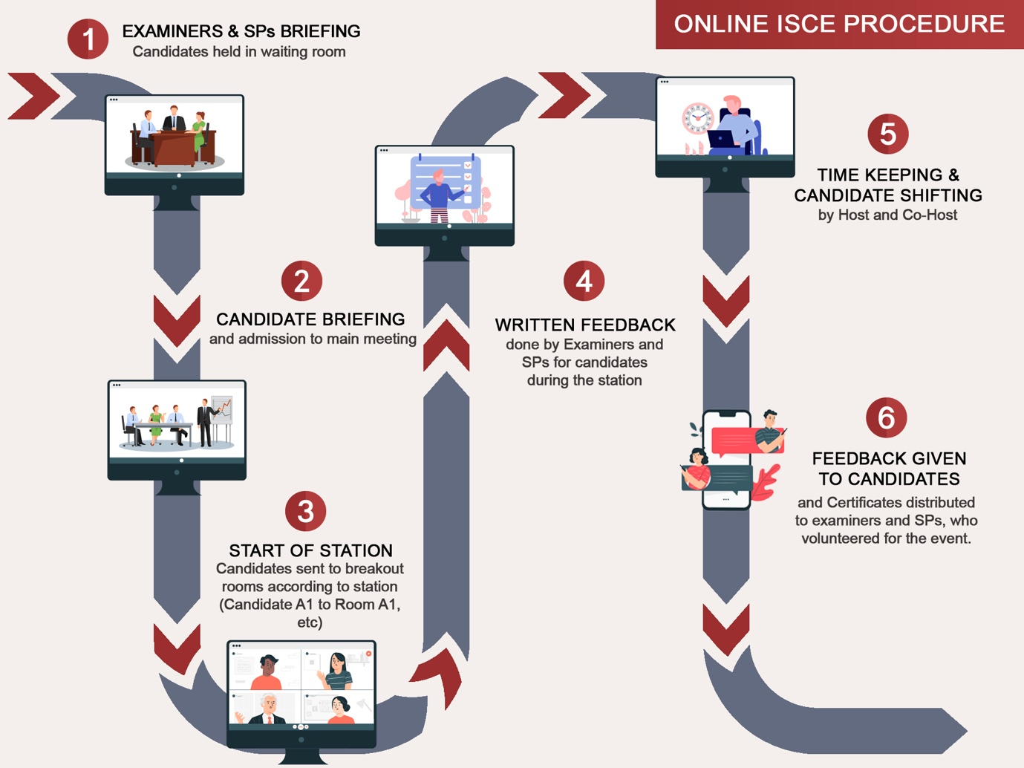

1. Simulated patients (SPs) and examiners arrive 15 minutes prior to candidate’s arrival and are admitted by the Event organisers (Host and Co-host) for a briefing.
2. Host of Zoom meeting sends examiners and simulated patients into named breakout rooms according to station number to set up their station.
3. Whilst in the waiting room, Mock ISCE candidates are advised to add their pre-allocated start station number at the end of their name. Host admits all mock ISCE candidates to the main meeting for a briefing.
4. Host sends candidates into their respective start station breakout room (i.e. Candidate A1 to Breakout Room A1, and so on). Co-host keeps the time and observes each breakout room to ensure stations run as expected and reports to the host. Host broadcasts timing via a banner message to every breakout room at the start of station, at 4, 7, 11 and 14 minutes (to indicate 1 minute remaining of station).
5. Candidates complete their starting station with the host automatically moving candidates to the next breakout room (i.e., A1 to A2, A4-A1, etc.) at the 15-minute time limit.
6. At the end of the final station, all meeting participants (all candidates, SPs and examiners) return to the main meeting for a debrief. Host asks candidates to fill in a post-online Mock ISCE Questionnaire before closing the session. Written feedback was given to the candidates and certificates were provided to the examiners and simulated patients.

Supplementary 2 Quality assessment of each station
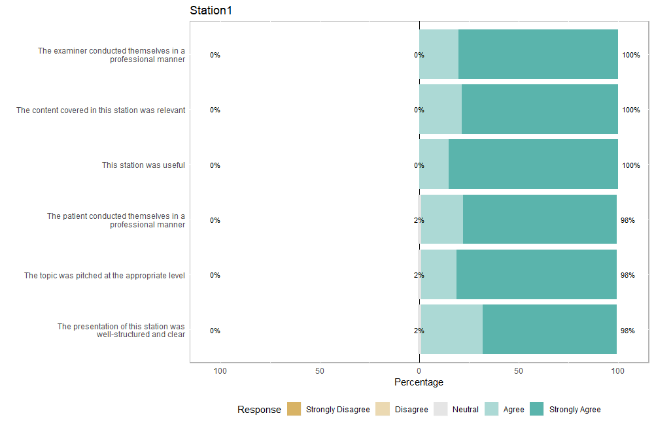
Supplementary 2.1 demonstrates a Likert scale plot of student feedback for Station 1. Y-axis indicates the questions asked in the feedback form. X-axis indicates the percentage response for each question.
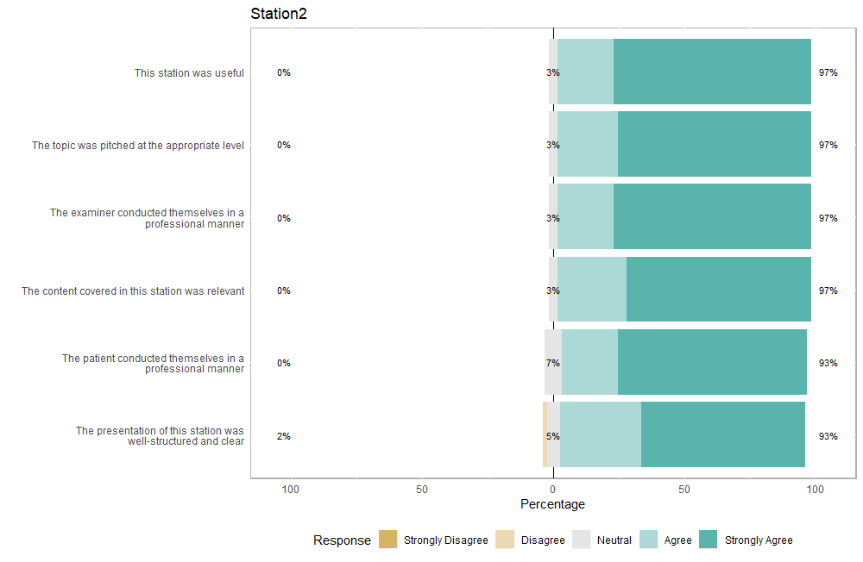
Supplementary 2.2 demonstrates a Likert scale plot of student feedback for Station 2. Y-axis indicates the questions asked in the feedback form. X-axis indicates the percentage response for each question.
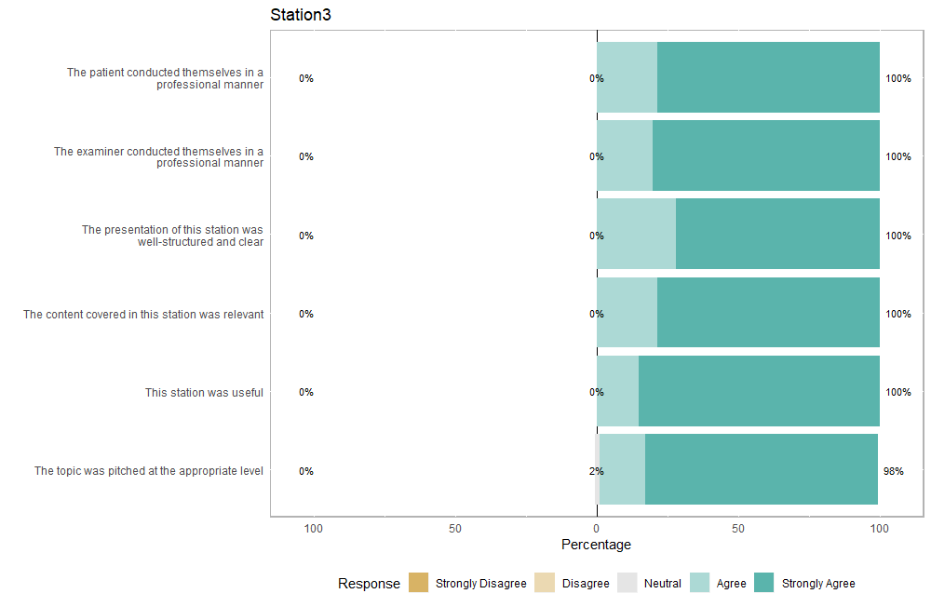

Supplementary 2.3 demonstrates a Likert scale plot of student feedback for Station 3. Y-axis indicates the questions asked in the feedback form. X-axis indicates the percentage response for each question.

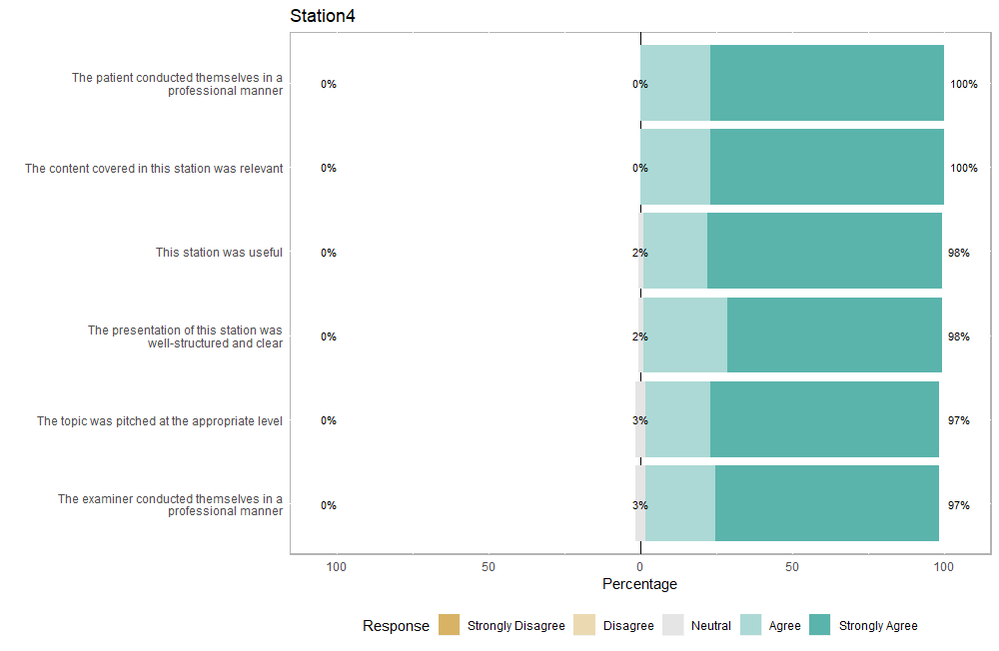

Supplementary 2.4 demonstrates a Likert scale plot of student feedback for Station 4. Y-axis indicates the questions asked in the feedback form. X-axis indicates the percentage response for each question.

Supplementary 3 Word Cloud analysis of Student’s Concerns and Perspectives.
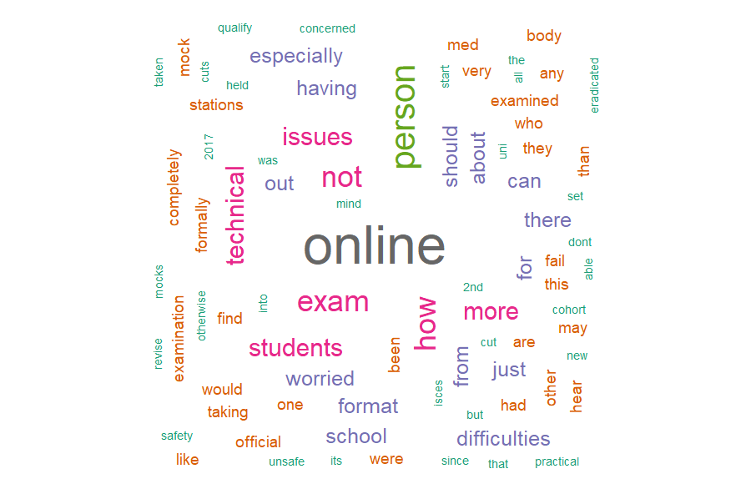
Supplementary 3.1 demonstrates a word cloud analysis of student’s concern about virtual ISCE before participating in the Mock ISCE. The size of each word in the diagram correlates with the frequency of its appearance in the response.
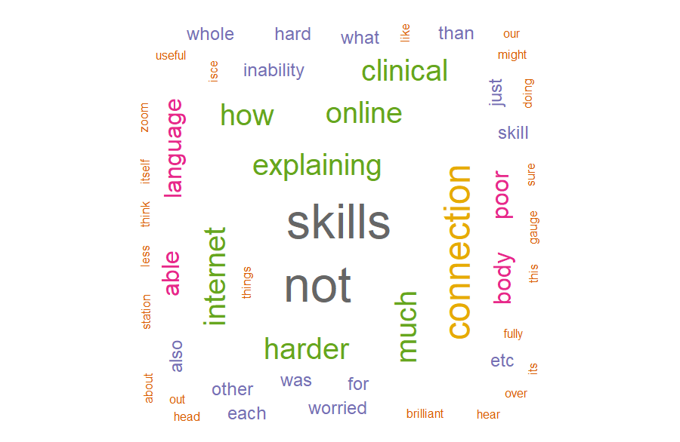

Supplementary 3.2 demonstrates a word cloud analysis of student’s concern about virtual ISCE after participating in the Mock ISCE. The size of each word in the diagram correlates with the frequency of its appearance in the response.

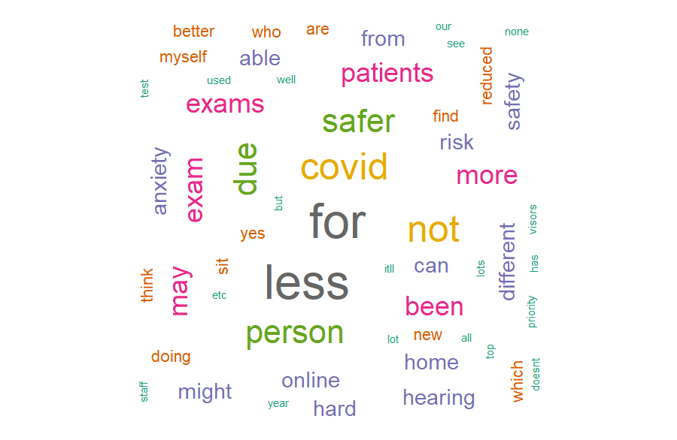

Supplementary 3.3 demonstrates a word cloud analysis of a student's perspective on the advantages of virtual ISCE before participating in the Mock ISCE. The size of each word in the diagram correlates with the frequency of its appearance in the response.

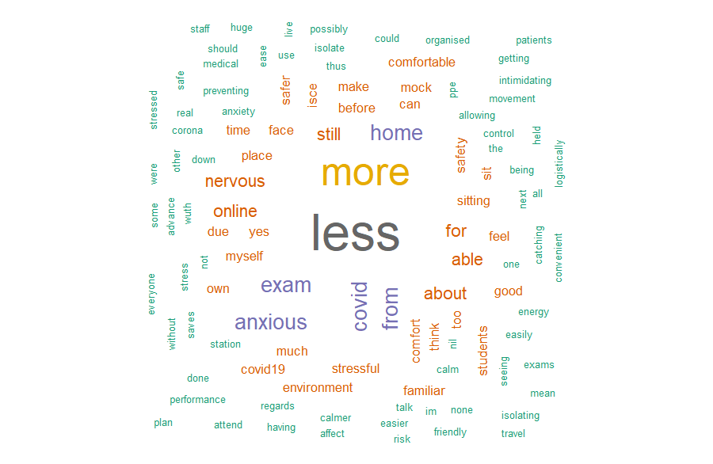
Supplementary 3.4 demonstrates a word cloud analysis of a student's perspective on the advantages of virtual ISCE after participating in the Mock ISCE. The size of each word in the diagram correlates with the frequency of its appearance in the response.

