Supplement Figure 1 A. Wright map: Person-item distribution for individual items of the AIS: Factor-1 (Sleep characteristics)
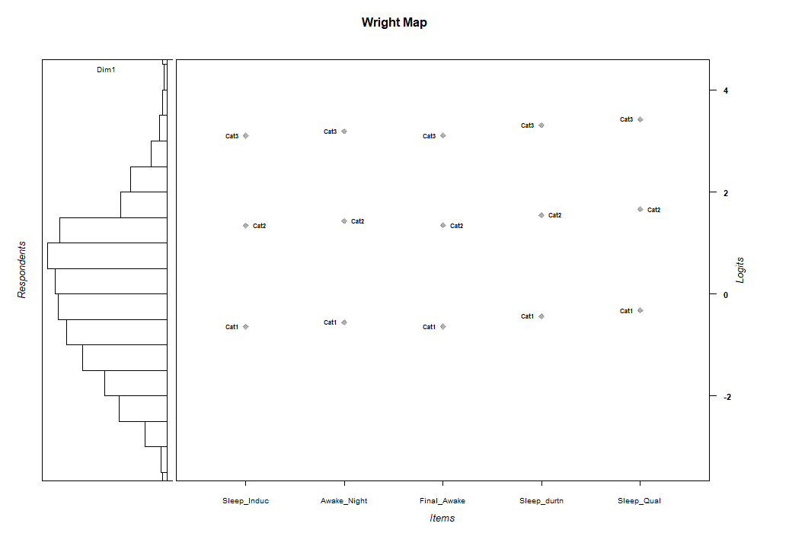

Supplement Figure 1 B. Wright map: Person-item distribution for individual items of the AIS: Factor-2 (Daytime symptoms)
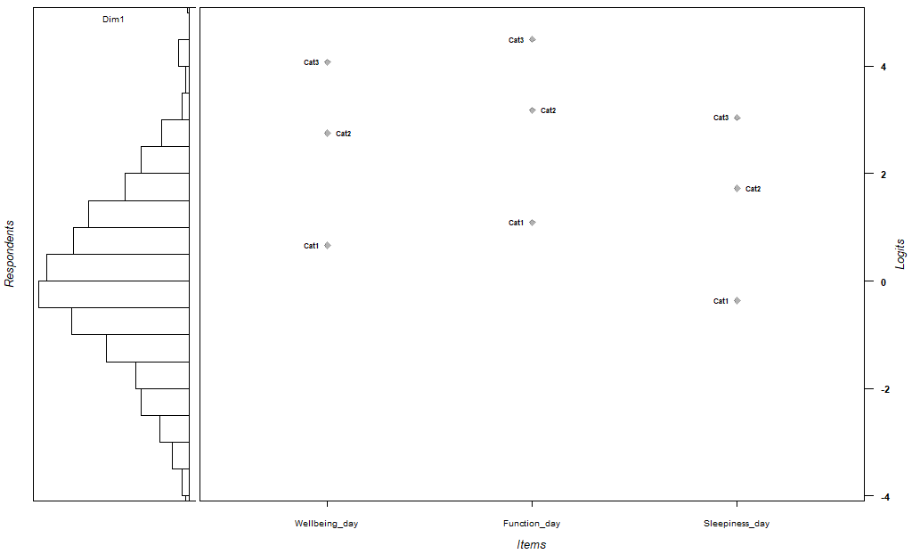
Athens Insomnia Scale (AIS) items; Sleep_Induc: Sleep induction, Awake_Night: Awakenings during the night, Final_Awake: Final awakening earlier than desired, Sleep_durtn: Total sleep duration, Sleep_Qual: Overall quality of sleep, Wellbeing_day: Sense of wellbeing during the day, Function_day: Functioning (physical and mental) during the day, and Sleepiness_day: Sleepiness during the day.
Cat1 to Cat3: Level of scoring for each items; Cat0 is not shown as it is the reference level. Dim1: dimension-1.

Supplement Table 1 Sample size adequacy measures of the Athens Insomnia Scale (AIS) scores in nurses
Measures | Values
Measures | Total sample | CFA sub-sample | EFA sub-sample
Anti-image matrix | 0.84-0.93 | 0.82-0.91 | 0.84-0.91
Bartlett’s test of Sphericity | Χ² (28) = 1759.4, p<0.001 | Χ² (28) = 948.0, p<0.001 | Χ² (28) = 852.9, p<0.001
Determinant | .043 | 0.032 | 0.046
Kaiser-Meyer-Olkin Test of Sampling Adequacy (KMO) | 0.88 | 0.86 | 0.87
Communality | 0.32-0.69 | 0.28-0.73 | 0.35-0.66
CFA: Confirmatory factor analysis, EFA: Exploratory factor analysis

Supplement Table 2 Inter-item Correlation matrix of the Athens Insomnia Scale (AIS) scores in nurses

Items of  the AIS | AIS-1 | AIS-2 | AIS-3 | AIS-4 | AIS-5 | AIS-6 | AIS-7 | AIS-8 | CFA sub-sample
AIS-1 |  | .51** | .25** | .50** | .52** | .34** | .36** | .36** | CFA sub-sample
AIS-2 |  |  | .37** | .48** | .52** | .45** | .37** | .30** | CFA sub-sample
AIS-3 |  |  |  | .44** | .41** | .29** | .27** | .21** | CFA sub-sample
AIS-4 |  |  |  |  | .76** | .55** | .50** | .31** | CFA sub-sample
AIS-5 |  |  |  |  |  | .54** | .54** | .32** | CFA sub-sample
AIS-6 |  |  |  |  |  |  | .63** | .27** | CFA sub-sample
AIS-7 |  |  |  |  |  |  |  | .35** | CFA sub-sample
AIS-8 |  |  |  |  |  |  |  |  | CFA sub-sample
AIS-1 |  | .37** | .37** | .30** | .35** | .42** | .32** | .17** | EFA sub-sample
AIS-2 |  |  | .53** | .45** | .44** | .38** | .38** | .36** | EFA sub-sample
AIS-3 |  |  |  | .45** | .39** | .35** | .29** | .33** | EFA sub-sample
AIS-4 |  |  |  |  | .71** | .50** | .45** | .41** | EFA sub-sample
AIS-5 |  |  |  |  |  | .56** | .51** | .38** | EFA sub-sample
AIS-6 |  |  |  |  |  |  | .62** | .37** | EFA sub-sample
AIS-7 |  |  |  |  |  |  |  | .37** | EFA sub-sample
AIS-8 |  |  |  |  |  |  |  |  | EFA sub-sample
* p < 0.05; **p < 0.01; EFA: exploratory factor analysis; CFA: confirmatory factor analysis

Supplement Table 3 Summary of the factor extraction measures used in principal component analysis of the Athens Insomnia Scale (AIS) scores in nurses

Number of Factors | Eigenvalue | Cumulative Variance Explained (%) | Above point of inflection on Scree plot | Decision to extract
 |  |  |  | Kaiser’s criteria (Eigenvalue≥1) | Cumulative variance rule (>40%) | Scree test
1 | 4.04 | 50.44 | Yes | √ | √ | √
2 | 0.88 | 61.43 | No | Χ | Χ | Χ
3 | 0.80 | 71.41 | No | Χ | Χ | Χ
4 | 0.67 | 79.73 | No | Χ | Χ | Χ

√ indicates extraction criteria fulfilled, Χ indicates otherwise

