Table S1 Supplementary OR and 95% CI for healthy diet characteristics
 | “What do you consider a healthy diet?”
Response categories | % (n) | Odds Ratioª | 95 % CI
Dietary variety
T1D (reference)  T2D  General population* | 15.4 (185)  13.8 (135)  12.7 (951) | 1  0.964  0.653 | -  0.712-1.305  0.528-0.809
Home cooked
T1D (reference)  T2D  General population* | 4.8 (58)  7.1 (69)  3.9 (289) | 1  1.249  0.715 | -  0.835-1.867  0.523-0.977
Fresh foods/ingredients
T1D (reference)  T2D  General population | 9.8 (118)  8.8 (86)  8.0 (601) | 1  0.766  0.792 | -  0.546-1.076  0.624-1.006
Organic
T1D (reference)  T2D  General population* | 2.1 (25)  2.7 (26)  3.7 (280) | 1  1.305  2.034 | -  0.725-2.350  1.320-3.132
Sustainable
T1D (reference)  T2D  General population | 0.2 (3)  0.4 (4)  0.3 (23) | 1  1.270  1.337 | -  0.263-6.128  0.386-4.635
Low in fat
T1D (reference)  T2D  General population | 14.5 (175)  16.6 (162)  17.1 (1280) | 1  1.118  1.175 | -  0.831-1.506  0.950-1.452
High in dietary fibre
T1D (reference)  T2D  General population* | 13.0 (157)  11.6 (113)  6.1 (457) | 1  0.914  0.325 | -  0.667-1.252  0.259-0.408
High in wholegrain foods
T1D (reference)  T2D  General population* | 5.7 (69)  5.9 (58)  2.5 (188) | 1  1.136  0.344 | -  0.757-1.705  0.253-0.468
Includes whole meal bread e.g. ryebread
T1D (reference)  T2D  General population* | 3.2 (38)  2.6 (25)  2.0 (148) | 1  0.615  0.520 | -  0.355-1.067  0.353-0.765
High in vegetables
T1D (reference)  T2D  General population* | 16.8 (202)  14.9 (145)  26.0 (1944) | 1  1.050  2.063 | -  0.778-1.419  1.668-2.552
High in fruit
T1D (reference)  T2D  General population* | 0.4 (5)  0.6 (6)  4.4 (333) | 1  1.724  9.314 | -  0.518-5.737  3.816-22.734
Includes proteins, vitamins and minerals
T1D (reference)  T2D  General population* | 3.5 (42)  1.6 (16)  6.0 (449) | 1  0.581  1.609 | -  0.314-1.075  1.140-2.270
Includes lean meat
T1D (reference)  T2D  General population* | 3.7 (44)  4.2 (41)  2.6 (194) | 1  0.959  0.624 | -  0.594-1.549  0.437-0.892
High in fish
T1D (reference)  T2D  General population | 3.7 (44)  3.8 (37)  3.3 (248) | 1  0.821  0.817 | -  0.507-1.330  0.576-1.558
Low in added sugar
T1D (reference)  T2D  General population* | 3.3 (40)  5.3 (52)  1.3 (101) | 1  1.590  0.362 | -  0.989-2.557  0.244-0.538
Total number of responses, % (n)
T1D (reference)  T2D  General population | 100 (1205)  100 (975)  100 (7486) | -  -  - | -  -  -
Binary logistic regression model adjusted for age, gender and education testing odds ratio for each response category separately in individuals with T1D (reference group), T2D and the general population.
Percentages have been calculated using numbers of responses for each group and each response category divided with total number of responses for each group separately.
ªAdjusted for age, gender and education.
CI, confidence interval; T1D, Type 1 diabetes; T2D, type 2 diabetes.
*Significantly different OR and 95% CI compared with T1D (reference group).

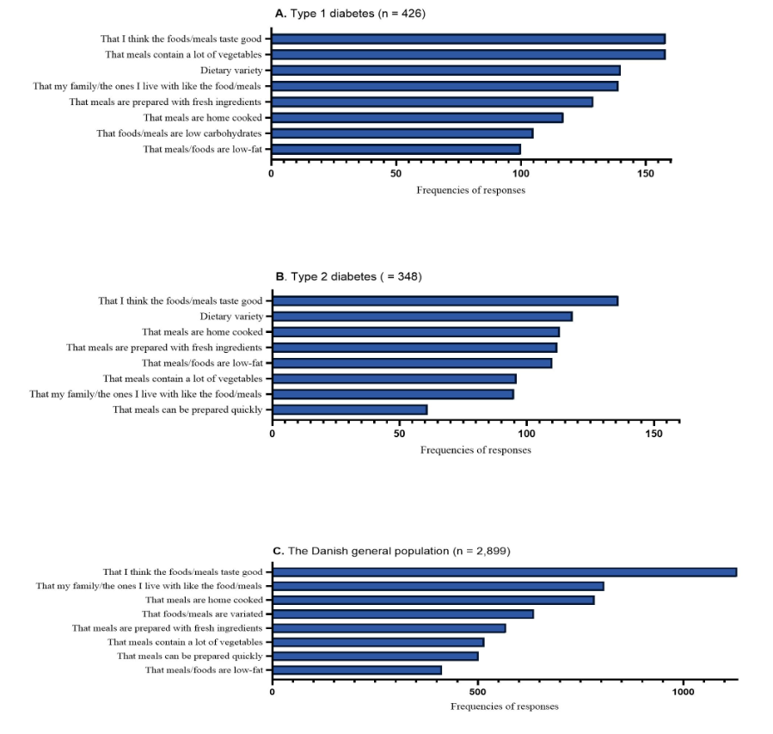
Figure S1. Frequencies of reported reasons for choosing which foods or meals to eat: A) in patients with type 1 diabetes, B) in patients with type 2 diabetes and C) in the Danish general population. In the online diabetes survey the question was ”What do you think is most important when you cook or buy groceries?” and in the DANSDA survey of the general population the question was ”What do you think is most important when you choose dinner meals?”. In the online diabetes survey up to three answers were accepted and in DANSDA only two answers were accepted. The same response categories were used in both surveys.

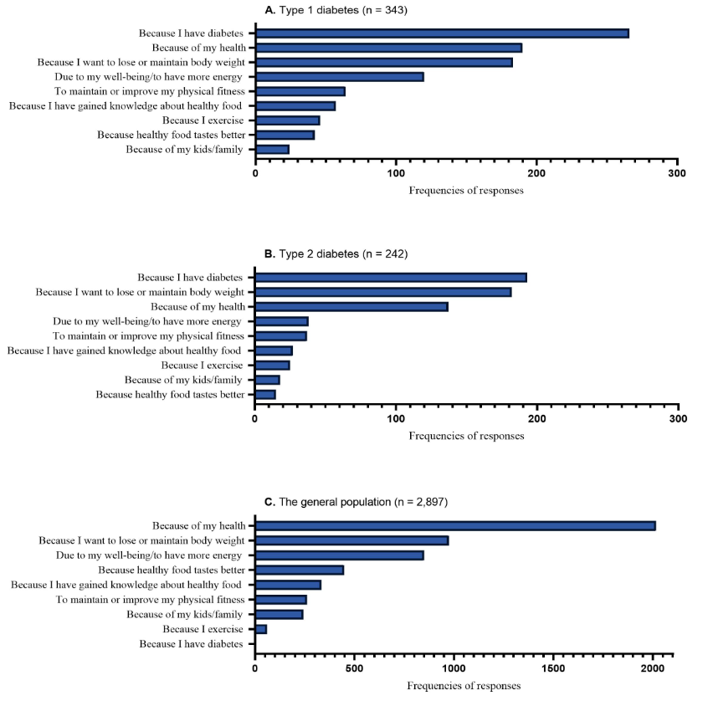
Figure S2. Frequencies of reported reasons for aiming to eat healthily often or very often: A) in patients with type 1 diabetes, B) in patients with type 2 diabetes and C) in the Danish general population. Only patients with diabetes reporting to eat healthily every day ”often” or ”very often” were asked this question. In both surveys the question was ”What is the most important reason why you aim to eat healthily?” with up to three accepted answers in the online diabetes survey and up to two accepted answers in the DANSDA survey of the general population. The same response categories were used in both surveys except for ”because I have diabetes” which was an additional question in the online diabetes survey.

