Cost-effectiveness of a proteomic test for preterm birth prediction
SUPPLEMENTAL MATERIALS

METHODS COMMENTS

- Illustrations of the model decision tree (Appendix Figure A1) and Markov model (Appendix Figure A2) are included below. No half-cycle correction was used for the Markov model due to the very short length of the model states (1 week).

- Details of the progesterone and HICM cost calculations are available from the corresponding author upon request. Costs for mothers are based on a cohort with complete enrollment during pregnancy and ≥12 months enrollment after delivery. Costs from infants with partial enrollment (<12 or <30 months) after birth were included over the time period available, without further adjustment. Death events are reflected through their effect on costs and not explicitly modelled (except as part of the NMI as described below).

- Handling of missing data: For Scenario 3, costs during 13-30 months for continuously enrolled infants born at week 23 were missing and were imputed using costs of those born in week 24. No other missing data issues occurred.

- The neonatal mortality/morbidity index was adapted for a claims environment from the following article: Hassan SS, Romero R, Vidyadhari D, et al. Vaginal progesterone reduces the rate of preterm birth in women with a sonographic short cervix: a multicenter, randomized, double-blind, placebo-controlled trial. Ultrasound in obstetrics & gynecology: the official journal of the International Society of Ultrasound in Obstetrics and Gynecology. 2011;38(1):18-31.
  - Specifically, the article’s supplementary material (Appendix S1) defines 4 separate “Composite Perinatal Mortality/Neonatal Morbidity Outcome Scores”. We used the “0 to 4 scale with NICU” and a timeframe of birth to 30 days after birth for an assessment of morbidity and mortality events.
  - A list of ICD-10-CM codes to identify each morbidity event from claims is available from the corresponding author upon request.
  - Neonatal mortality was determined from inpatient discharge records, enrollment data, and the Death Master File of the Social Security Administration. As stillbirths were excluded, mortality estimates are conservative.
  - Validation of this claims-based implementation of the NMI is a subject for future research.

- Derivation of risk ratios: Counts of deliveries in untreated and treated groups categorized by gestational age brackets were obtained from published data on studies of vaginal progesterone, 17-α-hydroxyprogesterone caproate (17-OHPC), high intensity case management, or bundles of two or more of these modalities.¹⁻⁸ Simple random-effects analysis at gestational age boundaries <32, <35 and <37 weeks across all treatment types showed significant efficacy, with no significant heterogeneity at <32 or <35 weeks. A joint analysis across all studies and gestational age brackets was conducted using a multivariate, multilevel random effects model with a heteroscedastic autoregressive structure and gestational age at delivery as a moderator. Treatment efficacy was significant and gestational age at treatment was a significant moderator with direction of effect showing improvement in efficacy at earlier gestational ages. We carried out sub-analyses of studies stratified by treatment type to obtain treatment-type-specific efficacy estimates. Notably, the estimate of the efficacy of bundled treatments^{3,8} was nearly identical to the summed efficacies of 17-OHPC^{1,4,7} and HICM^{2,5}, providing support from seven studies for the additive efficacy of treatments in combination. Three treatment effect sizes were established for analysis:
- Lower effectiveness: the central estimate across all treatment types and studies combined, largely reflective of single-modality treatment effects.¹⁻⁸
- Base case: the central estimate for studies with bundled treatments.^{3,8}
- Higher effectiveness: the estimated effect size from a recent RCT incorporating the protein ratio test and intensive bundled treatments.⁸

- Meis PJ, Klebanoff M, Thom E, et al. Prevention of recurrent preterm delivery by 17 alpha-hydroxyprogesterone caproate. N Engl J Med. 2003; 348(24):2379-2385.
- Newman RB, Sullivan SA, Menard MK, et al. South Carolina Partners for Preterm Birth Prevention: a regional perinatal initiative for the reduction of premature birth in a Medicaid population. Am J Obstet Gynecol. 2008; 199(4):393.e391-398.
- Manuck TA, Henry E, Gibson J, et al. Pregnancy outcomes in a recurrent preterm birth prevention clinic. Am J Obstet Gynecol. 2011; 204(4):320.e321-326.
- Grobman WA, Thom EA, Spong CY, et al. 17 alpha-hydroxyprogesterone caproate to prevent prematurity in nulliparas with cervical length less than 30 mm. Am J Obstet Gynecol. 2012; 207(5):390.e391-398.
- Hillemeier MM, Domino ME, Wells R, et al. Effects of maternity care coordination on pregnancy outcomes: propensity-weighted analyses. Matern Child Health J. 2015; 19:121-127.
- Romero R, Conde-Agudelo A, Da Fonseca E, et al. Vaginal progesterone for preventing preterm birth and adverse perinatal outcomes in singleton gestations with a short cervix: a meta-analysis of individual patient data. Am J Obstet Gynecol. 2018; 218(2):161-180.
- Blackwell SC, Gyamfi-Bannerman C, Biggio JR, Jr., et al. 17-OHPC to prevent recurrent preterm birth in singleton gestations (PROLONG Study): a multicenter, international, randomized double-blind trial. Am J Perinatol. 2020; 37(2):127-136.
- Branch DW, Esplin MS, Porter F, et al. Prediction and prevention of preterm birth: a prospective, randomized intervention trial. Society for Reproductive Investigation. 2020; abstract LBA-003.

- Derivation of transition probabilities: The Markov model has 19 states, each corresponding to a week of pregnancy (from week 19 to week 37+). Pregnant women enter the model at week 19 and either gave birth that week (PTB) or advanced to the next week of pregnancy (ultimately resulting in full-term birth if the “week 37+” state was reached).
  - For usual care, the probability of having a PTB in a specific week was calculated as the number of PTBs observed in the HIRD study population that week, divided by the population at risk that week. The transition probabilities between Markov states were calculate as 1.0 minus the probability of a PTB.
  - For the risk-screening-and-treat strategy, the risks of PTB were modified by treatment effects (the risk ratios; see prior section for details on their derivation). Using the number of PTBs modified by these treatment effects, we calculated the transition probabilities given preterm status.
  - The following table contains the numerical details for the base case. For example, starting with a population of 62,093 pregnant women, 4 of them had a PTB at week 22 of gestational age.
    - The PTB rate at week 22 for usual care was 4/62,093, and the transition probability from week 22 to week 23 was (1 minus 4/62,093).
    - In the risk-screening-and-treat arm, the number of PTBs was adjusted by the treatment effects and 4 and 2 PTBs occurred in weeks 22 and 23, respectively. The PTB rate and transition probabilities in this arm were calculated similarly, but using the full preterm population (N=4,360) as the denominator: PTB rate at week 22 was 4/4,360 and transition probability to week 23 was (1 minus 4/4,360).
Gestational age at birth | Number of pregnancies observed in the HIRD study population | Number of births observed in the HIRD study population | Usual care -Transition probabilities | Risk-screening-and-treat
 |  |  |  | Risk ratios (treatment effects) – base case | Number of births after adjusting for treatment effects | Transition probabilities with treatment effects among preterm
Week 19 | 62,093 | 0 | 0.0000 | NA | 0 | 0.0000
Week 20 | 62,093 | 0 | 0.0000 | NA | 0 | 0.0000
Week 21 | 62,093 | 0 | 0.0000 | NA | 0 | 0.0000
Week 22 | 62,093 | 4 | 0.0001 | NA | 4 | 0.0009
Week 23 | 62,089 | 12 | 0.0002 | 0.1315 | 2 | 0.0004
Week 24 | 62,077 | 26 | 0.0004 | 0.1492 | 4 | 0.0009
Week 25 | 62,051 | 29 | 0.0005 | 0.1693 | 5 | 0.0011
Week 26 | 62,022 | 32 | 0.0005 | 0.1921 | 6 | 0.0014
Week 27 | 61,990 | 63 | 0.0010 | 0.2179 | 14 | 0.0032
Week 28 | 61,927 | 65 | 0.0010 | 0.2473 | 16 | 0.0037
Week 29 | 61,862 | 75 | 0.0012 | 0.2806 | 21 | 0.0049
Week 30 | 61,787 | 104 | 0.0017 | 0.3183 | 33 | 0.0077
Week 31 | 61,683 | 115 | 0.0019 | 0.3612 | 42 | 0.0098
Week 32 | 61,568 | 200 | 0.0032 | 0.4098 | 82 | 0.0194
Week 33 | 61,368 | 299 | 0.0049 | 0.4649 | 139 | 0.0336
Week 34 | 61,069 | 674 | 0.0110 | 0.5275 | 356 | 0.0890
Week 35 | 60,395 | 820 | 0.0136 | 0.5985 | 491 | 0.1349
Week 36 | 59,575 | 1,842 | 0.0309 | 0.6791 | 1,251 | 0.3975
Week 37+ | 57,733 | 57,733 | 1.0000 | NA | 59,629 | N/A

- Identification of gestational age at birth via ICD-10-CM codes:

 | Mother claims | Neonate claims
Weeks of gestation
<23 | Z3A.17, Z3A.18, Z3A.19, Z3A.20, Z3A.21, Z3A.22 | P07.21
23 | Z3A.23 | P07.22
24 | Z3A.24 | P07.23
25 | Z3A.25 | P07.24
26 | Z3A.26 | P07.25
27 | Z3A.27 | P07.26, P07.20
28 | Z3A.28 | P07.31
29 | Z3A.29 | P07.32
30 | Z3A.30 | P07.33
31 | Z3A.31 | P07.34
32 | Z3A.32 | P07.35
33 | Z3A.33 | P07.36
34 | Z3A.34 | P07.37
35 | Z3A.35 | P07.38
36 | Z3A.36 | P07.39, P07.30
≥37 | Z3A.37, Z3A.38, Z3A.39, Z3A.40, Z3A.41, Z3A.42, Z3A.49 | P08.21, P08.22

SUPPLEMENTARY TABLES

Table A1. Patient Selection

Steps | Identification criteria for mothers | Counts
1 | ≥1 claim for delivery in an inpatient setting. Index Date = admission date of the delivery hospitalization | 96,222
2 | ≥1 claim for gestational age during gestational age identification periodª | 94,004
3 | Age ≥18 years old as of the estimated pregnancy start date^{b} | 93,253
4 | Continuously enrolled in the health plan with medical and pharmacy benefit during the baseline period (i.e. during pregnancy) | 70,047
5 | No evidence for multiple gestation during intake period | 68,306
6 | No progesterone therapy >12 to <21 weeks of gestation | 67,286
7 | No fetal chromosomal abnormality or structural anomaly associated with shortened gestation during the intake period | 63,406
8 | No preterm labor or rupture of membranes <21 weeks gestation | 63,237
9 | Continuously enrolled in the health plan with medical and pharmacy benefit during the 12 months post-index period | 42,233
10 | No claim for still births or abortion during the intake period | 40,649
ªGestational age identification period: index date (delivery date) minus 7 days through index date plus 7 days, using ICD-10-CM code descriptions of gestational age.
^{b}Estimated claims-based pregnancy start date: index date minus weeks of gestation identified during gestational week identification period.

Steps | Identification criteria for infants | Counts
1 | Among those with medical and pharmacy health plan eligibility, birth year was 2016 | 101,435
2 | ≥1 medical claim with gestational age or ≥1 medical claim indicative of single live born infant within 30 days of birth date. Index Date is Birth Date | 63,945
3 | No code for multiple gestation | 62,093
4a | Only applied for derivation of costs in Scenario 5: Continuously enrolled in the health plan with medical and pharmacy benefit during the 12 months post-index period | 40,116
4b | Only applied for derivation of costs in Scenario 3: Continuously enrolled in the health plan with medical and pharmacy benefit during the 30 months post-index period | 22,212

Table A2. Model assumptions on preterm births and risk-screening-and-treat effectiveness

Weeks of gestation | # of births* | % of births | Treatment effectiveness (base case)** | Treatment effectiveness (worst case)** | Treatment effectiveness (best case)**
<23 | 4 | 0.0% | NA | NA | NA
23 | 12 | 0.0% | 0.1315 | 0.5338 | 0.0087
24 | 26 | 0.0% | 0.1492 | 0.5521 | 0.0127
25 | 29 | 0.0% | 0.1693 | 0.5711 | 0.1820
26 | 32 | 0.1% | 0.1921 | 0.5907 | 0.0258
27 | 63 | 0.1% | 0.2179 | 0.6109 | 0.0360
28 | 65 | 0.1% | 0.2473 | 0.6319 | 0.0497
29 | 75 | 0.1% | 0.2806 | 0.6536 | 0.0679
30 | 104 | 0.2% | 0.3183 | 0.6760 | 0.0971
31 | 115 | 0.2% | 0.3612 | 0.6993 | 0.1227
32 | 200 | 0.3% | 0.4098 | 0.7233 | 0.1626
33 | 299 | 0.5% | 0.4649 | 0.7481 | 0.2136
34 | 674 | 1.1% | 0.5275 | 0.7738 | 0.2783
35 | 820 | 1.3% | 0.5985 | 0.8003 | 0.3599
36 | 1,842 | 3.0% | 0.6791 | 0.8278 | 0.4620
≥37 | 57,733 | 93.0% | NA | NA | NA
TOTAL | 62,093 | 100.0% | - | - | -
Total preterm | 4,360 | 7.0% | - | - | -

*Based on observed frequencies in the HIRD, 01 Jan 2016 to 31 Dec 2016
**Numbers represent risk ratios. For example, in the base case, the risk of a preterm birth at week 23 with the treatment is 0.1315 (87% lower) compared to without the treatment.

Table A3. Model assumptions on maternal and infant costs

Weeks of gestation | Maternal care costs ($)  (total, conception to 12m post-birth) |  |  | Infant care costs ($)  (birth to 12m post-birth) |  |  | Infant care costs ($)  (13m to 30m post-birth)
 | Base case | Lower limit | Upper limit | Base case | Lower limit | Upper limit | Base case | Lower limit | Upper limit
23 | 54,806 | 14,296 | 95,315 | 274,114 | 22,267 | 525,962 | 52,410 | 0 | 167,764
24 | 40,559 | 21,965 | 59,152 | 671,371 | 440,732 | 902,011 | 17,753 | 4,882 | 30,624
25 | 44,678 | 31,509 | 57,848 | 381,852 | 275,578 | 488,126 | 4,934 | 414 | 9,454
26 | 52,187 | 21,186 | 83,188 | 645,687 | 473,004 | 818,371 | 25,789 | 9,966 | 41,612
27 | 55,267 | 36,539 | 73,996 | 447,108 | 300,441 | 593,776 | 10,676 | 0 | 24,853
28 | 42,709 | 30,756 | 54,662 | 289,745 | 222,120 | 357,369 | 7,541 | 522 | 14,561
29 | 53,862 | 34,939 | 72,785 | 299,118 | 233,177 | 365,058 | 4,850 | 2,368 | 7,333
30 | 45,541 | 31,379 | 59,703 | 251,890 | 207,870 | 295,910 | 5,606 | 3,221 | 7,991
31 | 52,311 | 35,574 | 69,048 | 228,934 | 169,931 | 287,937 | 15,638 | 2,817 | 28,460
32 | 37,734 | 32,002 | 43,465 | 127,758 | 108,944 | 146,572 | 4,740 | 3,008 | 6,471
33 | 42,750 | 35,890 | 49,610 | 105,837 | 85,942 | 125,732 | 3,881 | 1,259 | 6,503
34 | 38,061 | 33,249 | 42,873 | 76,584 | 65,832 | 87,335 | 3,603 | 2,816 | 4,390
35 | 33,842 | 30,737 | 36,946 | 43,289 | 36,244 | 50,333 | 3,978 | 2,939 | 5,018
36 | 31,744 | 29,580 | 33,908 | 37,123 | 30,441 | 43,805 | 3,831 | 3,072 | 4,590
37+ | 24,143 | 23,960 | 24,327 | 8,642 | 8,348 | 8,936 | 2,642 | 2,510 | 2,775

All values are reported in 2018 USD. Costs were sourced from the HIRD. Maternal care costs were derived from a cohort with complete enrollment during pregnancy and ≥12 months enrollment after delivery. Infant care costs were derived from a cohort with no minimum required enrollment and without further adjustment. Lower and upper limits refer to 95% confidence intervals. For PSA, all costs were modelled via gamma distributions.

Table A4. Model assumptions on infant costs for Scenario 3 (costs of continuously enrolled infants only)

Weeks of gestation | Infant care costs ($)  (birth to 12m post-birth)  N=40,116 | Infant care costs ($)  (13m to 30m post-birth)  N=22,212
23 | 632,808 | 49,948
24 | 875,166 | 49,948
25 | 546,558 | 17,802
26 | 648,327 | 56,047
27 | 549,492 | 44,765
28 | 396,711 | 12,177
29 | 319,118 | 11,959
30 | 257,987 | 12,044
31 | 292,950 | 26,853
32 | 141,001 | 7,787
33 | 119,681 | 10,729
34 | 86,980 | 6,369
35 | 45,484 | 8,021
36 | 39,276 | 7,958
37+ | 9,568 | 4,933

All values are reported in 2018 USD. Costs were sourced from the HIRD.

SUPPLEMENTARY FIGURES

Figure A1. Decision tree for the preterm birth model
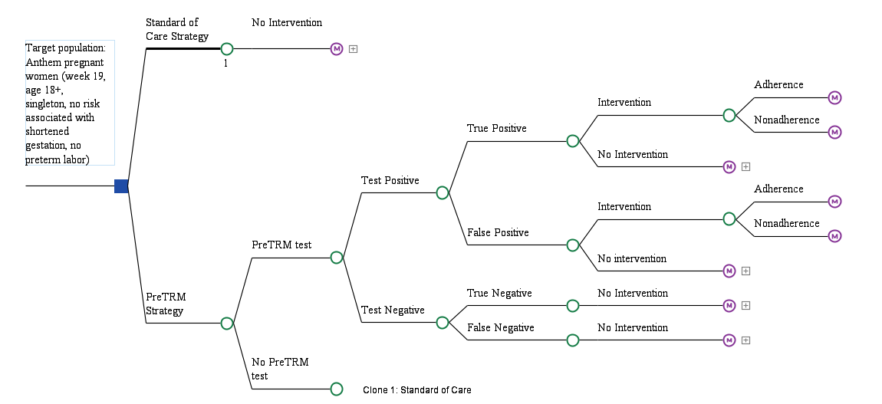
Figure A2. Markov states and transitions for the preterm birth model
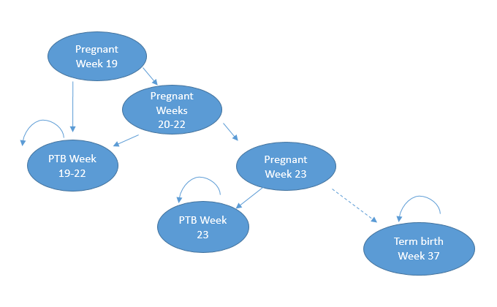

Figure A3. Number of births and change in the risk-screening-and-treat arm vs. usual care, base case
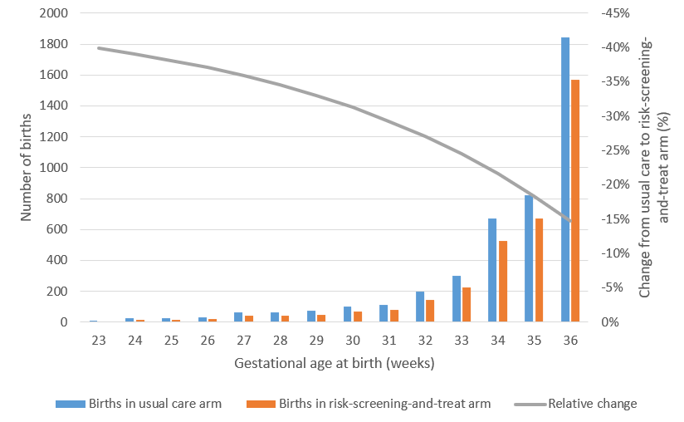

Figure A4. Univariate sensitivity analysis (tornado diagram), births <32 weeks as endpoint

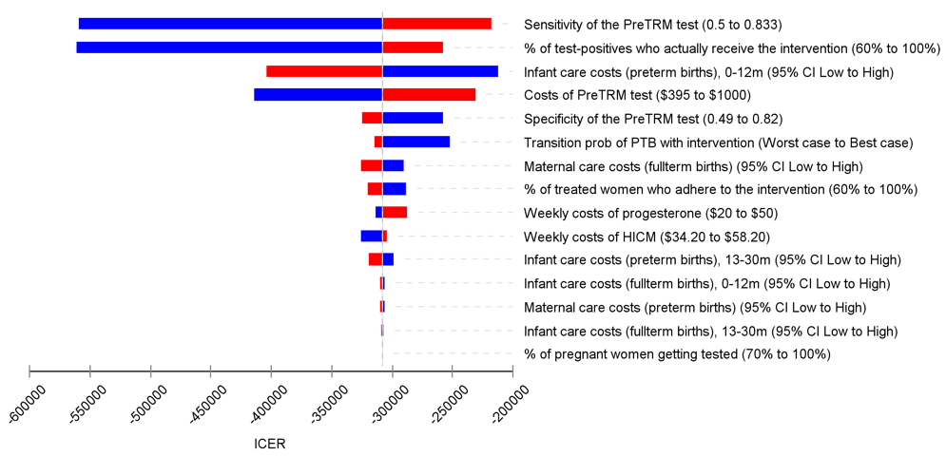

PTB = preterm birth; ICER = incremental cost-effectiveness ratio; HICM = high-intensity case management

Figure A5. Univariate sensitivity analysis (tornado diagram), births <35 weeks as endpoint

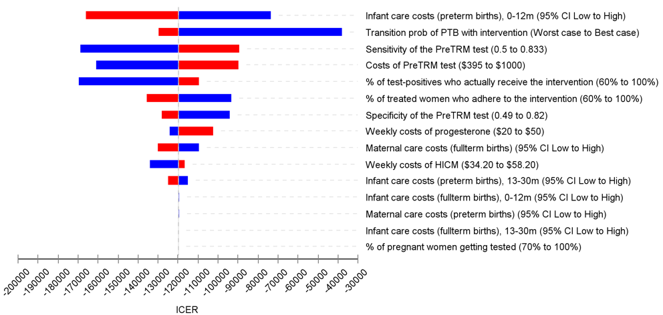

PTB = preterm birth; ICER = incremental cost-effectiveness ratio; HICM = high-intensity case management

Figure A6. ICER scatter plot and cost-effectiveness acceptability curves, worst-case effectiveness scenario

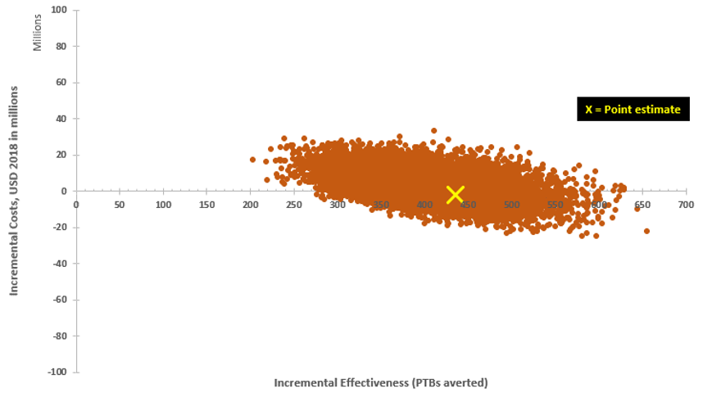

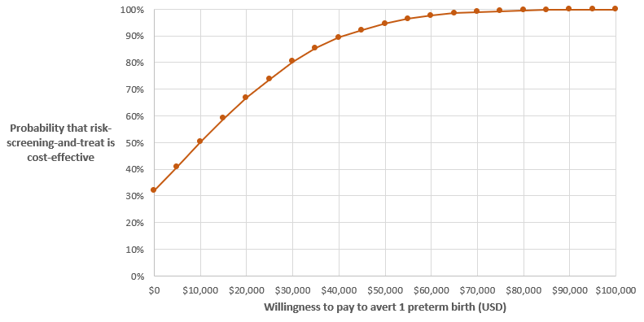

PTB = preterm birth; ICER = incremental cost-effectiveness ratio; USD = US dollars

