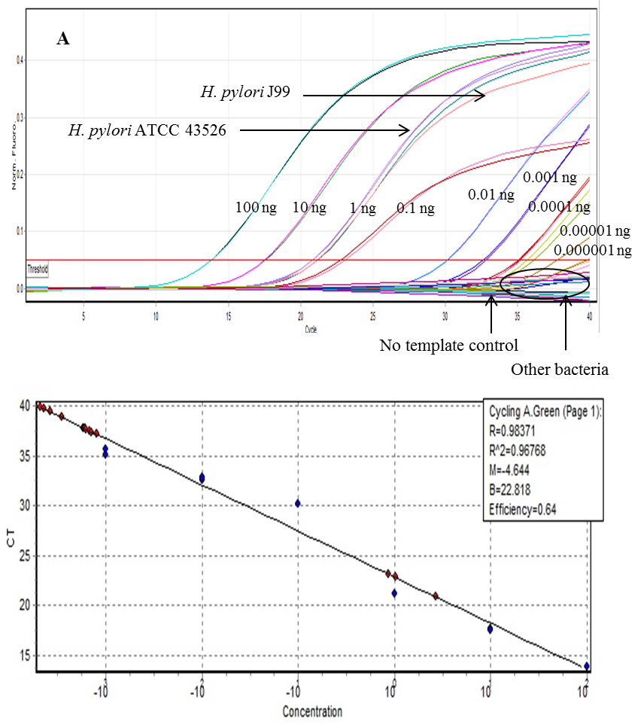
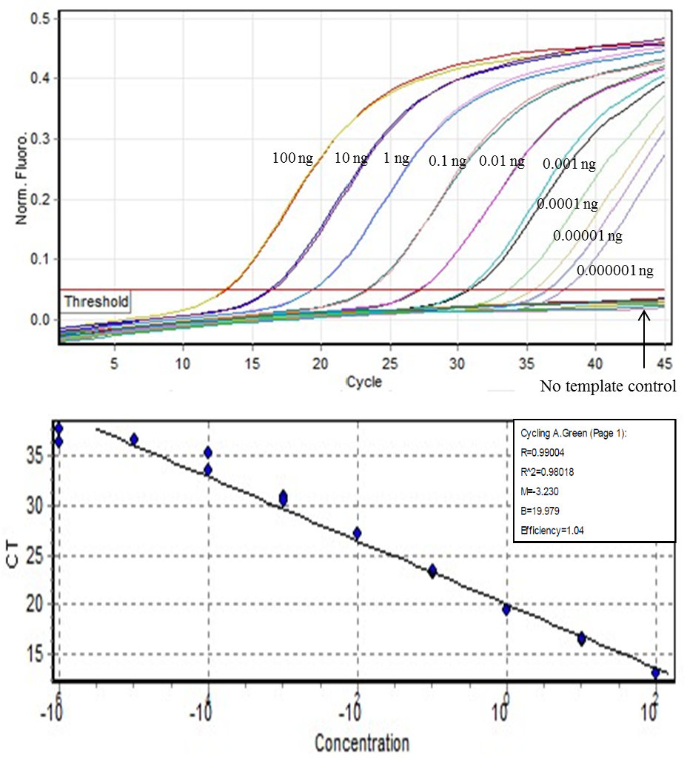
SUPPLEMENT 1
A
B

Figure 1 (A) The specificity of ureA qPCR. (B) Standard curve for quantification was generated using the optimized qPCR amplification assay conditions based on DNA concentration ranging from 100 ng to 0.01 fg.

SUPPLEMENT 2
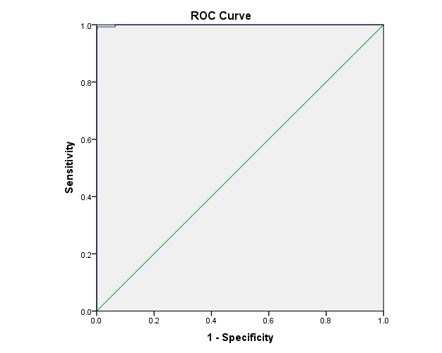

Figure 1 Receiver operating characteristic (ROC) curve for the qPCR assay of all biopsy specimens. The area under the curve is 0.999

SUPPLEMENT 3

Figure. 1. Distribution of C_{q} values determined by qPCR results among the 571 biopsy samples displaying a C_{q} value during the 40 cycles of the assay. Black bars, biopsy specimens positive for qPCR ($≥$ 0.5 copies number per 100 human cells); gray bars, biopsy specimens negative for qPCR ($<$0.5 copies number per 100 human cells).

SUPPLEMENT 4
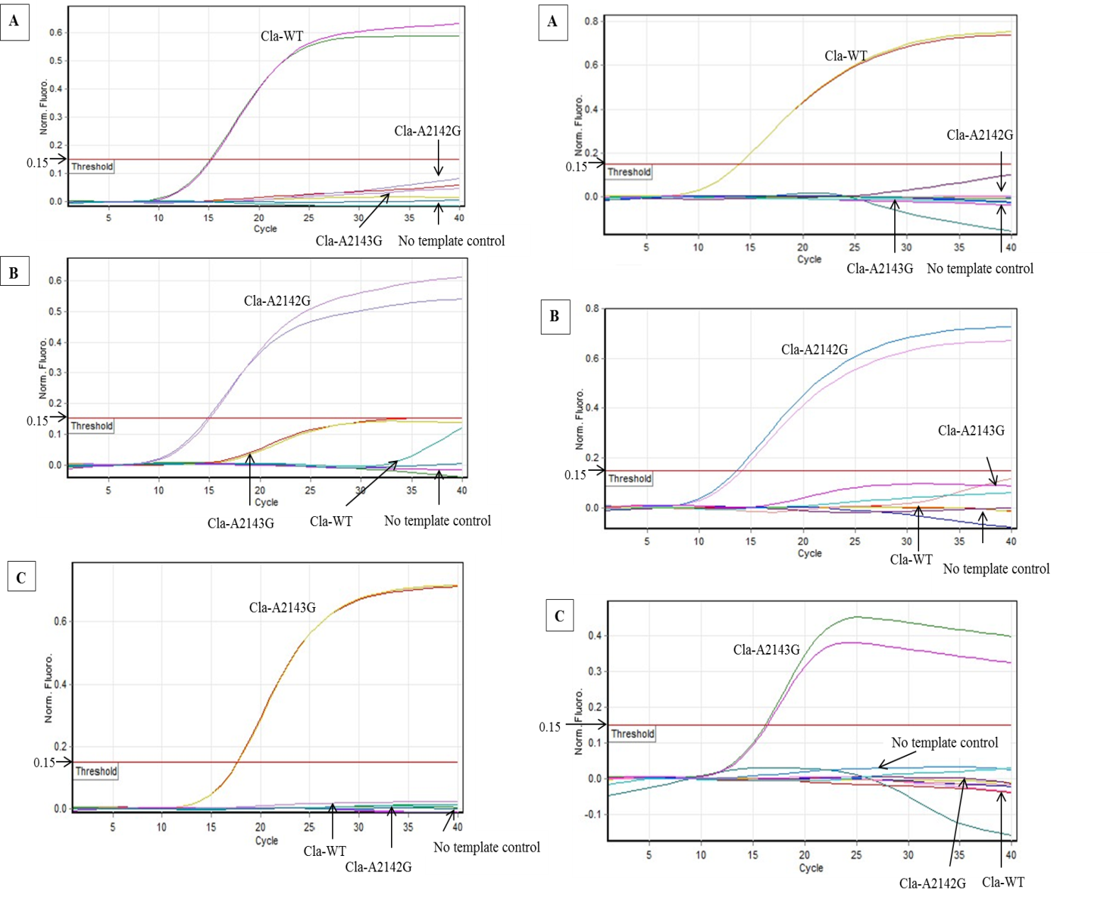
Singleplex qPCR
Multiplex qPCR

Figure 1 Amplification curves of the singleplex qPCR and multiplex qPCR assay for detection of the wild-type, A2142G, and A2143G mutations. (A) The fluorescence signal from the Cy5 dye (Red) of the Cla-PWT. (B) The fluorescence signal from HEX dye (Yellow) of the Cla-P2142G. (C) The fluorescence signal from the FAM dye (Green) of the Cla-P2143G.

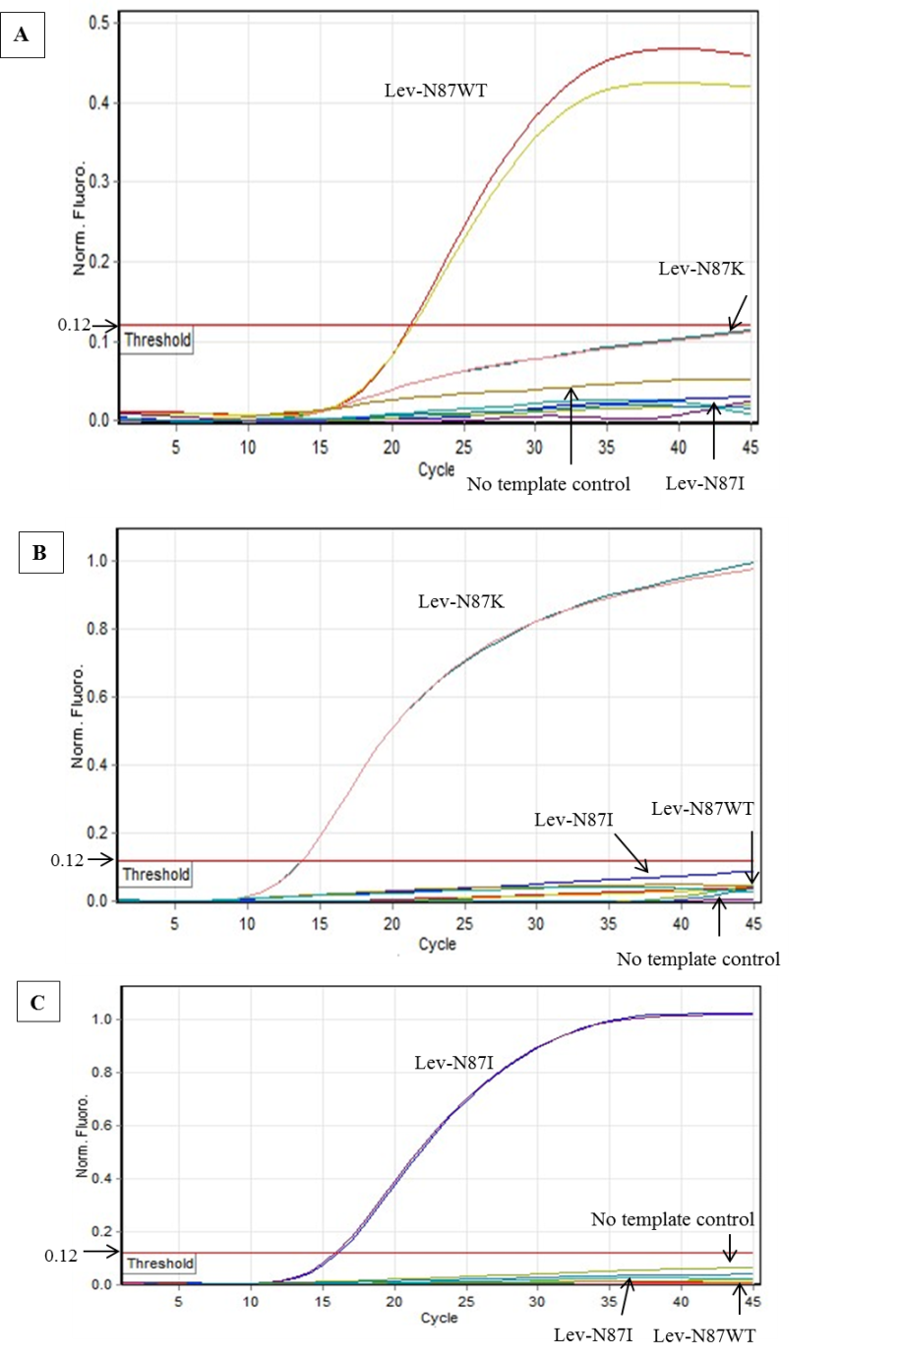
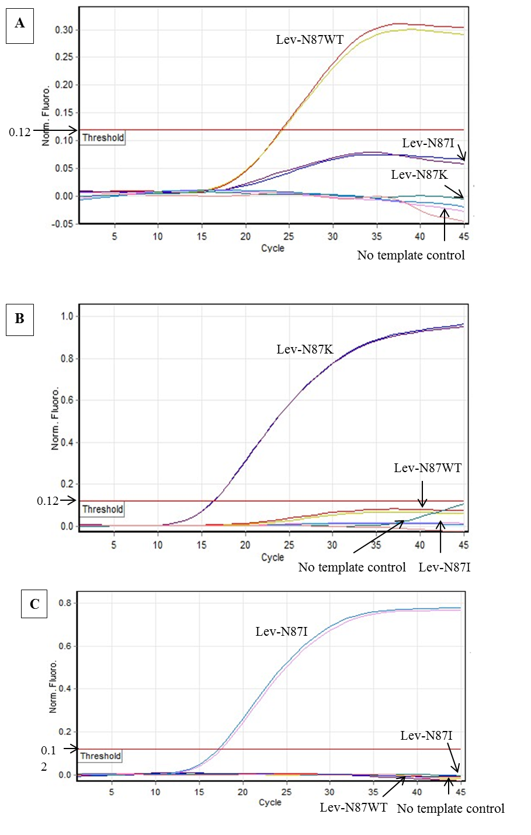
SUPPLEMENT 5
Singleplex qPCR
Multiplex qPCR

Figure 1. Amplification curves of the singleplex and multiplex qPCR assay for detection of Lev-N87WT, Lev-N87K, and Lev-N87I mutations. (A) The fluorescence signal from the HEX dye (Yellow) of the Lev-N87WT. (B) The fluorescence signal from the FAM dye (Green) of the Lev-N87K. (C) The fluorescence signal from Cy5 dye (Red) of the Lev-N87I.

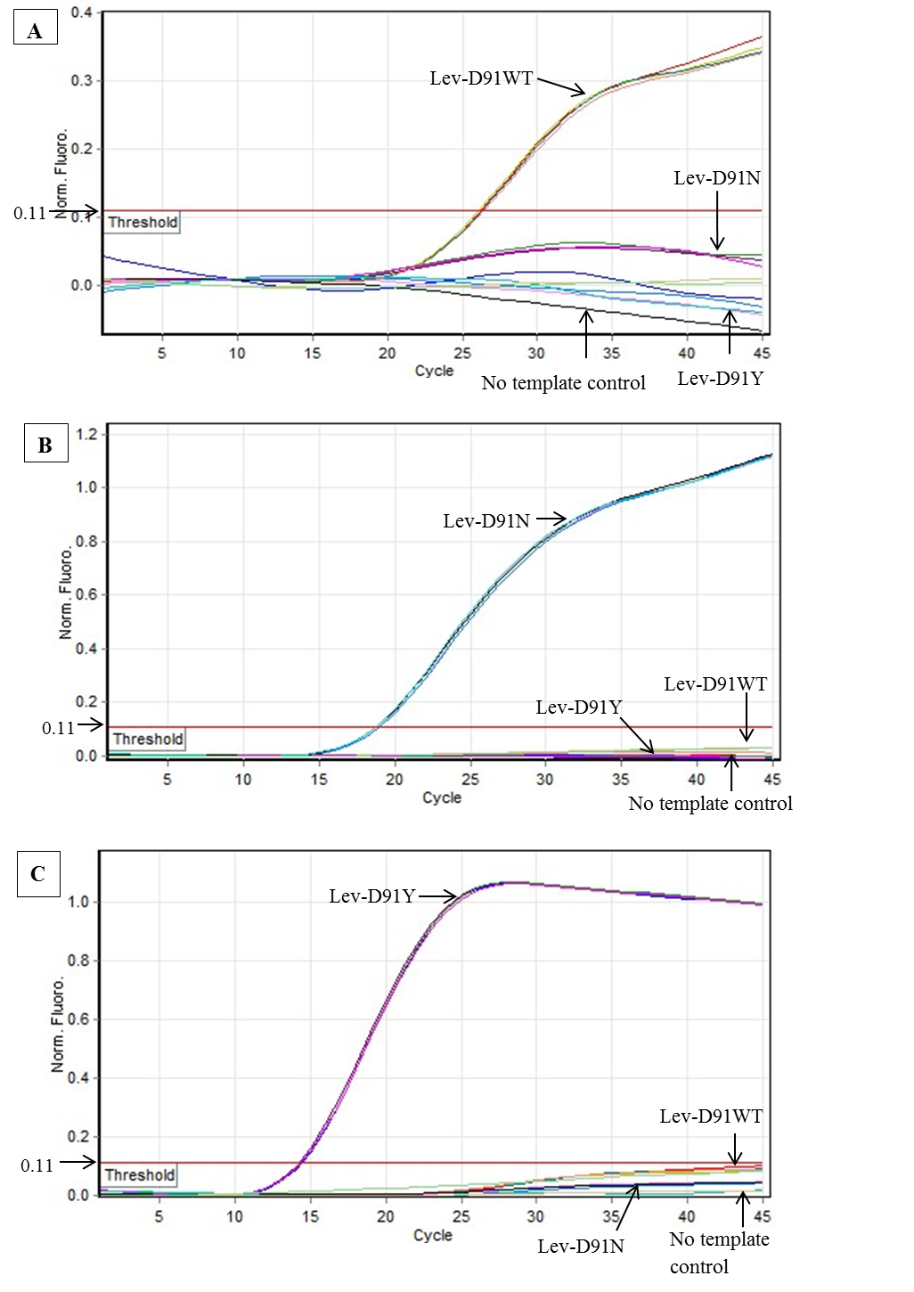
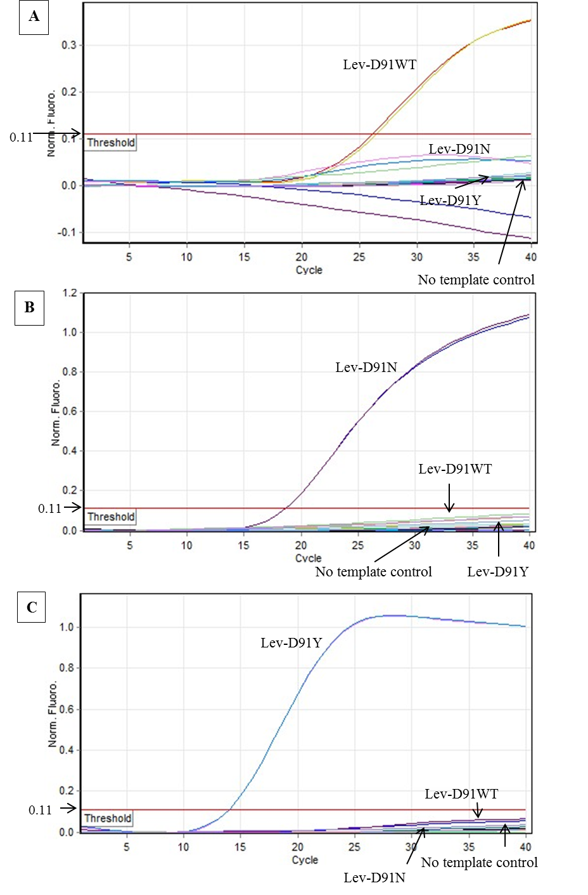
SUPPLEMENT 6
Multiplex qPCR
Singleplex qPCR

Figure 1. Amplification curves of the singleplex qPCR assay for detection of Lev-D91WT, Lev-D91N, and Lev-D91Y mutations. (A) The fluorescence signal from the HEX dye (Yellow) of the Lev-D91WT. (B) The fluorescence signal from Cy5 dye (Red) of the Lev-D91N. (C) The fluorescence signal from the FAM dye (Green) of the Lev-D91Y.

SUPPLEMENT 7
Table 1 Analytical sensitivity and corresponding threshold cycles (Cq) values from singleplex and multiplex qPCR assay for each target
Probe detection for | Quantity (ng/reaction) | Cq (mean ± SDª) |  | P value^{b}
Probe detection for | Quantity (ng/reaction) | Singleplex | Multiplex | P value^{b}
Wild-type | 10 | 16.38 ± 0.03 | 16.57 ± 0.08 | 0.920
 | 1 | 18.97 ± 0.00 | 19.12 ± 0.06
 | 0.1 | 22.18 ± 0.11 | 22.26 ± 0.02
 | 0.01 | 22.57 ± 0.02 | 25.91 ± 0.04
A2142G mutation | 10 | 16.28 ± 0.06 | 16.45 ± 0.007 | 0.531
 | 1 | 19.84 ± 0.04 | 20.20 ± 0.28
 | 0.1 | 23.54 ± 0.01 | 23.68 ± 0.43
 | 0.01 | 27.45 ± 0.30 | 27.48 ± 0.07
A2143G mutation | 10 | 18.55 ± 0.04 | 19.05 ± 0.06 | 0.747
 | 1 | 21.93 ± 0.14 | 22.60 ± 0.42
 | 0.1 | 25.28 ± 0.11 | 26.05 ± 0.10
 | 0.01 | 28.94 ± 0.21 | 29.75 ± 0.03
ª, Standard deviation; ^{b}, Independent sample t-test

SUPPLEMENT 8
Table 1. Analytical sensitivity and corresponding threshold cycles (Cq) values from singleplex and multiplex qPCR assay for each target
Probe detection for | Quantity (ng/reaction) | Cq (mean ± SDa^{b}) |  | P value^{b}
Probe detection for | Quantity (ng/reaction) | Singleplex | Multiplex | P value^{b}
N87Wild-type | 10 | 18.85 ± 0.49 | 19.12 ± 0.47 | 0.926
 | 1 | 21.92 ± 0.04 | 22.15 ± 0.06
 | 0.1 | 25.33 ± 0.07 | 25.38 ± 0.13
 | 0.01 | 27.84 ± 0.01 | 27.98 ± 0.05
N87K mutation | 10 | 14.76 ± 0.16 | 14.55 ± 0.23 | 0.920
 | 1 | 17.85 ± 0.03 | 17.77 ± 0.08
 | 0.1 | 21.12 ± 0.03 | 21.08 ± 0.01
 | 0.01 | 24.40 ± 0.54 | 23.96 ± 0.15
N87I mutation | 10 | 15.80 ± 0.02 | 15.92 ± 0.08 | 0.956
 | 1 | 19.12 ± 0.11 | 19.03 ± 0.04
 | 0.1 | 22.47 ± 0.02 | 22.65 ± 0.02
 | 0.01 | 25.73 ± 0.07 | 25.97 ± 0.32
ª, Standard deviation; ^{b}, Independent sample t-test

SUPPLEMENT 9
Table 1. Analytical sensitivity and corresponding threshold cycles (Cq) values from singleplex and multiplex qPCR assay for each target
Probe detection for | Quantity (ng/reaction) | Cq (mean ± SDª) |  | P value^{b}
Probe detection for | Quantity (ng/reaction) | Singleplex | Multiplex | P value^{b}
D91Wild-type | 10 | 22.07 ± 0.01 | 22.12 ± 0.16 | 0.943
 | 1 | 25.01 ± 0.01 | 25.07 ± 0.03
 | 0.1 | 27.14 ± 0.13 | 27.26 ± 0.37
 | 0.01 | 30.51 ± 0.72 | 30.50 ± 0.68
D91N mutation | 10 | 20.42 ± 0.03 | 20.33 ± 0.00 | 0.984
 | 1 | 23.60 ± 0.08 | 23.67 ± 0.40
 | 0.1 | 28.13 ± 0.17 | 28.33 ± 0.04
 | 0.01 | 31.46 ± 0.74 | 31.46 ± 0.79
D91Y mutation | 10 | 21.76 ± 0.25 | 21.73 ± 0.36 | 0.948
 | 1 | 26.50 ± 0.61 | 26.07 ± 0.03
 | 0.1 | 32.40 ± 0.17 | 32.31 ± 0.41
 | 0.01 | - | -
ª, Standard deviation; ^{b}, Independent sample t-te

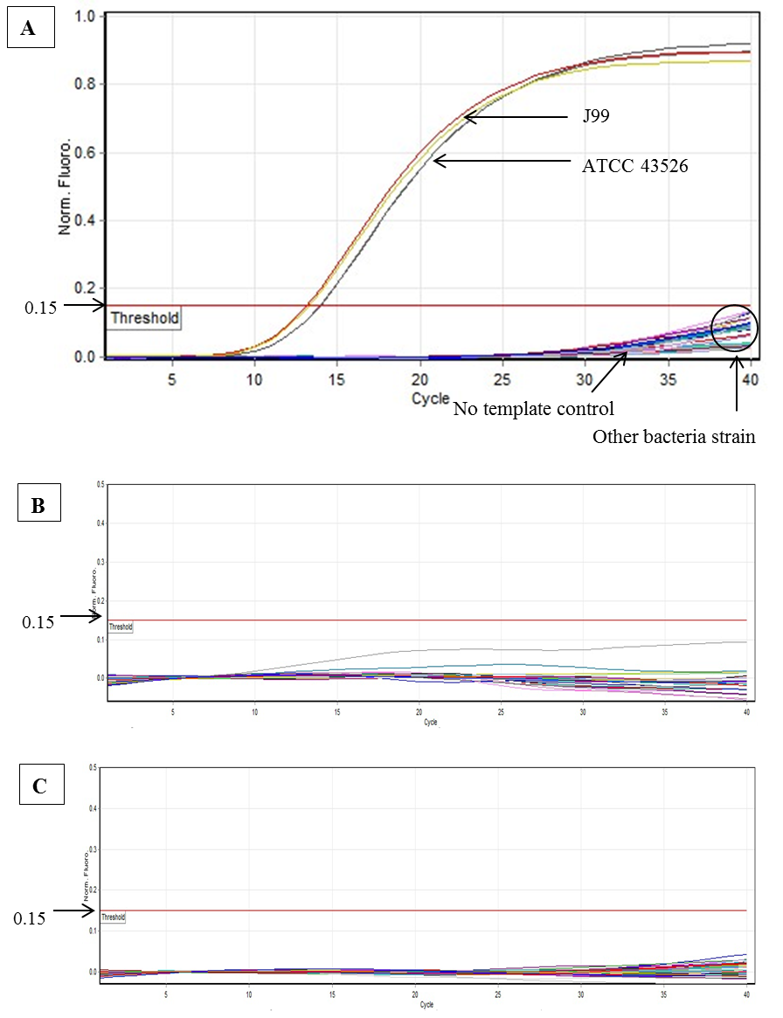
SUPPLEMENT 10

Figure 1. The specificity of triplex 23S rRNA qPCR. (A) The fluorescence signal was from the Cy5 dye (Red) of the Cla-PWT. (B) The fluorescence signal was from HEX dye (Yellow) of the Cla-P2142G. (C) The fluorescence signal was from the FAM dye (Green) of the Cla-P2143G.
SUPPLEMENT 11
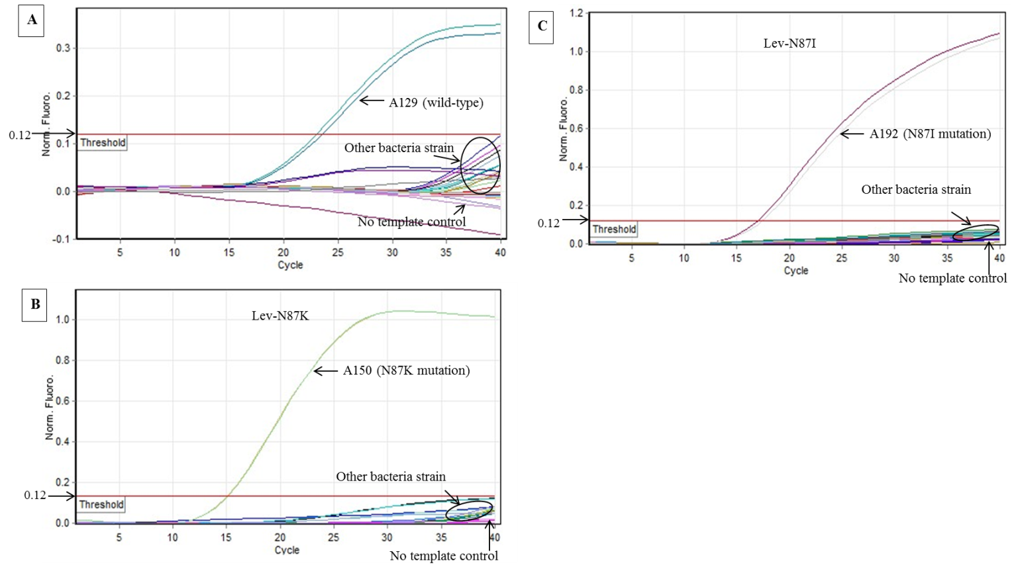

Figure 1. The specificity of triplex gyrA-N87 qPCR. (A) The fluorescence signal from the HEX dye (Yellow) of the Lev-N87WT. (B) The fluorescence signal from the FAM dye (Green) of the Lev-N87K. (C) The fluorescence signal from Cy5 dye (Red) of the Lev-N87I.

SUPPLEMENT 12
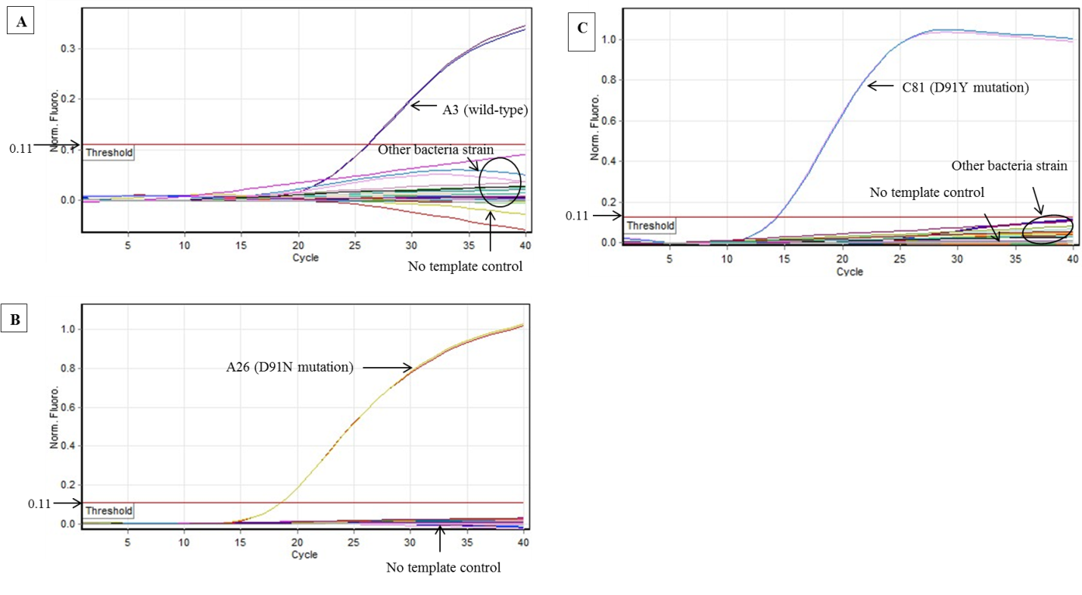

Figure 1. The specificity of triplex gyrA-D91 qPCR. (A) The fluorescence signal from the HEX dye (Yellow) of the Lev-D91WT. (B) The fluorescence signal from Cy5 dye (Red) of the Lev-D91N. (C) The fluorescence signal from the FAM dye (Green) of the Lev-D91Y.

