Supplementary materials
Supplementary figure 1: PCR Products of aac (6')-Ib gene. L; 100 bp DNA ladder supplied from Solis BioDyne, Estonia; lanes 60-75 and lanes 76-83 represent isolate number. The name of amplified gene and its molecular weight (482 bp) were stated above and below the amplified bands, respectively.
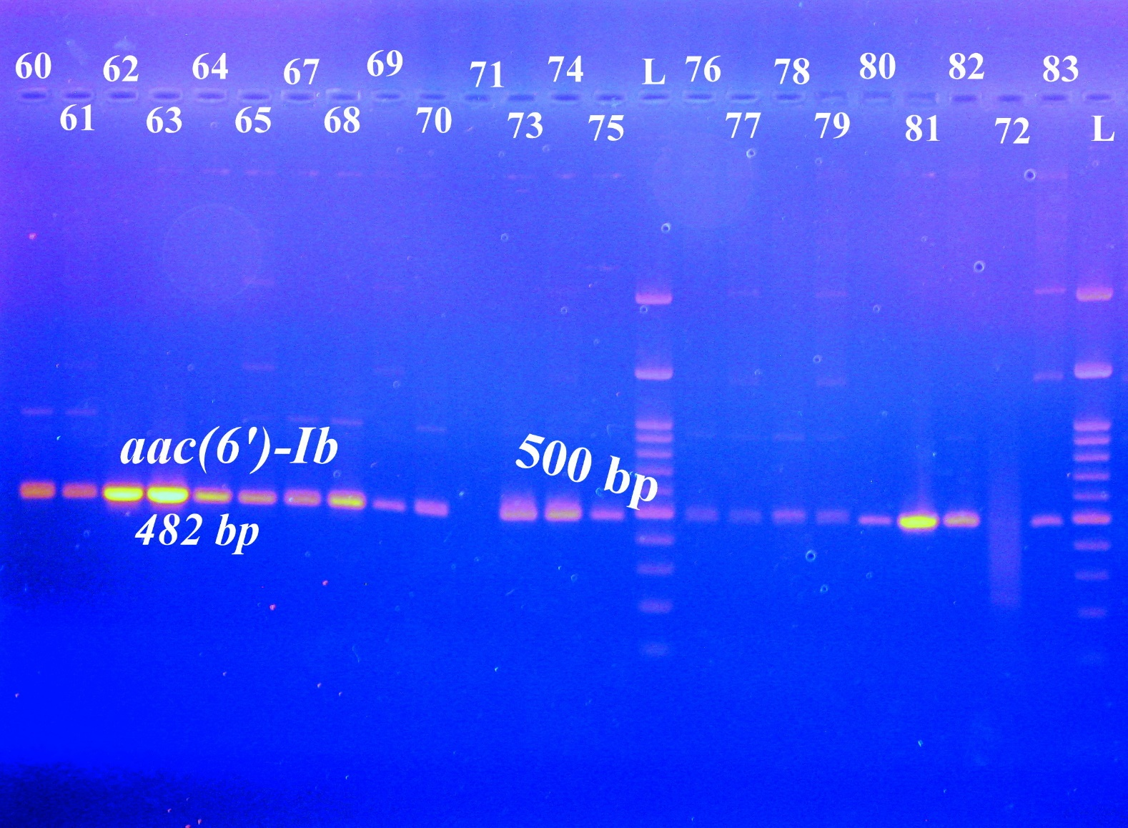

Supplementary figure 2: PCR Products of aph (3')-IV gene. L; 100 bp DNA ladder supplied from Solis BioDyne, Estonia; lanes 60-73 and lanes 74-94 represent isolate number. The name of amplified gene and its molecular weight (780 bp) were stated above and below the amplified bands, respectively. 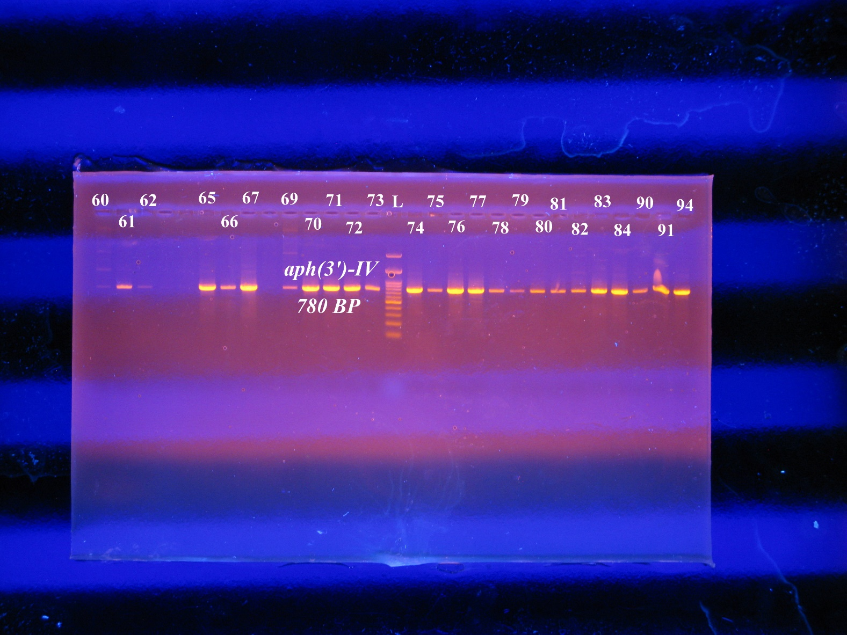
Supplementary figure 3: PCR Products of aph (3')-IV gene. L; 100 bp DNA ladder supplied from Solis BioDyne, Estonia; lanes 95-112 represent isolate number. The name of amplified gene and its molecular weight (780 bp) were stated above and below the amplified bands, respectively.
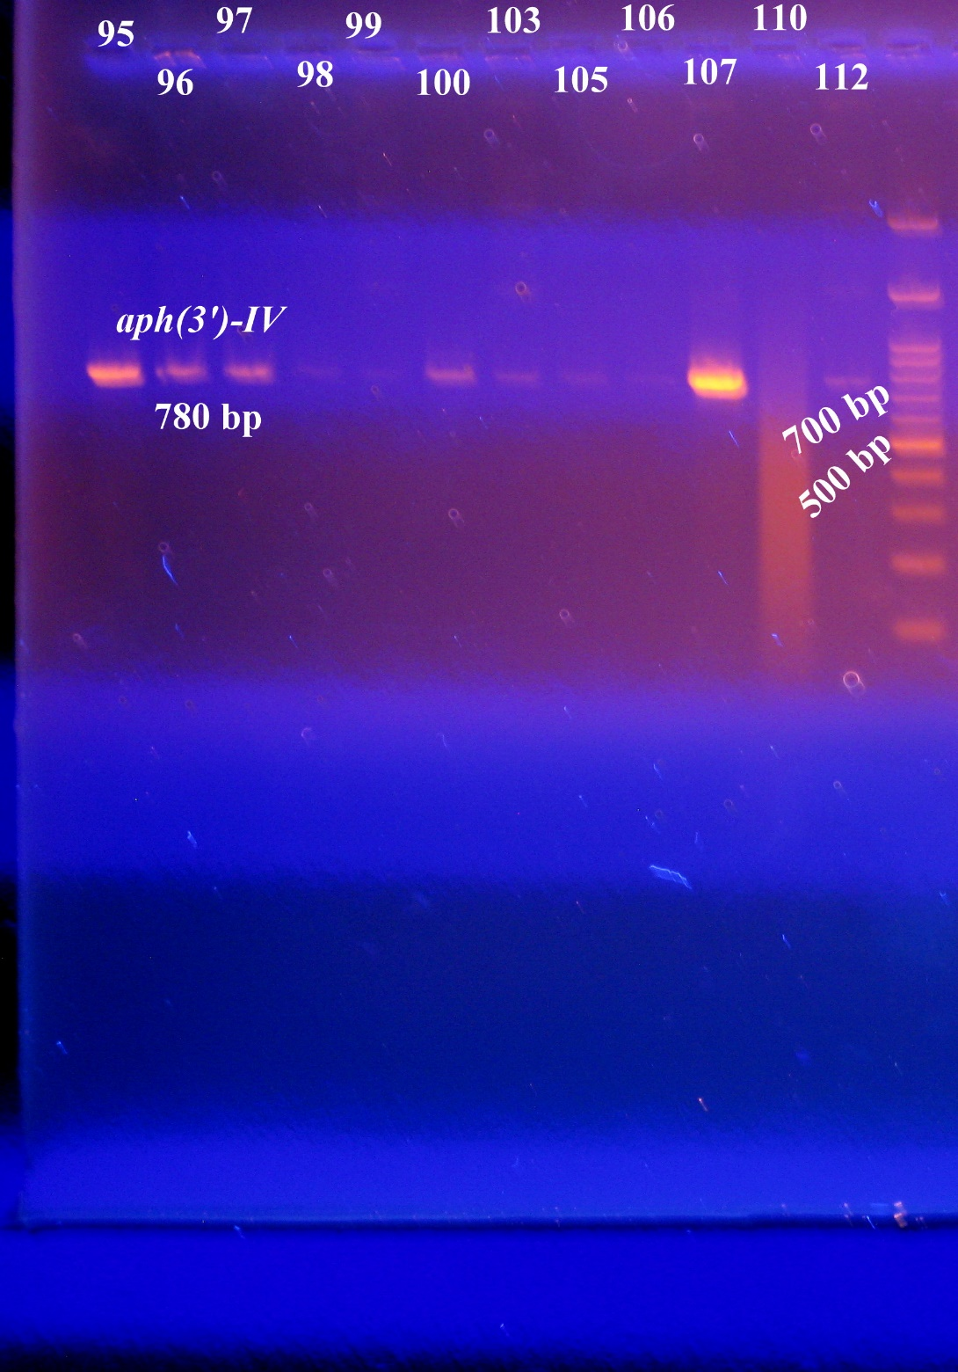
Supplementary figure 4: PCR Products of ant (3'')-I gene. L; 100 bp DNA ladder supplied from Solis BioDyne, Estonia; lanes 60-68 and lanes 69-76 represent isolate number. The name of amplified gene and its molecular weight (787 bp) were stated above and below the amplified bands, respectively.
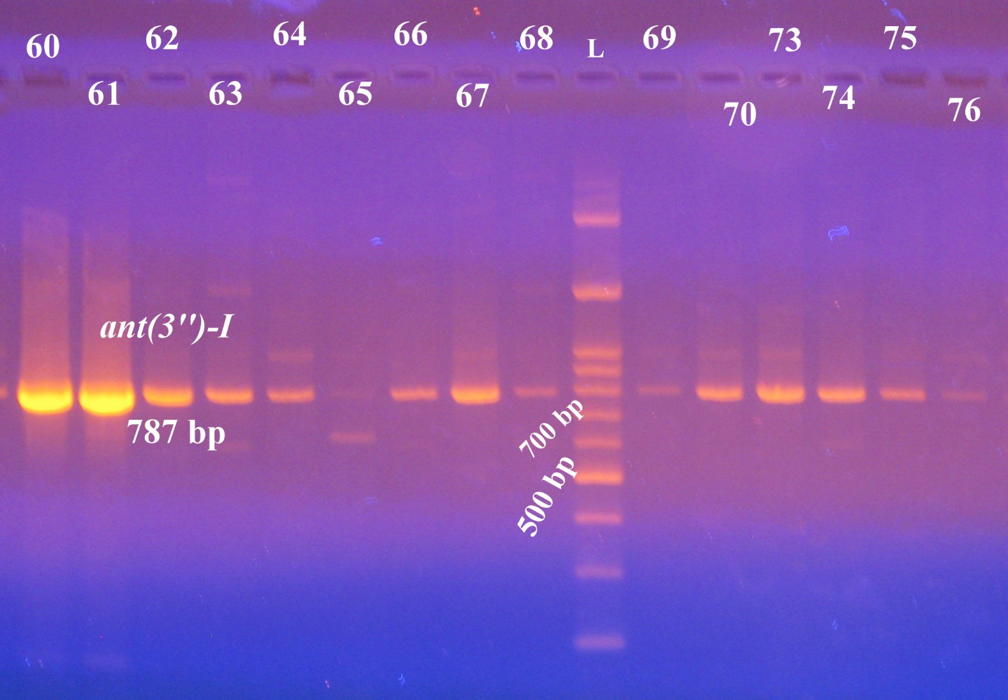

Supplementary figure 5: PCR Products of armA gene. L; 100 bp DNA ladder supplied from Solis BioDyne, Estonia; lanes 60-70 and lanes 75-94 represent isolate number. The name of amplified gene and its molecular weight (846 bp) were stated above and below the amplified bands, respectively.
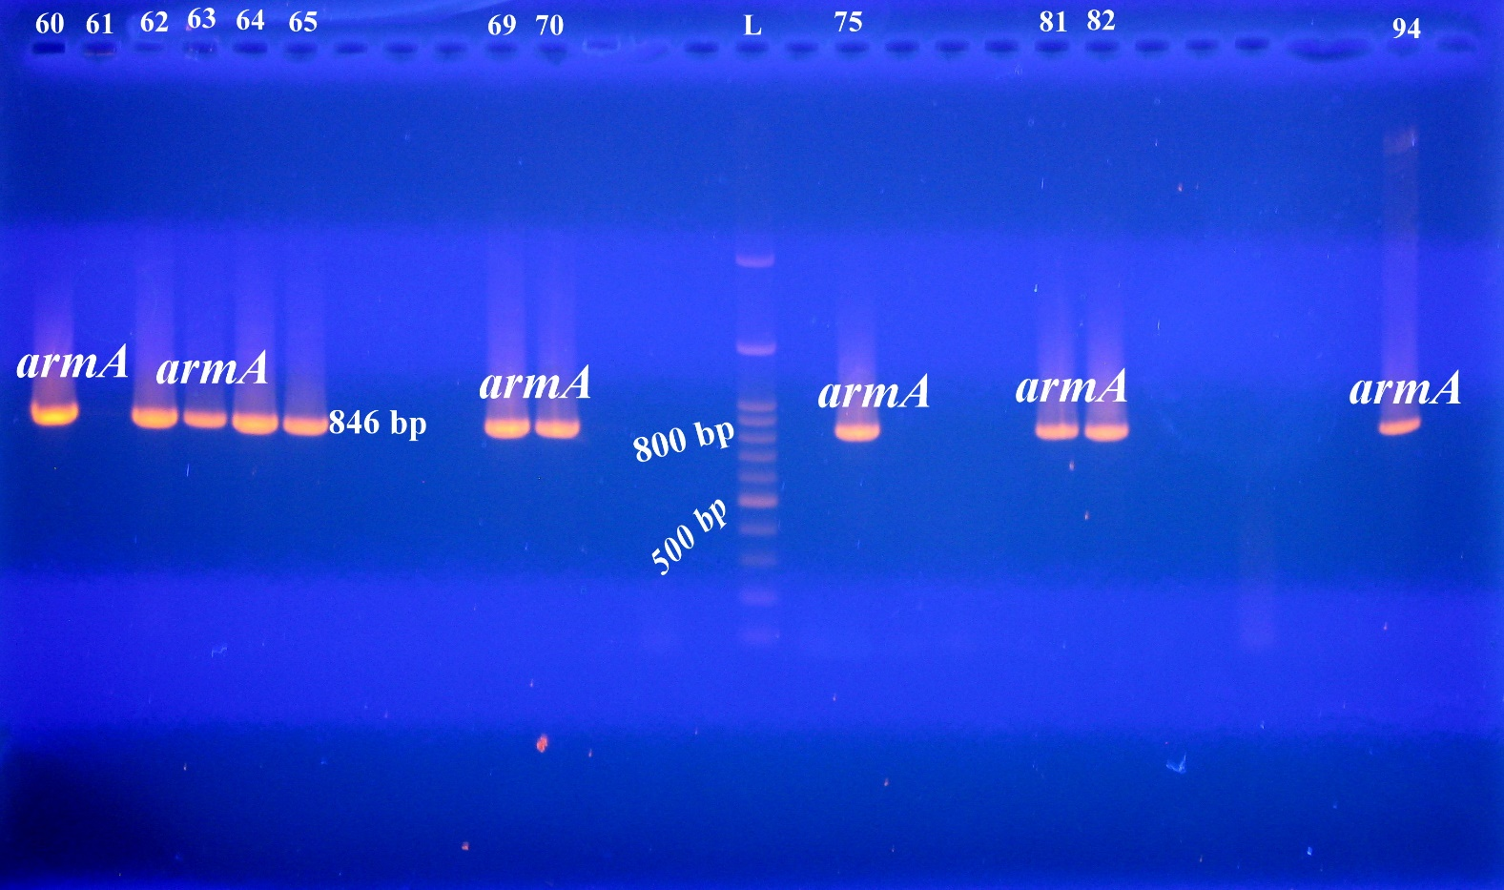

Supplementary figure 6: PCR Products of armA gene. L; 100 bp DNA ladder supplied from Solis BioDyne, Estonia; lanes 96-112 represent isolate number. The name of amplified gene and its molecular weight (846 bp) were stated above and below the amplified bands, respectively.
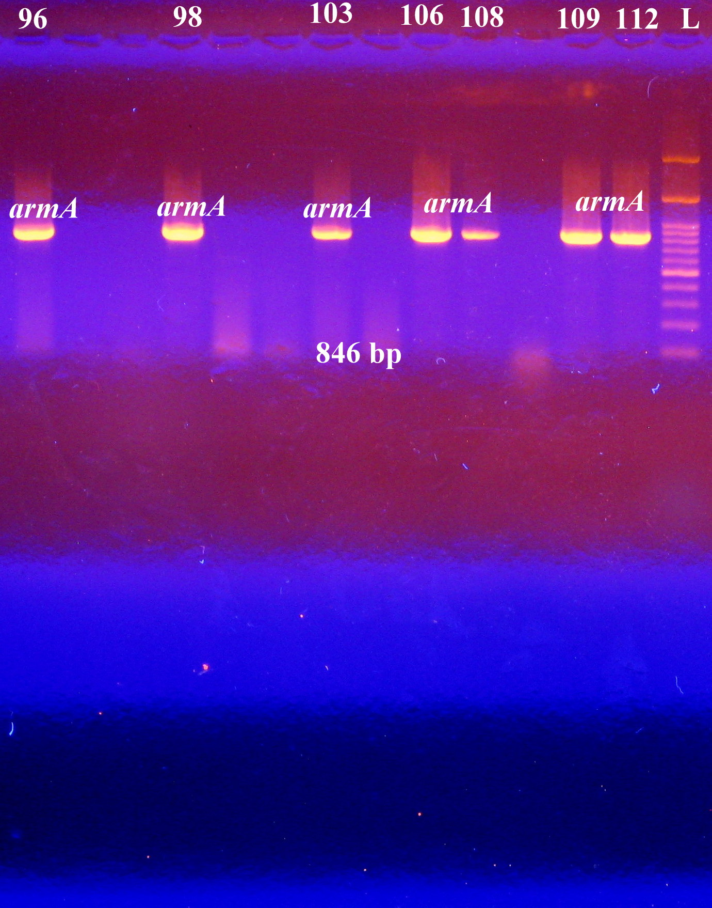
Supplementary figure 7: PCR Products of sul1 gene. L; 100 bp DNA ladder supplied from Solis BioDyne, Estonia; lanes 61 and62 represent isolate number. The name of amplified gene and its molecular weight (822 bp) were stated above and below the amplified bands, respectively.
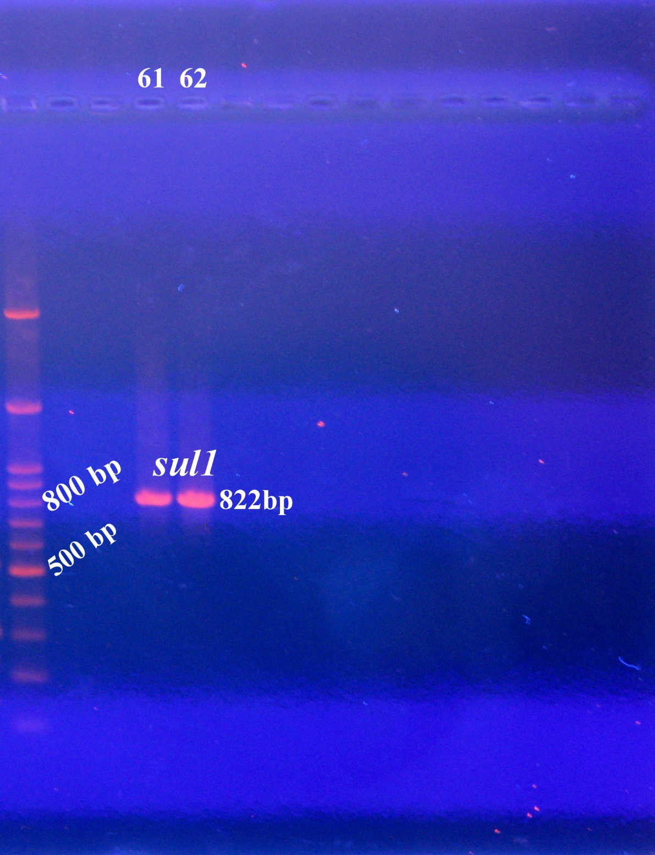
Supplementary figure 8: PCR Products of sul1 gene. L; 100 bp DNA ladder supplied from Solis BioDyne, Estonia; lanes 81 and 96 represent isolate number. The name of amplified gene and its molecular weight (822 bp) were stated above and below the amplified bands, respectively.
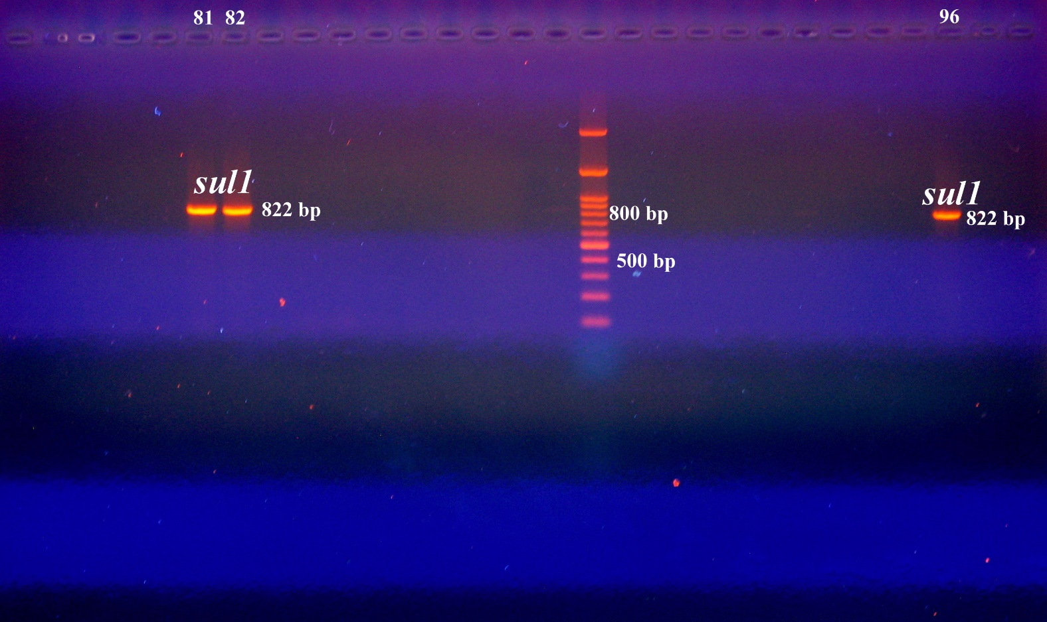

Supplementary figure 9: DNA fingerprint profile generated by RAPD-PCR for A. baumannii clinical isolates. L1 and L2, represent 100bp DNA ladder supplied from Solis BioDyne, Estonia. Lanes 60-69, lanes 70 -81, and lanes 82 -112 represent the isolate number.
