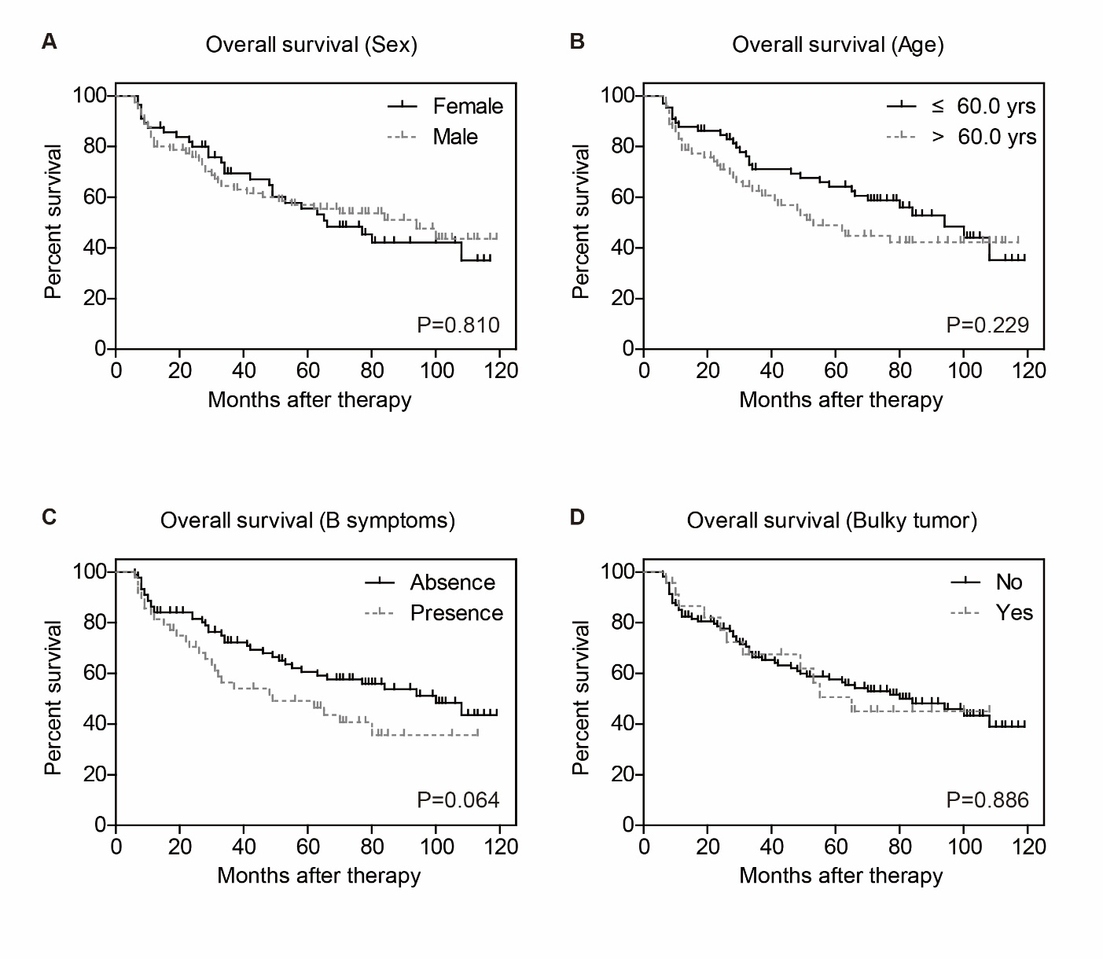
Figure S1. Kaplan-Meier survival analyses of enrolled DLBCL patients.
The survival curves were plotted according to patients’ sex (A), age (B), B symptoms (C), and Bulky tumor (D).

