Table S1 Primers used in construction of recombinant strains and RT-PCR
Primer name |  | Sequence (5’-3’)
Construction of recombinant strains
Left arm of Rv1453 | LFP | TTTTTTTTCCATAAATTGGCGCATTGAGGGCATTGAGC
Left arm of Rv1453 | LRP | TTTTTTTTCCATTTCTTGGGCAGCGATGGATGGGTTGG
Right arm of Rv1453 | RFP | TTTTTTTTCCATAGATTGGGCAACACCTTGATGAACCGAC
Right arm of Rv1453 | RRP | TTTTTTTTCCATCTTTTGGTGACACAATGGGCCACTC
pMV361+Rv1453 | FP | CGGAAGCTTGGGTGCACATTTGCCCTACTAT
pMV361+Rv1453 | RP | CGCATCGATCTCTTGCTAACGCATCTTGGTG
RT-PCR
sigA | FP | CGGCTACGCTTCGGCCTTAC
sigA | RP | GGCGCAACTTCGACATAGTCTTG
Rv1453 | FP | TCCAATCGGGCGCATCTCAT
Rv1453 | RP | ACATCCAGTAATTCGTGCAACTCGTC
Rv1455 | FP | GCCAATCTGCTGAACTCGC
Rv1455 | RP | GGAAGACCAACACGGTCTCG
qor | FP | GACCAGCCGCAACCTCAACC
qor | RP | CTCCACCGTGCCGCATACCT
Restriction endonuclease site is underlined in italics.

Table S2 Primers used in EMSA and protein expression
EMSA
Qor | FP | GCGAACCGGGCACTACAG
Qor | RP | AATAGTCCACGCGGATCTGG
Rv1455 | FP | GACCTTGGCGGTCAGAGATG
Rv1455 | RP | CATGATAGCCACATGCACGC
Qor-1-biotin | FP | CAGGTCACGTAGGTAACGGCGCTCG-biotin
Qor-1-biotin | RP | CGAGCGCCGTTACCTACGTGACCTG
Qor-2-biotin | FP | GGGTAGTCCAGGCCAAAAACTCGTC-biotin
Qor-2-biotin | RP | GACGAGTTTTTGGCCTGGACTACCC
Rv1455-biotin | FP | GCGGATATTGCCCGGAGCGGAAGTAGGTGTCGATGAAG-biotin
Rv1455-biotin | RP | CTTCATCGACACCTACTTCCGCTCCGGGCAATATCCGC-biotin
Protein expression
Rv1453 | FP | TTACATATGGTGGCATTGCGGGAAAC
Rv1453 | RP | CACAAGCTTACGCATCTTGGTGCCAT
Restriction endonuclease site is underlined in italics.

A
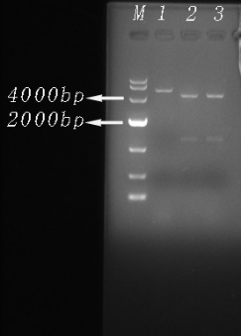
M：DL10000bp DNA Marker，lane1：Electrophoresis results of plasmid digestion with HindIII enzyme，lane2、3：Electrophoresis results of plasmid digestion with HindIII and ClaI enzymes.
B
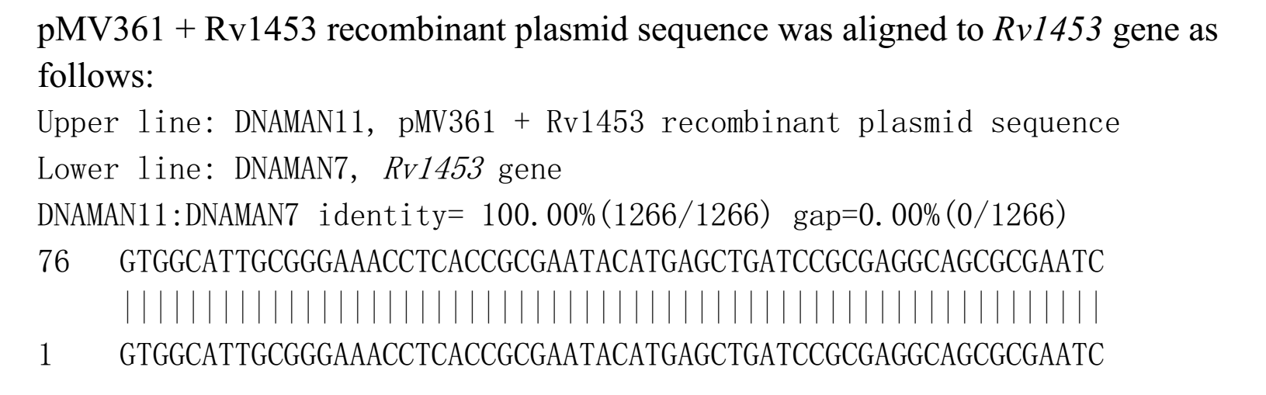
C
M：DL10000bp DNA Marker，lane1：Electrophoresis results of plasmid digestion with HindIII and NdeI enzymes，lane2-4：Electrophoresis results of plasmid digestion with HindIII enzyme.
D
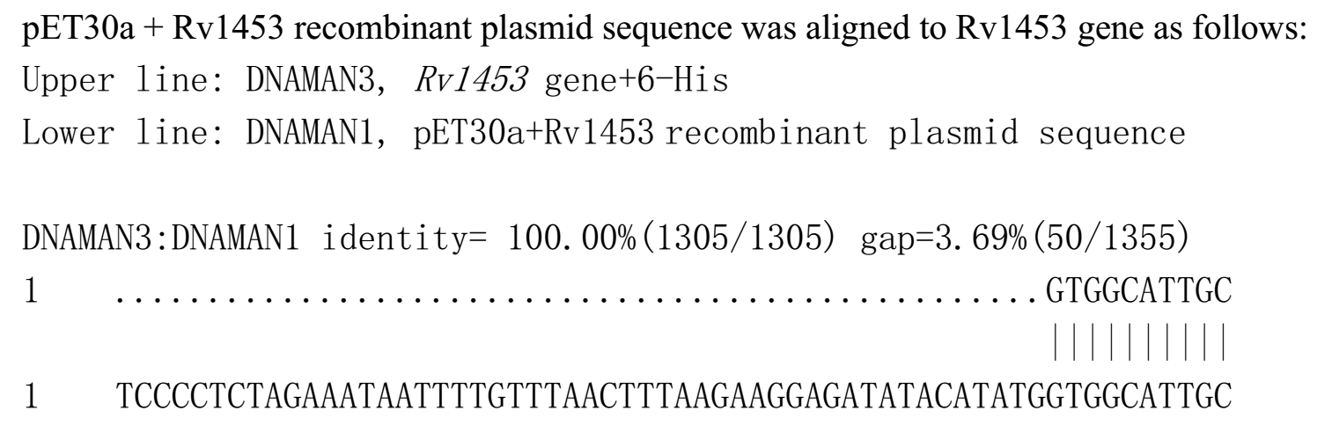
Figure S1 Validation of the recombinant plasmid pMV361 +Rv1453 and pET30a+Rv1453. (A) Electrophoretogram of recombinant pMV361 +Rv1453 after digestion. (B) Sequence alignment results of recombinant plasmid pMV361 +Rv1453. (C) Electrophoretogram of recombinant pET30a+Rv1453 after digestion. (D) Sequence alignment results of recombinant plasmid pMV361 +Rv1453.

