Horseradish peroxidase-functionalized gold nanoconjugates for breast cancer treatment based on enzyme prodrug therapy
Gema Vivo-Llorca,^{1,3,4} Ángela Morellá-Aucejo,^{1,3,4} Alba García-Fernández,*^{1,3,4} Paula Díez,^{1,3,4,6} Antoni Llopis-Lorente,^{1,7} Mar Orzáez^{3,4} and Ramón Martínez-Máñez*^{1,2,3,4,6}

¹Instituto Interuniversitario de Investigación de Reconocimiento Molecular y Desarrollo Tecnológico (IDM). Universitat Politècnica de València, Universitat de València. Spain;
² Departamento de Química, Universitat Politècnica de València, València, Spain;
³ CIBER de Bioingeniería, Biomateriales y Nanomedicina (CIBER-BBN), Spain;
⁴ Unidad Mixta UPV-CIPF de Investigación de Mecanismos de Enfermedades y Nanomedicina, Valencia, Universitat Politècnica de València, Centro de Investigación Príncipe Felipe, València, Spain;
⁵ Centro de Investigación Príncipe Felipe, Laboratorio de Péptidos y Proteínas, València, Spain;
⁶ Unidad Mixta de Investigación en Nanomedicina y sensores.Universitat Politènica de València, Instituto de Investigación Sanitaria la Fe, Valènica, Spain;
⁷ Department of Chemical Engineering and Chemistry, Institute for Complex Molecular Systems, Eindhoven University of Technology, Eindhoven, The Netherlands.

Figure S1. Nanoparticle nomenclature and composition.

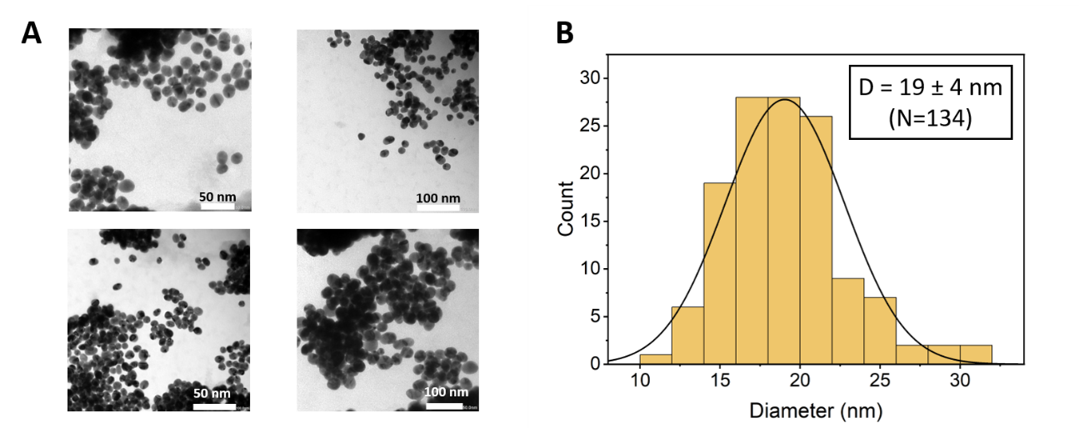
Figure S2. A) TEM images of the as-prepared HRP-AuNCs showing the presence of spherical gold nanoparticles. B) Nanoparticle size distribution graph obtained from analysing the TEM images.
Figure S3. FT-IR analysis of prepared nanodevices. FT-IR spectra of AuNPs (black), (3-MPA) -AuNCs (red) and HRP-AuNCs (blue), showing the characteristic absorption bands of each functionalization process.

Figure S4. AuNPs and HRP-AuNCs catalytic activity. Kinetics of ABTS oxidation by AuNPs (red) and HRP-AuNCs (black) measured for 2 min at 405 nm. It can be appreciated that the AuNPs showed negligible activity whereas a sharp increase in ABTS oxidation is observed in the presence of HRP-AuNCs.

Figure S5. AuNPs for EPT in breast cancer cells. Cell viability analysis in A) MDA-MB-231 and B) MCF-7 incubated with AuNPs in the absence or presence of IAA. Cell viability was determined after 48 h of incubation by WST-1 assay. Data represent means ± SEM (n=3). Statistically significance was determined by one-way ANOVA and Dunns post-test. No significant difference was observed.
A
B
Figure S6. MDA-MB-231 multicellular tumour spheroid-like cultures. The structures present apoptotic/necrotic areas in the center. The images were taken under an optical microscope.

