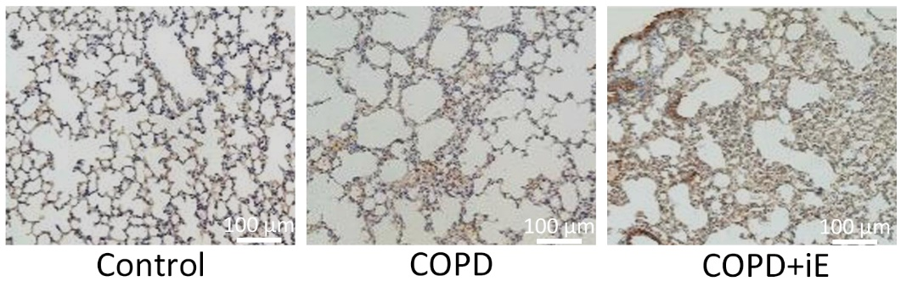
Figure S1. Immunohistochemistry analysis of NOD1 expressions in lung tissues among the three groups.

