Supplementary materials
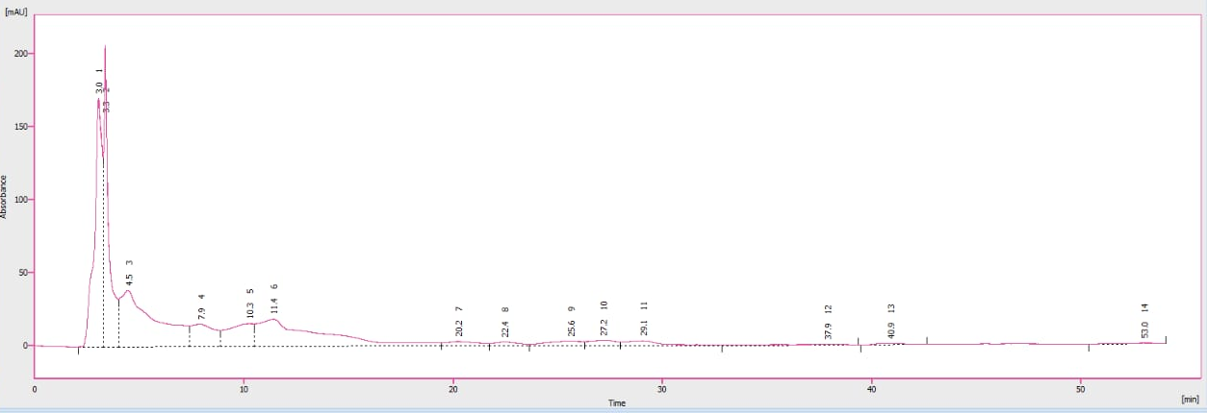
Figure S1: HPLC finger print for monoamines and its metabolites in the hippocampal tissue.
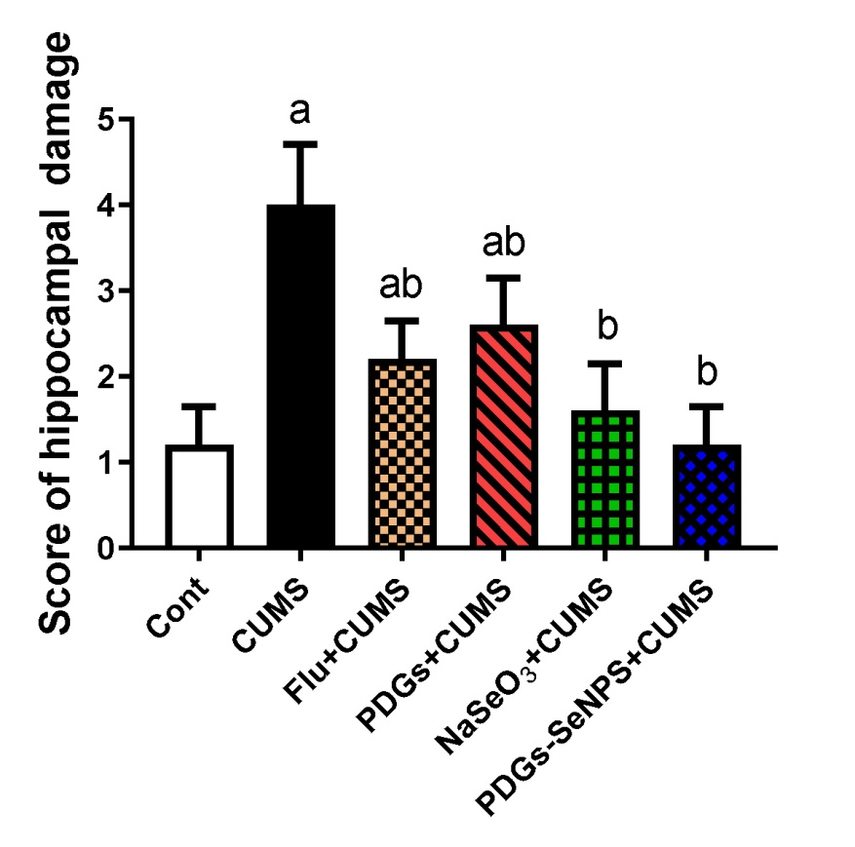
Figure S2: Score of hippocampal damage as measured by using a semi-quantitative scoring system. Data were analyzed using one-way ANOVA, followed by Duncan’s post hoc test (p< 0.05), and are expressed as the mean ± SD (n=10 field of 3 rats/group). ª significant difference relative to the control group (Non-stressed). ^{b} significant difference relative to the CUMS group (depression model).

