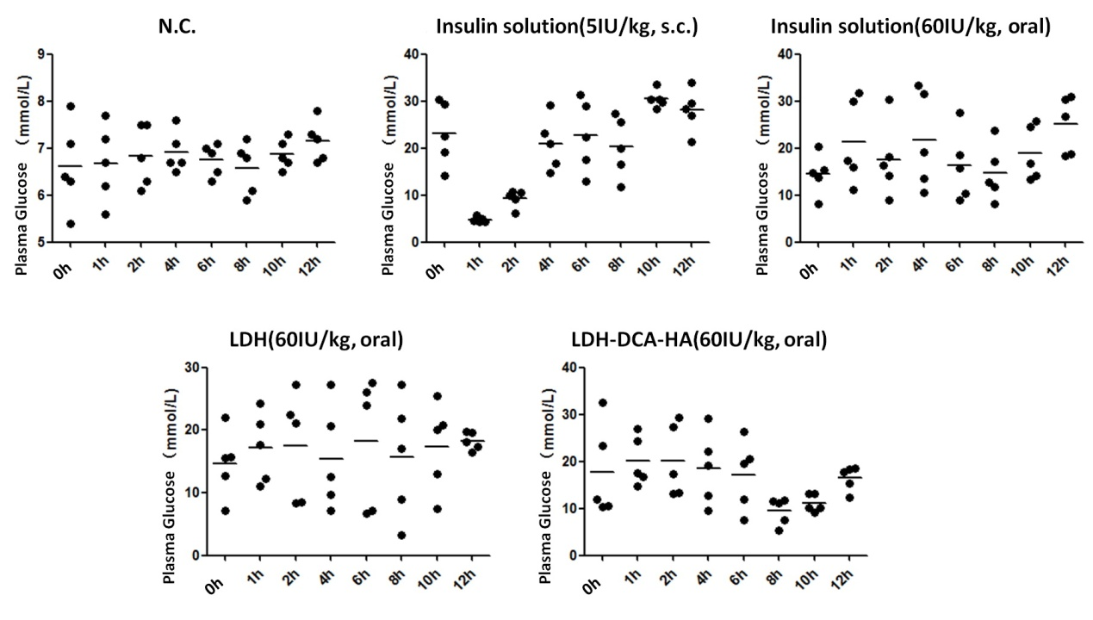
Figure S1. Hypoglycemic effect of insulin delivered by LDH and LDH-DCA-HA via oral drug delivery(expressed by plasma glucose concentration)

