Supplementary table S1. Multivariate analysis for cancer specific survival in 311 PSCC patients
Clinical pathological data | P value | Hazard ratio | 95% CI
Glans of penisª | 0.837 | 1.245 | 0.154-10.066
Body of penisª | 0.464 | 2.489 | 0.217-28.505
T₂ (8th edition)^{b} | 0.814 | 1.117 | 0.444-2.808
T₃ (8th edition)^{b} | 0.490 | 1.382 | 0.552-3.460
T₄ (8th edition)^{b} | 0.096 | 3.114 | 0.816-11.883
Moderately differentiated^{c} | 0.139 | 2.006 | 0.797-5.050
Poorly/ undifferentiated^{c} | 0.073 | 2.523 | 0.918-6.936
LVI present/ identified^{d} | 0.236 | 1.510 | 0.763-2.989
cN+^{e} | 0.090 | 2.674 | 0.858-8.340
pN₁e | 0.879 | 1.108 | 0.297-4.142
pN₂e | 0.001 | 9.977 | 4.543-21.970
pN₃e | 0.001 | 32.569 | 12.529-84.665
Glans of penisª | 0.609 | 1.693 | 0.224-12.771
Body of penisª | 0.375 | 2.822 | 0.285-27.888
Moderately differentiated^{c} | 0.726 | 1.173 | 0.481-2.861
Poorly/ undifferentiated^{c} | 0.087 | 2.261 | 0.887-5.765
LVI present/ identified^{d} | 0.107 | 1.706 | 0.890-3.267
AJCC group II (8th editions)^{f} | 0.088 | 3.918 | 0.816-18.801
AJCC group III (8th editions)^{f} | 0.001 | 12.686 | 2.776-57.963
AJCC group IV (8th editions)^{f} | 0.001 | 50.341 | 10.386-244.013
ª: reference group is disease without penile body invasion; ^{b}: reference group is T₁; ^{c}: reference group is nuclear well differentiated group; ^{d}: LVI negative; ^{e}: reference group is cN₀+pN₀; ^{f}: reference group is AJCC group I. PSCC: penile squamous cell carcinoma; CI: confidence interval.

Supplementary Figure legends
Supplementary Figure 1: Calibration curves of 2-year survival for nomogram 1. 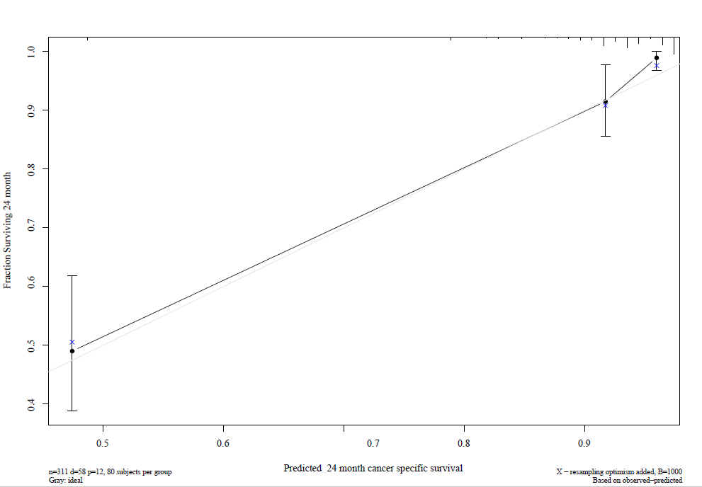
Supplementary Figure 2: Calibration curves of 2-year survival for nomogram 2.
