Supplementary Material

Supplementary Table 1: Codes for identifying diagnoses, medication records and procedures
 | ICD 10 | ICD 9 | Code description
Suicidal ideation | R45.851 | V62.84
Suicide Attempt (Self-Harm) | X60 -X84 | E950 E951 E952 E953 E954 E955 E956 E957 E958 E959 | Intentional self-harm (X60-X84). Includes: purposely self-inflicted poisoning or injury suicide (attempted)
 | Y87.0 |  | Sequelae of intentional self-harm
 | T14.91 |  | Suicide attempt
Injury, undetermined intents |  | E980 E981 E982 E983 E984
 | Y21 |  | Drowning and submersion, undetermined intent
 | Y22-Y28, Y30-Y33 | E985 E986 E987 E988 E989 | Event of undetermined intent (Y10-Y34)
 | Y29 |  | Contact with blunt object, undetermined intent
 | Y34 |  | ‘Unspecified event, undetermined intent’
 | Y10-Y15 |  | ‘undetermined intent’
 | Y16 |  | Poisoning by and exposure to organic solvents and halogenated hydrocarbons and their vapors, undetermined intent
 | Y17 |  | Poisoning by and exposure to other gases and vapors, undetermined intent
 | Y18 |  | Poisoning by and exposure to pesticides, undetermined intent
 | Y19 |  | Poisoning by and exposure to other and unspecified chemicals and noxious substances, undetermined intent
 | Y20 |  | Hanging, strangulation and suffocation, undetermined intent
Violent behavior | R45.6 | 300.9 | Violent behavior
Hostility | R45.5 | 300.9 | Tendency to feel anger toward and to seek to inflict harm upon a person or group
Homicidal ideation | R45.850 | V62.85 | Homicidal ideation, homicidal thoughts, ideation homicidal
Aggressive behavior | F03.91 | 312 | Aggressive unsocial conduct disorder, angry, behavior disorder, aggressive type unsocialized, feeling angry, unsocialized behavior, aggressive type
Aggressive behavior | F91.8 | 312.89, 312.10 | F91.8 is grouped within Diagnostic Related Group (MS-DRG v34.0)
Schizophrenia diagnosis
 |  | 295.7 | Schizoaffective disorder
 | F20.x |  | Schizophrenia
 |  | 295.70-295.74 | Schizoaffective disorder (unspecified, subchronic, chronic, subchronic with acute exacerbation, chronic with exacerbation)
 |  | 295.75 | Schizoaffective disorder, in remission
 | F25.8 | 295.8 | Other specified types of schizophrenia
 |  | 295.80-295.85 | Other specified types of schizophrenia (unspecified, subchronic, chronic, subchronic with acute exacerbation, chronic with acute exacerbation, in remission)
 | F25.9 | 295.9 | Unspecified schizophrenia
 |  | 295.90-295.95 | Unspecified schizophrenia (unspecified, subchronic, chronic, subchronic with acute exacerbation, chronic with acute exacerbation, in remission)
 | F25.0 |  | Schizoaffective disorder, bipolar type
 | F25.1 |  | Schizoaffective disorder, depressive type
 |  | 297 | Paranoid states (Delusional disorders)
 |  | 297.0 | Paranoid state, simple
 |  | 297.1 | Delusional disorder
 |  | 297.2 | Paraphrenia
 |  | 297.3 | Shared psychotic disorder
 |  | 297.8 | Other specified paranoid states
Mania and bipolar
 |  | 296.0 | Bipolar I disorder, single manic episode
 |  | 296.00-296.06 | Bipolar I disorder, single manic episode (unspecified, mild, moderate, severe without mention of psychotic behavior, severe specified as with psychotic behavior, in partial or unspecified remission, in remission)
 |  | 296.1 | Manic disorder, recurrent episode
 |  | 296.10-296.16 | Manic affective disorder, recurrent episode (unspecified, mild, moderate, severe without mention of psychotic behavior, severe specified as with psychotic behavior, in partial or unspecified remission, in remission)
 |  | 296.4 | Bipolar I disorder, most recent episode (or current) manic
 |  | 296.40-296.46 | Bipolar I disorder, most recent episode/current manic (unspecified, mild, moderate, severe without mention of psychotic behavior, severe specified as with psychotic behavior, in partial or unspecified remission, in remission)
 |  | 296.5 | Bipolar I disorder, most recent episode (or current) depressed
 |  | 296.50 -296.56 | Bipolar I disorder, most recent episode/current depressed (unspecified, mild, moderate, severe without mention of psychotic behavior, severe specified as with psychotic behavior, in partial or unspecified remission, in remission)
 |  | 296.6 | Bipolar I disorder, most recent episode (or current) mixed
 |  | 296.7 | Bipolar I disorder, most recent episode (or current) unspecified
 |  | 296.8 | Other and unspecified bipolar disorders
 | F30 |  | Mania
 | F31 |  | Bipolar disorder
Dementia
 |  | 46 | Kuru
 |  | 46.1 | Jakob-Creutzfeldt disease
 |  | 46.11 | Variant Creutzfeldt-Jakob disease
 |  | 46.19 | Other and unspecified Creutzfeldt-Jakob disease
 |  | 94.1 | General paresis
 |  | 290 | Dementias
 |  | 290.0 | Senile dementia, uncomplicated
 |  | 290.1 | Presenile dementia
 |  | 290.2 | Senile dementia with delusional or depressive features
 |  | 290.3 | Senile dementia with delirium
 |  | 290.4 | Vascular dementia
 |  | 290.8 | Other specified senile psychotic conditions
 |  | 290.9 | Unspecified senile psychotic condition
 |  | 291.1 | Alcohol-induced persisting amnestic disorder
 |  | 291.2 | Alcohol-induced persisting dementia
 |  | 292.82 | Drug-induced persisting dementia
 |  | 294 | Amnestic disorder in conditions classified elsewhere
 |  | 294.1 | Dementia in conditions classified elsewhere
 |  | 294.2 | Dementia, unspecified
 |  | 294.8 | Other persistent mental disorders due to conditions classified elsewhere
 |  | 294.9 | Unspecified persistent mental disorders due to conditions classified elsewhere
 |  | 310 | Frontal lobe syndrome
 |  | 310.2 | Post-concussion syndrome
 |  | 330 | Cerebral degenerations usually manifest in childhood
 |  | 330.1 | Cerebral lipidoses
 |  | 330.2 | Cerebral degeneration in generalized lipidoses
 |  | 330.3 | Cerebral degeneration of childhood, in other diseases classified elsewhere
 |  | 330.8 | Other specified cerebral degenerations in childhood
 |  | 330.9 | Unspecified cerebral degenerations in childhood
 |  | 331 | Alzheimer's disease
 |  | 331.1 | Frontotemporal dementia
 |  | 331.11 | Pick's disease
 |  | 331.19 | Other frontotemporal dementia
 |  | 331.2 | Senile degeneration of brain
 |  | 331.3 | Communicating hydrocephalus
 |  | 331.4 | Obstructive hydrocephalus
 |  | 331.5 | Idiopathic normal pressure hydrocephalus
 |  | 331.7 | Cerebral degeneration in diseases classified elsewhere
 |  | 331.8 | Other cerebral degeneration
 |  | 333.4 | Huntington's chorea
 |  | 780.93 | Memory loss
 |  | 797 | Senility without mention of psychosis
Autism | Z91.83, F84.0 | 299.0
Depressive disorder
 |  | 296.2, 296.20, 296.21, 296.22, 296.23, 296.24 | Major depressive disorder, single episode
 |  | 296.3, 296.30, 296.31, 296.32, 296.33, 296.34 | Major depressive disorder, recurrent episode
 |  | 300.4, 300.40, 309.0, 309.00, 309.1, 309.10 | Dysthymic disorder, dysthymia specify prim
 |  | 311, 311.0, 311.00 | Depressive disorder, NOS
 | F32, F33 or F34 |  | depression:
Substance abuse
 |  | 291 | Alcohol-induced mental disorders
 |  | 291.0 | Alcohol withdrawal delirium
 |  | 291.3 | Alcohol-induced psychotic disorder with hallucinations
 |  | 291.4 | Idiosyncratic alcohol intoxication
 |  | 291.5 | Alcohol-induced psychotic disorder with delusions
 |  | 291.8 | Other specified alcohol-induced mental disorders
 |  | 291.81 | Alcohol withdrawal
 |  | 291.82 | Alcohol induced sleep disorders
 |  | 291.89 | Other alcohol-induced mental disorders
 |  | 291.9 | Unspecified alcohol-induced mental disorders
 |  | 292 | Drug-induced mental disorders
 |  | 292.1 | Drug-induced psychotic disorders
 |  | 292.11 | Drug-induced psychotic disorder with delusions
 |  | 292.12 | Drug-induced psychotic disorder with hallucinations
 |  | 292.8 | Other specified drug-induced mental disorders
 |  | 292.9 | Unspecified drug-induced mental disorder
 |  | 293 | Delirium due to conditions classified elsewhere
 |  | 293.1 | Subacute delirium
 |  | 293.81 | Psychotic disorder with delusions in conditions classified elsewhere
 |  | 296 | Episodic mood disorders
 |  | 296.9 | Other and unspecified episodic mood disorder
 |  | 296.90 | Unspecified episodic mood disorder
 |  | 298.2 | Reactive confusion
 |  | 301.1 | Affective personality disorder
 |  | 301.13 | Cyclothymic disorder
 |  | 303 | Alcohol dependence syndrome
 |  | 303.9 | Other and unspecified alcohol dependence
 |  | 305.8 | Antidepressant type abuse
 |  | 437.7 | Transient global amnesia
 | V11.3 |  | Personal history of alcoholism

Supplementary Table 2: Equivalent PP1M and PP3M dose
Strength Level | PP1M Dose | PP3M Dose
1 | 50 mg eq. (NDC 50458-562-01) | 175 mg eq. (NDC 50458-606-01)
2 | 75 mg eq. (NDC 50458-562-01) | 263 mg eq. (NDC 50458-607-01)
3 | 100 mg eq. (NDC 50458-563-01) | 350 mg eq. (NDC 50458-608-01)
4 | 150 mg eq. (NDC 50458-564-01) | 525 mg eq. (NDC 50458-609-01)
PP1M, Paliperidone palmitate once-monthly; PP3M, Paliperidone palmitate 3-monthly

Supplementary Table 3: Race in the PP3M and PP1M cohorts (‘≥4 lead-in PP1M dose and non-bipolar’ analysis set) for the PNUD approach
Race | PP1M |  | PP3M |  | Overall
Race | N | % | n | % | n | %
Black | 633 | 55.7 | 217 | 50.7 | 850 | 54.3
Inconsistency or Missing | 123 | 10.8 | 46 | 10.7 | 169 | 10.8
White | 252 | 22.2 | 124 | 29.0 | 376 | 24.0
Other | 115 | 10.1 | 31 | 7.2 | 146 | 9.3
Hispanic | 13 | 1.1 | 10 | 2.3 | 23 | 1.5
Total | 1136 | 100.0 | 428 | 100.0 | 1564 | 100.0
- Rules for handling of missing values in race:
  - Missing: when race was missing in all data tables,
  - White: if ‘White’ was the value in one table and ‘White’ or missing in all other data tables; same rule for ‘Black’, ‘Asian’, ‘Native American’, ‘Hispanic’.
- Inconsistency: Records were non-missing in at least 2 tables but inconsistent.
- Other: race was recorded not as ‘Black’, ‘White’, or ‘Hispanic’.

Supplementary table 4. Baseline lead-in PP1M injections (‘≥4 lead-in PP1M dose and non-bipolar’ analysis set) for PNUD and Concurrent control approach
 |  |  | PNUD control |  | Concurrent control
 |  |  | PP1M (n=1,136) | PP3M (n=428) | PP1M (n=1,525) | PP3M (n=518)
Lead-in PP1M |  |  | ASD=0.217 |  | ASD=0.124
4 |  |  | 213 (18.8) | 79 (18.5) | 238 (15.6) | 80 (15.4)
5 |  |  | 146 (12.9) | 49 (11.4) | 153 (10) | 49 (9.5)
6 |  |  | 124 (10.9) | 42 (9.8) | 125 (8.2) | 42 (8.1)
7 |  |  | 110 (9.7) | 40 (9.3) | 124 (8.1) | 41 (7.9)
8 |  |  | 109 (9.6) | 36 (8.4) | 109 (7.1) | 36 (6.9)
9 |  |  | 49 (4.3) | 16 (3.7) | 54 (3.5) | 18 (3.5)
10 |  |  | 51 (4.5) | 19 (4.4) | 73 (4.8) | 23 (4.4)
11 |  |  | 57 (5.0) | 22 (5.1) | 72 (4.7) | 24 (4.6)
12 |  |  | 31 (2.7) | 12 (2.8) | 50 (3.3) | 17 (3.3)
13 |  |  | 26 (2.3) | 7 (1.6) | 28 (1.8) | 9 (1.7)
14 |  |  | 32 (2.8) | 14 (3.3) | 48 (3.1) | 16 (3.1)
15 |  |  | 19 (1.7) | 7 (1.6) | 29 (1.9) | 10 (1.9)
16 |  |  | 15 (1.3) | 6 (1.4) | 22 (1.4) | 7 (1.4)
17 |  |  | 19 (1.7) | 6 (1.4) | 26 (1.7) | 9 (1.7)
18 |  |  | 14 (1.2) | 4 (0.9) | 24 (1.6) | 8 (1.5)
19 |  |  | 16 (1.4) | 10 (2.3) | 37 (2.4) | 13 (2.5)
20 |  |  | 21 (1.8) | 9 (2.1) | 33 (2.2) | 10 (1.9)
>20 |  |  | 84 (7.4) | 50 (11.7) | 280 (18.4) | 106 (20.5)

Supplementary Table 5: Demographics and baseline characteristics (all patients, non-bipolar patients)
 | All |  | Non-bipolar
 | PP1M | PP3M | PP1M | PP3M
All, n (%) | 2,836 (100.0) | 969 (100.0) | 2,033 (100.0) | 690 (100.0)
Gender, n (%) | ASD=0.033 |  | ASD=0.026
Men | 1,886 (66.5) | 629 (64.9) | 1,459 (71.8) | 487 (70.6)
Women | 950 (33.5) | 340 (35.1) | 574 (28.2) | 203 (29.4)
Age categories, n (%) | ASD=0.036 |  | ASD=0.043
18-24 | 386 (13.6) | 130 (13.4) | 265 (13.0) | 86 (12.5)
25-34 | 978 (34.5) | 334 (34.5) | 677 (33.3) | 229 (33.2)
35-44 | 613 (21.6) | 212 (21.9) | 442 (21.7) | 154 (22.3)
45-54 | 540 (19.0) | 187 (19.3) | 406 (20.0) | 136 (19.7)
55-64 | 310 (10.9) | 101 (10.4) | 234 (11.5) | 80 (11.6)
≥65 | 9 (0.3) | 5 (0.5) | 9 (0.4) | 5 (0.7)
Paliperidone dose, n (%) | ASD=0.019 |  | ASD=0.031
Level 1 | 29 (1.0) | 11 (1.1) | 21 (1.0) | 7 (1.0)
Level 2 | 448 (15.8) | 158 (16.3) | 350 (17.2) | 127 (18.4)
Level 3 | 1,177 (41.5) | 401 (41.4) | 837 (41.2) | 281 (40.7)
Level 4 | 1,182 (41.7) | 399 (41.2) | 825 (40.6) | 275 (39.9)
Mania / Bipolar Diagnosis at Baseline, n (%) | ASD=0.011 |  | N/A
No | 2,033 (71.7) | 690 (71.2) | 2,033 (100.0) | 690 (100.0)
Depression Diagnosis at Baseline, n (%) | ASD=0.016 |  | ASD=0.013
No | 2,121 (74.8) | 718 (74.1) | 1,643 (80.8) | 554 (80.3)

Supplementary Table 6: Relapse criteria (all patients, non-bipolar patients)
 | All |  | Non-bipolar
 | PP1M | PP3M | PP1M | PP3M
Non-relapse, n (%) | 2,243 (79.1) | 815 (84.1) | 1,660 (81.7) | 603 (87.4)
Relapse | 593 (20.9) | 154 (15.8) | 373 (18.3) | 87 (12.6)
Relapse Criteria, n (%)
Inpatient hosp. (Sch.) | 327 (11.5) | 78 (8.0) | 234 (11.5) | 50 (7.2)
Suicidal ideation | 148 (5.2) | 53 (5.5) | 74 (3.6) | 22 (3.2)
Homicidal ideation | 26 (0.9) | 10 (1.0) | 15 (0.7) | 7 (1.0)
Suicidal ideation, homicidal ideation | 25 (0.9) | 3 (0.3) | 13 (0.6) | 2 (0.3)
Aggressive/Violent behavior | 19 (0.7) | 2 (0.2) | 12 (0.6) | .
Suicide attempt | 15 (0.5) | 6 (0.6) | 5 (0.2) | 5 (0.7)
Clozapine use | 11 (0.4) | 2 (0.2) | 9 (0.4) | 1 (0.1)
Aggressive/violent behavior; hostility | 9 (0.3) | . | 5 (0.2) | .
Suicidal ideation; suicide attempt | 6 (0.2) | . | 5 (0.2) | .
Suicidal ideation; aggressive/violent behavior; hostility | 4 (0.1) | . | 1 (0.0) | .
Suicidal ideation; aggressive/violent behavior | 2 (0.1) | . | . | .
Suicidal ideation; suicide attempt; homicidal ideation | 1 (0.0) | . | . | .

Supplementary Figure 1: Time to relapse (all patients, non-bipolar patients)
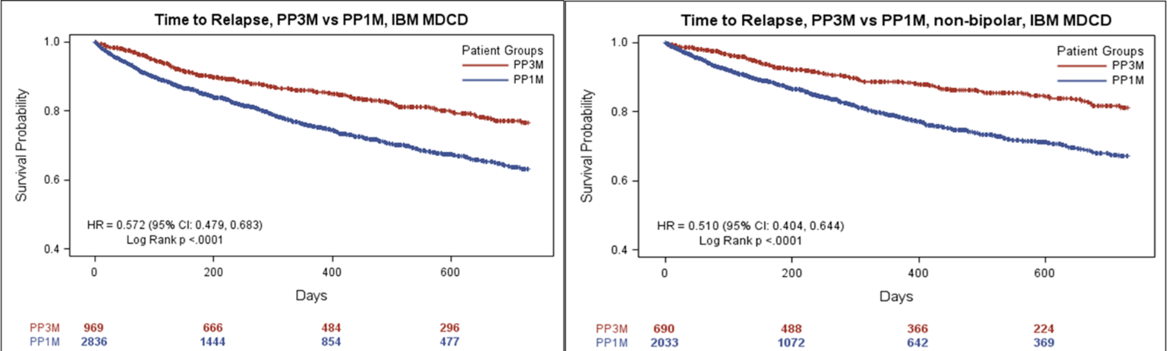

Supplementary Figure 2: Adherence and relapse (all patients, non-bipolar patients)
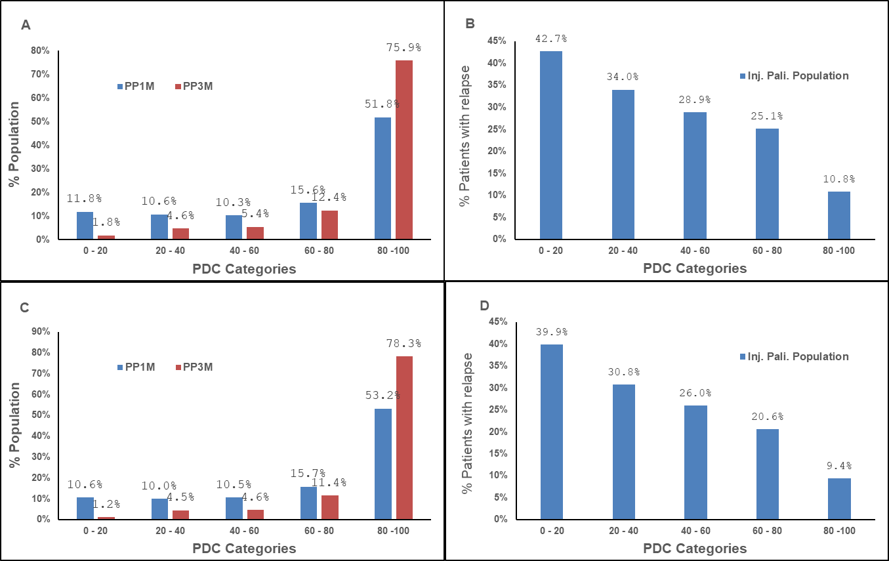
(A) Adherence rate in all patients; (B) Relapse rate in all patients; (C) Adherence rate in non-bipolar patients; (D) Relapse rates in non-bipolar patients

Supplementary figure 3: Time to relapse in subgroups White and Black (‘≥ 4 lead-in PP1M dose and non-bipolar’ analysis set) for PNUD approach.
