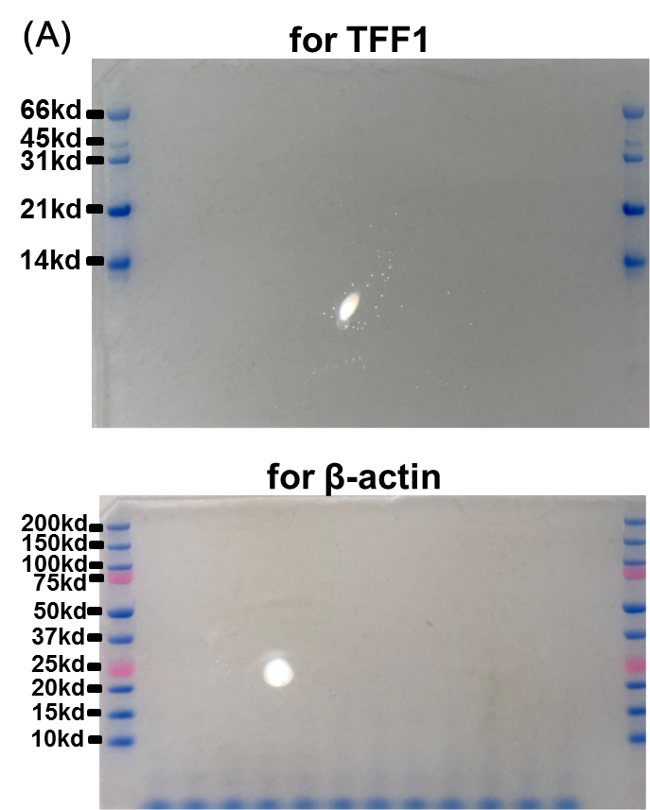
Figure 1
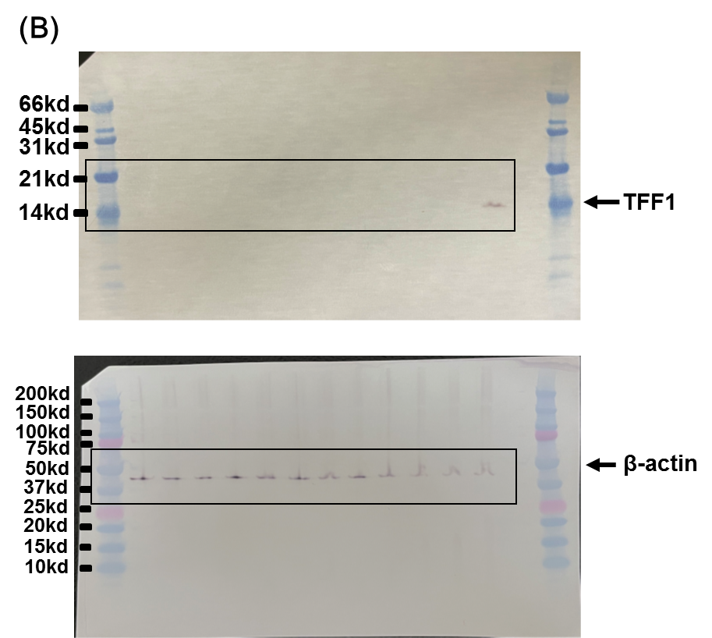
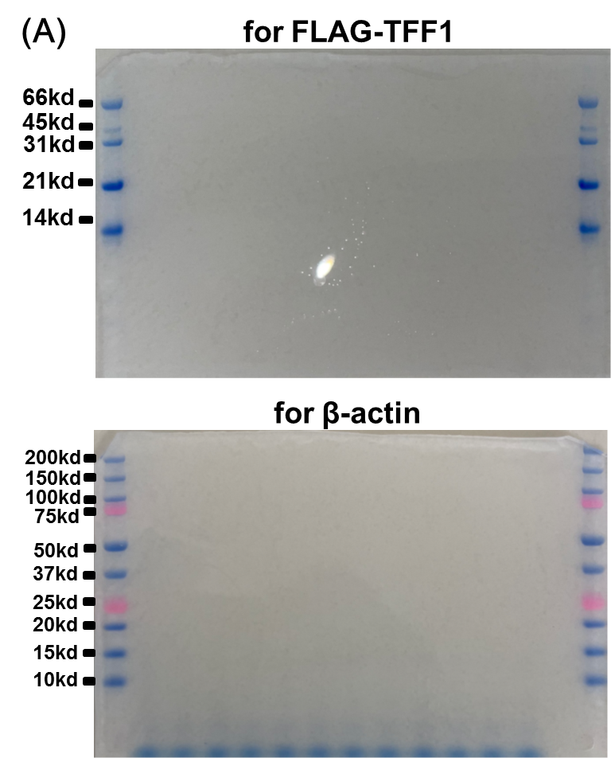
Figure 2
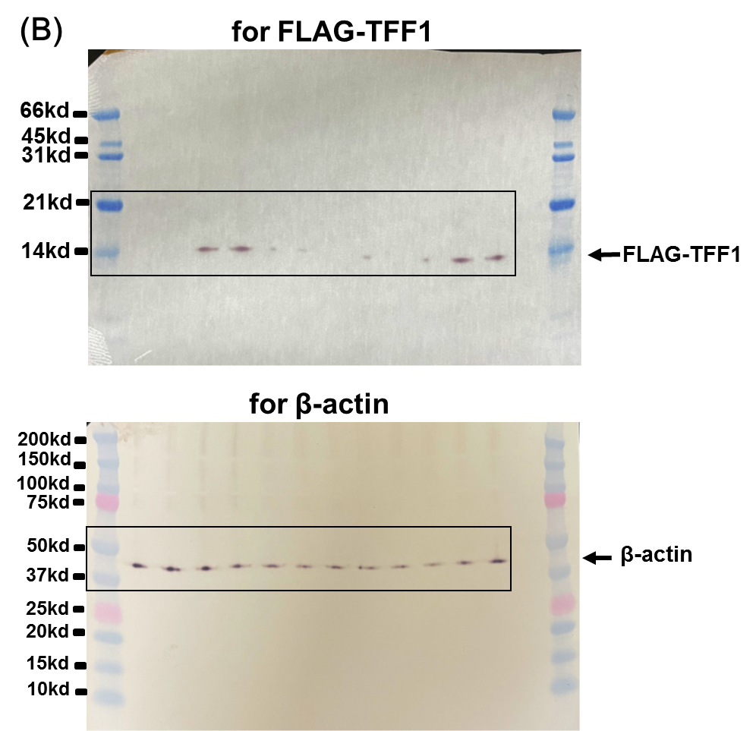
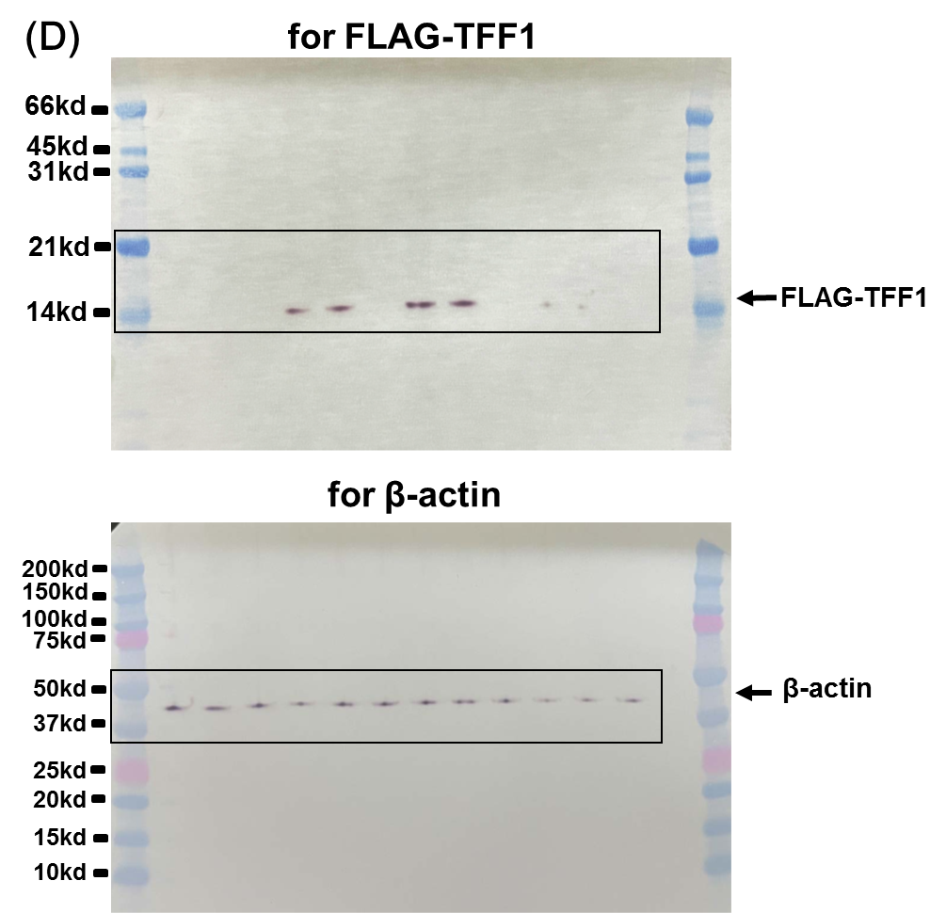
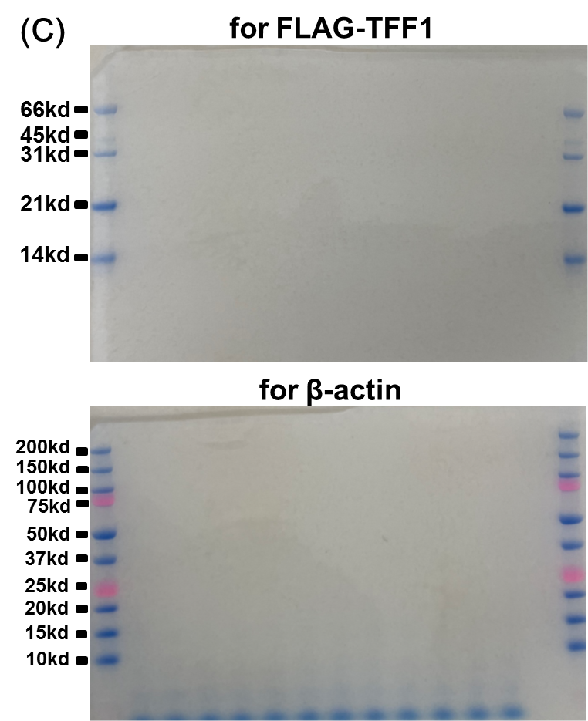
Supplementary Figure 1. Expression of endogenous TFF-1 and β-actin protein in cultured cells from human lung carcinoma evaluated by immunoblotting. A. B. Whole image of gels before transfer (A) and membranes blotted with anti-TFF-1 or anti-β-actin antibodies and colorized (B). Areas indicated by squares in (B) were cropped and inserted into the upper and lower parts, respectively, of Figure 1A. Positions of molecular weight markers (Prestained SDS-PAGE Standards, Low Range, 161-0305 [upper], and Precision Plus Protein™ Dual Color Standards, 161-0374 [lower], BioRad, Tokyo, Japan) were indicated on both edges.

Supplementary Figure 2. Expression of introduced FLAG-TFF-1 and endogenous β-actin proteins in cultured cells from human lung carcinoma evaluated by immunoblotting. A. C. Whole image of gels of cell lysates from SBC-5 (A) and LC-AI (C) before transfer. B. D. Whole image of membranes for the cell lysates from SBC-5 (B) and LC-AI (D) blotted with anti-TTF-1 (upper) or anti-β-actin (lower) antibodies and colorized. Areas indicated by squares were cropped and inserted into the corresponding sites of Figure 2A. Positions of molecular weight markers (Prestained SDS-PAGE Standards, Low Range, 161-0305 [upper], and Precision Plus Protein™ Dual Color Standards, 161-0374 [lower], BioRad, Tokyo, Japan) were indicated on both edges.

