Supplementary Material

Supplementary Table 1. Physical performance at baseline and follow up and changes by malnutrition risk status among participants in disability-free SLAS-2 cohort

Supplementary Figure 1. Percentage frequencies of prevalent disability (2a), incident disability (2b) and functional decline (2c) by malnutrition risk status and presence of specific nutritional indicators.

Supplementary Figure 2. Adjusted means of Knee extension strength (1a), gait velocity (1b) and Timed Up-and-Go (1c) at baseline and follow-up by malnutrition risk status among disability-free SLAS2 participants.
Footnote: Estimated mean values adjusted for age, sex, ethnicity, education, housing type, marital status, living alone, hours of moderate-high physical activity and number of comorbidities.
Error bars are 95% confidence interval.

Supplementary Table 1. Physical performance at baseline and follow up and changes by malnutrition risk status among participants in disability-free SLAS-2 cohort
 |  | Unadjusted Mean (SD) |  |  |  |  |  |  |  | Adjusted Mean (95%CI) |  |  |  |  |  |  |  | Group
 |  | N | Baseline |  |  | N | Follow-up |  |  | Baseline |  |  | Follow-up |  |  | Group | Time | Time
KES, kg
Malnutrition risk score | 0 | 960 | 17.9 | ± 6.6 |  | 505 | 15.5 | ± 5.5 |  | 17.9 | (17.3, 18.5) |  | 15.4 | (14.8, 16.0) |  | 0.088 | 0.001 | 0.315
 | 1-2 | 1056 | 17.1 | ± 6.6 |  | 526 | 15.2 | ± 5.2 |  | 17.5 | (17.0, 18.0) |  | 15.3 | (14.8, 15.9)
 | 3+ | 397 | 16.6 | ± 6.1 |  | 170 | 15.1 | ± 5.8 |  | 16.9 | (16.2, 17.6) |  | 15.2 | (14.3, 16.0)
Eating difficulty | No | 2443 | 17.3 | ± 6.6 |  | 1200 | 15.3 | ± 5.5 |  | 17.5 | (17.1, 17.9) |  | 15.2 | (14.7, 15.7) |  | 0.093 | 0.001 | 0.130
 | Yes | 165 | 15.7 | ± 5.6 |  | 72 | 14.9 | ± 5.3 |  | 16.3 | (15.4, 17.3) |  | 15.1 | (14.0, 16.3)
Taking 5 or more drugs | No | 2158 | 17.4 | ± 6.5 |  | 1087 | 15.4 | ± 5.5 |  | 17.5 | (17.0, 18.0) |  | 15.3 | (14.8, 15.8) |  | 0.439 | 0.001 | 0.661
 | Yes | 454 | 16.2 | ± 6.6 |  | 188 | 14.5 | ± 4.9 |  | 17.2 | (16.5, 17.9) |  | 15.2 | (14.3, 16.0)
Few fruits or vegetables | No | 2369 | 17.2 | ± 6.5 |  | 1170 | 15.2 | ± 5.3 |  | 17.5 | (17.0, 17.9) |  | 15.2 | (14.7, 15.7) |  | 0.866 | 0.001 | 0.071
 | Yes | 239 | 17.1 | ± 6.4 |  | 102 | 16.2 | ± 6.7 |  | 17.0 | (16.2, 17.8) |  | 15.8 | (14.8, 16.8)
Low cholesterol | No | 2075 | 17.3 | ±6.5 |  | 1036 | 15.3 | ± 5.3 |  | 17.6 | (17.2, 18.1) |  | 15.4 | (14.9, 15.9) |  | 0.055 | 0.001 | 0.984
 | Yes | 336 | 17.5 | ± 7.0 |  | 164 | 15.6 | ± 5.8 |  | 17.2 | (16.4, 17.8) |  | 14.9 | (14.0, 15.7)
Low albumin | No | 1943 | 17.5 | ± 6.6 |  | 988 | 15.4 | ± 5.4 |  | 17.6 | (17.1, 18.1) |  | 15.3 | (14.8, 15.8) |  | 0.308 | 0.001 | 0.593
 | Yes | 493 | 16.7 | ± 6.4 |  | 224 | 14.9 | ± 5.5 |  | 17.2 | (16.6, 17.9) |  | 15.2 | (14.5, 15.9)
Low haemoglobin | No | 1932 | 17.6 | ± 6.7 |  | 990 | 15.5 | ± 5.6 |  | 17.7 | (17.2, 18.1) |  | 15.4 | (14.8, 15.9) |  | 0.038 | 0.001 | 0.571
 | Yes | 477 | 16.1 | ± 6.0 |  | 209 | 14.3 | ± 4.4 |  | 17.1 | (16.4, 17.7) |  | 15.0 | (14.2, 15.8)
Low lymphocyte count | No | 2250 | 17.4 | ± 6.6 |  | 1123 | 15.4 | ± 5.5 |  | 17.6 | (17.1, 18.0) |  | 15.3 | (14.7, 15.8) |  | 0.697 | 0.001 | 0.349
 | Yes | 163 | 16.6 | ± 5.8 |  | 78 | 14.7 | ± 4.4 |  | 17.1 | (16.1, 18.1) |  | 15.4 | (14.3, 16.6)
GV, m/s
Malnutrition risk score | 0 | 1002 | 1.31 | ± 0.36 |  | 510 | 1.24 | ± 0.31 |  | 1.28 | (1.24, 1.31) |  | 1.20 | (1.17, 1.24) |  | 0.170 | <0.001 | 0.002
 | 1-2 | 1078 | 1.31 | ± 0.37 |  | 531 | 1.20 | ± 0.30 |  | 1.29 | (1.26, 1.32) |  | 1.17 | (1.13, 1.21)
 | 3+ | 421 | 1.28 | ± 0.34 |  | 173 | 1.12 | ± 0.31 |  | 1.30 | (1.26, 1.34) |  | 1.11 | (1.06, 1.16)
Eating difficulty | No | 2574 | 1.30 | ± 0.36 |  | 1208 | 1.20 | ± 0.31 |  | 1.29 | (1.26, 1.32) |  | 1.18 | (1.15,1.21) |  | 0.516 | 0.001 | 0.102
 | Yes | 186 | 1.29 | ± 0.37 |  | 76 | 1.13 | ± 0.33 |  | 1.32 | (1.25, 1.37) |  | 1.13 | (1.06, 1.20)
Taking 5 or more drugs | No | 2276 | 1.30 | ± 0.36 |  | 1099 | 1.22 | ± 0.31 |  | 1.28 | (1.25, 1.31) |  | 1.19 | (1.15, 1.22) |  | 0.251 | 0.001 | 0.001
 | Yes | 488 | 1.29 | ± 0.37 |  | 188 | 1.09 | ± 0.30 |  | 1.33 | (1.29, 1.37) |  | 1.10 | (1.04, 1.15)
Few fruits or vegetables | No | 2497 | 1.31 | ± 036 |  | 1182 | 1.20 | ± 0.31 |  | 1.29 | (1.26, 1.32) |  | 1.18 | (1.15, 1.21) |  | 0.059 | 0.001 | 0.462
 | Yes | 263 | 1.27 | ± 0.37 |  | 102 | 1.14 | ± 0.27 |  | 1.27 | (1.22, 1.32) |  | 1.13 | (1.06, 1.19)
Low cholesterol | No | 2160 | 1.31 | ± 0.36 |  | 1046 | 1.22 | ± 0.31 |  | 1.28 | (1.25, 1.32) |  | 1.19 | (1.15, 1.22) |  | 0.100 | 0.001 | 0.015
 | Yes | 337 | 1.28 | ± 0.35 |  | 165 | 1.13 | ± 0.31 |  | 1.30 | (1.25, 1.34) |  | 1.12 | (1.07, 1.17)
Low albumin | No | 2010 | 1.31 | ± 0.36 |  | 998 | 1.22 | ± 0.31 |  | 1.29 | (1.25, 1.32) |  | 1.19 | (1.15, 1.22) |  | 0.044 | 0.001 | 0.046
 | Yes | 515 | 1.28 | ± 0.34 |  | 227 | 1.15 | ± 0.30 |  | 1.28 | (1.24, 1.33) |  | 1.13 | (1.08, 1.18)
Low haemoglobin | No | 1992 | 1.31 | ± 0.36 |  | 1000 | 1.21 | ± 0.31 |  | 1.28 | (1.25, 1.31) |  | 1.18 | (1.15, 1.21) |  | 0.700 | 0.001 | 0.255
 | Yes | 504 | 1.29 | ± 0.36 |  | 212 | 1.17 | ± 0.32 |  | 1.29 | (1.25, 1.33) |  | 1.16 | (1.11, 1.21)
Low lymphocyte count | No | 2330 | 1.30 | ± 0.0 |  | 1131 | 1.21 | ± 0.31 |  | 1.29 | (1.26, 1.32) |  | 1.18 | (1.14, 1.21) |  | 0.206 | 0.001 | 0.848
 | Yes | 171 | 1.27 | ± 0.0 |  | 83 | 1.16 | ± 0.28 |  | 1.25 | (1.19, 1.32) |  | 1.15 | (1.08, 1.22)
TUG, sec
Malnutrition risk score | 0 | 1006 | 7.9 | ± 2.1 |  | 511 | 8.5 | ±2.0 |  | 8.6 | (8.3, 8.8) |  | 9.3 | (9.0, 9.6) |  | 0.001 | <0.001 | 0.301
 | 1-2 | 1101 | 8.7 | ± 3.2 |  | 535 | 9.1 | ± 3.2 |  | 8.9 | (8.7, 9.2) |  | 9.7 | (9.3, 10.0)
 | 3+ | 419 | 9.4 | ± 3.9 |  | 173 | 10.2 | ± 4.4 |  | 9.0 | (8.7, 9.4) |  | 10.2 | (9.7, 10.7)
Eating difficulty | No | 2553 | 8.6 | ± 3.2 |  | 1214 | 9.0 | ± 3.0 |  | 9.1 | (8.8, 9.3) |  | 9.8 | (9.5, 10.1) |  | 0.229 | 0.001 | 0.433
 | Yes | 179 | 9.3 | ± 4.9 |  | 76 | 9.9 | ± 4.4 |  | 9.1 | (8.6, 9.6) |  | 10.2 | (9.5, 10.9)
Taking 5 or more drugs | No | 2261 | 8.3 | ± 3.0 |  | 1104 | 8.8 | ± 2.7 |  | 9.0 | (8.7, 9.2) |  | 9.6 | (9.4, 10.0) |  | 0.001 | 0.001 | 0.207
 | Yes | 475 | 9.9 | ± 4.3 |  | 189 | 10.6 | ± 4.6 |  | 9.4 | (9.1, 9.8) |  | 10.5 | (10.0, 11.0)
Few fruits or vegetables | No | 2476 | 8.6 | ± 3.4 |  | 1187 | 9.0 | ± 3.1 |  | 9.1 | (8.9, 9.3) |  | 9.9 | (9.6, 10.1) |  | 0.158 | 0.001 | 0.699
 | Yes | 256 | 8.7 | ± 2.7 |  | 103 | 9.2 | ± 2.7 |  | 8.8 | (8.3, 9.2) |  | 9.7 | (9.1, 10.3)
Low cholesterol | No | 2179 | 8.3 | ± 2.7 |  | 1051 | 8.8 | ± 2.8 |  | 8.8 | (8.5, 9.0) |  | 9.5 | (9.2, 9.8) |  | 0.001 | 0.001 | 0.399
 | Yes | 346 | 9.4 | ± 4.3 |  | 165 | 10.0 | ± 4.3 |  | 9.1 | (8.8, 9.5) |  | 10.1 | (9.6, 10.6)
Low albumin | No | 2031 | 8.4 | ± 3.0 |  | 1002 | 8.8 | ± 2.8 |  | 8.8 | (8.6, 9.0) |  | 9.9 | (9.2, 9.8) |  | 0.001 | 0.001 | 0.019
 | Yes | 518 | 8.9 | ± 3.1 |  | 228 | 9.8 | ± 3.8 |  | 8.9 | (8.6, 9.2) |  | 10.2 | (9.8, 10.6)
Low haemoglobin | No | 2002 | 8.3 | ± 2.8 |  | 1005 | 8.9 | ± 2.9 |  | 8.7 | (8.5, 9.0) |  | 9.6 | (9.3, 9.8) |  | 0.030 | 0.001 | 0.668
 | Yes | 500 | 9.2 | ± 3.8 |  | 212 | 9.4 | ± 3.7 |  | 9.1 | (8.8, 9.4) |  | 9.8 | (9.3, 10.2)
Low lymphocyte count | No | 2352 | 8.5 | ± 3.1 |  | 1136 | 9.0 | ± 3.0 |  | 8.8 | (8.6, 9.1) |  | 9.6 | (9.3, 9.9) |  | 0.931 | 0.001 | 0.152
 | Yes | 174 | 8.6 | ± 2.5 |  | 83 | 9.4 | ± 3.1 |  | 8.5 | (8.1, 9.0) |  | 9.9 | (9.2, 10.5)
Statistically significant associations are bold highlighted.

Supplementary Figure 1

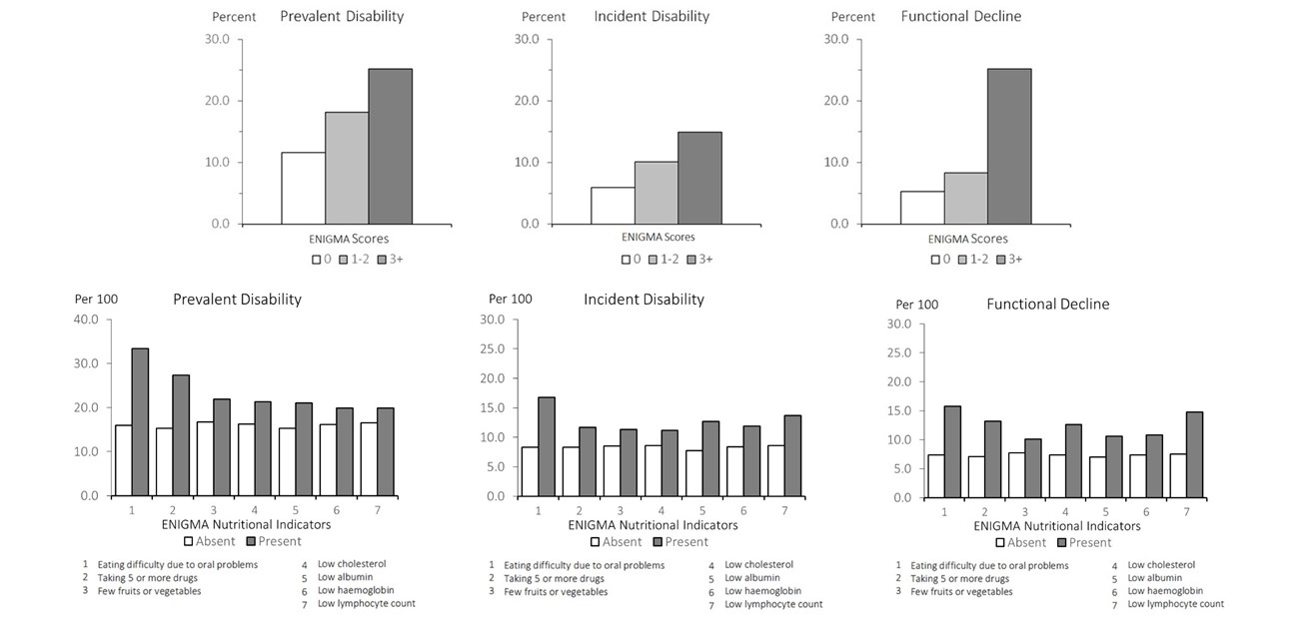

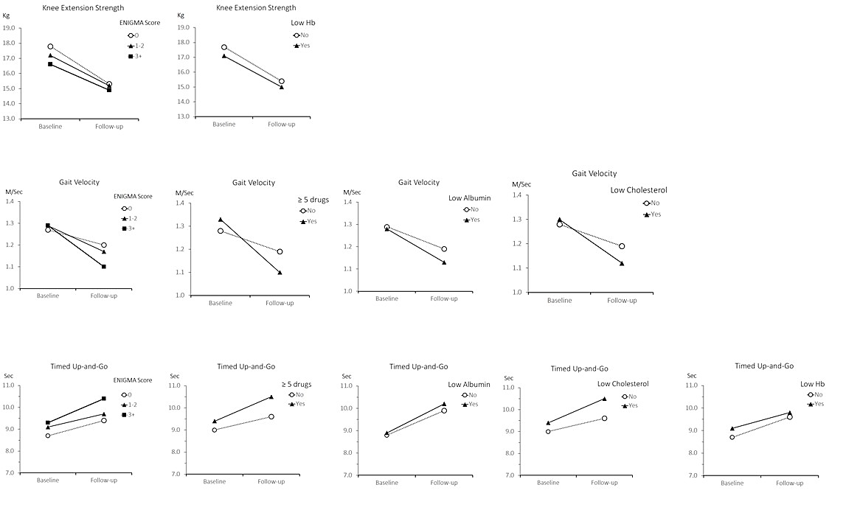
Supplementary Figure 2

