Supplementary Material
Supplemental figure 1
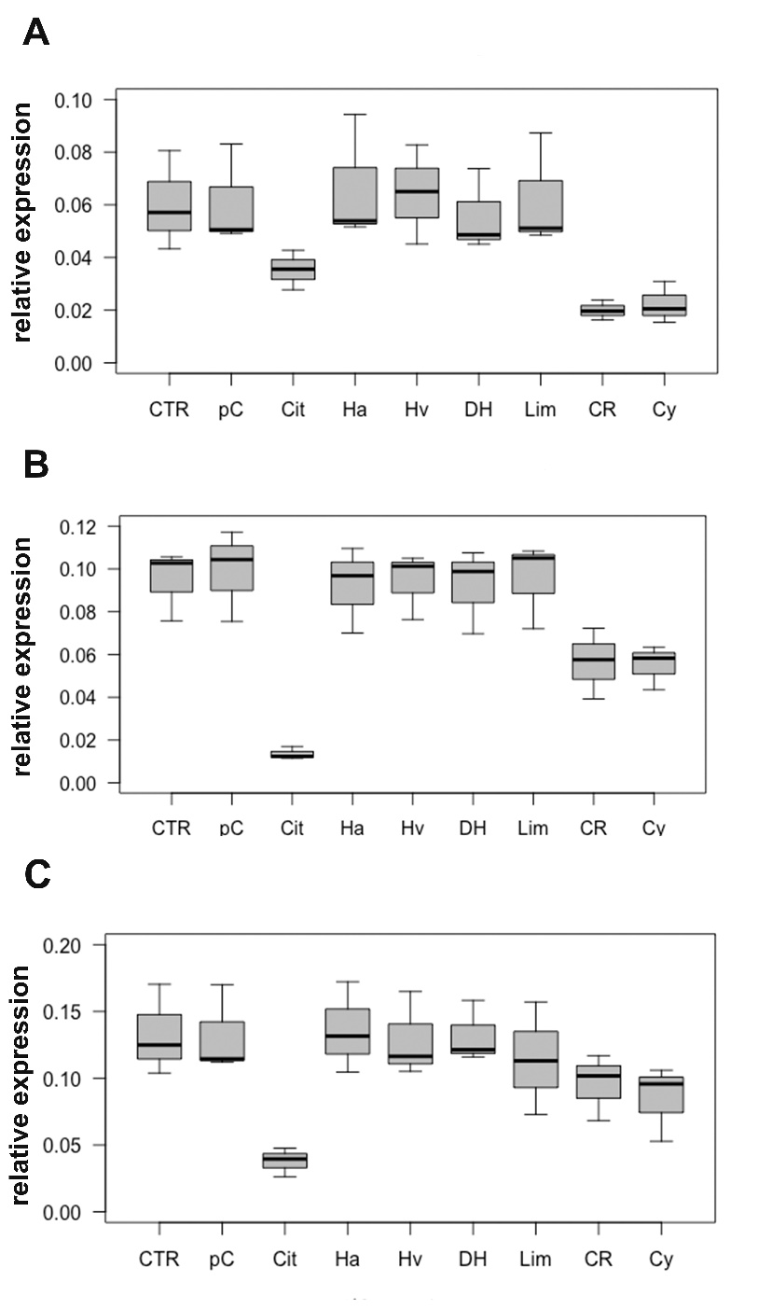
Supplemental figure 1: The effects of odorant substances on Ki67 in T-47D (A), MDA-MB-231 (B) and BT474 (C) cells
Effects of para-cymol (pC), citral (Cit), hexylacetat (Ha), herbavert (Hv), dihydromyrcerol (DH), limonen (Lim), citrathal R (CR) and cyclovertal (Cy) on Ki67 in the different cell lines. As control (CTR) the Ki67 RNA expression without an odorant substance.

Supplemental figure 2
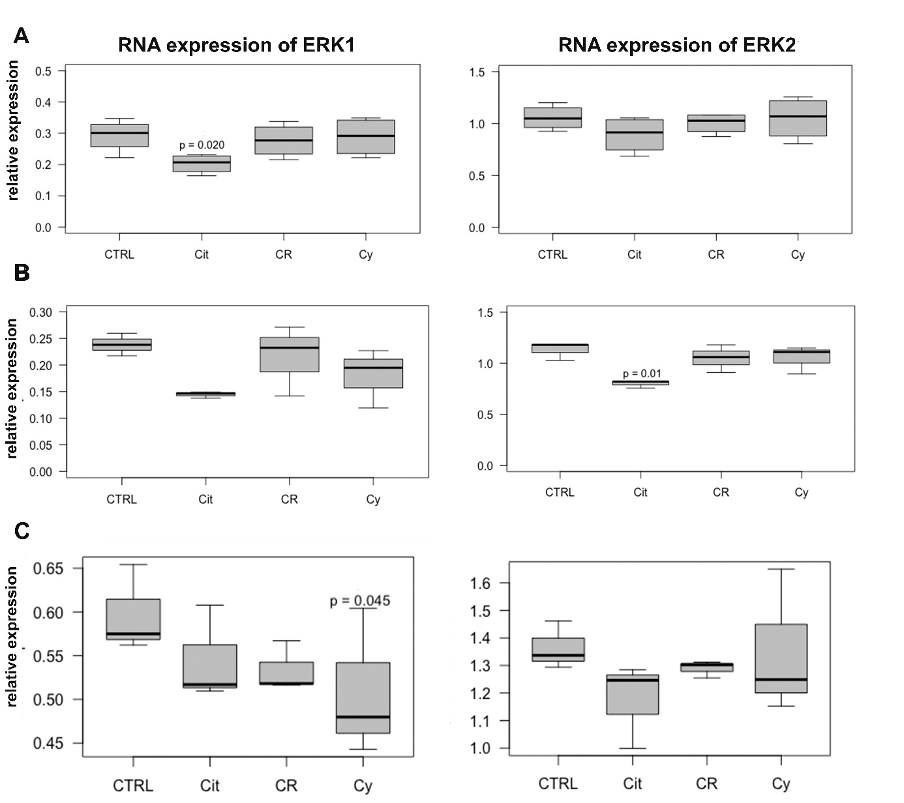
Supplemental figure 2: The effects of odorant substances on ERK1 and ERK2 in T-47D (A), MDA-MB-231 (B) and BT474 (C) cells
Significant reductions of RNA expression of ERK1 in MDA-MB-231 (p=0.034) and T-47D (p= 0.020) cells were observed following treatment with 50 µM citral and in BT474 cells after treatment with 50 µM cyclovertal (p=0.045). ERK2-RNA expression was reduced after treatment with 50µM citral in MDA-MB-231 cells (p=0.010) only

Supplemental figure 3
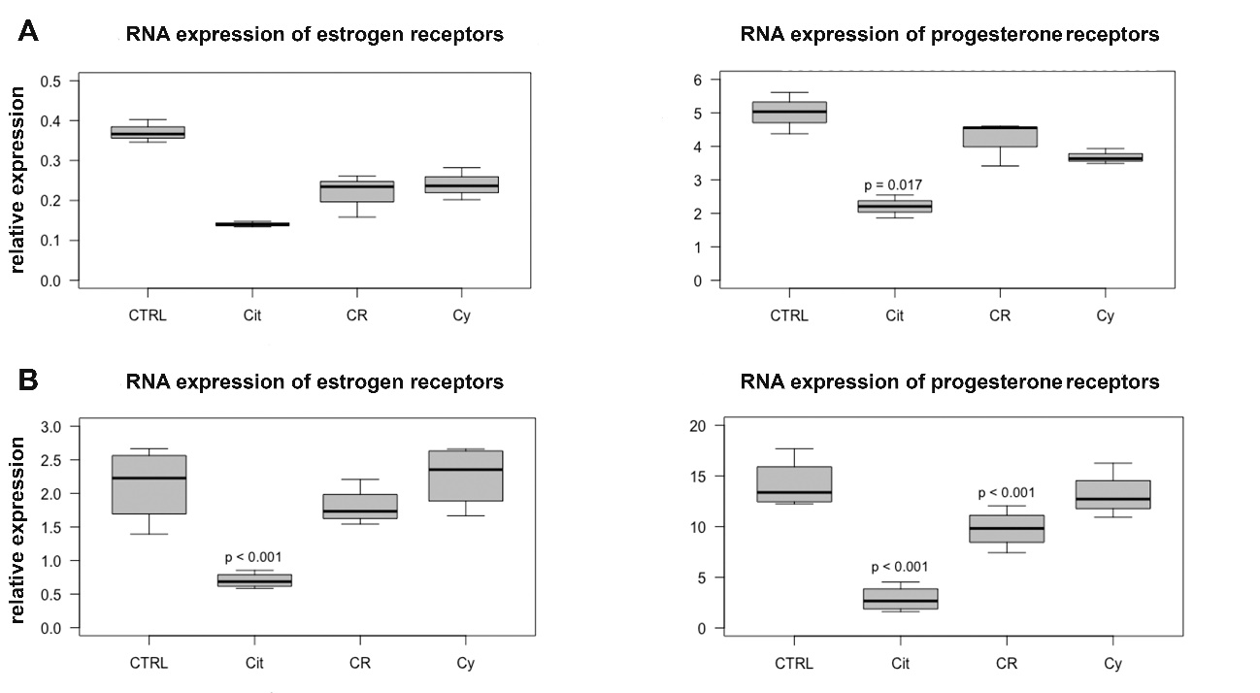
Supplemental figure 3: RNA expression of estrogen and progesterone receptors in BT474 (A) and T-47D (B)
50µM citral induced a significant reduction of progesterone receptor RNA expression in both cell lines (BT474: p=0.017, T-47D: p<0.001), in T-47D also 50µM citrathal R (p<0.001). RNA expression of estrogen receptors in T-47D cells was significantly reduced after treatment with 50µM citral (p<0.001)

