Appendix 1: Variability in Opioid Dose Taper Among Clinicians Survey

Thank you for choosing to complete this survey. The purpose of this survey is to assess provider motivation and comfort level with tapering opioid prescriptions. As a reminder, your responses are completely voluntary and anonymous. Below is some information that you may choose to reference to assist your completion of this survey.
Survey requires Java. (https://www.java.com/en/download/) For best results utilize a laptop or desktop computer.
MME is defined as morphine milligram equivalence and refers to the milligrams of morphine that is considered “equivalent” to milligrams of another opioid. A range of doses for commonly prescribed drugs is provided for you in chart form for consideration of your comfort level when tapering patients off of opioids. The chart is embedded in the survey after question 3. Please refer to the chart to complete the survey.

1. Please select your role below:
a. Physician
b. pharmacist
c. Nurse Practitioner
d. Physician’s Assistant

2. Indicate your specialty (Check only ONE that includes the majority of your practice)
a. Pain
b. Palliative Care
C. General Practice (Internal Medicine)
D. None of the above

3. What state do you most often practice:
4. MME Reference Chart 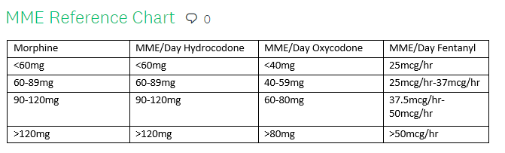At what dosage level are you most comfortable tapering opioids if that patient has been receiving them chronically for more than 90 days (refer to the chart above) .
a. <60 MME/day
b. 60-89 MME/day
c. 90-120 MME/day
d. >120MME/day
e. I do not feel comfortable at any dose
5. If the past year, if you’ve tapered opioids what was the most common reason? (check all that apply)
a. Insurance regulations
b. patient misuse
c. New CDC guidelines
d. Adverse effects/toxicity
e. Other non-medical reason
f. Other medical reason
g. Patient request

6. If tapering a patient on long-acting or extended release opioids, which of the following best describes your approach.
a. Lower the dose of ER opioid
b. Stop the ER opioid and initiate methadone.
c. Stop the ER opioid and initiate IR opioid
d. reduce the dose of ER opioid and use an IR to taper PRN
e. None of the above

7. when tapering opioids do you prescribe any pharmacological agents to blunt symptoms of withdrawal?
a. Yes, an alpha-2 adrenergic receptor agonist such as clonidine or lofexidine (Lucymera)
b. Yes, another agent
c. No

8. On average, which of the following most closely correlates to how you taper opioids when the MME is greater than or equal to 60mh?
a. 1-9% of total daily dose per reduction
b. 10-19% of total daily dose per reduction
c. 20-29% of total daily dose per reduction
d. 30% or more of total daily dose per reduction
e. It depends on the patient's total daily dose
f. I do not follow any specific pattern when tapering

9. How do you approach an opioid taper when the patient is on greater than 60MME/day?
a. daily
b. Every other day
c. Every 3-5 days
d. Every week
e. Every 2 weeks
f. Every month
g. I do not follow any specific patter when tapering

