Supplemental Appendix
Figure S1. Site Outliers for Co-Primary Endpoint of 2-hour Pain Freedom
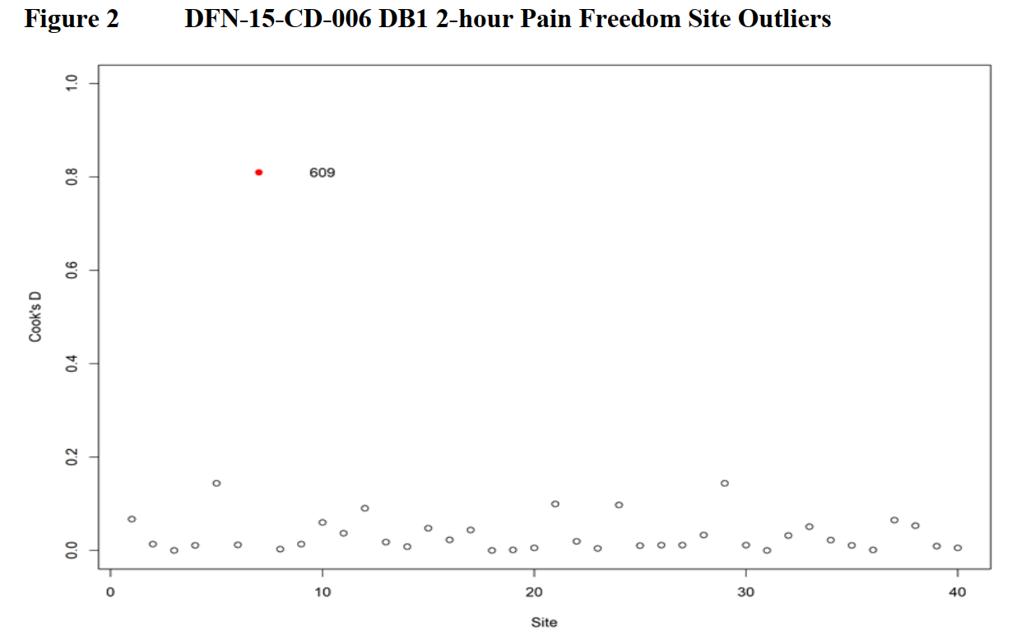

Figure S2. Freedom From Nausea, Photophobia, and Phonophobia at Prespecified Timepoints Post-dose Using LOCF, FAS†

FAS, full analysis set; LOCF, last observation carried forward; Pbo, placebo.
†Analysis includes outlier site.
*Denotes statistical significance

Figure S3. Proportion of Patients With Headache Pain Relief by Post-dose Timepoint Using LOCF, FAS†

P=0.245
P=0.474
P=0.492
P=0.010
P=0.006
P=0.038
P=0.024
P=1.000
n=257 n=275
n=271 n=281
n=239 n=247
n=254 n=269
n=261 n=278
n=262 n=279
n=267 n=280
LOCF, last observation carried forward.
†Analysis includes outlier site.

Table S1. Co-Primary Efficacy Analysis: Headache Pain Freedom and MBS Freedom 2 Hours Post-dose†
 | Placebo  n=280 | Celecoxib oral solution  n=287 | Placebo  n=280 | Celecoxib oral solution  n=287
 | LOCF |  | Observed
Headache pain freedom at 2 hours post-dose
Assessments at 2 hours post-dose, n | 267 | 280 | 256 | 275
Number of responses | 69 | 92 | 63 | 89
Proportion (95% CI), % | 25.8 (20.7, 31.5) | 32.9 (27.4, 38.7) | 24.6 (19.5, 30.4) | 32.4 (26.9, 38.2)
P-value | - | 0.075 | - | 0.055
Odds ratio (95% CI) | - | 1.4 (1.0, 2.0) | - | 1.5 (1.0, 2.1)
Absence of screening MBS at 2 hours post-dose
Assessments at 2 hours post-dose, n | 231 | 241 | 223 | 236
Number of responses | 104 | 142 | 99 | 138
Proportion (95% CI), % | 45.0 (38.5, 51.7) | 58.9 (52.4, 65.2) | 44 (37.8, 51.2) | 58.5 (51.9, 64.8)
P-value | - | 0.003 | - | 0.003
Odds ratio (95% CI) | - | 1.8 (1.2, 2.5) | - | 1.8 (1.2, 2.6)
CI, confidence interval; LOCF, last observation carried forward; MBS, most bothersome symptom.
†Analysis includes outlier site.

