Supplementary materials
Table S1 Characteristics background of patients with clinical symptoms of suspected allergic diseases in different genders from February to June between 2017 and 2020 in south China

 |  | 2017 |  | 2018 |  | 2019 |  | 2020 |  | p-value
 |  | total | (%) | total | (%) | total | (%) | total | (%)
d1 | male | 775 | 46 | 1035 | 49 | 1124 | 48 | 469 | 64 | <0·001
 | female | 482 | 45 | 590 | 42 | 687 | 43 | 307 | 53 | 0·012
d2 | male | 223 | 64 | 407 | 59 | 402 | 67 | 240 | 75 | 0·001
 | female | 164 | 52 | 269 | 50 | 311 | 51 | 169 | 64 | 0·016
i6 | male | 721 | 16 | 887 | 17 | 1067 | 17 | 420 | 30 | <0·001
 | female | 420 | 16 | 480 | 15 | 658 | 16 | 265 | 23 | 0·038
e5 | male | 547 | 5 | 751 | 7 | 777 | 3 | 215 | 10 | 0·001
 | female | 310 | 4 | 385 | 5 | 464 | 4 | 126 | 13 | 0·001
f1 | male | 580 | 25 | 835 | 25 | 936 | 23 | 203 | 27 | 0·547
 | female | 343 | 24 | 442 | 24 | 505 | 19 | 102 | 32 | 0·010
f2 | male | 584 | 34 | 847 | 35 | 924 | 35 | 192 | 28 | 0·221
 | female | 341 | 35 | 450 | 32 | 494 | 29 | 101 | 37 | 0·300
f14 | male | 154 | 3 | 259 | 3 | 274 | 5 | 130 | 8 | 0·122
 | female | 115 | 4 | 144 | 4 | 190 | 4 | 11 | 36 | 0·988
f24 | male | 631 | 13 | 847 | 15 | 992 | 12 | 308 | 21 | 0·001
 | female | 380 | 12 | 448 | 11 | 601 | 10 | 200 | 17 | 0·100
tIgE | male | 1598 | 48 | 2235 | 47 | 2464 | 46 | 1370 | 55 | <0·001
 | female | 1139 | 39 | 1539 | 37 | 1850 | 35 | 1001 | 45 | <0·001

Notes:
- P-value for Chi-square test or Fisher exact test;
- significant difference: P<0.05;
- Abbreviations: d1, Dermatophagoides pteronyssinus; d2, Dermatophagoides farina; i6, German cockroach; e5, dog dander; f1, egg white; f2, milk; f14, soya bean; f24, shrimp; tIgE, total immunoglobulin E
Table S2 Characteristics background of patients with clinical symptoms of suspected allergic diseases in different age groups from February to June between 2017 and 2020 in south China

 |  | 2017 |  | 2018 |  | 2019 |  | 2020
 |  | total | (%) | total | (%) | total | (%) | total | (%) | p-value
d1 | 0-5 | 618 | 39 | 846 | 35 | 847 | 35 | 188 | 48 | 0·004
 | 6-17 | 262 | 74 | 359 | 78 | 449 | 73 | 236 | 85 | 0·004
 | >17 | 377 | 37 | 420 | 41 | 515 | 40 | 352 | 49 | 0·004
d2 | 0-5 | 159 | 44 | 279 | 43 | 180 | 47 | 58 | 59 | 0·190
 | 6-17 | 108 | 85 | 206 | 74 | 218 | 83 | 151 | 89 | 0·003
 | >17 | 120 | 55 | 191 | 54 | 315 | 51 | 200 | 61 | 0·203
i6 | 0-5 | 554 | 8 | 714 | 7 | 798 | 7 | 159 | 8 | 0·671
 | 6-17 | 242 | 24 | 302 | 25 | 434 | 21 | 212 | 32 | 0·034
 | >17 | 345 | 22 | 351 | 28 | 493 | 28 | 314 | 34 | 0·010
e5 | 0-5 | 532 | 3 | 715 | 3 | 764 | 2 | 142 | 4 | 0·265
 | 6-17 | 176 | 9 | 272 | 13 | 329 | 6 | 115 | 17 | 0·002
 | >17 | 149 | 5 | 149 | 7 | 148 | 7 | 84 | 14 | 0·091
f1 | 0-5 | 678 | 28 | 953 | 27 | 1013 | 26 | 166 | 34 | 0·154
 | 6-17 | 187 | 17 | 255 | 20 | 351 | 11 | 114 | 23 | 0·003
 | >17 | 58 | 5 | 69 | 4 | 77 | 9 | 25 | 16 | 0·296
f2 | 0-5 | 682 | 42 | 966 | 4 | 1015 | 41 | 168 | 40 | 0·796
 | 6-17 | 188 | 13 | 258 | 20 | 351 | 13 | 113 | 19 | 0·069
 | >17 | 55 | 0 | 73 | 1 | 52 | 4 | 12 | 17 | 0·159
f14 | 0-5 | 55 | 0 | 140 | 3 | 100 | 6 | 7 | 0 | 0·524
 | 6-17 | 17 | 18 | 25 | 4 | 21 | 10 | 10 | 10 | 0·601
 | >17 | 197 | 3 | 238 | 4 | 343 | 4 | 227 | 6 | 0·524
f24 | 0-5 | 496 | 6 | 716 | 7 | 854 | 5 | 144 | 9 | 0·155
 | 6-17 | 176 | 18 | 240 | 24 | 343 | 15 | 119 | 21 | 0·048
 | >17 | 339 | 21 | 339 | 21 | 396 | 22 | 245 | 24 | 0·694
tIgE | 0-5 | 955 | 42 | 1233 | 35 | 1323 | 37 | 345 | 54 | <0·001
 | 6-17 | 330 | 66 | 461 | 66 | 604 | 63 | 349 | 74 | 0·004
 | >17 | 1452 | 41 | 2080 | 43 | 2387 | 39 | 1677 | 46 | <0·001

Notes:
- P-value for Chi-square test or Fisher exact test;
- significant difference: P<0.05;
- Abbreviations: d1, Dermatophagoides pteronyssinus; d2, Dermatophagoides farina; i6, German cockroach; e5, dog dander; f1, egg white; f2, milk; f14, soya bean; f24, shrimp; tIgE, total immunoglobulin E

Figure S1: The ratio of allergic patients with a higher indoor inhalant allergen content (Class 1-3) to those with a lower indoor inhalant allergen content (Class 4-6) from February to June between 2017 and 2020 in south China.
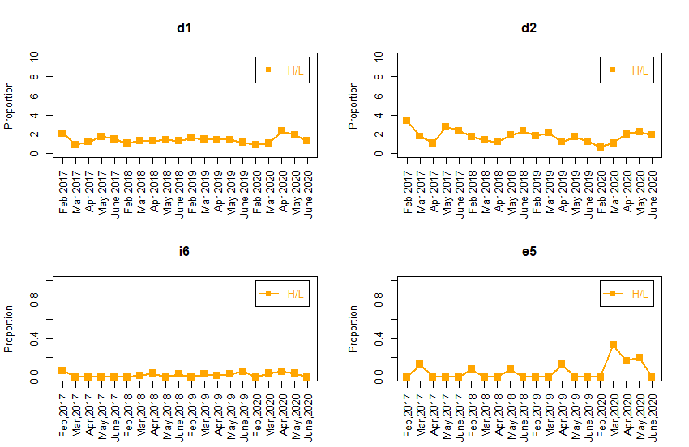
Legends: H:Class 4-6; L:Class 1-3; d1, Dermatophagoides pteronyssinus; d2, Dermatophagoides farina; i6, German cockroach; e5, dog dander

Figure S2: The ratio of allergic patients with a higher food allergen content (Class 1-3) to those with a lower food allergen content (Class 4-6) from February to June between 2017 and 2020 in south China.
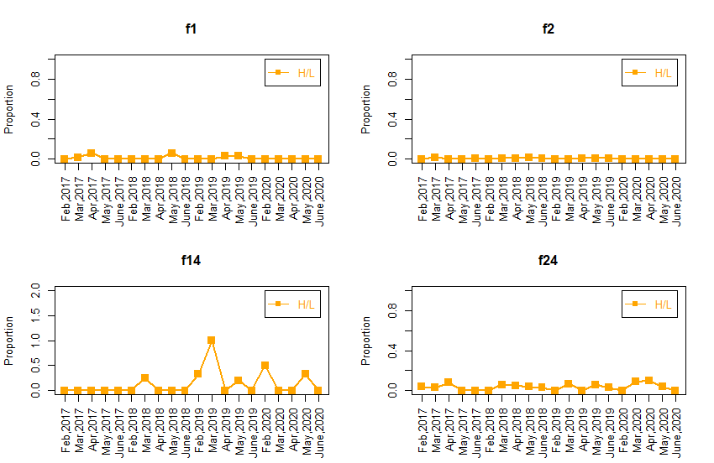
Legends: H:Class 4-6; L:Class 1-3; f1, egg white; f2, milk; f14, soya bean; f24, shrimp

