Supplementary materials

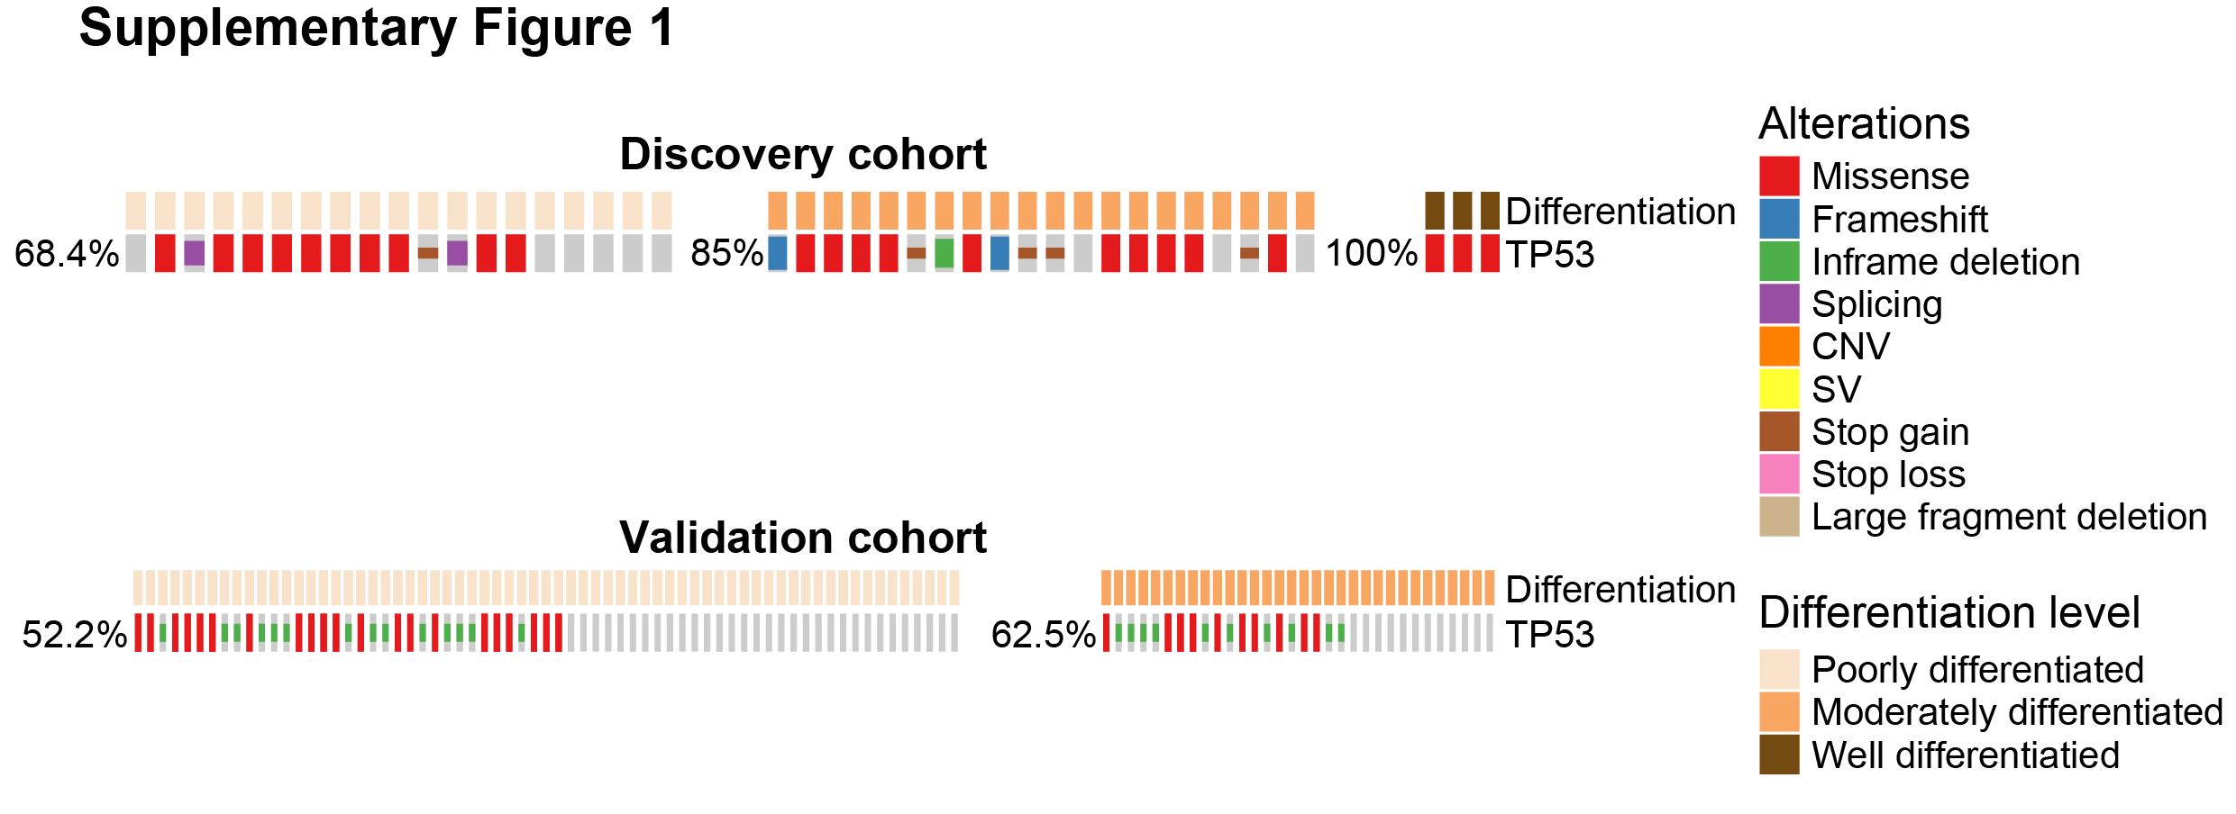Supplementary Figure 1 TP53 mutation frequency was associated with differentiation level in gastric cancer. Co-mutation plot of TP53 mutations with various differentiation levels in the discovery patient cohort (upper panel) or the validation patient cohort (lower panel). CNV, copy number variation; SV, structural variant.

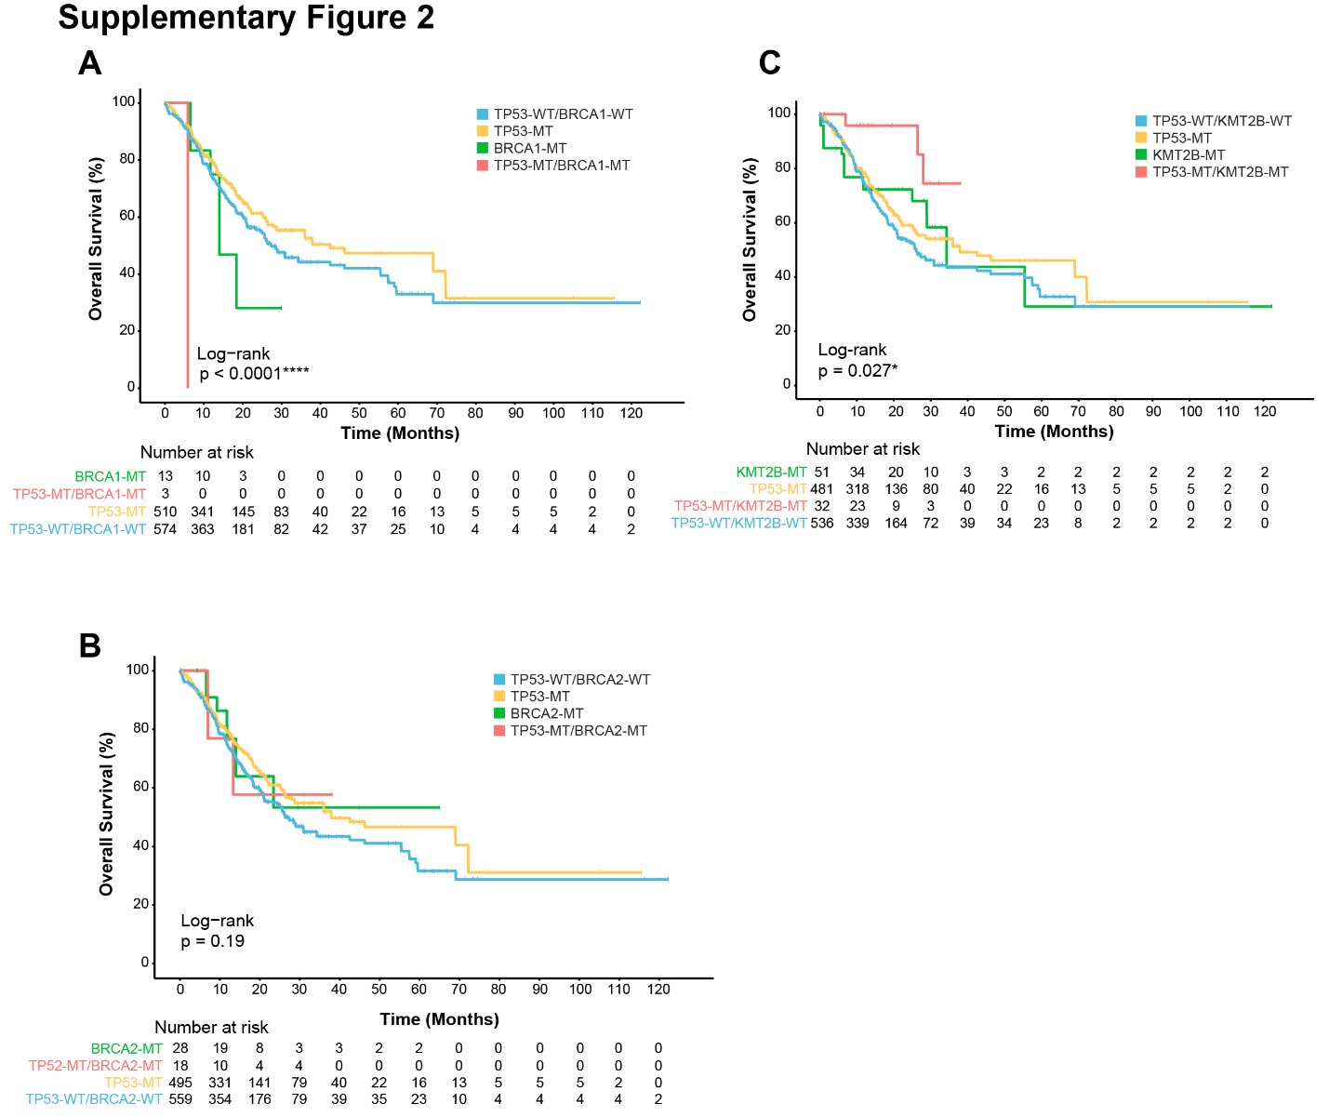
Supplementary Figure 2 Patient survival with different co-mutational status. Kaplan-Meier curve of overall survival (OS) of patients from the validation patient cohort in strata of different TP53 and BRCA1 mutation status (A), TP53 and BRCA2 mutation status (B), and different TP53 and KMT2B mutation status (C). The log-rank test was used for analyzing the survival data. WT: wild type; MT: mutant. Two-sided p values of less than 0.05 was considered as statistically significant (*p<0.05, **p<0.01, ***p<0.001, ****p<0.0001).

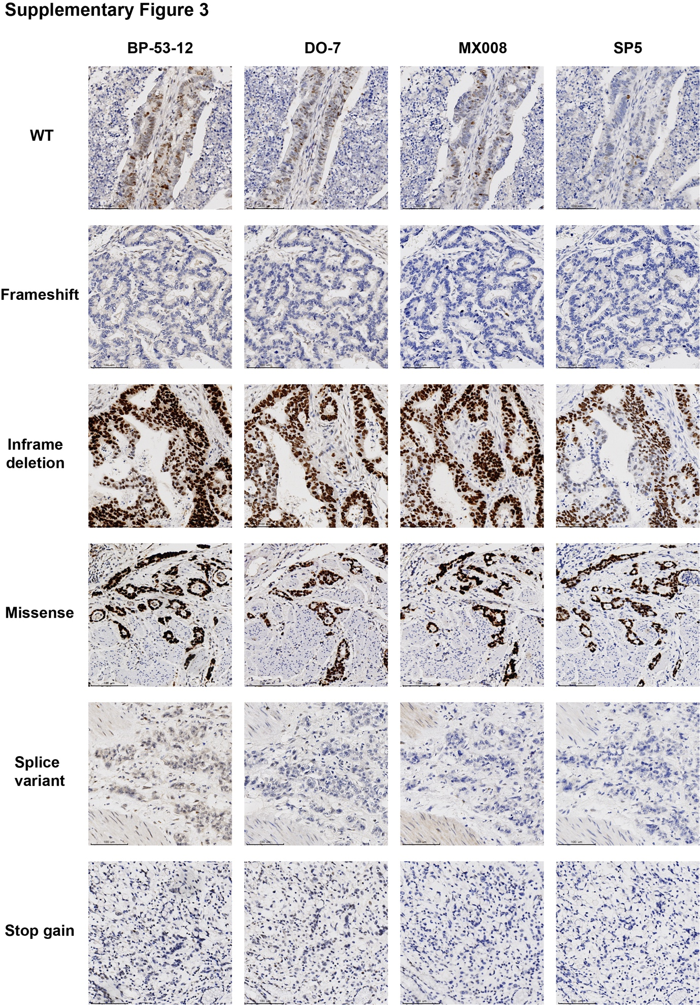
Supplementary Figure 3 Representative IHC images of each TP53 mutational type, including TP53 WT, TP53 frameshift mutation, TP53 inframe deletion, TP53 messense mutation, TP53 splice variant, and TP53 stop gain mutation. The IHC images of each TP53 mutational were generated from similar sections of the same tumor specimen. WT: wild type.

Supplementary Table 1 The demographic characteristics of 1,313 gastric cancer patients in the validation cohort. EBV, Epstein-Barr virus; MSI, microsatellite instability; GS, genomically stable; CIN, chromosomal instability; MSS, microsatellite stable; NA, not available.
 | No. of patient | Percentage (%)
Median age, years (range) | 67 (30-90)
Gender
Male | 812 | 61.8
Female | 466 | 35.5
NA | 35 | 2.7
Tumor differentiation level
Poorly differentiated | 67 | 5.1
Moderate to well differentiated | 33 | 2.5
NA | 1213 | 92.4
Microsatellite status
MSI | 74 | 5.6
MSS | 321 | 24.4
NA | 918 | 69.9
Stage
Tis | 1 | 0.1
I | 8 | 0.6
II | 20 | 1.5
III | 41 | 3.1
IV | 30 | 2.3
NA | 1213 | 92.4
Subtypes
EBV-positive | 30 | 2.3
MSI | 72 | 5.5
CIN | 220 | 16.8
GS | 49 | 3.7
NA | 942 | 71.7

Supplementary Table 2 Detailed mutated genes in 42-patient cohort. Amp, amplification.
Patient ID | Gene | Amino acid change | Mutation type
P1 | TP53 | c.742C>T(p.R248W) | missense_variant
P1 | MAP2K4 | c.938T>G(p.V313G) | missense_variant
P1 | FGF19 | . | Amp
P1 | CCND1 | . | Amp
P2 | FBXW7 | c.1310G>A(p.G437E) | missense_variant
P2 | ERBB2 | c.2033G>A(p.R678Q) | missense_variant
P2 | FLT4 | c.508C>T(p.R170C) | missense_variant
P3 | GATA1 | c.889A>G(p.M297V) | missense_variant
P3 | RNF43 | c.575delC(p.P192Rfs*11) | frameshift_variant
P3 | KMT2B | c.3769C>T(p.R1257C) | missense_variant
P3 | RNF43 | c.1111C>T(p.R371*) | stop_gained
P3 | EPHA2 | c.2698G>A(p.G900S) | missense_variant
P3 | TNFRSF11A | c.1679C>T(p.A560V) | missense_variant
P3 | TGFBR2 | c.1582C>T(p.R528C) | missense_variant
P3 | SETBP1 | c.154G>A(p.G52R) | missense_variant
P3 | SMARCA4 | c.4801C>T(p.R1601W) | missense_variant
P3 | LRP1B | c.67G>A(p.V23M) | missense_variant
P3 | SMARCA4 | c.3634_3636delGAG(p.E1212del) | inframe_deletion
P3 | IDH2 | c.435delG(p.T146Lfs*15) | frameshift_variant
P3 | STK11 | c.996G>A(p.W332*) | stop_gained
P3 | SLC3A2 | c.899delA(p.K300Rfs*31) | frameshift_variant
P3 | CHEK1 | c.1136G>A(p.R379Q) | missense_variant
P3 | RARA | c.1319delC(p.P440Rfs*203) | frameshift_variant
P3 | BAX | c.121delG(p.E41Rfs*19) | frameshift_variant
P3 | FGFR3 | c.1206dupC(p.K403Qfs*93) | frameshift_variant
P3 | GATA4 | c.1027G>A(p.A343T) | missense_variant
P3 | TTF1 | c.821delA(p.K274Sfs*149) | frameshift_variant
P3 | LRP1B | c.10295-2A>G | splice_acceptor_variant
P3 | FANCA | c.1844C>A(p.P615Q) | missense_variant
P3 | DPYD | c.1376G>A(p.W459*) | stop_gained
P3 | CDK4 | c.308A>G(p.Y103C) | missense_variant
P3 | NSD1 | c.5397delT(p.F1799Lfs*22) | frameshift_variant
P3 | PIK3CA | c.3061T>C(p.Y1021H) | missense_variant
P3 | PIK3CA | c.1589A>G(p.Q530R) | missense_variant
P3 | ARID1B | c.5296A>G(p.T1766A) | missense_variant
P3 | NBN | c.1396dupA(p.R466Kfs*5) | frameshift_variant;splice_region_variant
P3 | ETV6 | c.1140G>T(p.W380C) | missense_variant
P3 | WISP3 | c.678delA(p.K226Nfs*24) | frameshift_variant
P3 | ZNF217 | c.724delA(p.T242Lfs*30) | frameshift_variant
P3 | THADA | c.1639_1642delGATT(p.D547Ifs*7) | frameshift_variant
P3 | TOP1 | c.1384C>T(p.R462*) | stop_gained
P3 | PKHD1 | c.10118A>T(p.K3373I) | missense_variant
P3 | NSD1 | c.6502G>A(p.G2168R) | missense_variant
P3 | TTF1 | c.2538dupA(p.G847Rfs*3) | frameshift_variant
P3 | ETV1 | c.428C>T(p.T143M) | missense_variant
P3 | NAT1 | c.806dupA(p.N269Kfs*4) | frameshift_variant
P3 | ERBB2IP | c.1781T>G(p.V594G) | missense_variant
P3 | NOTCH1 | c.7455delC(p.S2486Rfs*103) | frameshift_variant
P3 | CTCF | c.637C>T(p.R213C) | missense_variant
P3 | NTRK3 | c.994A>C(p.T332P) | missense_variant
P3 | MAP3K4 | c.479delA(p.N160Mfs*8) | frameshift_variant
P3 | BRD4 | c.3479C>A(p.P1160H) | missense_variant
P3 | LHCGR | c.774delA(p.K258Nfs*16) | frameshift_variant
P3 | ATR | c.2320dupA(p.I774Nfs*3) | frameshift_variant
P3 | FOXP1 | c.1537G>A(p.V513M) | missense_variant
P3 | MSH6 | c.3261dupC(p.F1088Lfs*5) | frameshift_variant
P3 | NOTCH1 | c.4670A>G(p.D1557G) | missense_variant
P3 | DPYD | c.2530G>A(p.E844K) | missense_variant
P3 | PRKCI | c.826dupA(p.T276Nfs*16) | frameshift_variant
P3 | FAT1 | c.11856delT(p.F3952Lfs*31) | frameshift_variant
P3 | JAK1 | c.2580delA(p.K860Nfs*16) | frameshift_variant
P3 | PREX2 | c.4589G>T(p.S1530I) | missense_variant
P3 | HNF1A | c.1136delC(p.P379Lfs*5) | frameshift_variant
P3 | NTRK3 | c.1184T>C(p.F395S) | missense_variant
P3 | KMT2B | c.5726C>T(p.P1909L) | missense_variant
P3 | FANCA | c.346A>G(p.M116V) | missense_variant
P3 | BRCA2 | c.3134T>C(p.V1045A) | missense_variant
P3 | RAF1 | c.1852C>T(p.R618W) | missense_variant
P3 | CDKN2A | c.225dupC(p.A76Rfs*44) | frameshift_variant
P3 | KRAS | c.175G>A(p.A59T) | missense_variant
P3 | SETD2 | c.4757A>G(p.H1586R) | missense_variant
P3 | SGK1 | c.1231G>A(p.V411I) | missense_variant
P3 | NSD1 | c.1493G>A(p.R498Q) | missense_variant
P3 | NF1 | c.3916C>T(p.R1306*) | stop_gained
P3 | ALK | c.1833G>T(p.M611I) | missense_variant
P3 | EXT1 | c.1237G>A(p.E413K) | missense_variant
P3 | BRCA2 | c.7806-2A>G | splice_acceptor_variant
P3 | LRP1B | c.8606T>C(p.F2869S) | missense_variant
P3 | MYC | . | Amp
P4 | RUNX1 | c.313C>G(p.H105D) | missense_variant
P4 | NTRK3 | c.1788C>G(p.I596M) | missense_variant
P4 | BRCA2 | c.6170G>A(p.G2057E) | missense_variant
P4 | LRP1B | c.313G>T(p.D105Y) | missense_variant
P4 | PTPN13 | c.7424G>A(p.R2475H) | missense_variant
P4 | FGF19 | . | Amp
P4 | CCND1 | . | Amp
P5 | ARID1A | c.1080_1081dupGC(p.P361Rfs*3) | frameshift_variant
P5 | RHOA | c.50G>A(p.G17E) | missense_variant
P5 | TP63 | c.1094C>T(p.S365L) | missense_variant
P5 | TP53 | c.377A>G(p.Y126C) | missense_variant;splice_region_variant
P5 | TP53 | c.742C>T(p.R248W) | missense_variant
P5 | KRAS | c.35G>A(p.G12D) | missense_variant
P5 | PTCH1 | c.3338G>A(p.R1113H) | missense_variant
P5 | MUTYH | c.253C>T(p.H85Y) | missense_variant
P6 | GNAS | c.626A>G(p.K209R) | missense_variant
P6 | FGF19 | c.379C>T(p.R127C) | missense_variant
P6 | BRCA2 | c.4540G>A(p.E1514K) | missense_variant
P6 | PDE11A | c.1484C>T(p.P495L) | missense_variant
P6 | MCL1 | . | Amp
P6 | MYC | . | Amp
P7 | PARP2 | c.247G>A(p.V83M) | missense_variant
P7 | LRP1B | c.4490A>G(p.K1497R) | missense_variant
P7 | LRP1B | c.2555G>T(p.C852F) | missense_variant
P7 | TP53 | c.734G>A(p.G245D) | missense_variant
P7 | ERBB2 | . | Amp
P8 | CDKN1A | c.302T>C(p.L101P) | missense_variant
P8 | SMAD3 | c.277C>T(p.R93*) | stop_gained
P8 | TP53 | c.747G>C(p.R249S) | missense_variant
P9 | SMARCA4 | c.719C>T(p.P240L) | missense_variant
P9 | FLT4 | c.3121C>T(p.R1041W) | missense_variant
P9 | ESR1 | c.260C>T(p.A87V) | missense_variant
P9 | ERBB2 | c.2264T>C(p.L755S) | missense_variant
P9 | PLK1 | c.410C>T(p.S137F) | missense_variant;splice_region_variant
P9 | ERBB3 | c.785C>A(p.P262H) | missense_variant
P9 | KMT2B | c.4235delG(p.G1412Afs*10) | frameshift_variant
P9 | KDM5A | c.3597delA(p.G1200Dfs*9) | frameshift_variant
P9 | IRF2 | c.500delA(p.N167Mfs*7) | frameshift_variant
P9 | ARID1A | c.6384G>T(p.Q2128H) | missense_variant
P9 | NKX2-1 | c.236C>T(p.S79L) | missense_variant
P9 | PGR | c.373G>A(p.G125R) | missense_variant
P9 | POLE | c.2091delC(p.L698Cfs*94) | frameshift_variant
P9 | ARID1A | c.5548delG(p.D1850Tfs*33) | frameshift_variant
P9 | EWSR1 | c.1426G>T(p.G476C) | missense_variant
P9 | CHEK1 | c.676dupA(p.T226Nfs*19) | frameshift_variant
P9 | FBXW7 | c.1877C>T(p.A626V) | missense_variant
P9 | KMT2B | c.521dupC(p.T176Dfs*8) | frameshift_variant
P9 | RNF43 | c.1976delG(p.G659Vfs*41) | frameshift_variant
P9 | PGR | c.40G>A(p.V14M) | missense_variant
P9 | MTOR | c.1856G>A(p.R619H) | missense_variant
P9 | RECQL4 | c.1759G>A(p.A587T) | missense_variant
P9 | CASP8 | c.1279_1280delGT(p.V427Ffs*28) | frameshift_variant
P9 | XRCC1 | c.1183C>T(p.R395W) | missense_variant
P9 | CHD4 | c.5737T>C(p.*1913Rext*41) | stop_lost
P9 | CDKN2B | c.265C>T(p.R89W) | missense_variant
P9 | ERBB3 | c.383G>A(p.S128N) | missense_variant
P9 | KMT2B | c.6764C>T(p.P2255L) | missense_variant
P9 | FANCL | c.783A>C(p.K261N) | missense_variant
P9 | SUFU | c.893G>A(p.R298Q) | missense_variant
P9 | BRD4 | c.1039A>C(p.S347R) | missense_variant
P9 | PIK3R1 | c.1559A>C(p.E520A) | missense_variant
P9 | NSD1 | c.430_431delAA(p.K144Dfs*10) | frameshift_variant
P9 | MCL1 | . | Amp
P10 | TP53 | c.776A>T(p.D259V) | missense_variant
P10 | TERT | c.1657G>A(p.V553I) | missense_variant
P10 | AXL | c.308+2_308+8dupTGTGTGG | frameshift_variant;splice_region_variant
P10 | GATA4 | c.797G>A(p.R266Q) | missense_variant
P11 | TP53 | c.488A>G(p.Y163C) | missense_variant
P11 | NOTCH2 | c.5764G>A(p.A1922T) | missense_variant
P11 | STAT3 | c.1654-76_1663del | splice_acceptor_variant;coding_sequence_variant;intron_variant
P11 | IGF1R | . | Amp
P12 | TP53 | c.637C>T(p.R213*) | stop_gained
P12 | PRSS1 | c.662C>G(p.A221G) | missense_variant
P13 | TP53 | c.782+1G>A | splice_donor_variant
P14 | CDH1 | c.1108G>C(p.D370H) | missense_variant
P14 | TP53 | c.799C>T(p.R267W) | missense_variant
P14 | EXT2 | c.106G>T(p.G36C) | missense_variant
P15 | TP53 | c.515T>G(p.V172G) | missense_variant
P15 | NTRK3 | c.1379C>G(p.S460C) | missense_variant
P15 | GRM3 | c.1891T>G(p.F631V) | missense_variant
P15 | PDGFRB | c.3098C>T(p.A1033V) | missense_variant
P15 | MYC | . | Amp
P17 | TP53 | c.488A>G(p.Y163C) | missense_variant
P17 | GNAS | c.1181C>T(p.A394V) | missense_variant
P17 | LRP1B | c.3933A>T(p.R1311S) | missense_variant
P17 | BAI3 | c.4066A>T(p.M1356L) | missense_variant
P17 | POLH | c.230_237dupTGGCACAA(p.V80Wfs*23) | frameshift_variant
P17 | FANCI | c.3496A>G(p.T1166A) | missense_variant
P18 | PTEN | c.376G>A(p.A126T) | missense_variant
P18 | PLK1 | c.1193_1194delAG(p.E398Gfs*3) | splice_acceptor_variant
P18 | ARID1A | c.4555C>T(p.Q1519*) | stop_gained
P18 | AKT3 | c.992G>T(p.G331V) | missense_variant
P18 | NRG1 | c.960A>C(p.K320N) | missense_variant
P19 | TP53 | c.97-1G>A | splice_acceptor_variant
P19 | NTRK2 | c.1853A>C(p.K618T) | missense_variant
P19 | PRSS1 | c.237A>C(p.E79D) | missense_variant
P19 | ERBB4 | c.2615A>C(p.E872A) | missense_variant
P19 | PTCH1 | c.3320C>T(p.A1107V) | missense_variant
P19 | LRP1B | c.6094delG(p.V2032Lfs*4) | frameshift_variant
P19 | SETBP1 | c.2398T>A(p.S800T) | missense_variant
P19 | IGF1R | c.2467G>A(p.A823T) | missense_variant
P19 | CDC73 | c.416G>A(p.R139Q) | missense_variant
P19 | PGR | c.1766T>C(p.V589A) | missense_variant
P19 | AR | c.1660T>C(p.F554L) | missense_variant
P19 | ERBB4 | c.3270A>C(p.E1090D) | missense_variant
P19 | EPHA5 | c.727T>C(p.F243L) | missense_variant
P19 | SMAD3 | c.1265C>T(p.S422F) | missense_variant
P19 | HGF | . | Amp
P19 | KRAS | . | Amp
P19 | CDK6 | . | Amp
P20 | TP53 | c.586C>T(p.R196*) | stop_gained
P20 | PRF1 | c.1136G>A(p.R379Q) | missense_variant
P20 | GATA3 | c.1038C>A(p.Y346*) | stop_gained
P20 | KMT2B | c.890G>A(p.R297Q) | missense_variant
P20 | MAP3K1 | c.2090G>A(p.R697H) | missense_variant;splice_region_variant
P21 | EGFR | . | Amp
P21 | TP53 | c.1045G>T(p.E349*) | stop_gained
P21 | ARID1A | c.531_532delAA(p.S178Pfs*221) | frameshift_variant
P21 | NTRK2 | c.2221A>C(p.I741L) | missense_variant
P21 | GRM3 | c.655G>A(p.E219K) | missense_variant
P21 | MYC | . | Amp
P22 | APC | c.3808T>C(p.C1270R) | missense_variant
P22 | TP53 | c.817C>T(p.R273C) | missense_variant
P22 | GNAS | c.1570C>T(p.R524C) | missense_variant
P23 | GATA1 | c.774C>A(p.C258*) | stop_gained
P23 | PIK3CA | c.1624G>A(p.E542K) | missense_variant
P23 | TP53 | c.578A>T(p.H193L) | missense_variant
P23 | ATM | c.6068G>A(p.G2023E) | missense_variant
P23 | LRP1B | c.10366T>G(p.C3456G) | missense_variant
P23 | DLL3 | . | Amp
P23 | CCNE1 | . | Amp
P23 | AKT2 | . | Amp
P24 | CDK12 | . | Amp
P24 | ERBB2 | . | Amp
P24 | FGFR3 | c.1703G>A(p.R568Q) | missense_variant
P24 | FANCA | c.488G>A(p.R163H) | missense_variant
P24 | CDK12 | IGR (upstream NEUROD2)~CDK12:exon7 | SV
P24 | CCNE1 | . | Amp
P24 | VEGFA | . | Amp
P25 | TP53 | c.844C>T(p.R282W) | missense_variant
P25 | CDK8 | c.1042G>A(p.G348S) | missense_variant
P25 | GRM8 | c.151C>A(p.L51I) | missense_variant
P25 | CDK6 | . | Amp
P25 | KRAS | . | Amp
P25 | RICTOR | . | Amp
P25 | MCL1 | . | Amp
P25 | IL7R | . | Amp
P26 | EGFR | . | Amp
P26 | FBXW7 | c.1513C>T(p.R505C) | missense_variant
P26 | TP53 | c.396G>T(p.K132N) | missense_variant
P26 | ATM | c.4010T>C(p.I1337T) | missense_variant
P26 | NOTCH2 | REG4:exon6~NOTCH2:exon17 | SV
P26 | CCNE1 | . | Amp
P27 | ERBB2 | . | Amp
P27 | CCNE1 | . | Amp
P27 | TP53 | c.817C>T(p.R273C) | missense_variant
P27 | AKT1 | c.1366G>A(p.D456N) | missense_variant;splice_region_variant
P27 | GRM3 | c.1303T>G(p.L435V) | missense_variant
P27 | MED12 | c.5803T>A(p.S1935T) | missense_variant
P27 | EXT2 | c.902A>G(p.H301R) | missense_variant
P27 | DICER1 | c.2063G>A(p.R688Q) | missense_variant
P27 | ATR | c.1363G>A(p.D455N) | missense_variant
P27 | LRP1B | c.13226A>G(p.E4409G) | missense_variant
P27 | PIK3C3 | c.628C>T(p.R210*) | stop_gained
P27 | EPHA5 | c.1723A>T(p.I575F) | missense_variant
P27 | NTRK1 | c.149G>A(p.C50Y) | missense_variant
P27 | ARAF | c.1571G>A(p.R524H) | missense_variant
P28 | TP53 | c.413C>T(p.A138V) | missense_variant
P28 | LRP1B | c.12551T>G(p.L4184R) | missense_variant
P28 | FLT4 | c.1429C>T(p.R477W) | missense_variant
P28 | HNF1A | c.516G>C(p.E172D) | missense_variant
P29 | ERBB2 | . | Amp
P29 | TOP2A | . | Amp
P29 | CDK12 | . | Amp
P29 | MYC | . | Amp
P29 | TP53 | c.414_415insT(p.K139*) | frameshift_variant
P29 | FANCG | c.47G>T(p.W16L) | missense_variant
P29 | PDE11A | c.2525G>A(p.G842E) | missense_variant
P29 | CHD4 | c.307T>A(p.S103T) | missense_variant
P29 | EPHA3 | c.2077A>C(p.K693Q) | missense_variant;splice_region_variant
P29 | MYCL | c.783G>T(p.R261S) | missense_variant
P29 | ARID1A | c.2571G>T(p.R857S) | missense_variant
P29 | SETBP1 | c.2003A>C(p.K668T) | missense_variant
P29 | FANCE | c.1441C>A(p.L481M) | missense_variant
P29 | PRF1 | c.727G>A(p.E243K) | missense_variant
P29 | ATR | c.2320dupA(p.I774Nfs*3) | frameshift_variant
P29 | NOTCH1 | c.977delG(p.G326Afs*305) | frameshift_variant
P29 | MLH3 | c.4076_4084delCTCTGTCCTinsG(p.A1359Gfs*20) | frameshift_variant
P29 | CRKL | . | Amp
P30 | ERBB2 | . | Amp
P30 | ZNF703 | . | Amp
P30 | TP53 | c.524G>A(p.R175H) | missense_variant
P30 | FLT4 | c.898G>A(p.V300I) | missense_variant
P30 | ZNF217 | c.2828C>A(p.P943H) | missense_variant
P30 | NTRK3 | c.1586-1G>T | splice_acceptor_variant
P30 | PAX5 | c.61A>G(p.N21D) | missense_variant
P30 | ERBB2 | . | large_fragment_deletion
P30 | MCL1 | . | Amp
P31 | CDK12 | . | Amp
P31 | ERBB2 | . | Amp
P31 | CDK12 | c.2420-2A>G | splice_acceptor_variant
P31 | TP53 | c.538G>T(p.E180*) | stop_gained
P31 | GRM3 | c.1835G>A(p.R612Q) | missense_variant
P31 | NTRK3 | c.2237A>C(p.K746T) | missense_variant
P31 | PREX2 | c.45G>C(p.K15N) | missense_variant
P31 | PTPN13 | c.1458A>C(p.E486D) | missense_variant
P31 | FBXW7 | c.248G>A(p.R83K) | missense_variant
P31 | TEK | c.2516T>C(p.L839P) | missense_variant
P31 | PKHD1 | c.7942G>A(p.G2648S) | missense_variant
P31 | ABCB1 | c.2744A>T(p.K915M) | missense_variant
P31 | LRP1B | c.12653A>C(p.K4218T) | missense_variant
P32 | ARID1A | c.5548delG(p.D1850Tfs*33) | frameshift_variant
P32 | KRAS | c.35G>A(p.G12D) | missense_variant
P32 | XPC | c.2173C>T(p.R725W) | missense_variant
P32 | PIK3R2 | c.921delC(p.K308Rfs*33) | frameshift_variant
P32 | MAP3K1 | c.746G>A(p.R249H) | missense_variant
P32 | GATA2 | c.599delG(p.G200Vfs*18) | frameshift_variant
P32 | KMT2B | c.3057delA(p.G1020Afs*4) | frameshift_variant
P32 | GATA3 | c.1134delA(p.V379Cfs*26) | frameshift_variant
P32 | APC | c.636dupA(p.R213Tfs*39) | frameshift_variant
P32 | PIK3CA | c.1637A>G(p.Q546R) | missense_variant
P32 | BRCA1 | c.669G>A(p.K223=) | splice_region_variant;synonymous_variant
P32 | BARD1 | c.1883G>A(p.C628Y) | missense_variant
P32 | KMT2B | c.837delC(p.R280Gfs*25) | frameshift_variant
P32 | MSH6 | c.3261dupC(p.F1088Lfs*5) | frameshift_variant
P32 | APC | c.2389G>T(p.G797C) | missense_variant
P32 | APC | c.4666dupA(p.T1556Nfs*3) | frameshift_variant
P32 | CHD8 | c.2359delA(p.R787Gfs*2) | frameshift_variant
P32 | HGF | c.1541G>T(p.R514I) | missense_variant;splice_region_variant
P32 | MAP2K4 | c.1132G>A(p.A378T) | missense_variant
P32 | MAP2K4 | c.219-1G>C | splice_acceptor_variant
P32 | MAP2K1 | c.670G>A(p.V224M) | missense_variant
P32 | PARP1 | c.1447delG(p.A483Qfs*3) | frameshift_variant
P32 | TEK | c.1250delC(p.P417Lfs*10) | frameshift_variant
P32 | RNF43 | c.1976delG(p.G659Vfs*41) | frameshift_variant
P32 | BAK1 | c.267T>A(p.Y89*) | stop_gained
P32 | CDK4 | c.382C>A(p.L128I) | missense_variant
P32 | KMT2A | c.3037G>A(p.A1013T) | missense_variant
P32 | SOCS1 | c.124T>C(p.C42R) | missense_variant
P33 | CCNE1 | . | Amp
P33 | TP53 | c.526_528delTGC(p.C176del) | inframe_deletion
P33 | FGFR3 | c.1483G>A(p.D495N) | missense_variant
P33 | CASP8 | c.1355G>A(p.R452Q) | missense_variant;splice_region_variant
P33 | BRCA2 | c.2507C>T(p.P836L) | missense_variant
P33 | CTCF | c.464G>T(p.C155F) | missense_variant
P33 | GATA6 | c.899_906delTGGCGGCC(p.L300Hfs*160) | frameshift_variant
P33 | PREX2 | c.1357T>C(p.F453L) | missense_variant
P33 | NRG1 | c.1337C>G(p.T446R) | missense_variant
P33 | IGF2 | . | Amp
P33 | MYC | . | Amp
P33 | ZNF703 | . | Amp
P34 | VEGFA | . | Amp
P34 | TP53 | c.916C>T(p.R306*) | stop_gained
P34 | KRAS | c.38G>A(p.G13D) | missense_variant
P34 | APC | c.4393_4394delAG(p.S1465Wfs*3) | frameshift_variant
P34 | ATR | c.2320dupA(p.I774Nfs*3) | frameshift_variant
P34 | NF2 | c.433G>A(p.A145T) | missense_variant
P34 | PREX2 | c.3446G>A(p.R1149H) | missense_variant
P34 | ERCC5 | c.3482T>C(p.V1161A) | missense_variant
P35 | TP53 | c.721T>C(p.S241P) | missense_variant
P35 | JUN | c.742dupG(p.E248Gfs*62) | frameshift_variant
P36 | KRAS | . | Amp
P36 | TP53 | c.743G>A(p.R248Q) | missense_variant
P36 | CHD8 | c.1691G>A(p.R564Q) | missense_variant
P36 | GNAS | c.1021G>A(p.G341R) | missense_variant
P37 | CCNE1 | . | Amp
P37 | ZNF703 | . | Amp
P37 | MYC | . | Amp
P37 | TERC | . | Amp
P37 | POLD1 | c.376C>T(p.R126C) | missense_variant
P37 | CBLB | c.1490T>C(p.L497P) | missense_variant
P37 | SETBP1 | c.1863G>T(p.K621N) | missense_variant
P37 | TP53 | c.814G>A(p.V272M) | missense_variant
P37 | ARID1A | c.1203C>A(p.Y401*) | stop_gained
P37 | PGR | c.533C>T(p.T178M) | missense_variant
P37 | ASCL4 | c.53G>A(p.R18H) | missense_variant
P37 | GNAS | c.1396G>A(p.D466N) | missense_variant
P37 | ALK | c.2468G>T(p.G823V) | missense_variant
P37 | MCL1 | . | Amp
P37 | FGFR1 | . | Amp
P38 | MDM2 | . | Amp
P38 | KRAS | . | Amp
P38 | CCNE1 | . | Amp
P38 | FAT1 | c.9279_9280dupTC(p.H3094Lfs*23) | frameshift_variant
P38 | PIK3C3 | c.307A>T(p.N103Y) | missense_variant
P38 | CCNE1 | CCNE1:exon10~IGR (upstream URI1) | SV
P38 | SMAD4 | . | Del
P39 | ERBB2 | . | Amp
P39 | TP53 | c.82_83insT(p.E28Vfs*15) | frameshift_variant
P39 | ARID1A | c.6572_6580delGTATCGGCA(p.S2191_G2193del) | inframe_deletion
P39 | ERBB2 | c.2797G>C(p.D933H) | missense_variant
P40 | EIF1AX | c.425A>G(p.D142G) | missense_variant
P40 | TP53 | c.817C>T(p.R273C) | missense_variant
P40 | NRG1 | c.1802C>A(p.A601E) | missense_variant
P40 | GNAS | c.245A>G(p.N82S) | missense_variant
P40 | KDM5A | c.4423C>T(p.P1475S) | missense_variant
P40 | MAP2K4 | c.220G>T(p.E74*) | stop_gained;splice_region_variant
P40 | PIK3CA | c.1624G>A(p.E542K) | missense_variant
P40 | NRG1 | c.645G>T(p.E215D) | missense_variant
P40 | EPHA3 | c.1812C>A(p.D604E) | missense_variant
P41 | MCL1 | . | Amp
P41 | MYCN | . | Amp
P41 | TP53 | c.763A>T(p.I255F) | missense_variant
P41 | PREX2 | c.4769C>A(p.A1590E) | missense_variant
P41 | CDK8 | c.1148A>G(p.N383S) | missense_variant
P42 | CCNE1 | . | Amp
P42 | TP53 | c.722C>G(p.S241C) | missense_variant
P42 | LRP1B | c.1205A>G(p.K402R) | missense_variant
P42 | TGFBR2 | c.707A>G(p.N236S) | missense_variant
P42 | CCNE1 | c.85A>G(p.R29G) | missense_variant

Supplementary Table 3 TP53 mutually exclusive or co-occurred mutated genes in 42-patient cohort.
Gene1 | Gene2 | p value | Event
RNF43 | TP53 | 0.00731707 | Mutually_Exclusive
BRCA2 | TP53 | 0.02589118 | Mutually_Exclusive
KMT2B | TP53 | 0.02589118 | Mutually_Exclusive
FGFR3 | TP53 | 0.11080139 | Mutually_Exclusive
MCL1 | TP53 | 0.11080139 | Mutually_Exclusive
FBXW7 | TP53 | 0.19571161 | Mutually_Exclusive
FLT4 | TP53 | 0.19571161 | Mutually_Exclusive
PIK3CA | TP53 | 0.19571161 | Mutually_Exclusive
KRAS | TP53 | 0.28807008 | Mutually_Exclusive
NTRK3 | TP53 | 0.28807008 | Mutually_Exclusive
ARID1A | TP53 | 0.33643347 | Mutually_Exclusive
APC | TP53 | 0.52473868 | Mutually_Exclusive
ATM | TP53 | 0.52473868 | Mutually_Exclusive
CCNE1 | TP53 | 0.52473868 | Mutually_Exclusive
MAP2K4 | TP53 | 0.52473868 | Mutually_Exclusive
NRG1 | TP53 | 0.52473868 | Mutually_Exclusive
PGR | TP53 | 0.52473868 | Mutually_Exclusive
GRM3 | TP53 | 0.56129724 | Co_Occurence
ERBB2 | TP53 | 1 | Mutually_Exclusive
GNAS | TP53 | 1 | Co_Occurence
PREX2 | TP53 | 1 | Co_Occurence
ATR | TP53 | 1 | Mutually_Exclusive
SETBP1 | TP53 | 1 | Mutually_Exclusive

