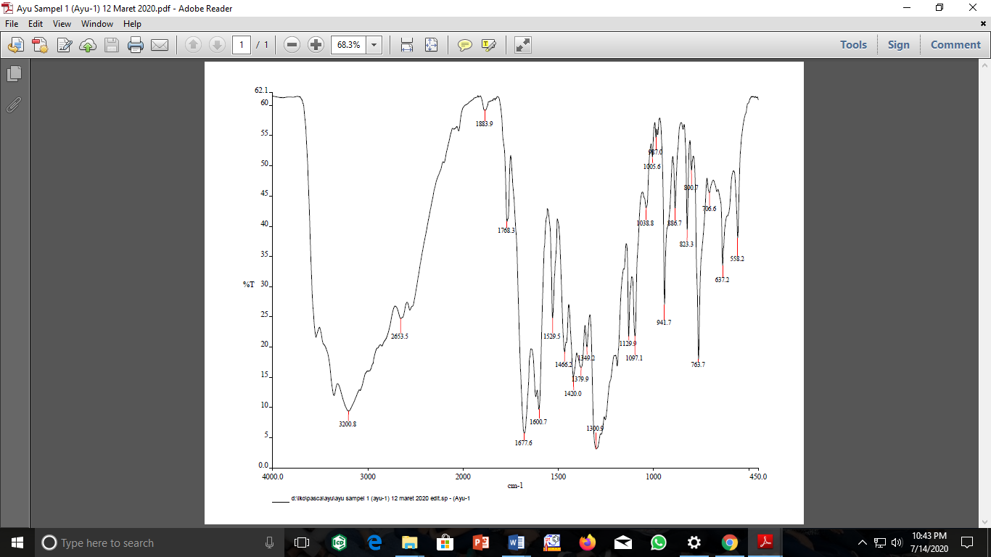
Supplementary Material 1 IR spectrum for compound 1.
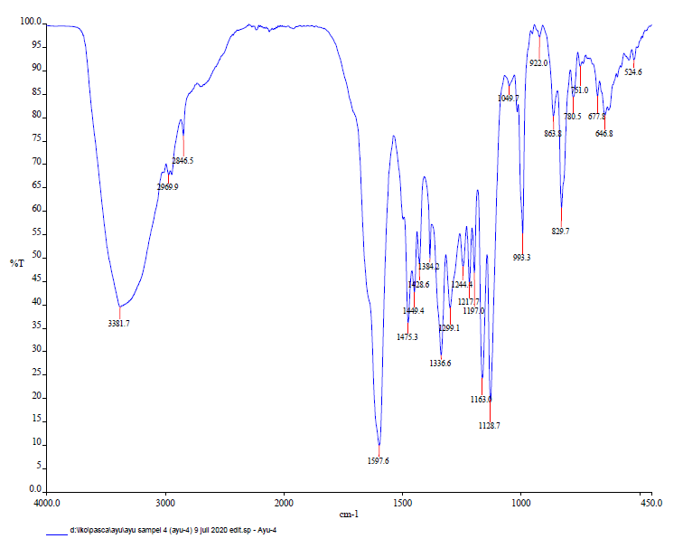
Supplementary Material 2 IR spectrum for compound 2.

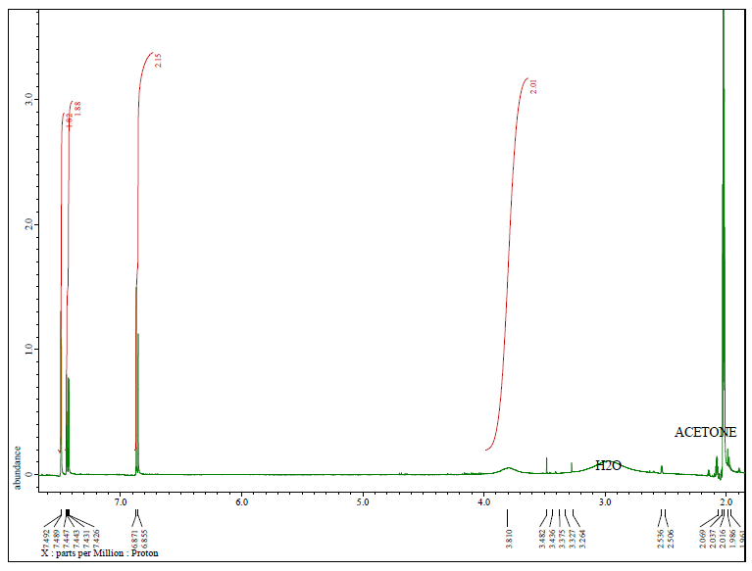
Supplementary Material 3 ¹H-NMR spectrum for compound 1.
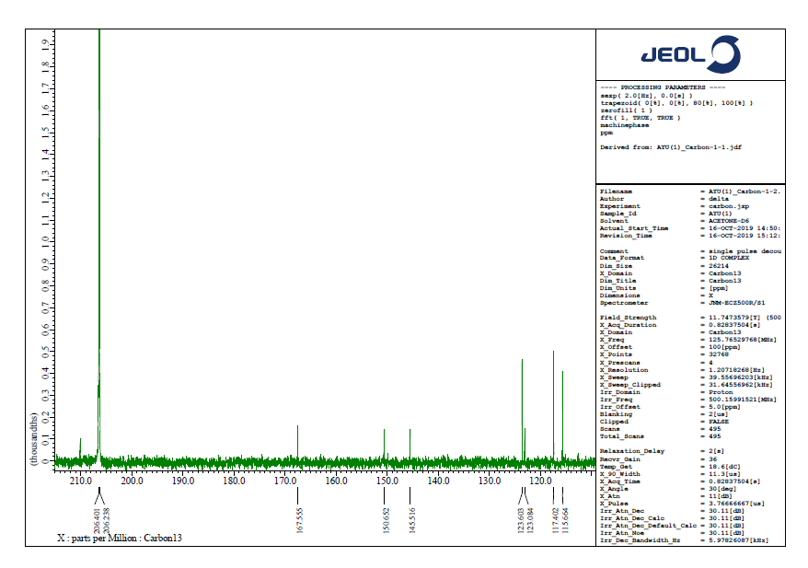
Supplementary Material 4 ¹³C-NMR spectrum for compound 1.
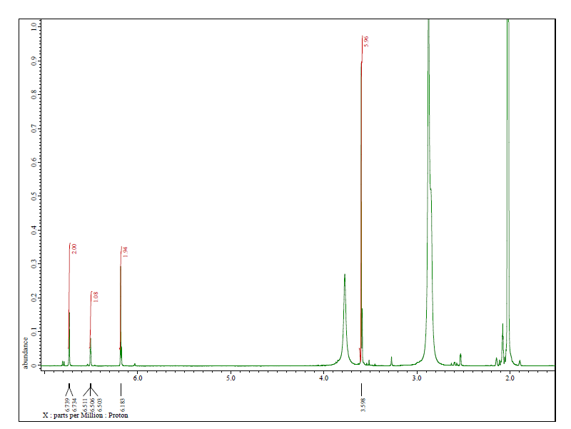
Supplementary Material 5 ¹H-NMR spectrum for compound 2.

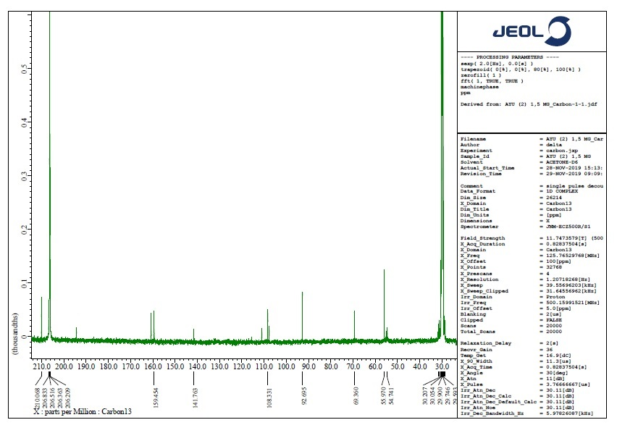
Supplementary Material 6 ¹³C-NMR spectrum for compound 2.

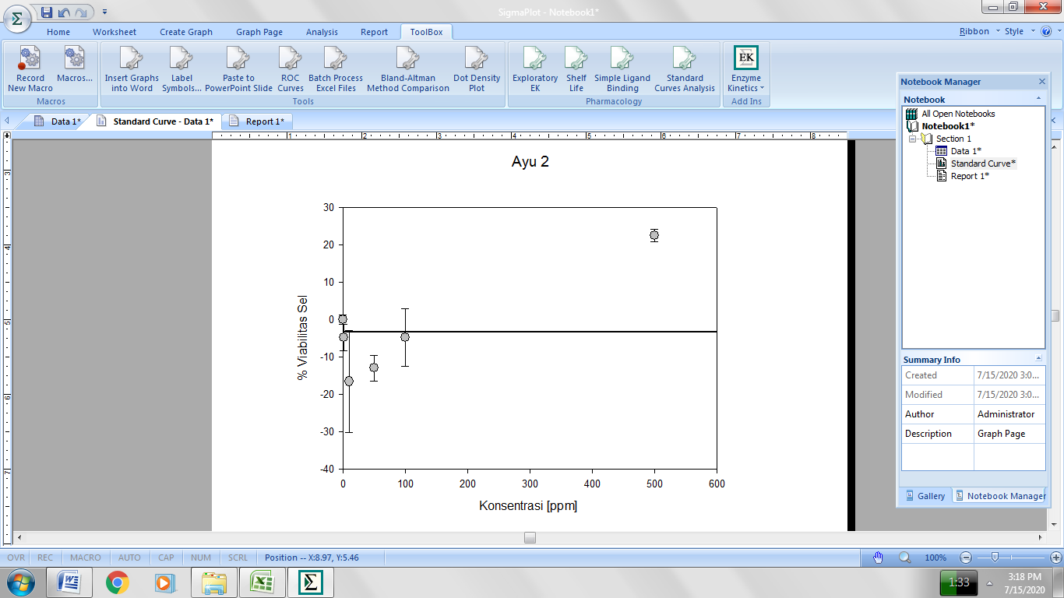
Compound 1
% Cell viability
Concentration (ppm)
Supplementary Material 7 The IC50 value of Compound 1, depsidone, against MCF-7 cell lines.
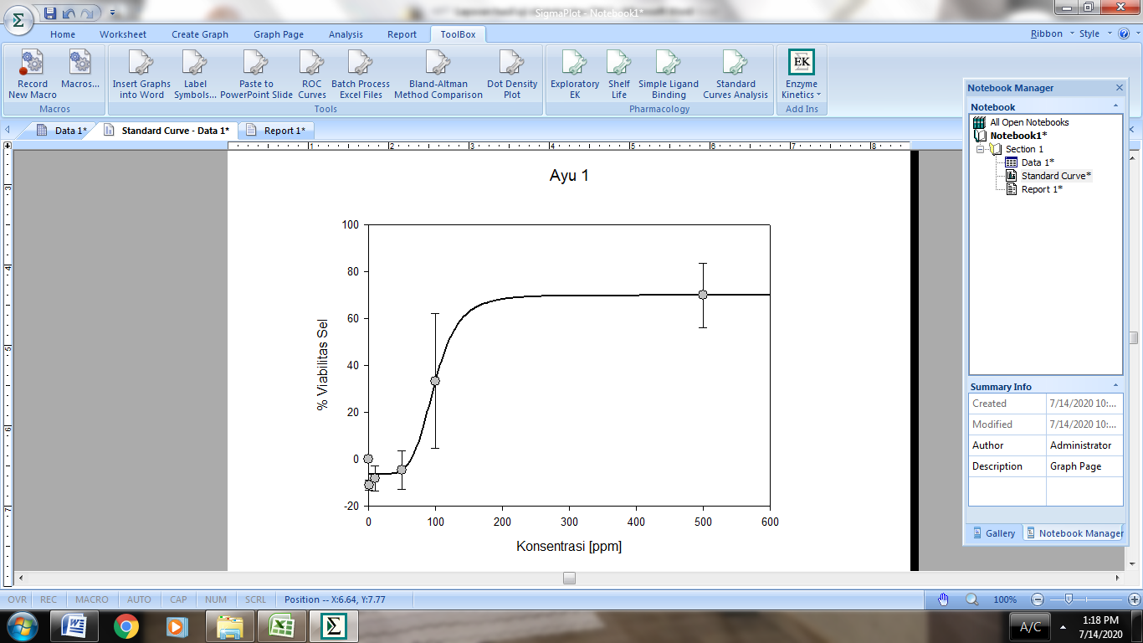
% Cell viability
Compound 2
Concentration (ppm)
Supplementary Material 8 The IC50 value of Compound 2, benzophenone, against MCF-7 cell lines.
% Cell viability
Concentration (ppm)
Supplementary Material 9 The IC50 value of doxorubicin against MCF-7 cell lines.

