Supplementary materials

Table S1. Sequences of primers for RT-PCR
Gene | Forward sequence | Reverse sequence
GRP78 | CATCACGCCGTCCTATGTCG | CGTCAAAGACCGTGTTCTCG
EDEM | CGGACGAGTACGAGAAGCG | CGTAGCCAAAGACGAACATGC
GADD34 | ATGATGGCATGTATGGTGAGC | AACCTTGCAGTGTCCTTATCAG
CHOP | GAACGGCTCAAGCAGGAAATC | TTCACCATTCGGTCAATCAGAG
XBP1s | GAGTCCGCAGCAGGTG | GTGTCAGAGTCCATGGGA
ATF4 | CCCTTCACCTTCTTACAACCTC | TGCCCAGCTCTAAACTAAAGGA
TBP | CCACTCACAGACTCTCACAACTG | CTGCGGTACAATCCCAGAACT

Table S2. Antibodies for WB or immunohistology
Antibody | Purpose | Company | Cat# | Dilution ratio
anti-Ubiquitin | WB/IHC | Proteintech, USA | 10201-2-AP | 1:1000/1:200
anti-GRP78 | WB | Proteintech, USA | 11587-1-AP | 1:1000
anti-caspase 12 | WB | Proteintech, USA | 55238-1-AP | 1:1000
anti-cleaved caspase 3(Asp175) | WB/IF | CST, USA | #9661 | 1:1000/1:400
anti-alpha tubulin | WB | Proteintech, USA | 66031-1-Ig | 1:20000
HRP-conjugated goat anti-rabbit | WB/IHC | Weiao, China | WB0177 | 1:10000/1:200
HRP-conjugated goat anti-mouse | WB | Weiao, China | WB0176 | 1:10000
FITC-goat anti-rabbit | IF | Weiao, China | WH1116 | 1：100
Anti-Ki67 | IHC | Proteintech, USA | 27309-1-AP | 1:10000
WB, Western blot; IHC, immunohistochemistry; IF, immunofluorescence.

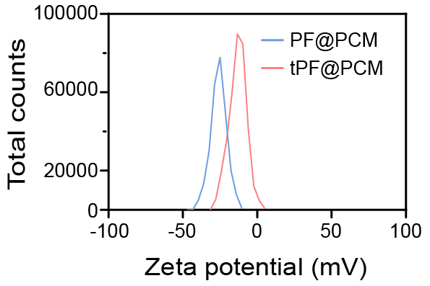
Figure S1 Zeta potentials of PF@PCM and tPF@PCM in distilled water.

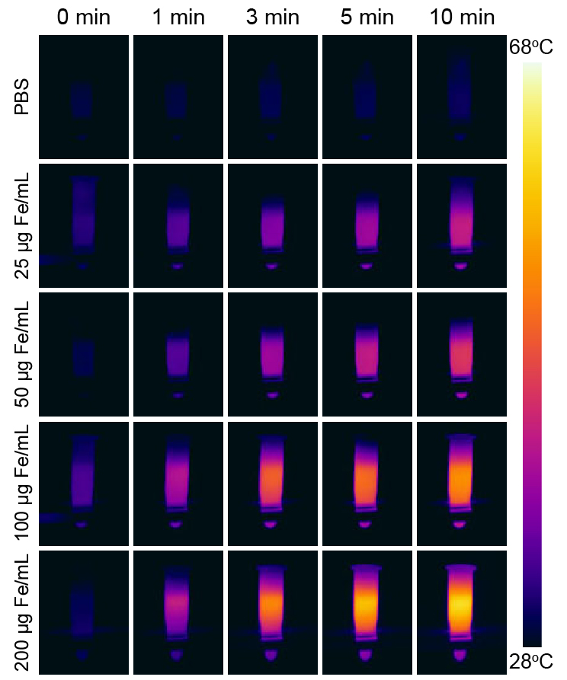
Figure S2 Thermal imaging of tPF@PCM suspension (0-200 μg Fe/mL) under 808 nm laser irradiation (1.6 W/cm², 10 min).

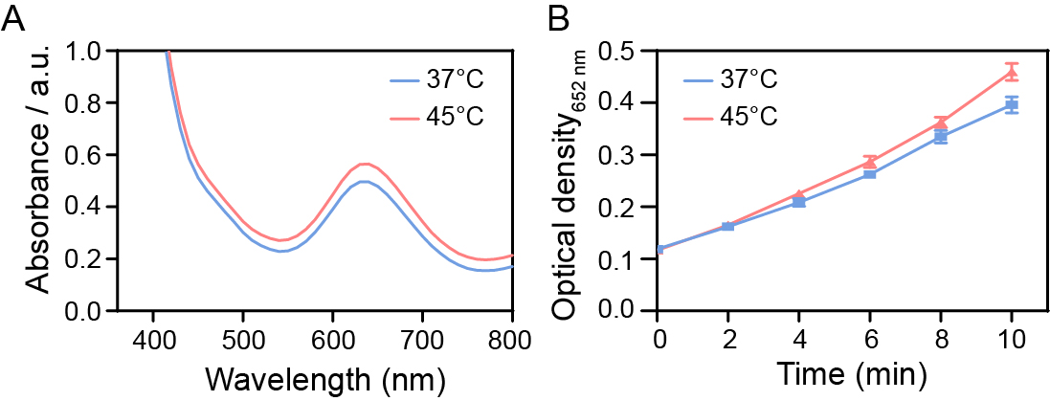
Figure S3 (A) POD-like activity of bare Fe₃O₄ NPs at 37°C and 45°C maintained by laser irradiation for 10 min. (B) Time-dependent absorbance variation at 652 nm at different temperatures. Error bar, mean ± SEM.

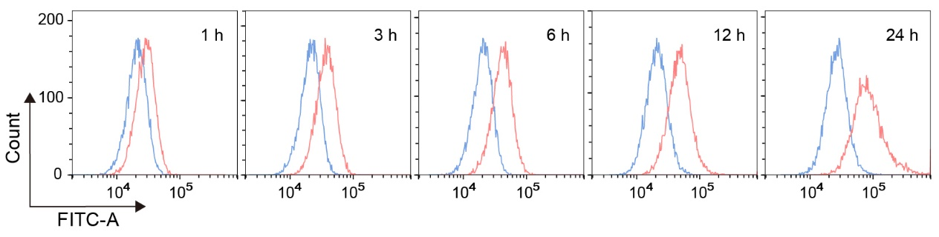
Figure S4 Cellular uptake of FITC-labeled PF@PCM (50 μg Fe/mL, blue lines) and tPF@PCM (50 μg Fe/mL, red lines) at different time intervals determined by flow cytometry.

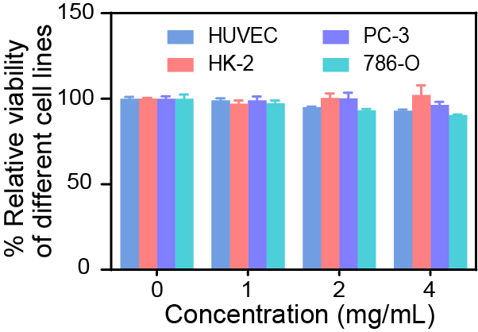
Figure S5 Cytotoxicity evaluation of empty PCM vehicles against HUVEC, HK-2, PC-3, and 786-O cells at different concentrations (0-4 mg/mL) for 48 h.

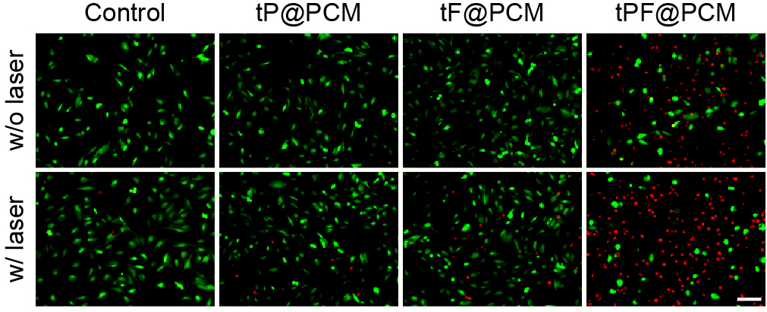
Figure S6 Live/dead cell staining of 786-O cells after different treatments by Calcein-AM/7-AAD double staining kit. Green fluorescence represents live cells while red fluorescence indicates dead cells. Scale bar is 100 μm.

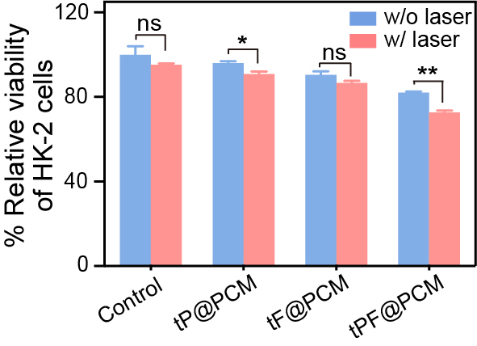
Figure S7 Cytotoxicity evaluation of tP@PCM, tF@PCM, and tPF@PCM (5 μM for PR-619 and 150 μg Fe/mL for Fe₃O₄ NPs) against HK-2 cells with or without laser irradiation. *P < 0.05; **P < 0.01; ns = P ≥ 0.05.

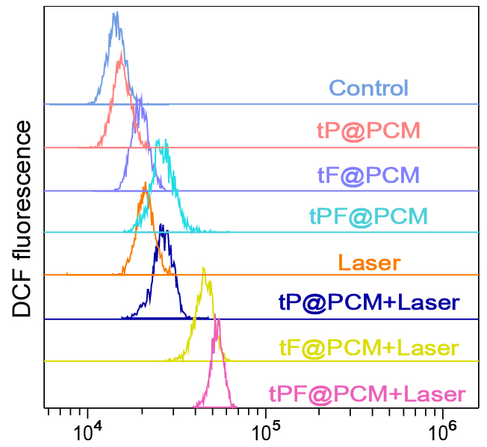
Figure S8 Quantification of intracellular ROS levels in 786-O cells after different treatments by flow cytometry.

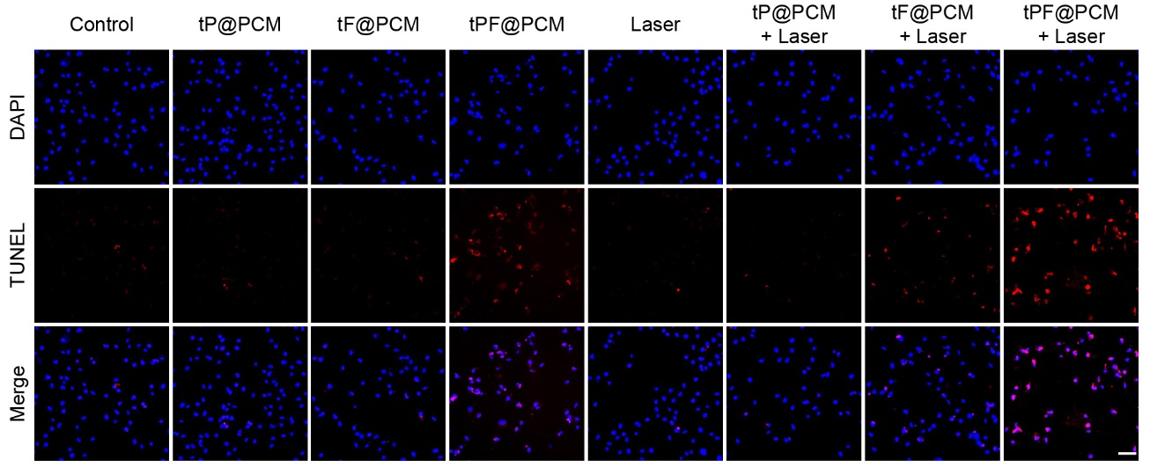
Figure S9 TUNEL staining images of 786-O cells after different treatments. Nuclei were stained with DAPI (blue), and apoptotic cells were stained with TUNEL (red). Scale bar is 100 μm.
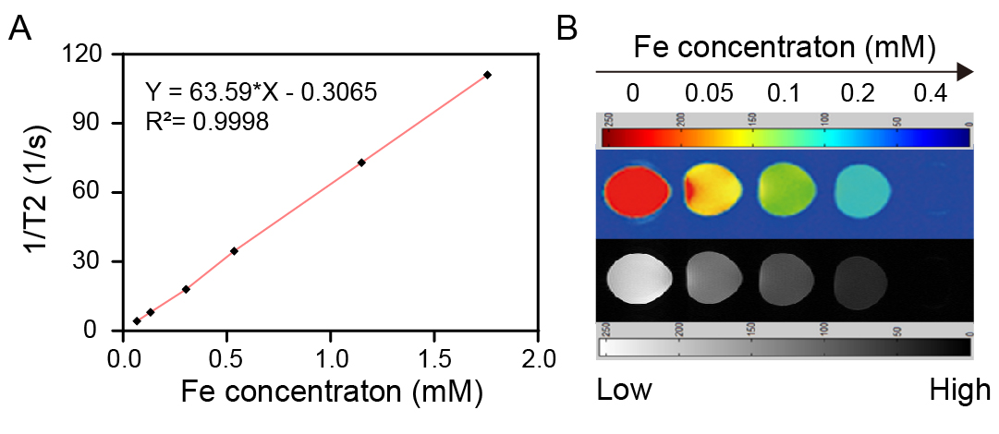
Figure S10 (A) T2 relaxation rate plotted as a function of various Fe concentrations of tPF@PCM (0-2.0 mM). (B) T2-weighted MR images of tPF@PCM with different concentrations of Fe (0-0.4 mM).

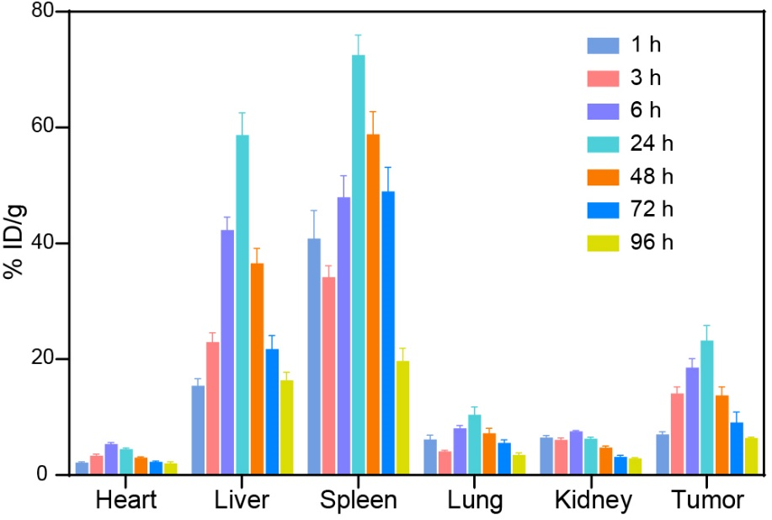
Figure S11 Biodistribution of Fe in major organs and tumor in 786-O tumor-bearing mice measured by AAS after 1, 3, 6, 24, 48, 72, and 96 h post-injection of 15 mg Fe/kg BW of tPF@PCM via the tail vein.

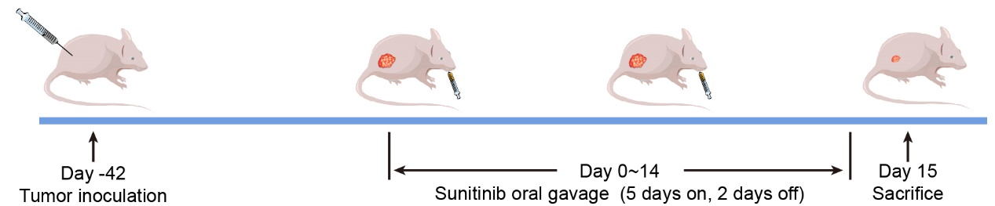
Figure S12 Schematic of the treatment regimen for 786-O tumor-bearing mice receiving sunitinib treatment. Sunitinib was treated at 20 mg/kg BW by oral gavage on a 5-day-on/2-day-off cycle for two cycles.

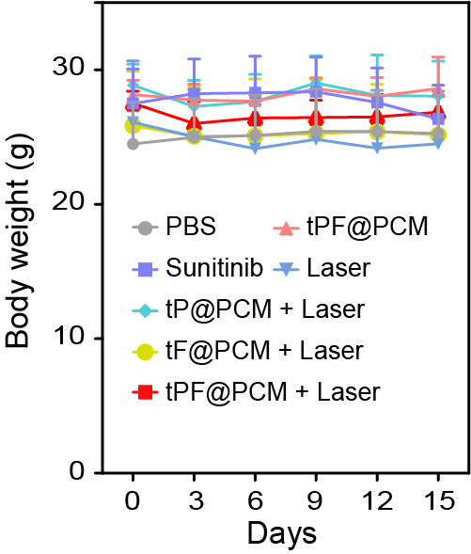
Figure S13 Body weight changes of 786-O tumor-bearing mice in each group measured for 15 days post-treatment.

