Supplemental Figure 1: ROC curve and accordingly Kaplan-Meier curves with corresponding HCO3⁻ cut-off value. A and B: 30-day ROC curve and KM survival curve; C and D: 90-day ROC curve and KM survival curve; E and F:1-year ROC curve and KM survival curve; G and H:5-year ROC curve and KM survival curve.
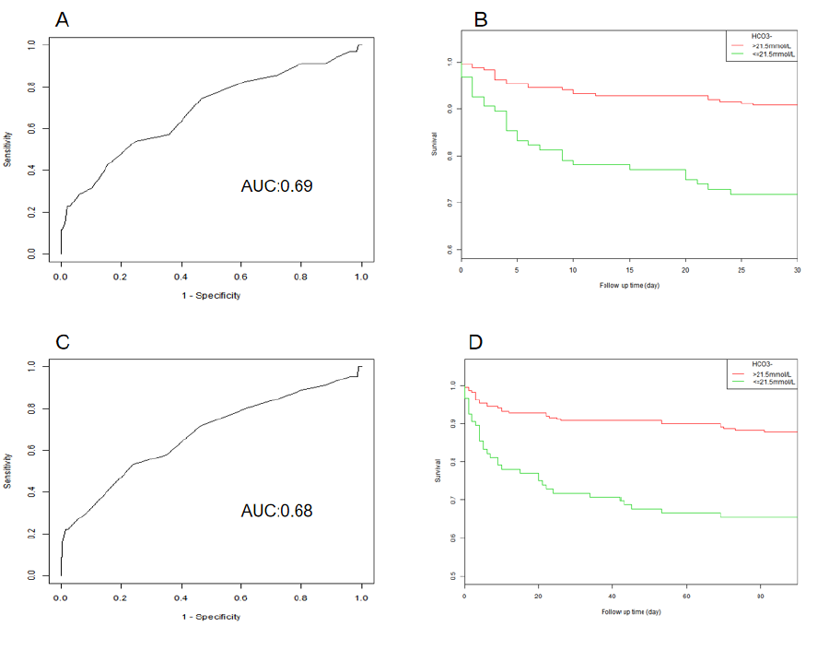
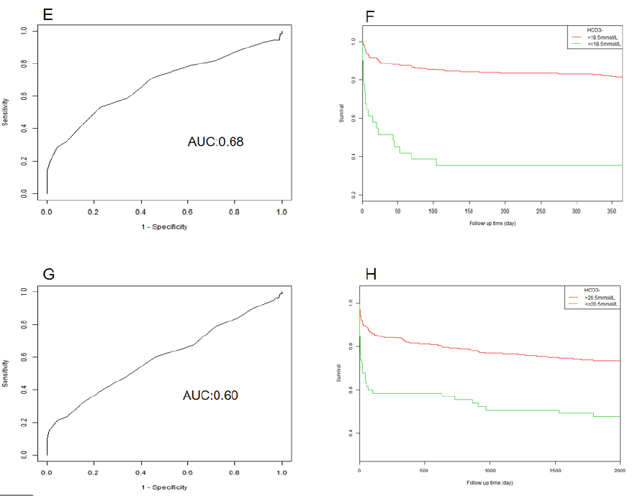

Supplemental Figure 2: The ROC curve of HCO3⁻, aniongap and lactate in predicting 1-year mortality of AAD.

Supplemental table 1: HRs (95% CIs) for mortality across groups of serum HCO3⁻ in type A AAD and type B AAD.
Serum HCO3⁻ level | Non-adjusted |  | Model 1 |  | Model 2
Serum HCO3⁻ level | HR (95%CIs) | P value | HR (95%CIs) | P value | HR (95%CIs) | P value
Type A AAD  30-day mortality  HCO3⁻, mmol/L  <22 mmol/L  22-24 mmol/L  >24 mmol/L  - day mortality  HCO3⁻, mmol/L  <22 mmol/L  22-24 mmol/L  >24 mmol/L  - year mortality  HCO3⁻,mmol/L  <22 mmol/L  22-24 mmol/L  >24 mmol/L  - year mortality  HCO3⁻, mmol/L  <22 mmol/L  22-24 mmol/L  >24 mmol/L  Type B AAD  30-day mortality  HCO3⁻, mmol/L  <22 mmol/L  22-24 mmol/L  >24 mmol/L  90-day mortality  HCO3⁻, mmol/L  <22 mmol/L  22-24 mmol/L  >24 mmol/L  1-year mortality  HCO3⁻,mmol/L  <22 mmol/L  22-24 mmol/L  >24 mmol/L  5-year mortality  HCO3⁻, mmol/L  <22 mmol/L  22-24 mmol/L  >24 mmol/L | 8.50 (1.05, 16.26)  1.0(ref)  0.95 (0.06, 16.29)  6.25 (1.60, 12.16)  1.0(ref)  2.00 (0.17, 23.96)  5.25(1.01, 11.25)  1.0(ref)  1.33(0.26, 6.88)  3.04(1.27, 5.26)  1.0(ref)  1.13(0.70, 1.84)  2.27 (1.17, 5.94)  1.0(ref)  0.65 (0.20, 2.09)  2.62(1.06, 6.51)  1.0(ref)  0.95 (0.34, 2.65)  2.26(1.89, 5.34)  1.0(ref)  1.10(0.41, 2.93)  2.27 (1.58, 5.91)  1.0(ref)  1.51(0.70, 3.27) | 0.046  /  0.972  0.017  /  0.584  0.048  /  0.731  0.003  /  0.617  0.021  /  0.467  0.037  /  0.927  0.042  /  0.849  0.033  /  0.216 | 7.85 (1.06, 15.33)  1.0(ref)  1.00 (0.04, 22.70)  6.81(1.73, 14.54)  1.0(ref)  2.63(0.16, 42.06)  7.95(1.02, 12.85)  1.0(ref)  1.22(0.20, 7.66)  2.99(1.24, 6.20)  1.0(ref)  1.10(0.67, 1.80)  2.15 (1.24, 5.81)  1.0(ref)  0.56 (0.16, 1.94)  2.44 (1.73, 6.23)  1.0(ref)  0.86(0.29, 2.55)  2.28(1.30, 5.28)  1.0(ref)  1.12(0.41, 2.93)  2.36(1.17, 5.19)  1.0(ref)  1.67(0.74, 3.78) | 0.045  /  0.998  0.017  /  0.493  0.048  /  0.829  0.004  /  0.700  0.034  /  0.363  0.042  /  0.791  0.040  /  0.720  0.003  /  0.084 | 7.17 (1.31,15.68)  1.0(ref)  0.98(0.29, 3.10)  6.76 (1.86, 9.37)  1.0(ref)  1.05(0.59, 3.23)  5.88 (1.38, 7.38)  1.0(ref)  1.58(0.49, 2.15)  3.69 (1.64, 6.72)  1.0(ref)  1.37 (0.58, 2.56)  2.27 (1.31,4.68)  1.0(ref)  0.68(0.07, 7.00)  2.46 (1.56, 14.44)  1.0(ref)  0.72(0.09, 577)  2.80(1.40, 6.25)  1.0(ref)  0.68(0.09, 5.47)  3.05(2.30, 5.69)  1.0(ref)  4.15(0.83, 20.89) | 0.038  /  0.712  0.005  /  0.380  0.005  /  0.312  0.004  /  0.899  0.039  /  0.748  0.040  /  0.756  0.031  /  0.294  0.004  /  0.899
Models were derived from Cox proportional hazards regression models. Non-adjusted model adjust for: none.
Adjust model 1 adjust to: gender; age; ethnicity and insurance.
Adjust 2 model adjust to: age; gender; ethnicity; insurance; ICU MV, therapy type, hypertension; diabetes; hypercholesterolemia; valvular disease; maligancy; stroke; CAD; CHF; atrial fibrillation; renal disease; liver disease; respiratory disease; AKI; WBC; RDW; Hb; AKI; WBC; RDW; RBC; PLT; BUN; creatitine; chloride; glucose; APTT; INR; sodium; potassium; total Ca; magnesium; anion gap; pH value; SBP; DBP; MBP; HR; RR; temperature and SPO₂.

Supplemental Table 2: HRs (95% CIs) for mortality of serum HCO3⁻, aniongap and lactate.
Exposure | HCO3⁻ | Aniongap | Lactate
 | HR (95% CI)  P value | HR (95% CI)  P value | HR (95% CI)  P value
30-day mortality | 0.81 (0.76, 0.87) <0.001 | 1.13 (1.05, 1.23) 0.002 | 1.02 (1.01, 1.04) 0.005
90-day mortality | 0.82 (0.77, 0.87) <0.001 | 1.14 (1.07, 1.23) <0.001 | 1.03 (1.01, 1.04) <0.001
1-year mortality | 0.84 (0.79, 0.89) <0.001 | 1.14 (1.07, 1.22) <0.001 | 1.02 (1.01, 1.04) <0.001
5-year mortality | 0.88 (0.83, 0.93) <0.001 | 1.10 (1.04, 1.17) 0.001 | 1.02 (1.01, 1.03) 0.003

