Table S1. Survival outcomes of T3N0M0 and T4N0M0 NPC patients.
Treatment outcomes | CCRT | IC+CCRT | P-values
T3N0M0 | n = 151 | n = 92
5-year LRFFS | 96.6% | 88.6% | 0.006
5-year DMFS | 96.0% | 92.1% | 0.204
5-year DFS | 92.7% | 81.0% | 0.002
5-year OS | 96.7% | 89.5% | 0.010
T4N0M0 | n = 65 | n = 54
5-year LRFFS | 85.5% | 85.2% | 0.908
5-year DMFS | 84.2% | 92.3% | 0.348
5-year DFS | 73.8% | 81.5% | 0.495
5-year OS | 86.0% | 83.3% | 0.978
Abbreviations: IC=introduction chemotherapy, CCRT=concurrent chemoradiotherapy, LRFFS=Locoregional failure-free survival, DMFS=Distant metastasis-free survival, DFS=Disease-free survival, OS=Overall survival.

Table S2. Multivariate analyses of clinical outcomes for the T4N0M0 subgroup.
 | HRs (95% CI) | P-values
T4N0M0 subgroup analyses: LRFFS
Gender (Female vs. Male) | 0.84 (0.30 ~ 2.38) | 0.747
Age (per year increase) | 0.99 (0.95 ~ 1.03) | 0.703
KPS (90-100 vs.70-80) | 1.99 (0.71 ~ 5.61) | 0.192
Treatment (IC+CCRT vs. CCRT) | 1.14 (0.43 ~ 3.02) | 0.796
T4N0M0 subgroup analyses: DFS
Gender (Female vs. Male) | 0.90 (0.40 ~ 2.03) | 0.806
Age (per year increase) | 1.01 (0.98 ~ 1.04) | 0.746
KPS (90-100 vs.70-80) | 0.91 (0.36 ~ 2.31) | 0.847
Treatment (IC+CCRT vs. CCRT) | 0.76 (0.36 ~ 1.62) | 0.477
T4N0M0 subgroup analyses: OS
Gender (Female vs. Male) | 0.77 (0.32 ~ 1.85) | 0.555
Age (per year increase) | 1.01 (0.97 ~ 1.04) | 0.673
KPS (90-100 vs.70-80) | 1.09 (0.39 ~ 3.03) | 0.875
Treatment (IC+CCRT vs. CCRT) | 0.99 (0.44 ~ 2.30) | 0.999
Abbreviations: KPS=Karnofsky performance status score, LRFFS=locoregional failure-free survival, DFS=disease-free survival, OS=overall survival, IC=introduction chemotherapy, CCRT=concurrent chemoradiotherapy, HR=hazard ratios, CI=confidence interval.

Figure S1. Workflow diagram showing the collection process of patients. Abbreviations: NPC=nasopharyngeal carcinoma, RT=radiotherapy.
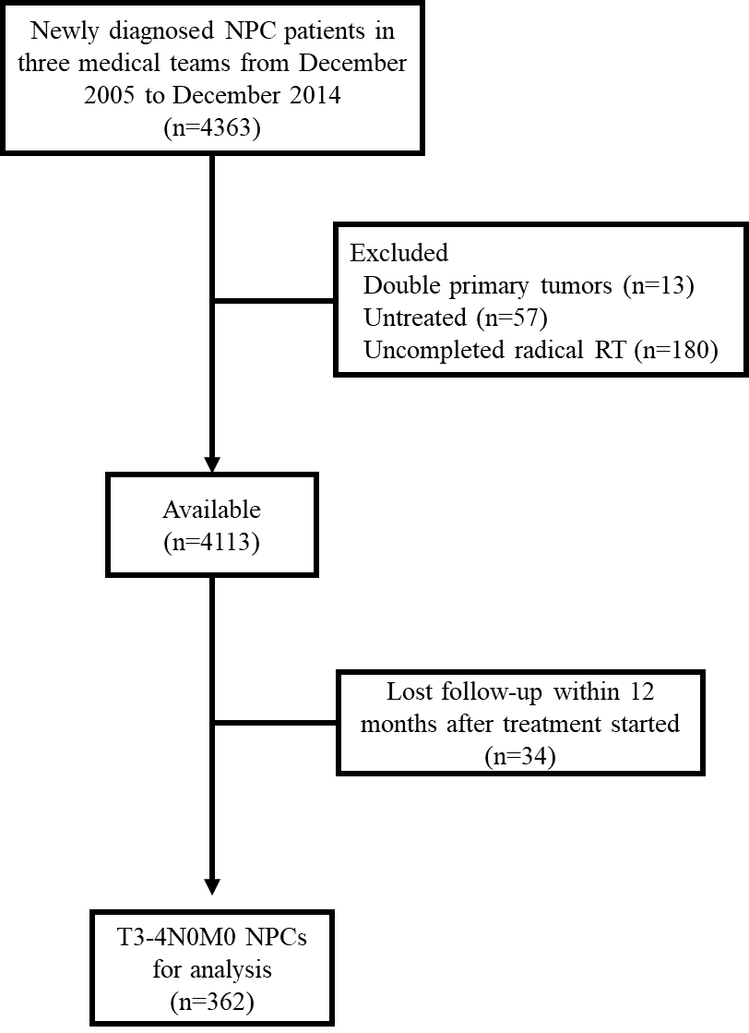

Figure S2. Kaplan–Meier estimates for the T4N0M0 subgroup: (A) Locoregional failure-free survival, (B) Distant metastasis-free survival, (C) Disease-free survival, (D) Overall survival. Abbreviations: IC=introduction chemotherapy, CCRT=concurrent chemoradiotherapy.

