Supporting information
Figure S1 Synthesis pathway of DPSE-PEG_{2k}-iRGD.

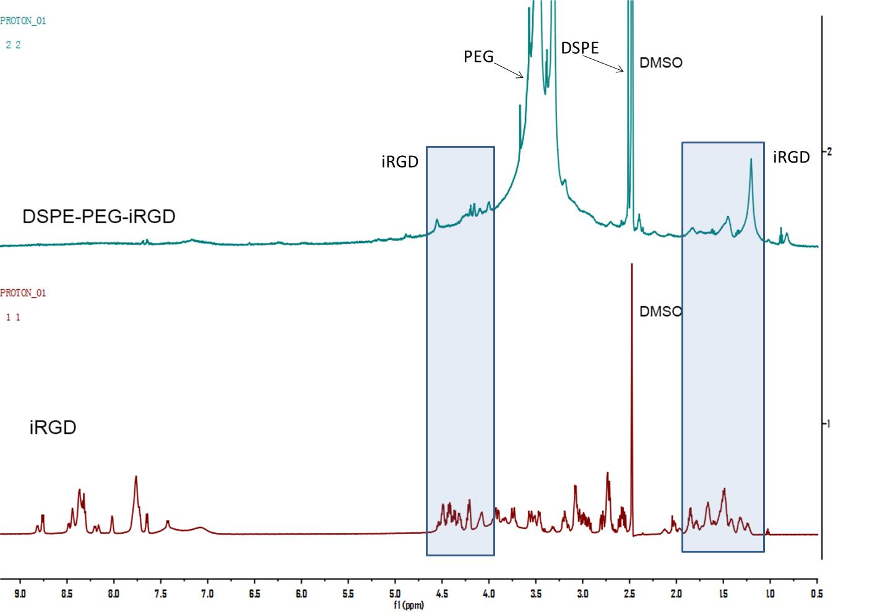
Figure S2 ¹H-NMR spectra of DPSE-PEG-iRGD and iRGD.
Figure S3 MALDI-TOF spectra of DPSE-PEG-iRGD.

Figure S4 The insertion amount and efficiency of DPSE-PEG-iRGD into RM.

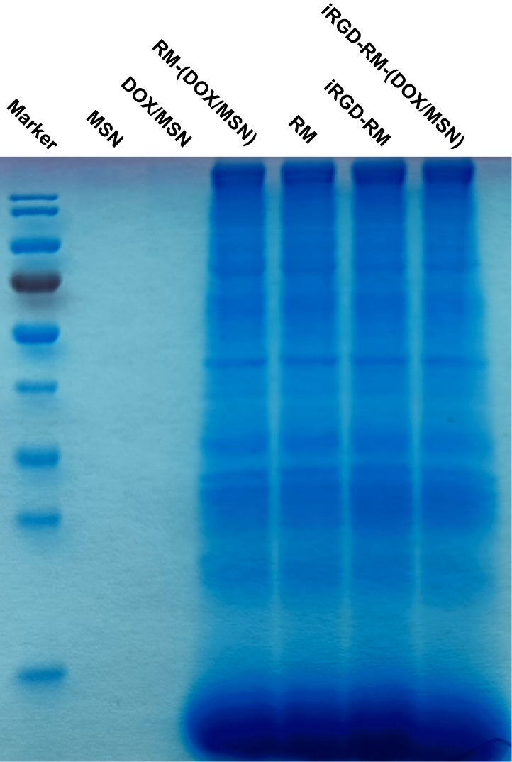
Figure S5 The composition of proteins on the surface of nanoparticles by SDS-PAGE.

Figure S6 Characterization of RM-(DOX/MSN) and iRGD-RM-(DOX/MSN). (A) N2 adsorption/desorption isotherm curves and (B) pore diameter.

Figure S7 Adsorption of plasma proteins by MSN, RM-MSN and iRGD-RM-MSN.

Figure S8 In vivo fluorescence imaging of various formulations in mice. (A) Whole body images of the tumor-bearing mice. (B) Fluorescence images of the excised tumors at 24 h post-injection of the formulations.
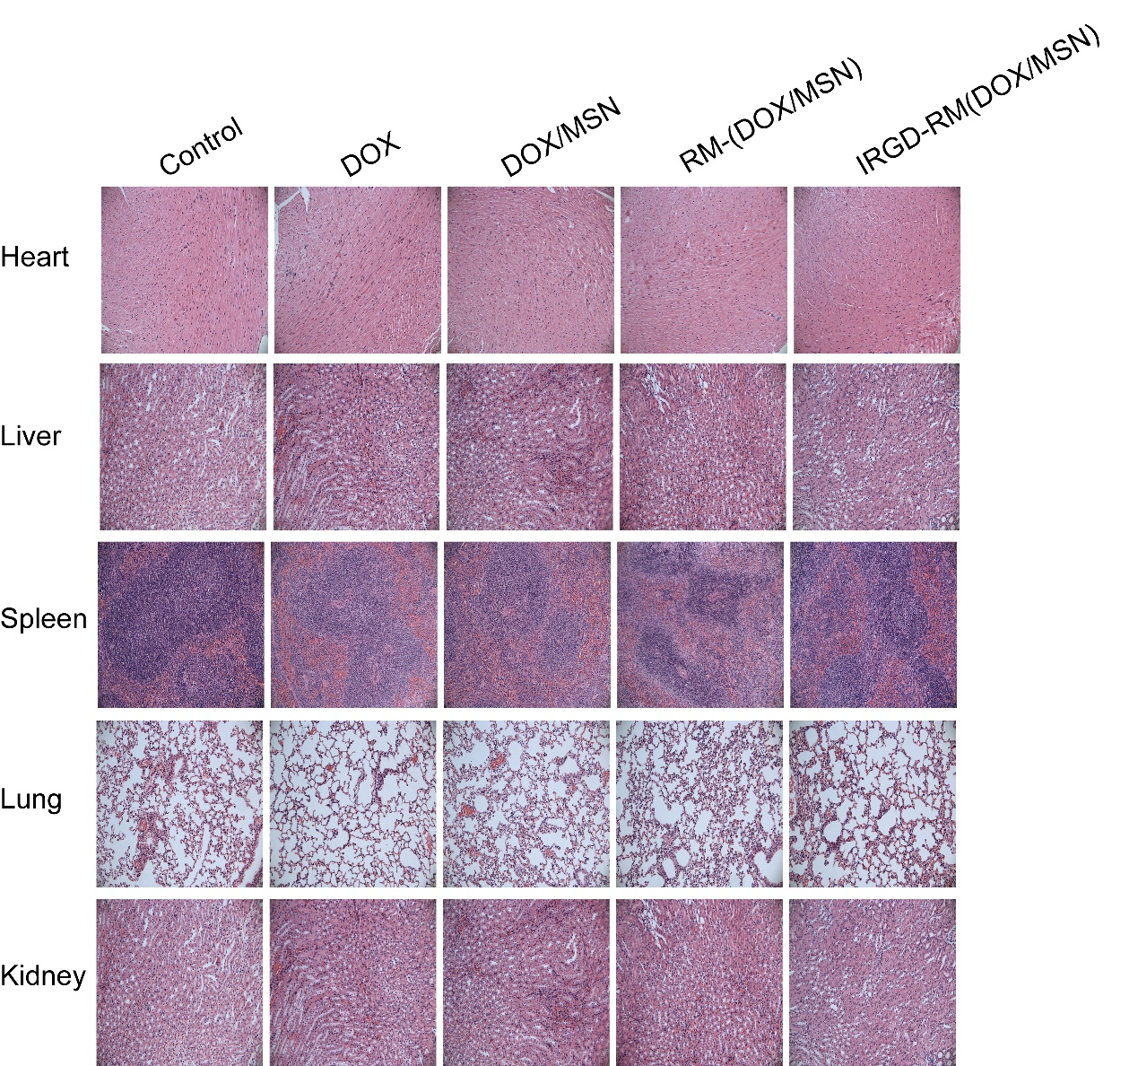
Figure S9 H&E staining of the heart, liver, spleen, lung and kidney after treatment with different nanoparticle formulations.

