Table S1. Genomic features of the P. stutzeri ZDHY95
features | chromosome | pZDHY95-VIM-2
Total number of bases (bp) | 4,500,524 | 88,056
G+C content (%) | 64.1 | 57
No. of protein-coding sequences | 4222 | 91
No. of tRNA genes | 61 | 0
Accessory modules | In1998, ISPst5, ISPpu22, ISPsy43, ISStma11, ISXc4, TnXax1 | In1722, Tn5563, ISAzs36, ISPst9, IS481,ISPpu30
Accession numbers | CP063358 | CP063359

Table S2. Mobile Genetic Elements of P. stutzeri ZDHY95
Genome | Mobile genetic elements | Length(bp) | Coordinates
Chromosome | ISPst5 | 341 | 3028537..3028878
Chromosome | ISPpu22 | 863 | 3030850..3031713
Chromosome | ISPsy43 | 2021 | 3087484..3089505
Chromosome | In1998 | 8183 | 3567667..3575859
Chromosome | ISStma11 | 398 | 3593886..3594284
Chromosome | ISXc4 | 470 | 3595230..3595700
Chromosome | ISXc4 | 2462 | 3595761..3598223
Chromosome | TnXax1 | 1298 | 3922041..3923339
pZDHY95-VIM-2 | ISPpu30 | 497 | 42396..42893
pZDHY95-VIM-2 | ISPst9 | 1370 | 43831..45201
pZDHY95-VIM-2 | ISAzs36 | 971 | 55370..56341
pZDHY95-VIM-2 | IS481 | 1661 | 56331..57992
pZDHY95-VIM-2 | In1722 | 3279 | 58848.. 62127
pZDHY95-VIM-2 | Tn5563 | 6253 | 71164.. 77404
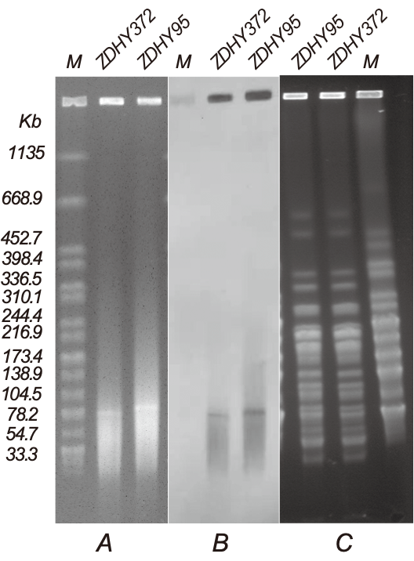
Figure S1. Plasmid profiles and homology analysis of P. stutzeri ZDHY95 and ZDHY372 (A) Plasmid size determination by S1-PFGE, with Salmonella enterica serotype Braenderup H9812 as the size marker. (B) Southern blotting hybridisation with bla_{VIM}-specific probe and color development. (C) Homology analysis of P. stutzeri ZDHY95 and ZDHY372 by PFGE.

