Supplementary Material

Supplementary Table 1 Example Quotes from Patients Treated with Dupilumab Compared with Placebo

Dupilumab
- The treatment helped my quality of life so much I can’t complain.
- I’ve observed a large improvement with the treatment. My senses of smell and taste have come back, no more pressure in my forehead, no more sleepless nights and no fatigue. Also no more runny nose compared to before the study, when it would sometimes drag on for 2 to 3 hours. The polyps are not yet gone, but as things are right now, “living” is very pleasant. Treatment during the study: excellent “service” by the medical staff.
- I have never felt better. I can smell and taste better than I have in the past 10 years.
- I didn’t expect to respond so rapidly to the medication and to recover a quality of life lost 7 years ago (sense of smell and easy breathing). What I like the most is obviously having received the medication, followed by the treatment received in the hospital by the entire team which was delightful.
- “I just hope and pray that my smell and taste lasts a long time. I love being able to smell my sweet two year old and my yummy food . Thanks a million!”
Placebo
- I am satisfied with the operation of the staff. I hope that if the medicine comes on the market that I will be eligible for it, because this disorder has a serious effect on normal functioning.
- My sense of smell seemed to be noticeably at its best shortly after getting the shots, but it was still unpredictable and would disappear regularly. My ability to breathe through my nose was consistently better than it has been in a while…again, with occasional and unpredictable occurrences and runny/stuffy periods.
- The treatment was very good, in particular all the professionals who perform it: physician, nurse, technicians who do the tests. The security you feel at all times when you’re in contact with a center (and the professionals) who provide support to the very difficult situation of polyposis (headache, loss of the sense of smell).
- I am very satisfied with how the study went. Clear appointments and good cooperation.
- It didn’t work for me I’m the same. What I liked is that they monitor you closely and they’re very friendly.

Supplementary Table 2 LS Mean Difference vs Placebo (95% CI) at Week 16 in SNOT-22, UPSIT, and Loss of Smell Score

 | Patients who completed  the SAT  (N=16 placebo/MFNS;  N=21 dupilumab/MFNS) |  |  | Patients who did not  complete the SAT  (N=14 placebo/MFNS;  N=9 dupilumab/MFNS)
SNOT-22 total score | –20.75  (–29.64, –11.85) | p < 0.0001 |  | –11.69  (–27.08, 3.70) | p = 0.1278
Smell test (UPSIT) | 14.50  (9.61, 19.39) | p < 0.0001 |  | 13.28  (6.14, 20.42) | p = 0.0012
Loss of smell score | –1.35  (–1.94, –0.77) | p < 0.0001 |  | –1.11  (–1.91, –0.31) | p = 0.0093
CI, confidence interval; LS, least squares; MFNS, mometasone furoate nasal spray; SNOT-22, 22-item Sino-Nasal Outcome Test; UPSIT, University of Pennsylvania Smell Identification Test.

Supplementary Figure 1 Word Clouds in the Overall Cohort of Patients Who Completed a Self-Assessment Tool

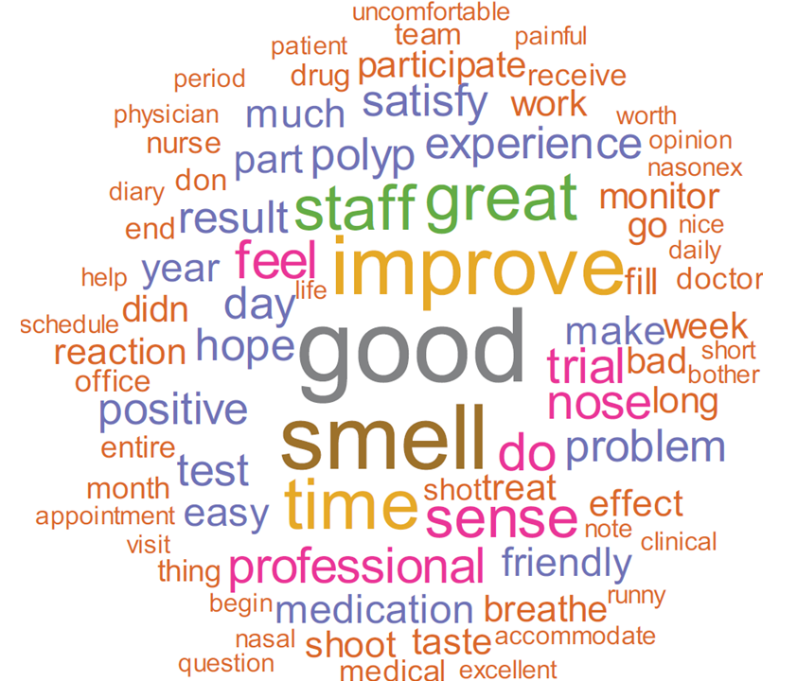

Only words that occur twice or more are shown. Stop words and the words “study” and “treatment” are omitted.
Supplementary Figure 2 Change from Baseline at Week 16 for (A) SNOT-22, (B) UPSIT, (C) Loss of Smell in Patients Completing the Self-Assessment Tool
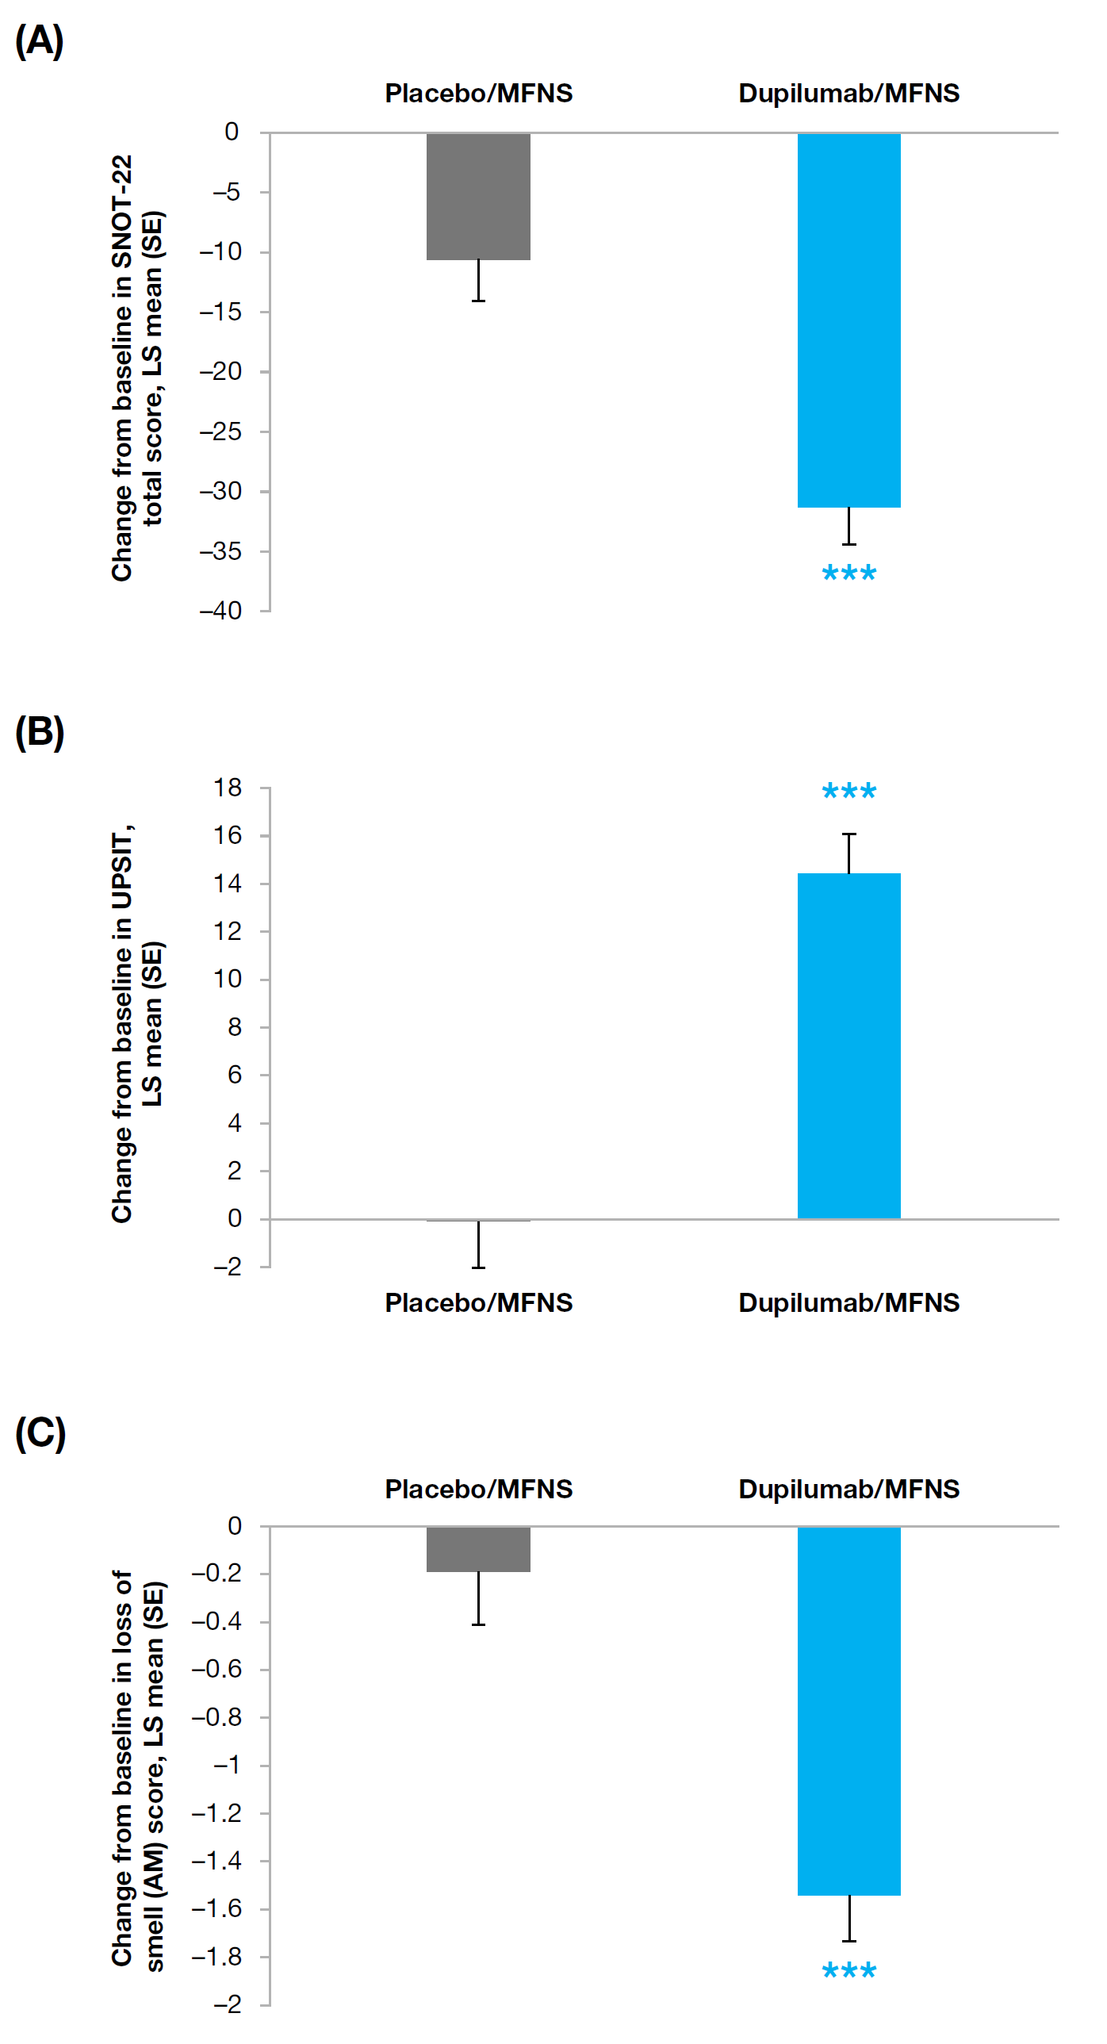
*** p < 0.0001
Abbreviations: AM, denotes morning; LS, least squares; MFNS, mometasone furoate nasal spray; SE, standard error; SNOT-22, 22-item Sino-Nasal Outcome Test; UPSIT, University of Pennsylvania Smell Identification Test.

