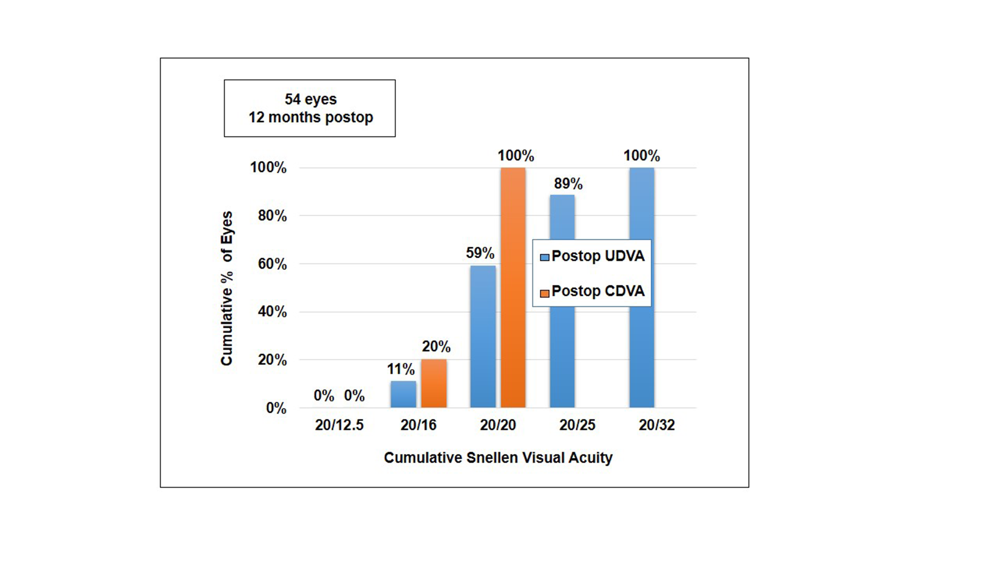Supplementary file 1: Histogram showing uniocular results for UDVA(n=54 eyes) and CDVA obtained following implantation of Optiflex trio trifocal IOL at 12 months post-operatively

Supplementary file 2: Histogram showing change in Snellen’s lines of post-operative UDVA versus CDVA at 12 months post-op.
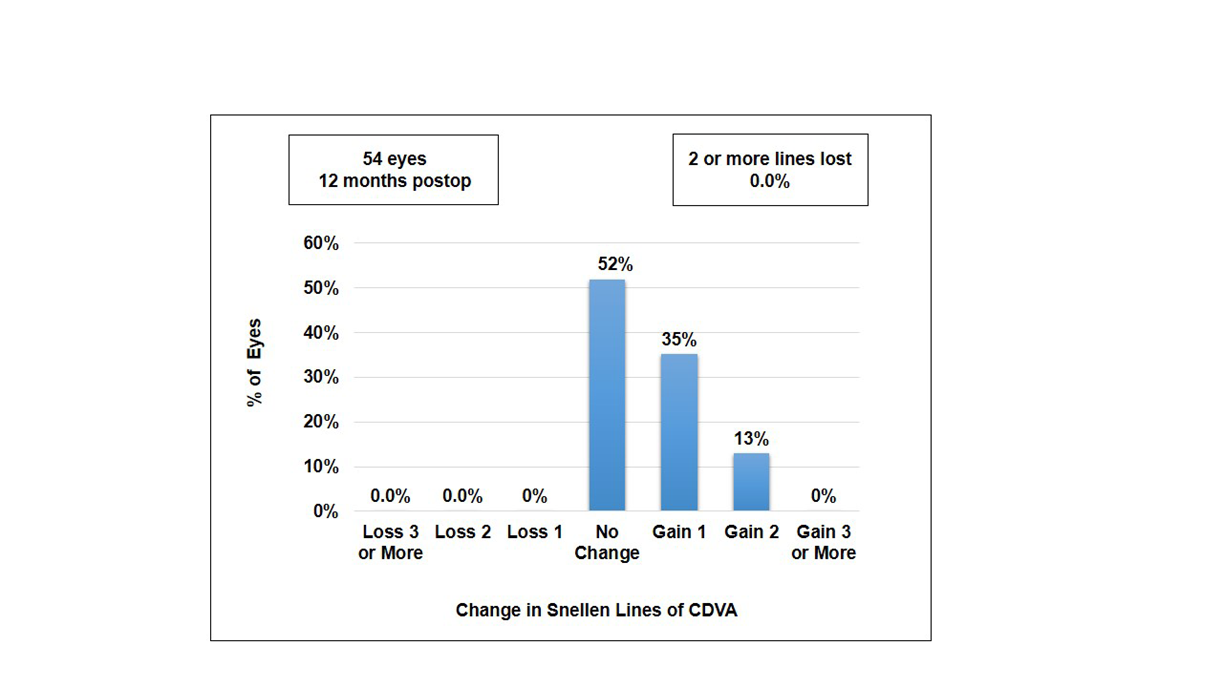

Supplementary file 3: Quality of vision (QOV) and patient satisfaction scores obtained at 3, 6 and 12 months post-op.
 | 3 months | 6 months | 12 months | p-value
DYSPHOTOPSIA SYMPTOMS (0-10)
[0-2 MILD, 3-7 MODERATE 8-10 SEVERE]
 | 3.11±0.43 | 1.26±0.96 | 0.61±0.49 | <0.005
SPECTACLE INDEPENDENCE SCORE (0-10)
[FEEL THE NEED TO USE GLASSES]
Distance | 9.49±0.16 | 9.54±0.08 | 9.56±0.09 | 0.26
Intermediate | 9.48±0.15 | 9.53±0.07 | 9.55±0.09 | 0.25
Near | 9.19±0.36 | 9.22±0.36 | 9.25±0.36 | 0.83
OVERALL PATIENT SATISFACTION SCORE (0-100)

 | 93.88±4.66 | 94.88±4.29 | 97.07±2.23 | 0.41

