Supplementary Material

Lung inflammatory response to environmental dust exposure in mice suggests a link to regional respiratory disease risk

Burr and Velazquez, et al.

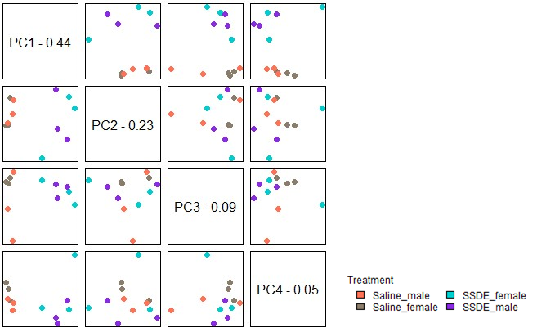

Supplemental Figure 1. Principal component analysis of overall gene expression data showing no clustering between the males and females. PCA analysis was performed by Nanostring advanced analysis module. N=3 females and n=3 males per treatment group.

