Appendix
Supplementary Table S1
Table S1. Computed tomography parameters at the participating hospitals.
 | NFH | SPH | YPH | ZCPH | ZPH
Scanner | PB | PB | PB | PB | SSDF
TV (kV) | 120 | 120 | 120 | 120 | 120
TC (mA) | 142 | 250 | 300 | 250 | 160
RT (s) | 0.75 | 0.5 | 0.75 | 0.5 | 0.5
DC (mm) | 128×0.625 | 64×0.625 | 64×0.625 | 128×0.625 | 64×0.625
FOV (mm) | 300×300 | 500×500 | 350×350 | 350×350 | 350×350
PM | 512×512 | 1024×1024 | 512×512 | 512×512 | 512×512
Reconstruction | FSH (C) | FSH (C) | FSH (C) | FST (B) | FSH (C)
ST (mm) | 5 | 5 | 2 | 5 | 2/ 5
PB: Philips Brilliance; SSDF: Siemens Somatom Definition Flash; TK: tube voltage; TC: tube current; RT: rotation time; DC: detector collimation; FOV: field of view; PM: pixel matrix; FSH: filter sharp; FST: filter Standard; ST: slice thickness;

Supplementary Figure S1
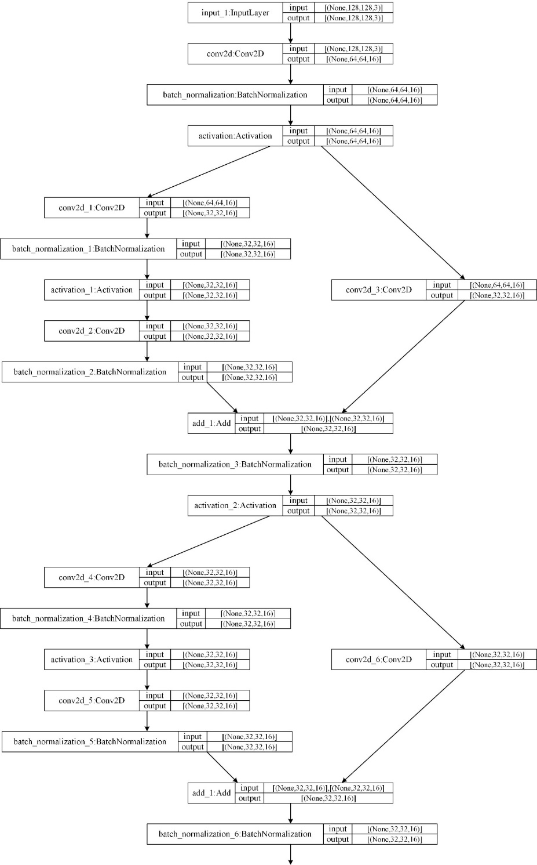

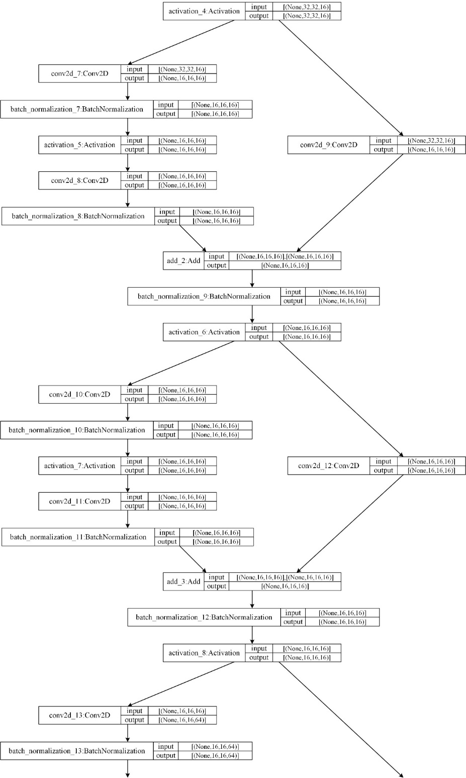
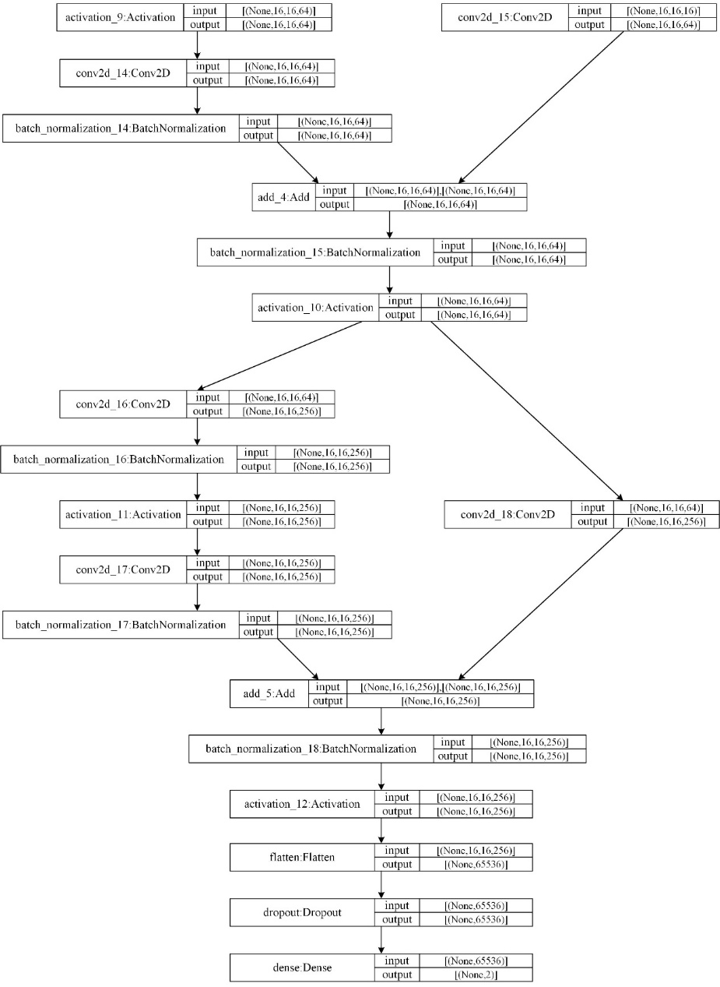

Supplementary Fig S1. Detailed structure of deep learning model for the aggressive-PD prediction
Supplementary Figure S2

Supplementary Fig S2. Sematic factors used in Model^{CS}.
(a) Hepatocellular carcinoma (HCC) with fusion lesions; (b) HCC with non-intact capsule; (c) HCC with intact capsule; and (d) HCC with nodule-in-nodule architecture.

Supplementary Table S2
Table S2. Univariate logistic regression analysis of clinical and sematic factors
Factors | OR (95% CI) | p-value
Clinical factors
Sex | 1.010 (0.687–1.483) | 0.962
Age | 0.586 (0.270–1.271) | 0.176
BCLC stage*
0 |  | Reference
A | 0.297 (0.094–0.941) | 0.399
AB | 0.506 (0.242–1.056) | 0.039
B | 0.917(0.482–1.742) | 0.062
Child-Pugh class | 1.817 (0.886–3.723) | 0.103
Treatments | 1.302 (0.738–2.297) | 0.363
HBV | 0.806 (0.221–2.941) | 0.744
AFP (ng/mL, N)*
<25 |  | Reference
25–400 | 0.556 (0.278–1.110) | 0.096
>400 | 1.665 (0.858–3.229) | 0.001
Number of lesions
1 |  | Reference
2 | 0.818 (0.353–1.898) | 0.640
3 | 1.455 (0.553–3.828) | 0.448
>3 | 2.000 (0.843–4.747) | 0.116
Maximum diameter* | 2.137 (1.418–3.219) | <0.001
Cirrhosis* | 1.701 (0.976–2.962) | 0.060
Neutrophil-lymphocyte ratio | 1.197 (0.964–1.487) | 0.104
Sematic factors
Location | 1.385 (0.716–2.679) | 0.333
Adjacent to liver surface* | 4.079 (0.904–18.405) | 0.067
Fusion lesion* | 3.783 (2.157–6.636) | <0.001
Invasive shape* | 2.883 (1.650–5.037) | <0.001
HCC capsule*
Absent |  | Reference
Non-intact | 0.952 (0.473–1.916) | 0.890
Intact | 0.191 (0.076–0.477) | 0.003
HCC capsule breakthrough* | 2.381 (1.178–4.812) | 0.016
Corona enhancement | 1.249 (0.659–2.367) | 0.495
Anti-corona enhancement | 1.791 (0.859–3.733) | 0.120
Mosaic architecture* | 2.530 (1.152–5.554) | 0.021
Nodule-in-nodule architecture* | 3.141 (1.780–5.543) | <0.001
HCC enhancement ratio*
<25% |  | Reference
25–50% | 4.381 (1.703–11.270) | 0.119
50–75% | 1.910 (0.917–3.978) | 0.345
>75% | 2.683 (1.337–5.384) | 0.002
*Factors with a p < 0.100 were included for multivariate regression
AFP: alpha-fetoprotein; BCLC: Barcelona Clinic Liver Cancer; CI: confidence interval; HBV: hepatis B virus; HCC: hepatocellular carcinoma; OR: odds ratio.

Supplementary Table S3
Table S3. Multivariate logistic regression analysis of clinical and sematic factors
Factors | OR (95% CI) | p-value
Clinical factors
Maximum diameter | 1.672 (1.003–2.786) | 0.049
Cirrhosis | 2.016 (1.090–3.727) | 0.025
Sematic factors
Fusion lesion | 1.710 (0.856–3.414) | 0.128
HCC capsule
Absent |  | Reference
Non-intact | 1.643 (0.727–3.715) | 0.233
Intact | 0.298 (0.110–0.805) | 0.004
Nodule-in-nodule architecture | 1.892 (0.910–3.935) | 0.088
CI: confidence interval; HCC: hepatocellular carcinoma; OR: odds ratio.

Supplementary Table S4
Table S4. Pairwise comparisons between models (p-values)
 | NRI | IDI | Delong test
Training dataset
Model^{CS} vs. Model^{D} | 0.027* | <0.001* | 0.073
Model^{CS} vs. Model^{CSD} | 0.002* | <0.001* | <0.001*
Model^{D} vs. Model^{CSD} | 0.406 | <0.001* | 0.009*
Validation dataset
Model^{CS} vs. Model^{D} | 0.047* | 0.056 | 0.501
Model^{CS} vs. Model^{CSD} | 0.034* | <0.001* | 0.170
Model^{D} vs. Model^{CSD} | 0.708 | 0.008* | 0.384
IDI: integrated discrimination improvement; NRI: net reclassification improvement *Statistically significant differences

Supplementary Figure S3
Supplementary Fig S3. Subgroup analysis of Model^{CSD}.
The performance of Model^{CSD} was not influenced by the type of treatment (a and b) or the disease stage (c and d) by AUC and calibration.

Supplementary Figure S4
Supplementary Fig S4. Kaplan-Meier analysis of aggressive PD and overall survival.
When subdivided by the threshold of Model^{CSD} predicted risk (0.28), significant differences were observed between the two subgroups in the time to aggressive PD (panels a and b) and overall survival (panels c and c) in both datasets. (Notes: Since only 2 patients had aggressive PD after 2000 days, they were censored at that point with respect to aggressive PD analysis). PD: progressive disease.

Supplementary Table S5
Table S5. Time to aggressive PD and overall survival between subgroups
 | Training dataset |  |  | Validation dataset
 | Median (days) | HR (95% CI) | p-value | Median (days) | HR (95% CI) | p-value
Time to aggressive PD |  | 0.108 (0.060–0.197) | <0.001 |  | 0.058 (0.017–0.199) | <0.001
Model^{CSD} predicted risk ≤0.28 | - |  |  | -
Model^{CSD} predicted risk >0.28 | 493 |  |  | 744
Overall survival |  | 0.357 (0.223–0.571) | <0.001 |  | 0.204 (0.096–0.436) | <0.001
Model^{CSD} predicted risk ≤0.28 | 2430 |  |  | 2676
Model^{CSD} predicted risk >0.28 | 882 |  |  | 832
HR: hazard ratio; CI: confidence interval; PD: progressive disease.

