Supplement 1. R code used in multivariate hierarchical generalized linear model
library(mdhglm)
## data loading ##
naproxen<-read.csv("Naproxen.csv")
naproxen$ln_Cmax=log(naproxen$Cmax)
naproxen$ln_AUC=log(naproxen$AUClast)
## initial model setting ##
jm1<-DHGLMMODELING(Link="identity", LinPred=ln_Cmax~PRD+SEQ+TRT_code+(1|ID),RandDist="gaussian")
jm2<-DHGLMMODELING(Link="identity", LinPred=ln_AUC~PRD+SEQ+TRT_code+(1|ID),RandDist="gaussian")
Init_Corr=list(c(0))
SSC=list(as.factor(c(naproxen$ID,naproxen$ID)),as.factor(c(naproxen$ID,naproxen$ID)))
EstimateOverDisp=c(TRUE,TRUE)
LaplaceFixed=c(TRUE,TRUE)
ZZ1<-model.matrix(~as.factor(naproxen$ID)-1)
ZZCorr=list(ZZ1,ZZ1)
#### separate two LMMs ####
res_ind<-jointfit(RespDist=c("gaussian","gaussian"),DataMain=list(naproxen,naproxen),
MeanModel=list(jm1,jm2),structure="correlated",
Init_Corr=Init_Corr,EstimateCorrelations=FALSE)
betas_ind<-data.frame(estimate=res_ind$Beta,stderr=res_ind$StdErrBeta,
z_value=res_ind$Beta/res_ind$StdErrBeta)
rownames(betas_ind)<-c("Cmax:Intercept","Cmax:prd","Cmax:seq","Cmax:trt",
"AUClast:Intercept","AUClast:prd","AUClast:seq","AUClast:trt")
betas_ind
Cmax_CI_ind<-exp(c(betas_ind[4,1],betas_ind[4,1]-qnorm(0.95)*betas_ind[4,2],betas_ind[4,1]+qnorm(0.95)*betas_ind[4,2]))
AUC_CI_ind<-exp(c(betas_ind[8,1],betas_ind[8,1]-qnorm(0.95)*betas_ind[8,2],betas_ind[8,1]+qnorm(0.95)*betas_ind[8,2]))
rbind(Cmax_CI_ind,AUC_CI_ind)
###binariate HGLMs###
res_cor<-jointfit(RespDist=c("gaussian","gaussian"),DataMain=list(naproxen,naproxen),
MeanModel=list(jm1,jm2),structure="correlated",
Init_Corr=Init_Corr,EstimateCorrelations=TRUE)
betas_cor<-data.frame(estimate=res_cor$Beta,stderr=res_cor$StdErrBeta,
z_value=res_cor$Beta/res_cor$StdErrBeta)
rownames(betas_cor)<-c("Cmax:Intercept","Cmax:prd","Cmax:seq","Cmax:trt",
"AUClast:Intercept","AUClast:prd","AUClast:seq","AUClast:trt")
betas_cor
c(res_cor$Correlations,res_cor$StdErrCorr)
Cmax_CI_cor<-exp(c(betas_cor[4,1],betas_cor[4,1]-qnorm(0.95)*betas_cor[4,2],betas_cor[4,1]+qnorm(0.95)*betas_cor[4,2]))
AUC_CI_cor<-exp(c(betas_cor[8,1],betas_cor[8,1]-qnorm(0.95)*betas_cor[8,2],betas_cor[8,1]+qnorm(0.95)*betas_cor[8,2]))
rbind(Cmax_CI_cor,AUC_CI_cor)

Supplement 2. Supplementary figures.
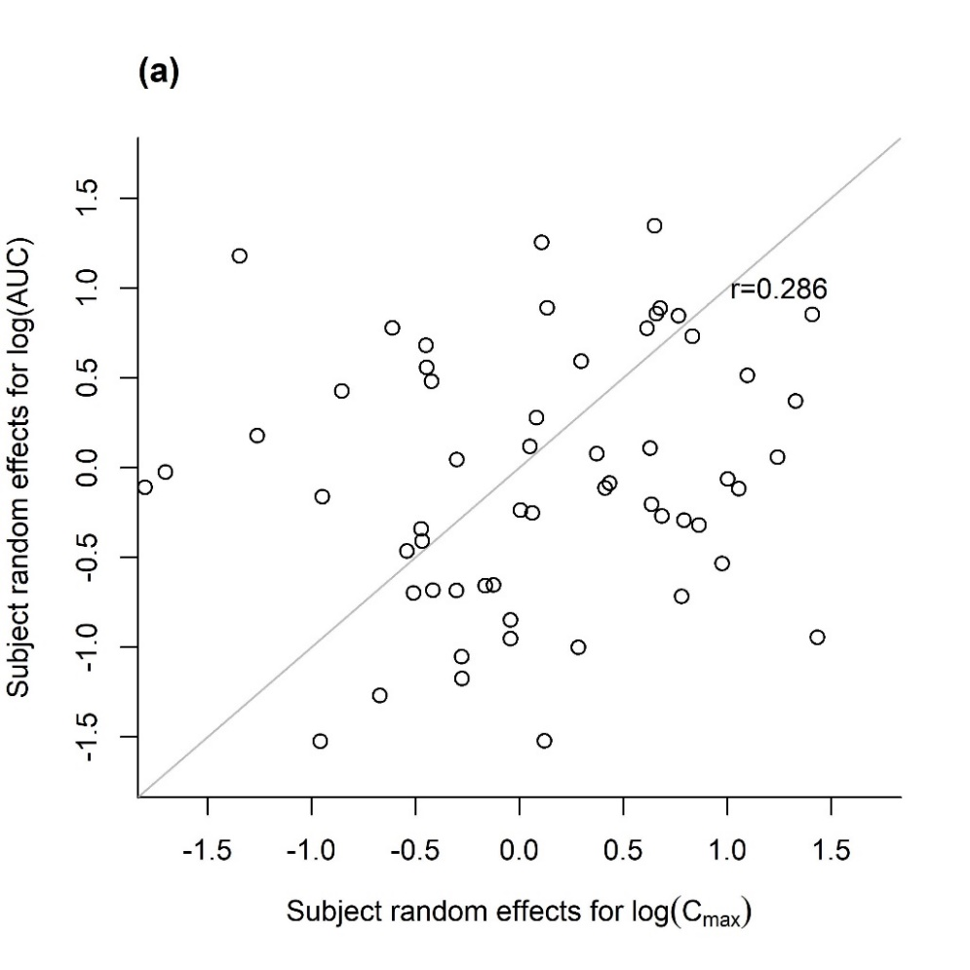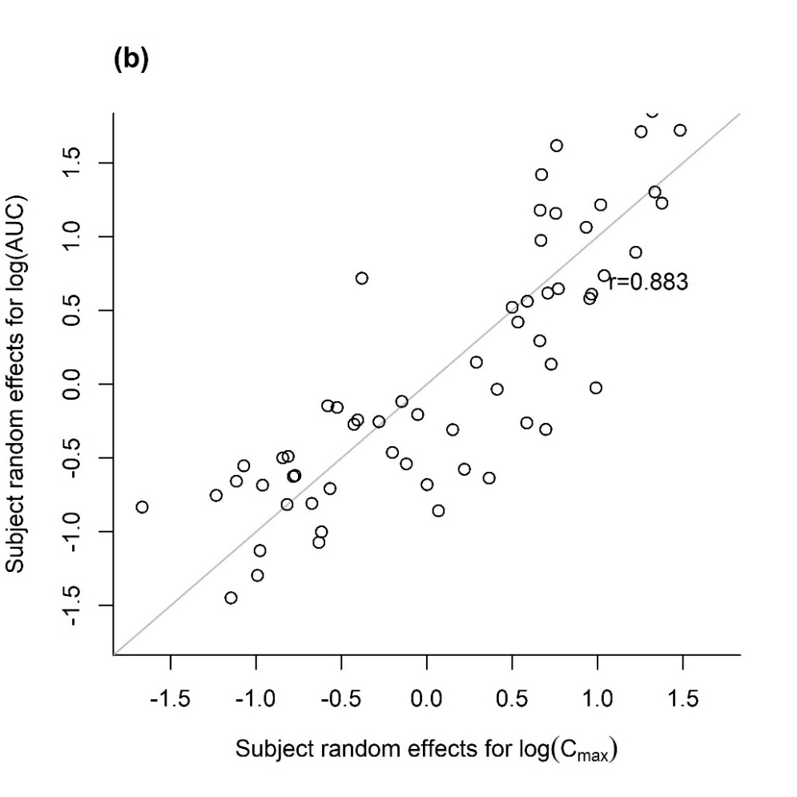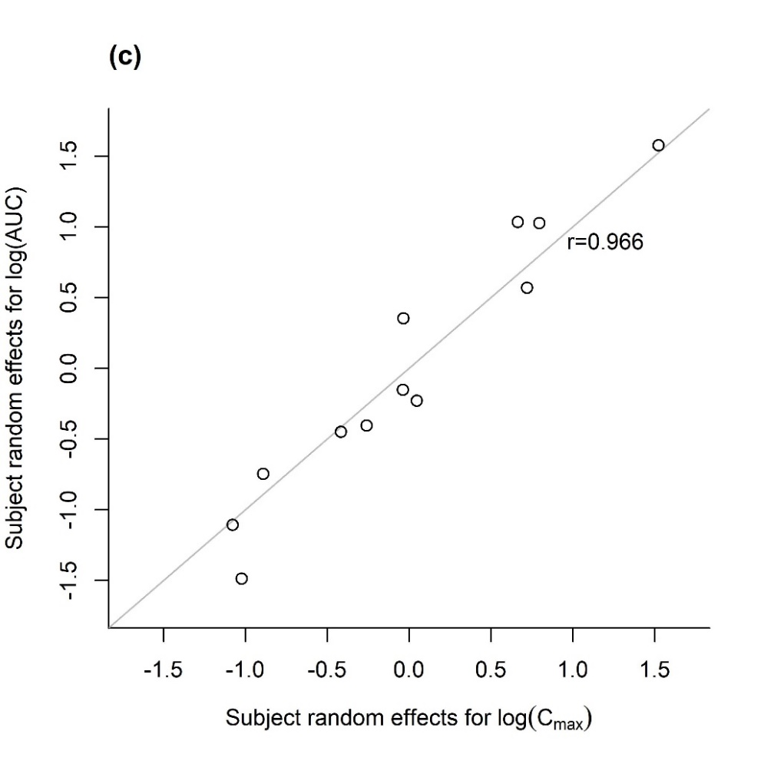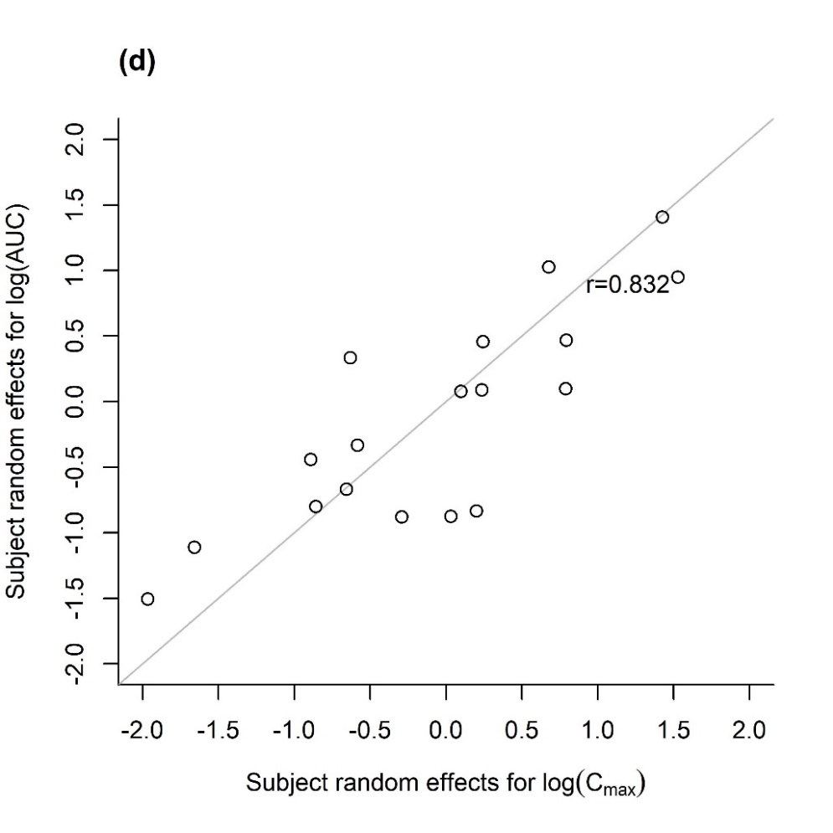
Figure S1.(a) Scatter plots of separately predicted subject random effects for log(C_{max}) and log(AUC) of naproxen in the fixed-dose combination data using the linear mixed model (1) and their correlation coefficients $r$; (b) of esomeprazole in the fixed-dose combination data using the linear mixed model (1) ; (c) of tramadol using the linear mixed model (1); (d) of fimasartan using the linear mixed model (1) without period and sequence effects.

