Supplementary Material
This file includes:
- Standard curve of TCPP and Iso (Figure S1)
- UV-Vis spectrum and (b) FT-IR spectrum of combined NPs (Figure S2)
- Particle size (R_{h}) and size distribution (PDI) of nanoparticle at 10th day and 14th day (Table S1)
- Temperature evolution of TCPP-NPs (Figure S3)

Figure S1
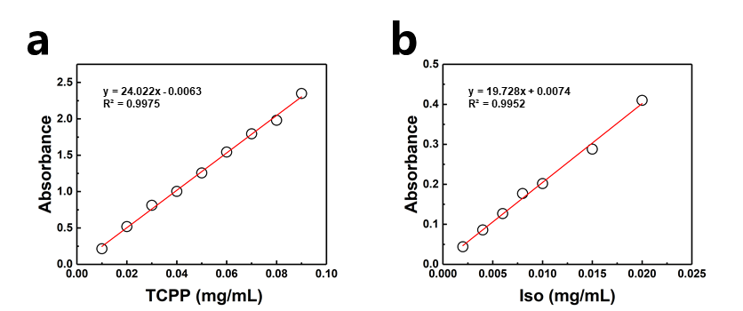
Figure S1. (a) Standard curve of TCPP; (b) standard curve of Iso.

Figure S2
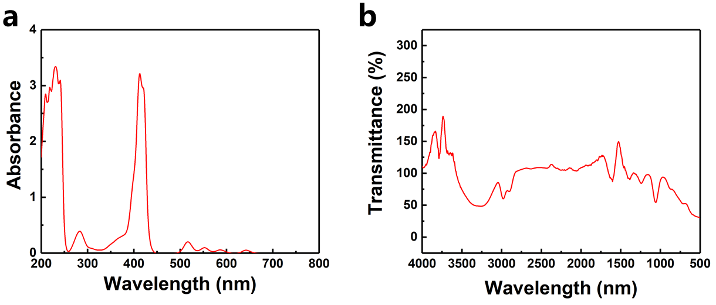
Figure S2. (a) UV-Vis spectrum and (b) FT-IR spectrum of combined NPs.

Table S1. Average R_{h} (hydrodynamic radius) and PDI of NPs at 10th day and 14th day
 | NPs at 10th day |  | NPs at 14th day
 | R_{h}  nm | PDI | R_{h}  nm | PDI
NP | 92.02 | 0.24 | 91.83 | 0.24

Figure S3
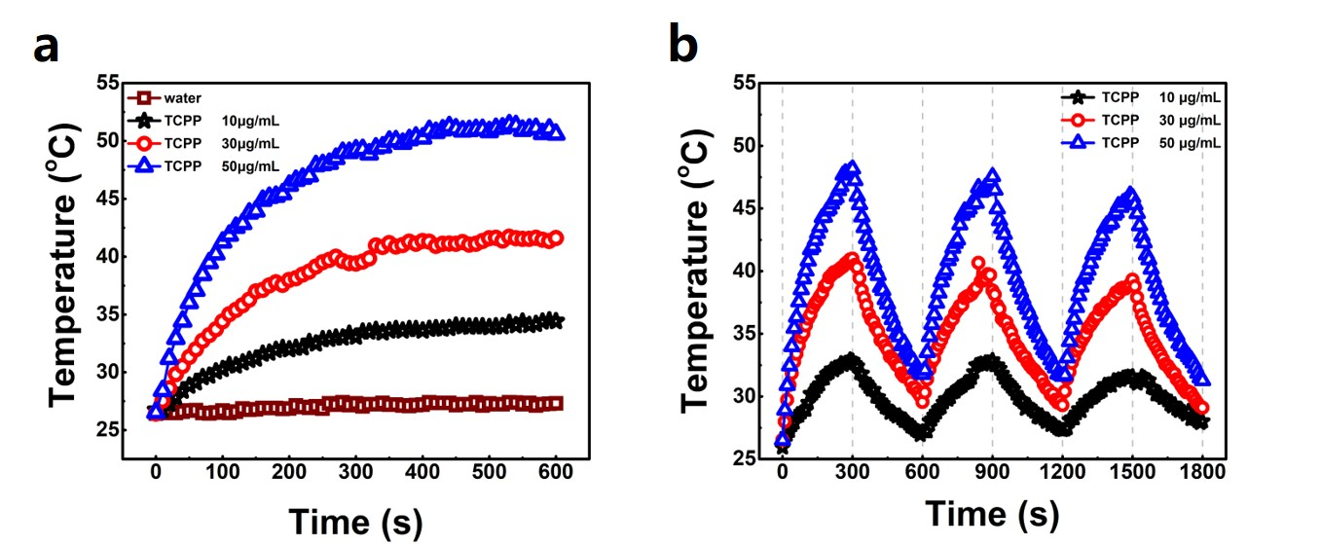
Figure S3. (a) Temperature evolution of TCPP-NPs solution under 650 nm laser irradiation (6.5 W·cm⁻²) at different TCPP concentrations; (b) Temperature evolution of TCPP-NPs solution with 3 cycles of laser on/off under 650 nm laser irradiation (6.5 W·cm⁻²) at different TCPP concentrations.

