Supplementary materials

Fig. S1 Chromatogram of MTS-R₈ H₃ peptide. The peptide was assayed by HPLC analysis, Chromatographic Conditions applied as follow: HPLC column C18 (Gemini-NX 10μ C18 100A, 4.6*250mm) used as chromatographic column. The mobile phase employed comprised of Solvent A: 0.1%Trifluoroacetic in 100% Acetonitrile and solvent B: 0.1%Trifluoroacetic in 100% Water. The Mobile phase was pumped through the column by gradient elution method. The injection volume was 10 µl and the flow rate was 1 ml/min. Sample detection was carried out at 220 nm.
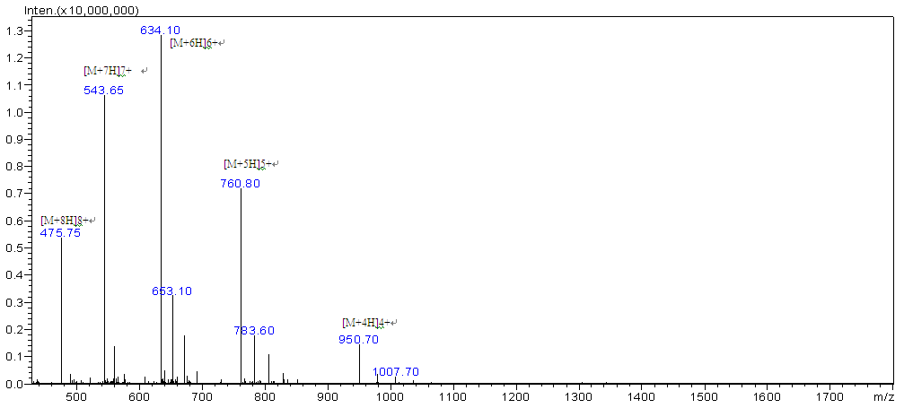
Fig. S2 Annotated MS spectra of MTS-R₈ H₃ peptide.

Fig. S3. CLSM images of MCF/ADR human breast cancer cells after incubation at different times with DOX, DOX lipo, DOX/CEL lipo, and targeting lipo. DOX was visualized as the red fluorescence, nucleuses labeled with DAPI were shown as the blue fluorescence and the merged showed purple. The scale bar is 20 μm.

Table S1. IC₅₀ values of representative drugs against MCF/ ADR cells.

Formulations | Doxorubicin (µg/mL) | Celecoxib (µg/mL)
DOX lipo | 4.71 ± 0.22 | ------
CEL lipo | ------ | 26.67 ± 2.72
DOX/CEL lipo | 3.33 ± 0.28 | 16.62 ± 1.71
Targeting lipo | 1.15 ± 0.19 | 5.74 ± 0.20

