Supporting Information

Materials and methods:

Materials
Tacrolimus (TAC) (anhydrous, 99.56%) (CAS number: 104987-11-3) was purchased from Shanghai Jinhe BioTechnology Co. Ltd, China, Maltodextrin (dextrose equivalent DE=16.5-19.5) (CAS number: 9050-36-6), D-α-tocopherol succinate (CAS number: 4345-03-3 98%), N,N-dicyclohexylcarbodiimide (DCC), 4-dimethylaminopyridine (DMAP), N-hydroxysuccinimide (NHS), triethylamine (TEA), N,N-Dimethylformamide (DMF), dimethyl sulfoxide (DMSO), DMSO-d6, NaCl, KCl, Na2HPO4, KH2PO4, 3-(4,5-dimethylthiazol-2-yl)- 2,5-diphenyl tetrazolium bromide (MTT) assay, complete Freund’s adjuvant (CFA) and Protease inhibitor cocktail were all purchased from Sigma Aldrich (St. Louise, MO, USA). Triton X-100 was provided by USB Corporation (OH, USA). Fetal bovine serum (FBS) was purchased from Gibco Life Technologies (AG, Switzerland). Vero normal cells and PBMCs were purchased from the American Type Culture Collection (ATCC). Sterile filtered Dulbecco’s modified Eagle’s medium (DMEM) and Roswell Park Memorial Institute (RPMI-1640) media were purchased from BioWhittaker (Lonza, USA). Alanine aminotransferase (ALT), aspartate aminotransferase activity (AST) and creatinine assay kits were purchased from Spectrum (Hannover, Germany). Moreover, the urea assay kit was purchased from Diamond Diagnostics (Hannover, Germany). Tumor necrosis factor-α (TNF-α) and interleukin-6 (IL-6) enzyme-linked immunosorbent (ELISA) kits were purchased from R&D (R&D Systems, Inc., Minneapolis, MN, USA). Besides, osteocalcin, osteopontin and SRY-box transcription factor 9 (SOX9) protein rat-specific ELISA kits were purchased from My BioSource (San Diego, CA, USA). RNeasy Mini Kit was purchased from Qiagen (Hilden, Germany). Superscript II reverse transcriptase and Sybr® Green PCR master mix were purchased from Invitrogen (Invitrogen, USA). All solvents used in this study were HPLC grade. Dialysis tubes with a MWCO (1000 and 12000-14000 Da) were purchased from Spectrumchemical (NJ, USA), Alcian blue (dye content ≥85 %) was purchased from Alfa Aesar.

Methodology

Preparation and characterization of MD-α-TOC conjugates
MD-α-TOC bioconjugates were prepared with two different molar ratios (10:2, 10:3) of MD repeating unit: α-tocopherol succinate according to the synthetic procedure described in (Fig. S1). Briefly, α-tocopherol succinate, DCC and NHSS were dissolved in anhydrous DMF under nitrogen at molar ratio of (1:2:2), respectively and the mixture was stirred for 2 hours at ambient temperature. MD was dissolved in anhydrous DMF with the addition of TEA. This was then added to the α-tocopherol-NHSS mixture and the reaction was performed under N₂ at 25°C for 48 h. The reaction solution was filtered, and the filtrate was further precipitated in a ten-fold excess of cold acetone. The suspension formed in acetone was stirred for 20 min at ambient temperature and centrifuged for 10 min (12,000 rpm at 4°C). The obtained precipitate was washed three times with cold acetone, lyophilized and kept at 4°C. The conjugates were fully characterized by 1H-NMR analysis, FT-IR analysis, UV spectrophotometry and TGA thermograms and the critical micelle concentration was determined as previously detailed.¹ The degree of derivatization (DD %) was calculated spectrophotometrically and from ¹H-NMR
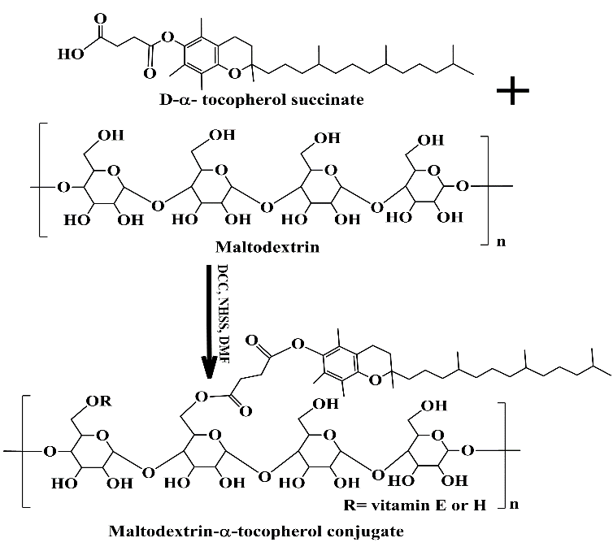
Figure S1 Schematic diagram of synthesis of maltodextrin-α-tocopherol conjugates via reaction between maltodextrin and vitamin E succinate.

Determination of critical micelle concentration
The critical micelle concentration (CMC) of the synthesized conjugates was determined by dynamic light scattering (DLS) technique using Malvern Zetasizer, NANO ZS (Malvern Instruments Limited, UK). Different concentrations ranging from (1×10⁻⁷ - 0.5 mg/mL) of tailored conjugates were prepared in distilled water and intensities were measured. Measured intensities were plotted against (-Log concentration) of the samples and CMC were determined at the concentration corresponding to the sharp change in intensity.

Physicochemical characterization of TAC-loaded MD-α-TOC nanomicelles
Particle size, zeta potential and particle size distribution were detected by DLS. The morphology of nanomicellar structure was observed by TEM while solid state characterization of freeze-dried micelles was assessed by DSC and FTIR. TAC encapsulation efficiency in micelles was measured after treatment with acetonitrile via HPLC method using a 1260 infinity system (Agilent, Sunnyvale, CA, USA) equipped with LiChrospher 100 RP- 18 reverse phase column (250 mm x 4.0 mm, 5 mm particle size; Merck, Darmstadt, Germany) where parameters were set as: wavelength = 213 nm, mobile phase of acetonitrile: acidified H₂O (pH~ 3) 90:10 (v/v) and temperature at 50°C. The drug loading (DL%) and encapsulation efficiency (EE%) were calculated according to the following equations:
$$DL \left(\%\right)=\frac{mass of TAC encapsulated in nanomicelles}{mass of feeding micelle plus TAC}×100\% Eq. 1$$
$$EE \left(\%\right)= \frac{mass of TAC encapsulated in nanomicelles}{mass of TAC added}×100\% Eq. 2$$

pH-dependent drug release of TAC from TAC-loaded MD-α-TOC nanomicelles
In vitro release of TAC was assessed using the dialysis tubes method in USP XXIII type-II dissolution apparatus. Micellar dispersions (equivalent to 2mg TAC) were placed in dialysis bags (MWCO 12-14KDa) and allowed to rotate freely in 100 ml of either of the release media [PBS pH 7.4 , pH 6.5 and pH 5.5 with isopropyl alcohol at a ratio of (60:40)]. ² The paddle speed was maintained at 100 rpm. At predetermined time intervals (2, 4, 6, 8, 24, 48 h), 5 mL samples of the release medium were collected and replaced with an equal volume of fresh medium. The collected samples were analyzed for TAC using the aforementioned HPLC-UV method. The release experiments were repeated three times and expressed as (mean± SD). The release of TAC from TAC@MD-α-TOC was compared to that from TAC ethanolic solution.
In vitro and in vivo toxicological assessment of TAC@ MD-α-TOC nanomicelles
Hemolytic activity assay
Free TAC, A10 and B10 TAC-loaded nanomicelles at a concentration of 3mg TAC/mL in 0.9% NaCl saline solution were prepared for hemolysis assay. The hemolytic activity was investigated using rat red blood cells (RBCs) which were separated from plasma washed three times with normal saline. RBCs were diluted to 2% suspension with cold normal saline, and then used for hemolytic activity assay. RBCs suspension was mixed with micellar dispersions at a ratio (1:1) (v/v). Mixtures were incubated in a shaking water bath at 37°C for 2h, and then centrifuged at 4000rpm for 5 min. The supernatant was examined spectrophotometrically using (T80 UV/VIS spectrophotometer, PG Instruments Ltd., Lutterworth, UK) at 540 nm, for determining the released hemoglobin. RBCs suspensions treated with 2% Triton X-100 and normal saline were considered to have 100% and 0% hemolysis, respectively. Hemolysis percentage was calculated using the equation:
$$Hemolysis \left(\%\right)=\frac{(As - A0)}{\left(A100 - A0\right)}×100 Eq. 3$$
where As, A0, and A100 are the absorbance values of samples, normal saline, and 2% Triton X-100, respectively.³

In vitro cytotoxicity test by MTT assay
Effect of free TAC, A10 and B10 on cell viability of Vero (kidney epithelial cells of African green monkey) normal cells and peripheral blood mononuclear cells (PBMCs) was evaluated using MTT cell viability assay as previously described.⁴ In brief, Vero and PBMCs cells (5.0×10³) were seeded in triplicates in 96 well sterile ﬂat bottom and U shape bottom tissue culture microplates for Vero and PBMCs, respectively. Vero cells were cultured in DMEM (Lonza, USA) and PBMCs cells were cultured in RPMI-1640 media, both DMEM and RPMI-1640 media were supplemented with 10% fetal bovine serum (FBS) and antibiotics (100 U/ml penicillin, 100 μg /ml streptomycin and amphotericin B), then cells were incubated at 37 °C in 5% CO₂ incubator for 24 h. Afterwards, test samples corresponding to TAC concentrations of 5, 10, 15, 20, 25 and 50μg/mL were added to the cells in triplicates and incubated at 37 °C in a 5% CO₂ incubator. After incubation for 24 h and 48 h, the treatments were removed, and the cells were washed three times with 1.0×PBS to remove debris and dead cells. Then, 200 µl of MTT solution (0.5 mg/ml) was added to each well and incubated at 37 °C and 5% CO₂ for about 3-5 h. The formazan crystals were dissolved in 200 µl/well of DMSO and the absorbance was measured at 630 nm and subtracted from measuring at 570 nm using reader a microplate ELISA reader (BioTek Instruments,Inc, VT, USA). The relative cell viability compared to control untreated cells was calculated using the following formula:
$$Relative cell viability \left(\%\right)=\frac{\left(A\right)test}{\left(A\right)control}× 100 \% Eq.4$$

In vitro antioxidant activity of MD-α-TOC
The antioxidant capacity of MD-α-TOC was measured by ABTS assay. Antioxidant capacities of conjugates were determined as reduction of ABTS absorbance (%) (mean% ±SD) and calculating half maximal inhibitory concentration (IC₅₀) using Graphpad Prism® 6 software.⁵
The ABTS radical scavenging (%) of MD-α-TOC conjugates increased progressively with increasing the concentration of α-TOC content within the conjugates (Fig. S4). Interestingly, ABTS radical scavenging (%) values of α-TOC (Vitamin E) succinate showed significant increase, compared to MD-α-TOC (10:2 and 10:3) at low concentrations of α-TOC content (6.25-25 µg/mL). However, at higher concentrations (50-200 µg/mL) results capsized as MD-α-TOC conjugates (10:2 and 10:3) showed significant increase of ABTS radical scavenging (%), compared to corresponding α-TOC succinate. Superiority of MD-α-TOC conjugates over α-tocopherol succinate was also supported by calculating IC₅₀ values (Fig. S4) that represent the concentration of α-TOC succinate or conjugate required to have 50% ABTS scavenging activity. Accordingly, α-tocopherol succinate possessed the highest IC₅₀ value indicating the superior antioxidant activity of MD-α-TOC conjugates compared to α-TOC succinate. This superiority could be attributed to the reducing property of MD as a reducing polysaccharide beside presence of α-TOC moiety conjugated in its backbone imparting a dual mechanism for antioxidant activity of the tailored conjugates.
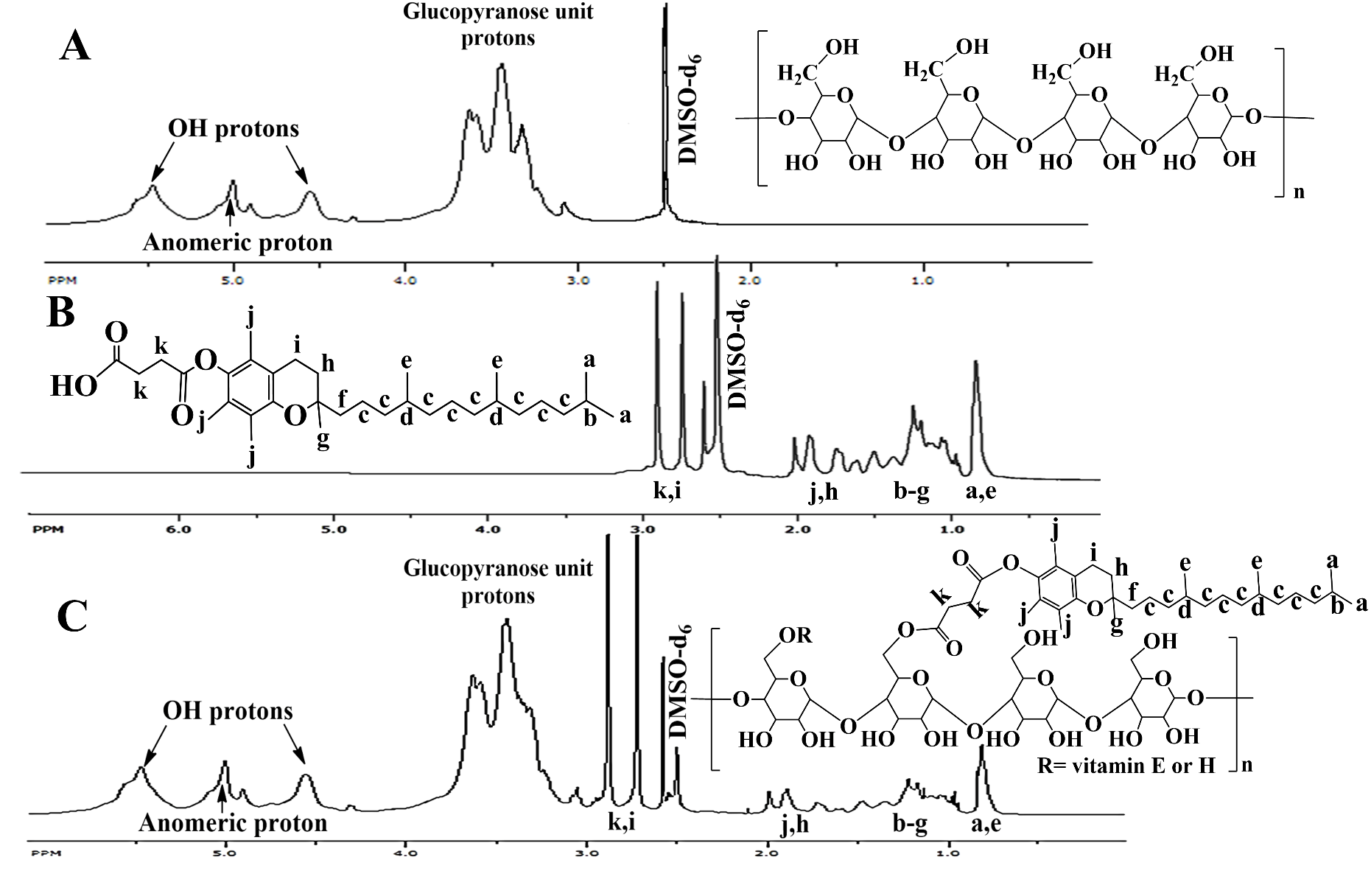
Figure S2 ¹H-NMR spectrum of (A) maltodextrin, (B) α-tocopherol succinate and (C) maltodextrin-α-tocopherol conjugate in DMSO-d₆ solvent.
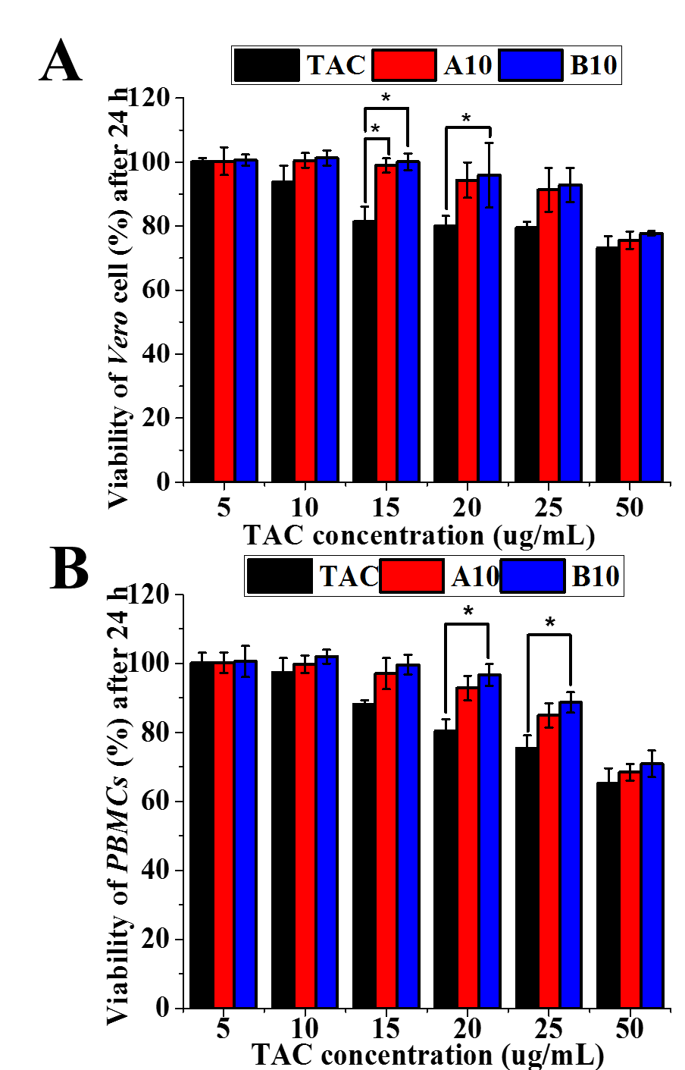
Figure S3. Cytotoxicity test by MTT assay of A10 and B10 on Vero kidney cell line and on PBMCs cell line after 24h of incubation [* P≤ 0.05 vs. TAC, mean ± SD].

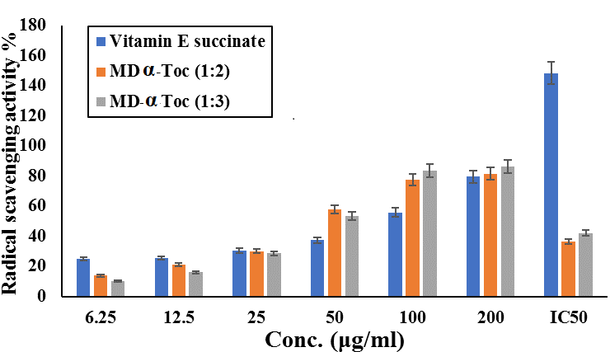
Figure S4. ABTS scavenging activities and IC₅₀ (µg/mL) of maltodextrin-α-tocopherol conjugates.

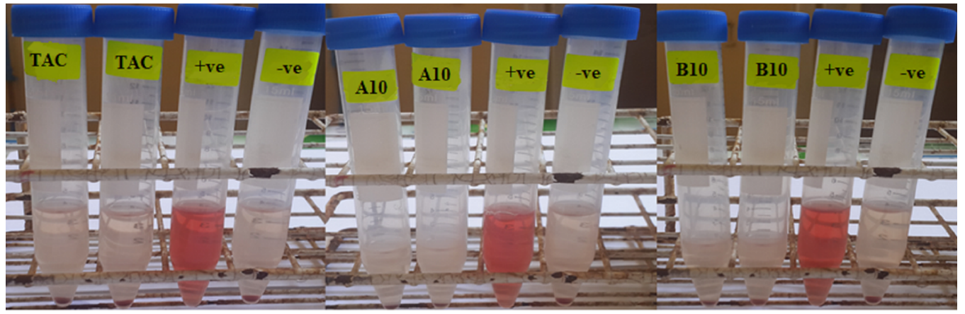

Figure S5. Hemolytic activity test of TAC, A10 and B10 expressed as visual hemocompatibility images compared to negative and positive control

References:
1. Helal HM, Samy WM, El-Fakharany EM, Kamoun EA, Mortada SM, Sallam MA. Maltodextrin-α-tocopherol conjugates of vitamin E: influence of degree of derivatization on physicochemical properties and biological evaluation. J. Drug Deliv. Sci. Technol. 2020:102097.
2. Alam MM, Han HS, Sung S, et al. Endogenous inspired biomineral-installed hyaluronan nanoparticles as pH-responsive carrier of methotrexate for rheumatoid arthritis. J. Controlled Release. 2017;252:62-72.
3. Helal HM, Mortada SM, Sallam MA. Paliperidone-loaded nanolipomer system for sustained delivery and enhanced intestinal permeation: superiority to polymeric and solid lipid nanoparticles. AAPS PharmSciTech. 2017;18(6):1946-1959.
4. Mosmann T. Rapid colorimetric assay for cellular growth and survival: application to proliferation and cytotoxicity assays. J. Immunol. Methods. 1983;65(1-2):55-63.
5. El-Fakharany EM, Abu-Elreesh GM, Kamoun EA, Zaki S, Abd-EL-Haleem DA. In vitro assessment of the bioactivities of sericin protein extracted from a bacterial silk-like biopolymer. RSC Advances. 2020;10(9):5098-5107.

