Table 1 The primers used in qRT-PCR.
Gene | Primer forward (5' to 3') | Primer reverse (5' to 3')
CD40 | ACTGAAACGGAATGCCTTCCT | CCTCACTCGTACAGTGCCA
CD80 | AAACTCGCATCTACTGGCAAA | GGTTCTTGTACTCGGGCCATA
CD86 | CTGCTCATCTATACACGGTTACC | GGAAACGTCGTACAGTTCTGTG
Cxcl16 | CCCGCCATCGGTTCAGTTC | CCCCGAGTAAGCATGTCCAC
Cxcl9 | CCAGTAGTGAGAAAGGGTCGC | AGGGCTTGGGGCAAATTGTT
CD163 | TTTGTCAACTTGAGTCCCTTCAC | TCCCGCTACACTTGTTTTCAC
CD200R | TGGTTGTTGAAAGTCAATGGCT | CTCAGATGCCTTCACCTTGTTT
CD206 | TCCGGGTGCTGTTCTCCTA | CCAGTCTGTTTTTGATGGCACT
Tnfrsf1b | CGGGCCAACATGCAAAAGTC | CAGATGCGGTTCTGTTCCC
Parp9 | TGCAATGGTCGTGAACAACCT | CAACTGGGACCGTTGAAACTG
Tgfβ | GGCCAGATCCTGTCCAAGC | GTGGGTTTCCACCATTAGCAC
IL10 | GACTTTAAGGGTTACCTGGGTTG | TCACATGCGCCTTGATGTCTG
Ccl18 | GTTGACTATTCTGAAACCAGCCCCC | GGTCGCTGATGTATTTCTGGACCC
CD36 | GGCTGTGACCGGAACTGTG | AGGTCTCCAACTGGCATTAGAA
TNF-α | GATCCCTGACATCTGGAATCTG | GAAACATCTGGAGAGAGGAAGG
IL-1β | CAAAGGCGGCCAGGATATAA | CTAGGGATTGAGTCCACATTCAG
GAPDH | GGTGTGAACCATGAGAAGTATGA | GAGTCCTTCCACGATACCAAAG

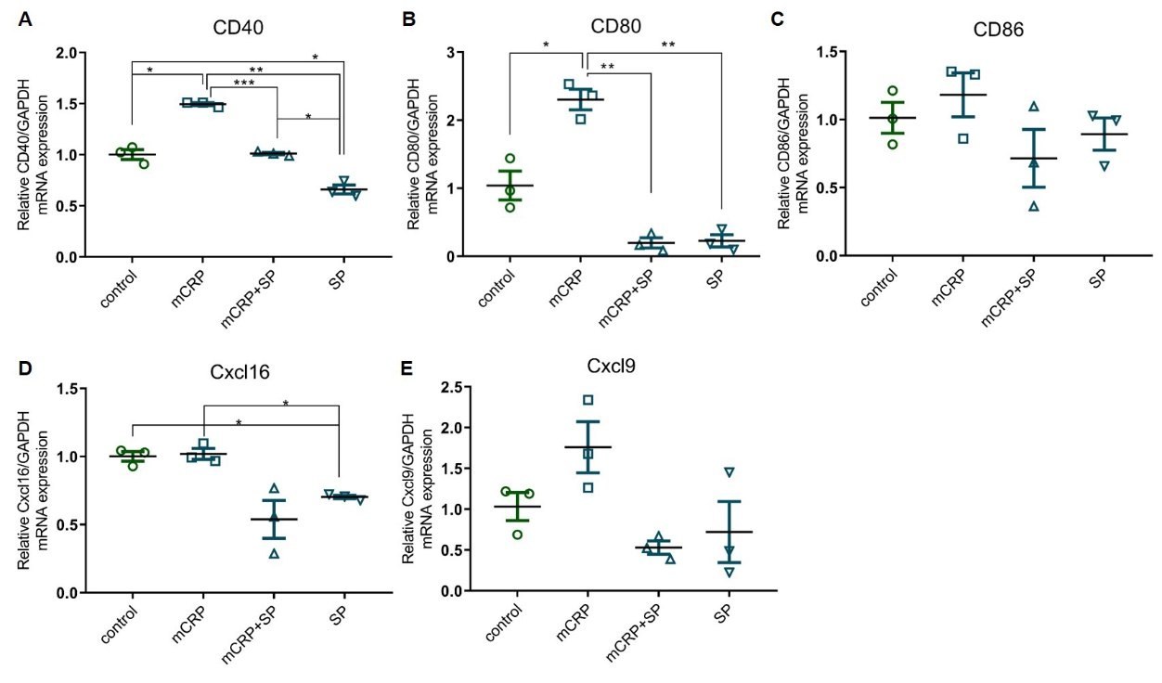
Supplementary Figure 1 Effects of mCRP and the JNK inhibitor (SP600125) on the mRNA levels of the panel of pro-inflammatory biomarkers on macrophages measured by qRT-PCR. (A)CD40, (B)CD80，(C)CD86, (D)Cxcl16, (E)Cxcl9 . THP-1 cells were incubated with mCRP (50μg/ml) for 8 h and/or co-cultured with the JNK inhibitor (SP600125, 10μM). Data are represented as mean ± SD, *p<0.05; **p<0.01; ***p<0.001
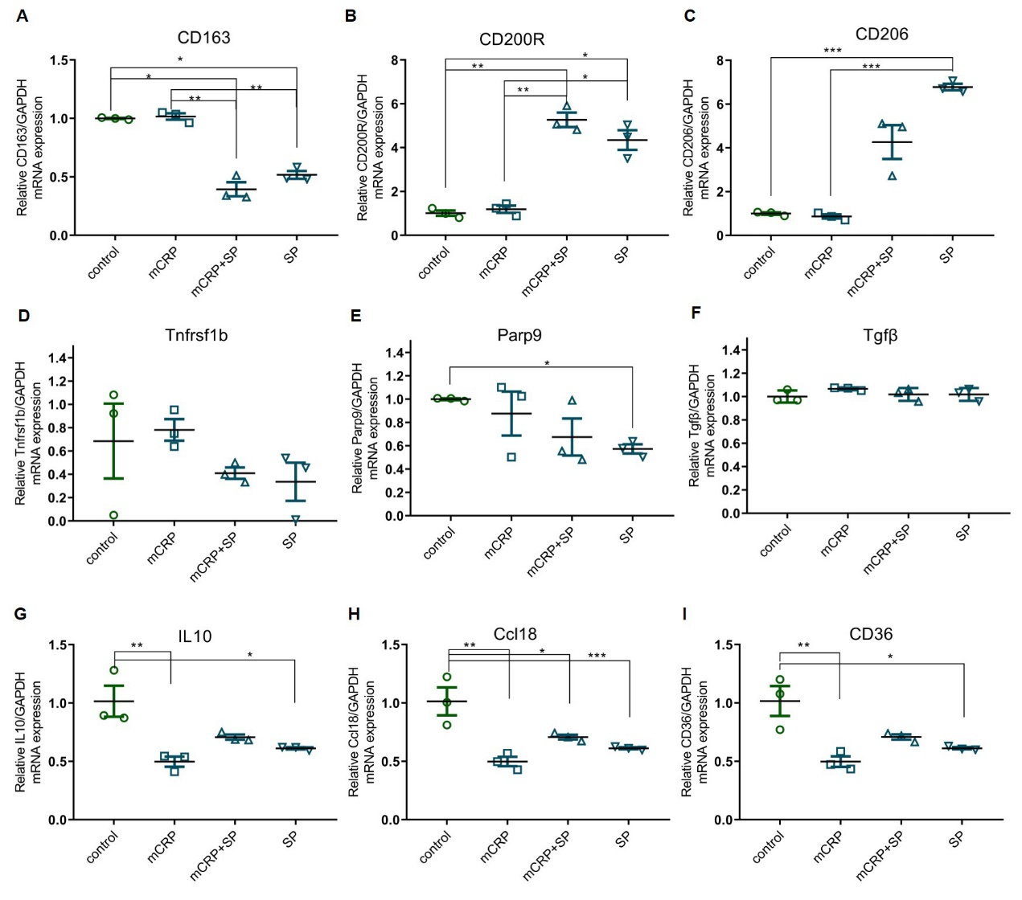

Supplementary Figure 2 Effects of mCRP and the JNK inhibitor (SP600125) on the mRNA levels of the panel of anti-inflammatory biomarkers on macrophages measured by qRT-PCR. (A)CD163, (B)CD200R，(C)CD206, (D)Tnfrsf1b, (E)Parp9, (F)Tgfβ, (G)IL10, (H)Ccl18, (I)CD36 THP-1 cells were induced by PMA with mCRP (50μg/ml) for 8 h and/or co-cultured with the JNK inhibitor (SP600125, 10μM). Data are represented as mean ± SD, *p<0.05; **p<0.01; ***p<0.001

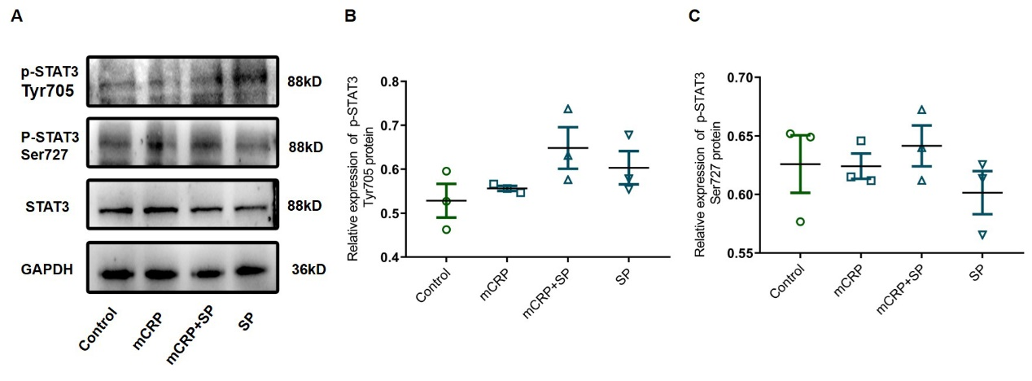
Supplementary Figure 3 Effects of mCRP and the JNK inhibitor, SP600125 on the protein levels of STAT3 signaling pathway. (A) Representative images of p-STAT3 at Tyr705 and Ser727 sites in THP-1 cells incubated with mCRP (50μg/ml) and/or JNK inhibitor (SP600125, 10μM) for 8 h. (B) Quantitative analysis of p-JNK at Tyr705 site in cultured THP-1 cells. (C) Quantitative analysis of p-JNK at Ser727 site in cultured THP-1 cells. Data are represented as mean ± SD. There is no statistical difference between any two groups.

