Appendix 1: Utilities elicitation process using “ping-pong” method
Initial question 1:
Which would you rather?
Life A: Living with hemophilia for 10 years followed by death
Life B: living in perfect health for 10 years followed by death
Participant chooses Life A (hemophilia): They likely do not understand exercise (or prefer hemophilia to perfect health – in which case, please terminate the interview)
Participant chooses Life B (perfect health): Proceed to question 2
Participant chooses ‘They are about the same’: You are done (utility = 1.00)
Initial question 2:
Which would you rather?
Life A: Living with hemophilia for 10 years followed by death
Life B: living in perfect health for 0 years followed by death
Participant chooses Life A (hemophilia): proceed to better than death (BTD) scale beginning at BTD question 3
Participant chooses Life B (perfect health): proceed with the worse than death (WTD) scale beginning at WTD question 3:
Participant chooses ‘They are about the same’: You are done (utility = 0.00)

Better than death (BTD) scale
BTD question 3:
Which would you rather?
Life A: Living with hemophilia for 10 years followed by death
Life B: living in perfect health for 9.5 years followed by death
Participant chooses Life A (hemophilia): You are done (final answer = 0.975 years)
Participant chooses Life B (perfect health): proceed to BTD question 4
Participant chooses ‘They are about the same’: You are done (final answer = 0.950 years)
BTD question 4:
Which would you rather?
Life A: Living with hemophilia for 10 years followed by death
Life B: living in perfect health for 0.5 years followed by death
Participant chooses Life A (hemophilia): proceed to BTD question 5
Participant chooses Life B (perfect health): you are done (final answer = 0.025 years)
Participant chooses ‘They are about the same’: You are done (final answer = 0.050 years)
BTD question 5:
Which would you rather?
Life A: Living with hemophilia for 10 years followed by death
Life B: living in perfect health for 9.0 years followed by death
Participant chooses Life A: You are done (final answer = 0.925 years)
Participant chooses Life B: Proceed to BTD question 6
Participant chooses ‘They are about the same’: You are done (final answer = 0.900 years)
BTD question 6:
Which would you rather?
Life A: Living with hemophilia for 10 years followed by death
Life B: living in perfect health for 1.0 year followed by death
Participant chooses Life A (hemophilia): proceed to BTD question 7
Participant chooses Life B (perfect health): you are done (final answer = 0.075 years)
Participant chooses ‘They are about the same’: You are done (final answer = 0.100 years)
BTD question 7:
Which would you rather?
Life A: Living with hemophilia for 10 years followed by death
Life B: living in perfect health for 8.5 years followed by death
Participant chooses Life A: You are done (final answer = 0.875 years)
Participant chooses Life B: Proceed to BTD question 8
Participant chooses ‘They are about the same’: You are done (final answer = 0.850 years)
BTD question 8:
Which would you rather?
Life A: Living with hemophilia for 10 years followed by death
Life B: living in perfect health for 1.5 years followed by death
Participant chooses Life A (hemophilia): proceed to BTD question 9
Participant chooses Life B (perfect health): you are done (final answer = 0.125 years)
Participant chooses ‘They are about the same’: You are done (final answer = 0.150 years)
BTD question 9:
Which would you rather?
Life A: Living with hemophilia for 10 years followed by death
Life B: living in perfect health for 8.0 years followed by death
Participant chooses Life A: You are done (final answer = 0.825 years)
Participant chooses Life B: Proceed to BTD question 10
Participant chooses ‘They are about the same’: You are done (final answer = 0.800 years)
BTD question 10:
Which would you rather?
Life A: Living with hemophilia for 10 years followed by death
Life B: living in perfect health for 2.0 years followed by death
Participant chooses Life A (hemophilia): proceed to BTD question 11
Participant chooses Life B (perfect health): you are done (final answer = 0.175 years)
Participant chooses ‘They are about the same’: You are done (final answer = 0.200 years)
BTD question 11:
Which would you rather?
Life A: Living with hemophilia for 10 years followed by death
Life B: living in perfect health for 7.5 years followed by death
Participant chooses Life A: You are done (final answer = 0.775 years)
Participant chooses Life B: Proceed to BTD question 12
Participant chooses ‘They are about the same’: You are done (final answer = 0.750 years)
BTD question 12:
Which would you rather?
Life A: Living with hemophilia for 10 years followed by death
Life B: living in perfect health for 2.5 years followed by death
Participant chooses Life A (hemophilia): proceed to BTD question 13
Participant chooses Life B (perfect health): you are done (final answer = 0.225 years)
Participant chooses ‘They are about the same’: You are done (final answer = 0.250 years)
BTD question 13:
Which would you rather?
Life A: Living with hemophilia for 10 years followed by death
Life B: living in perfect health for 7.0 years followed by death
Participant chooses Life A: You are done (final answer = 0.725 years)
Participant chooses Life B: Proceed to BTD question 14
Participant chooses ‘They are about the same’: You are done (final answer = 0.700 years)
BTD question 14:
Which would you rather?
Life A: Living with hemophilia for 10 years followed by death
Life B: living in perfect health for 3.0 years followed by death
Participant chooses Life A (hemophilia): proceed to BTD question 15
Participant chooses Life B (perfect health): you are done (final answer = 0.275 years)
Participant chooses ‘They are about the same’: You are done (final answer = 0.300 years)
BTD question 15:
Which would you rather?
Life A: Living with hemophilia for 10 years followed by death
Life B: living in perfect health for 6.5 years followed by death
Participant chooses Life A: You are done (final answer = 0.675 years)
Participant chooses Life B: Proceed to BTD question 16
Participant chooses ‘They are about the same’: You are done (final answer = 0.650 years)
BTD question 16:
Which would you rather?
Life A: Living with hemophilia for 10 years followed by death
Life B: living in perfect health for 3.5 years followed by death
Participant chooses Life A (hemophilia): proceed to BTD question 17
Participant chooses Life B (perfect health): you are done (final answer = 0.325 years)
Participant chooses ‘They are about the same’: You are done (final answer = 0.350 years)
BTD question 17:
Which would you rather?
Life A: Living with hemophilia for 10 years followed by death
Life B: living in perfect health for 6.0 years followed by death
Participant chooses Life A: You are done (final answer = 0.625 years)
Participant chooses Life B: Proceed to BTD question 18
Participant chooses ‘They are about the same’: You are done (final answer = 0.600 years)
BTD question 18:
Which would you rather?
Life A: Living with hemophilia for 10 years followed by death
Life B: living in perfect health for 4.0 years followed by death
Participant chooses Life A (hemophilia): proceed to BTD question 19
Participant chooses Life B (perfect health): you are done (final answer = 0.375 years)
Participant chooses ‘They are about the same’: You are done (final answer = 0.400 years)
BTD question 19:
Which would you rather?
Life A: Living with hemophilia for 10 years followed by death
Life B: living in perfect health for 5.5 years followed by death
Participant chooses Life A: You are done (final answer = 0.575 years)
Participant chooses Life B: Proceed to BTD question 20
Participant chooses ‘They are about the same’: You are done (final answer = 0.550 years)
BTD question 20:
Which would you rather?
Life A: Living with hemophilia for 10 years followed by death
Life B: living in perfect health for 4.5 years followed by death
Participant chooses Life A (hemophilia): proceed to BTD question 21
Participant chooses Life B (perfect health): you are done (final answer = 0.425 years)
Participant chooses ‘They are about the same’: You are done (final answer = 0.450 years)
BTD question 21:
Which would you rather?
Life A: Living with hemophilia for 10 years followed by death
Life B: living in perfect health for 5.0 years followed by death
Participant chooses Life A: You are done (final answer = 0.525 years)
Participant chooses Life B: You are done (final answer: 0.475 years)
Participant chooses ‘They are about the same’: You are done (final answer = 0.500 years)

Worse than death (WTD) scale

WTD question 3:
Which would you rather?
Life A: Living with perfect health for 0.5 years, followed by 9.5 years with hemophilia, then immediate death
Life B: Immediate death
Participant chooses Life A (perfect health/hemophilia): you are done (utility = -0.0256)
Participant chooses Life B (immediate death): proceed to question 4
Participant chooses ‘They are about the same’: you are done (utility = -0.0526)
WTD question 4:
Which would you rather?
Life A: Living with perfect health for 9.5 years, followed by 0.5 years with hemophilia, then immediate death
Life B: Immediate death
Participant chooses Life A (perfect health/hemophilia): you are done (utility = -39.0000)
Participant chooses Life B (immediate death): proceed to question 5
Participant chooses ‘They are about the same’: you are done (utility = -19.0000)
WTD question 5:
Which would you rather?
Life A: Living with perfect health for 1.0 years, followed by 9.0 years with hemophilia, then immediate death
Life B: Immediate death
Participant chooses Life A (perfect health/hemophilia): you are done (utility = -0.0811)
Participant chooses Life B (immediate death): proceed to question 4
Participant chooses ‘They are about the same’: you are done (utility = -0.1111)
WTD question 6:
Which would you rather?
Life A: Living with perfect health for 9.0 years, followed by 1.0 years with hemophilia, then immediate death
Life B: Immediate death
Participant chooses Life A (perfect health/hemophilia): you are done (utility = -12.3333)
Participant chooses Life B (immediate death): proceed to question 7
Participant chooses ‘They are about the same’: you are done (utility = -9.0000)
WTD question 7:
Which would you rather?
Life A: Living with perfect health for 1.5 years, followed by 8.5 years with hemophilia, then immediate death
Life B: Immediate death
Participant chooses Life A (perfect health/hemophilia): you are done (utility = -0.1429)
Participant chooses Life B (immediate death): proceed to question 4
Participant chooses ‘They are about the same’: you are done (utility = -0.1765)
WTD question 8:
Which would you rather?
Life A: Living with perfect health for 8.5 years, followed by 1.5 years with hemophilia, then immediate death
Life B: Immediate death
Participant chooses Life A (perfect health/hemophilia): you are done (utility = -5.6667)
Participant chooses Life B (immediate death): proceed to question 9
Participant chooses ‘They are about the same’: you are done (utility = -7.0000)
WTD question 9:
Which would you rather?
Life A: Living with perfect health for 2.0 years, followed by 8.0 years with hemophilia, then immediate death
Life B: Immediate death
Participant chooses Life A (perfect health/hemophilia): you are done (utility = -0.2121)
Participant chooses Life B (immediate death): proceed to question 4
Participant chooses ‘They are about the same’: you are done (utility = -0.2500)
WTD question 10:
Which would you rather?
Life A: Living with perfect health for 8.0 years, followed by 2.0 years with hemophilia, then immediate death
Life B: Immediate death
Participant chooses Life A (perfect health/hemophilia): you are done (utility = -4.7143)
Participant chooses Life B (immediate death): proceed to question 11
Participant chooses ‘They are about the same’: you are done (utility = -4.0000)
WTD question 11:
Which would you rather?
Life A: Living with perfect health for 2.5 years, followed by 7.5 years with hemophilia, then immediate death
Life B: Immediate death
Participant chooses Life A (perfect health/hemophilia): you are done (utility = -0.2903)
Participant chooses Life B (immediate death): proceed to question 4
Participant chooses ‘They are about the same’: you are done (utility = -0.3333)
WTD question 12:
Which would you rather?
Life A: Living with perfect health for 7.5 years, followed by 2.5 years with hemophilia, then immediate death
Life B: Immediate death
Participant chooses Life A (perfect health/hemophilia): you are done (utility = -3.4444)
Participant chooses Life B (immediate death): proceed to question 13
Participant chooses ‘They are about the same’: you are done (utility = --3.0000)
WTD question 13:
Which would you rather?
Life A: Living with perfect health for 3.0 years, followed by 7.0 years with hemophilia, then immediate death
Life B: Immediate death
Participant chooses Life A (perfect health/hemophilia): you are done (utility = -0.3793)
Participant chooses Life B (immediate death): proceed to question 4
Participant chooses ‘They are about the same’: you are done (utility = -0.4286)
WTD question 14:
Which would you rather?
Life A: Living with perfect health for 7.0 years, followed by 3.0 years with hemophilia, then immediate death
Life B: Immediate death
Participant chooses Life A (perfect health/hemophilia): you are done (utility = -2.6364)
Participant chooses Life B (immediate death): proceed to question 15
Participant chooses ‘They are about the same’: you are done (utility = -2.3333)
WTD question 15:
Which would you rather?
Life A: Living with perfect health for 3.5 years, followed by 6.5 years with hemophilia, then immediate death
Life B: Immediate death
Participant chooses Life A (perfect health/hemophilia): you are done (utility = -0.4815)
Participant chooses Life B (immediate death): proceed to question 4
Participant chooses ‘They are about the same’: you are done (utility = -0.5385)
WTD question 16:
Which would you rather?
Life A: Living with perfect health for 6.5 years, followed by 3.5 years with hemophilia, then immediate death
Life B: Immediate death
Participant chooses Life A (perfect health/hemophilia): you are done (utility = -2.0769)
Participant chooses Life B (immediate death): proceed to question 17
Participant chooses ‘They are about the same’: you are done (utility = -1.8751)
WTD question 17:
Which would you rather?
Life A: Living with perfect health for 4.0 years, followed by 6.0 years with hemophilia, then immediate death
Life B: Immediate death
Participant chooses Life A (perfect health/hemophilia): you are done (utility = -0.6000)
Participant chooses Life B (immediate death): proceed to question 4
Participant chooses ‘They are about the same’: you are done (utility = -0.6667)
WTD question 18:
Which would you rather?
Life A: Living with perfect health for 6.0 years, followed by 4.0 years with hemophilia, then immediate death
Life B: Immediate death
Participant chooses Life A (perfect health/hemophilia): you are done (utility = -1.6667)
Participant chooses Life B (immediate death): proceed to question 19
Participant chooses ‘They are about the same’: you are done (utility = -1.5000)
WTD question 19:
Which would you rather?
Life A: Living with perfect health for 4.5 years, followed by 5.5 years with hemophilia, then immediate death
Life B: Immediate death
Participant chooses Life A (perfect health/hemophilia): you are done (utility = -0.7391)
Participant chooses Life B (immediate death): proceed to question 4
Participant chooses ‘They are about the same’: you are done (utility = -0.8121)
WTD question 20:
Which would you rather?
Life A: Living with perfect health for 5.5 years, followed by 4.5 years with hemophilia, then immediate death
Life B: Immediate death
Participant chooses Life A (perfect health/hemophilia): you are done (utility = -1.3529)
Participant chooses Life B (immediate death): proceed to question 21
Participant chooses ‘They are about the same’: you are done (utility = -1.2222)
WTD question 21:
Which would you rather?
Life A: Living with perfect health for 5.0 years, followed by 5.0 years with hemophilia, then immediate death
Life B: Immediate death
Participant chooses Life A (perfect health/hemophilia): you are done (utility = -0.9048)
Participant chooses Life B (immediate death): you are done (utility = -1.1053)
Participant chooses ‘They are about the same’: you are done (utility = -1.0000)
Appendix 2: Study materials
Hemophilia adult
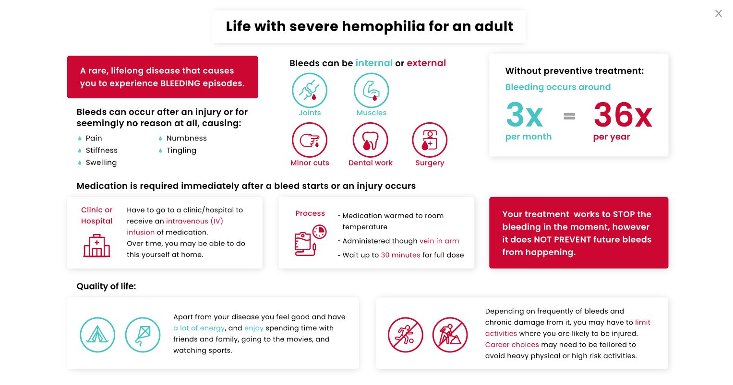
Hemophilia child
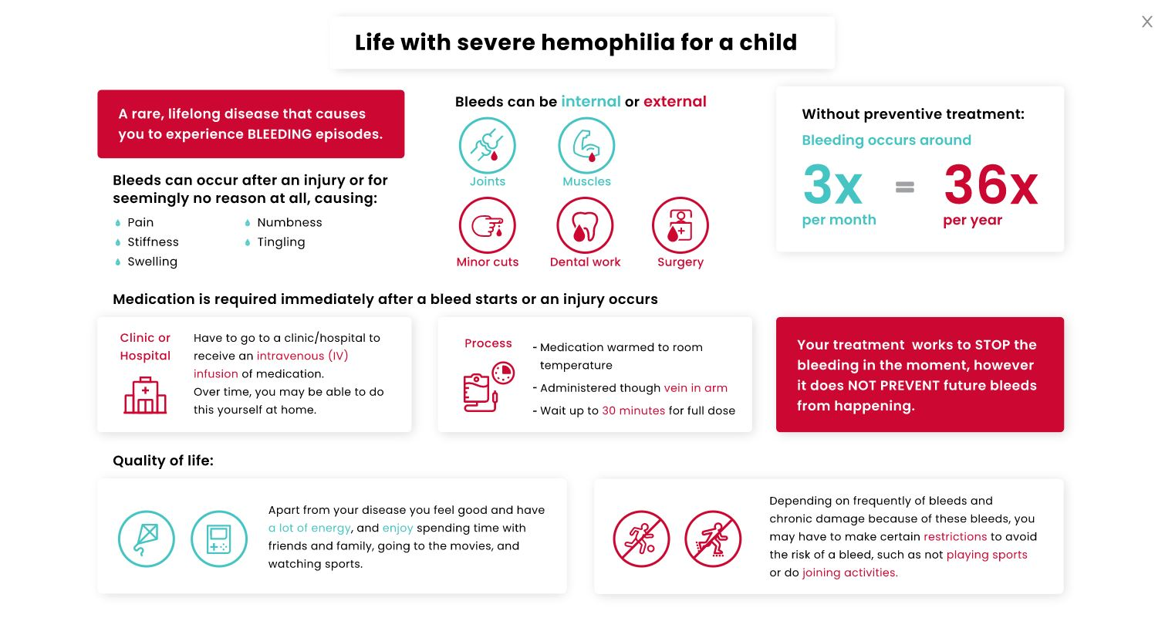
Intravenous infusion prophylaxis adult
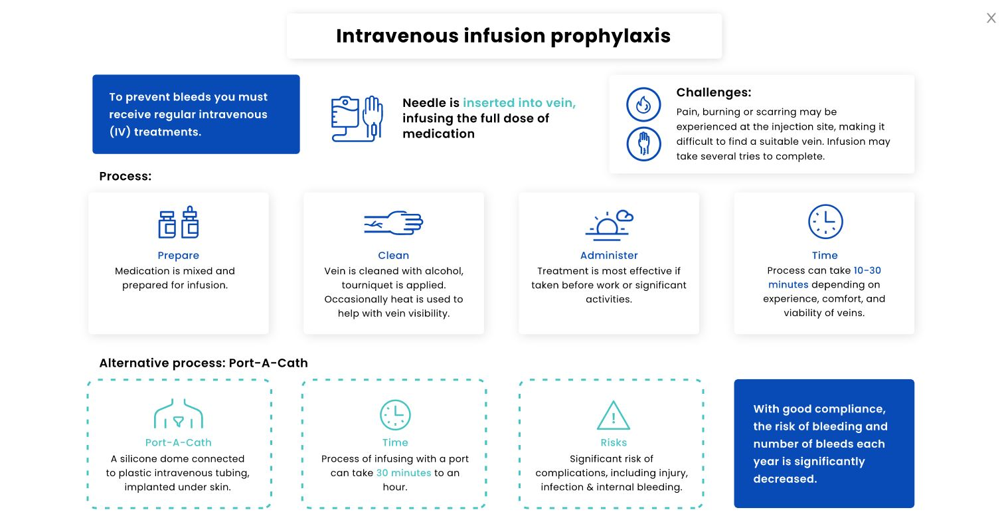
Intravenous prophylaxis child
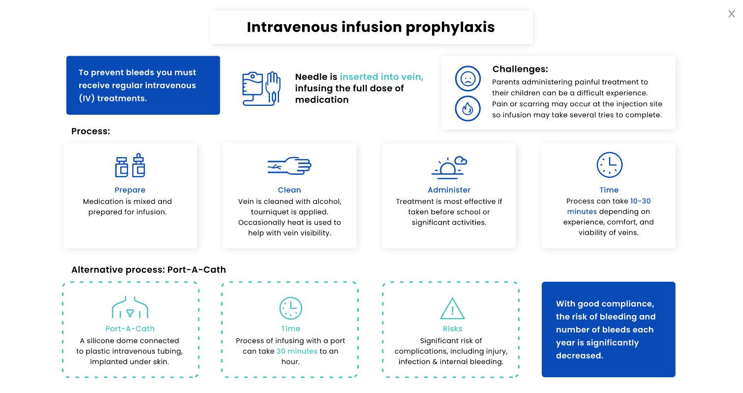
Subcutaneous prophylaxis adult
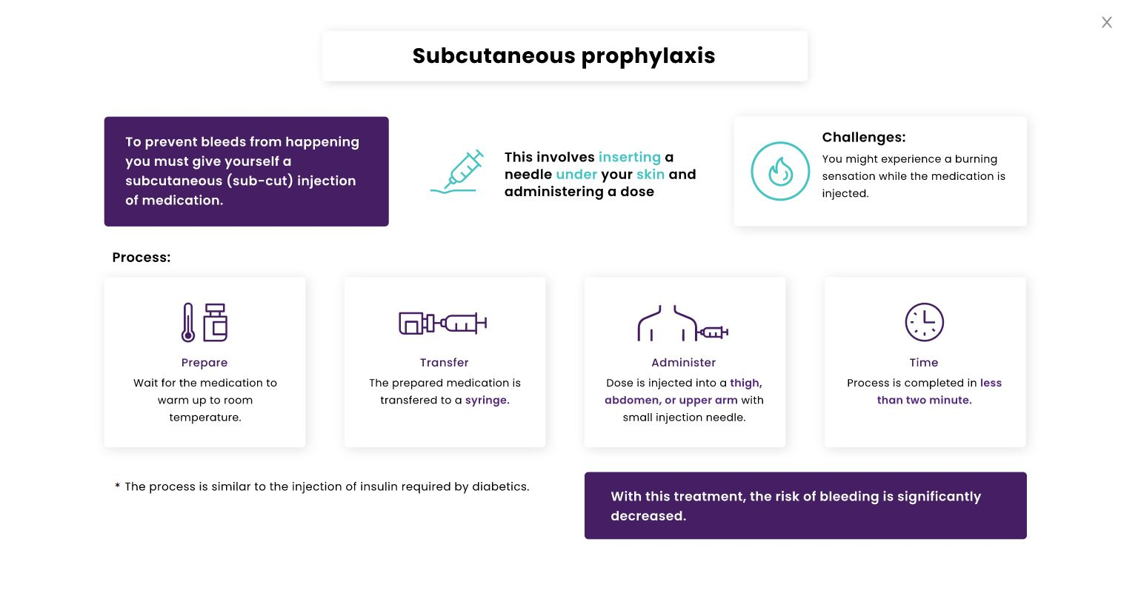
Subcutaneous prophylaxis child
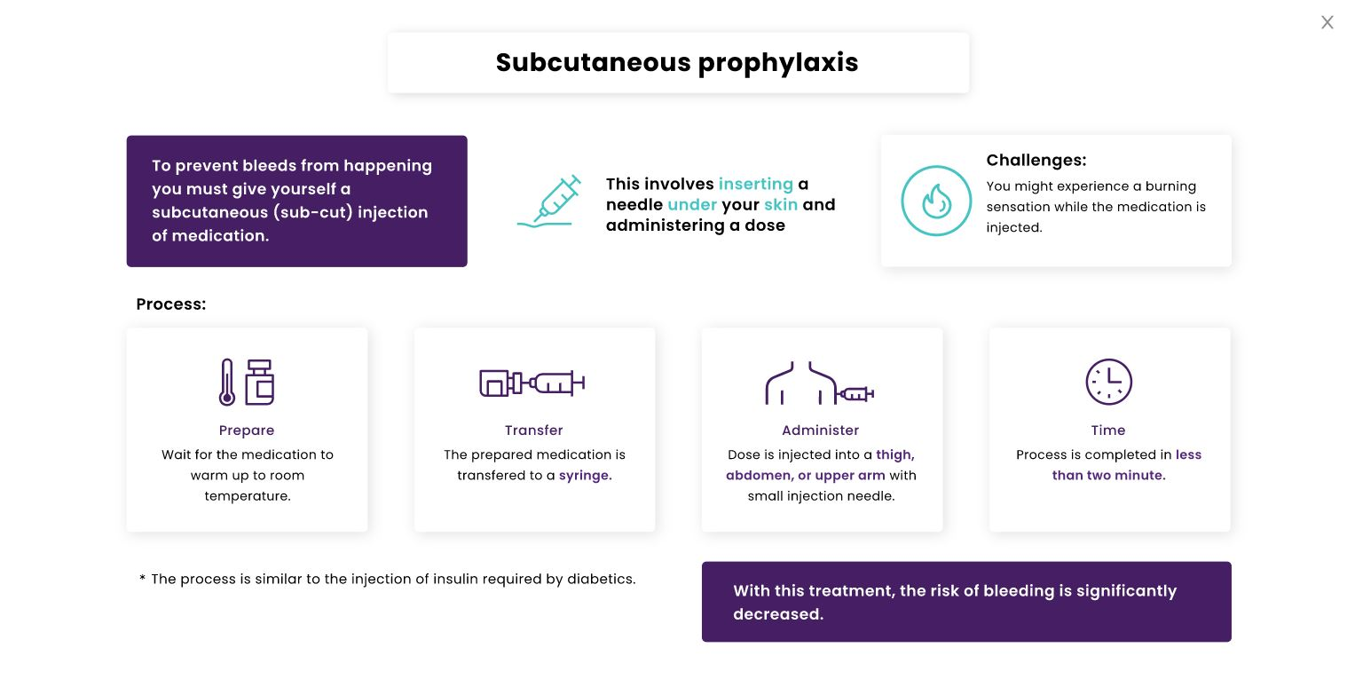
Time-trade off question example
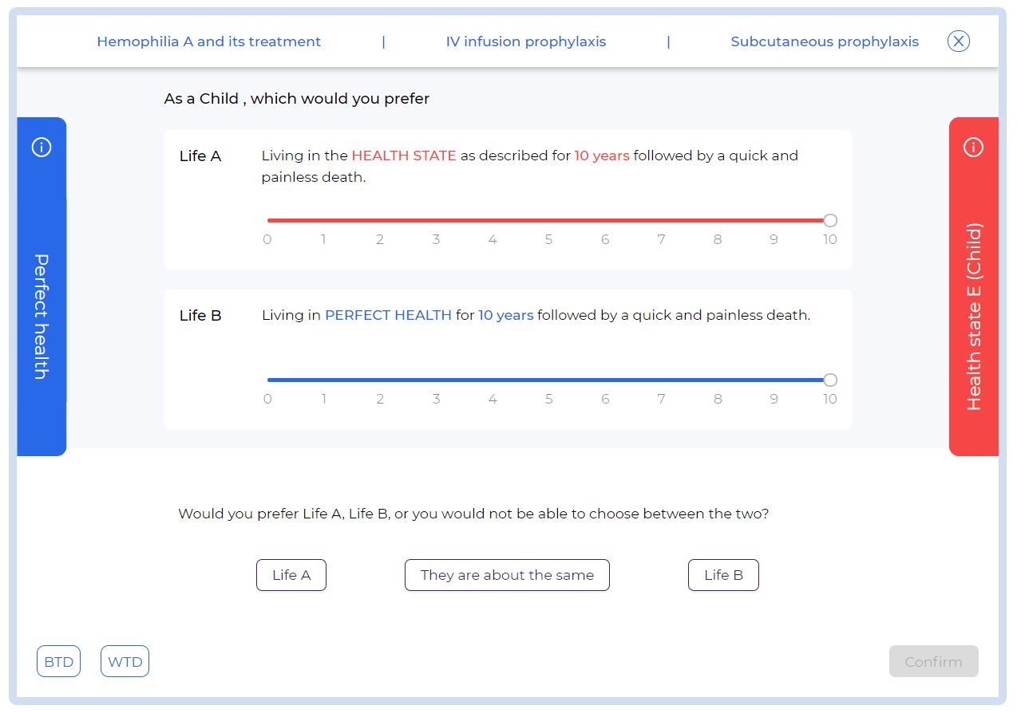
Visual analogue scale question
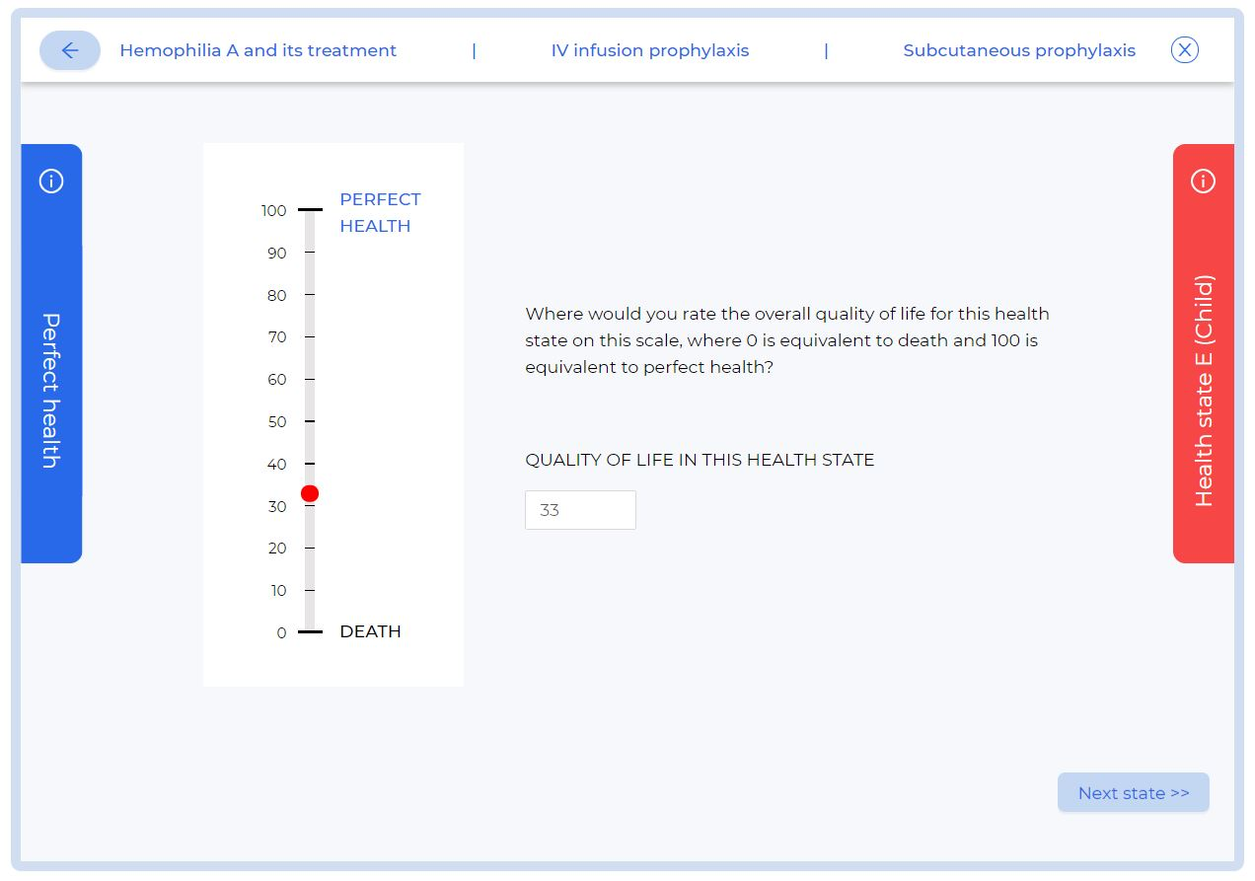
Example with “Perfect health” and “Health state” pop-ups activated
