The association between inflammatory and oxidative stress biomarkers and plasma metabolites in an occupational longitudinal analysis in healthy male workers
Supplementary Materials

Supplementary Table 1. The profile of urinary and plasma inflammatory biomarkers repeated measurements (529 observations).
 | Min | 25th | Median | Mean | 75th | Max | N_missing
U-8-OHdG (ng/mg-creatinine) | 4.5 | 17.4 | 23.5 | 24.1 | 29.6 | 63.5 | 81
U-8-isoprostane (pg/mg-creatinine) | 346.4 | 1069.1 | 1639.7 | 1892.5 | 2380.8 | 10028.0 | 63
Plasma C-Reactive Protein (CRP) Conc. (ng/mL) | 0.6 | 846.1 | 2034.8 | 4083.3 | 5282.7 | 67438.3 | 2
Plasma Serum Amyloid A (SAA) Conc. (ng/mL) | 1.1 | 1472.3 | 2700.3 | 5648.0 | 5299.6 | 101898.3 | 2
Plasma sICAM-1 Conc. (ng/mL) | 0.2 | 268.4 | 322.6 | 338.3 | 406.7 | 1287.8 | 2
Plasma sVCAM-1 Conc. (ng/mL) | 0.3 | 411.7 | 521.0 | 530.5 | 629.0 | 1516.2 | 2
Plasma Interleukin-1 (IL-1β) Conc. (pg/mL) | 0.0 | 0.0 | 0.5 | 2.9 | 1.6 | 293.0 | 2
Plasma Interleukin-2 (IL-2) Conc. (pg/mL) | 0.0 | 0.9 | 1.9 | 3.0 | 3.2 | 132.4 | 2
Plasma Interleukin-6 (IL-6) Conc. (pg/mL) | 2.8 | 14.0 | 22.4 | 66.8 | 34.2 | 7021.3 | 2
Plasma Interleukin-8 (IL-8) Conc. (pg/mL) | 1.7 | 11.4 | 15.6 | 18.9 | 20.4 | 175.9 | 2
Plasma Interleukin-10 (IL-10) Conc. (pg/mL) | 0.6 | 4.4 | 6.0 | 8.9 | 9.4 | 114.6 | 2
Plasma TNF-α (pg/mL) | 1.5 | 8.1 | 10.7 | 27.9 | 13.8 | 2882.2 | 2
Plasma VEGF Conc. (pg/mL) | 39.3 | 213.9 | 316.7 | 360.4 | 434.6 | 1417.5 | 2

Supplementary Table 2. The profile of metabolites that changed over time in participants who provided more than 10 repeated samples^{a,b}.
Model | Metabolites | $$β_{time}$$ | P-value
model1 | 3beta-hydroxy-5-cholestenoate | -4.67E-04 | 1.12E-05
model2 | 3beta-hydroxy-5-cholestenoate | -4.71E-04 | 6.65E-06
model3 | 3beta-hydroxy-5-cholestenoate | -4.36E-04 | 3.50E-05
model1 | 3-hydroxyhippurate | 2.02E-03 | 8.86E-05
model2 | 3-hydroxyhippurate | 2.02E-03 | 6.80E-05
model2 | 4-cholesten-3-one | -5.74E-04 | 5.10E-05
model3 | 4-cholesten-3-one | -6.06E-04 | 1.80E-05
model1 | 4-cholesten-3-one | -6.04E-04 | 2.54E-05
model2 | androstenediol (3beta,17beta) monosulfate (2) | 4.79E-04 | 2.39E-05
model3 | androstenediol (3beta,17beta) monosulfate (2) | 4.96E-04 | 1.08E-05
model1 | androstenediol (3beta,17beta) monosulfate (2) | 4.76E-04 | 3.60E-05
model1 | biliverdin | -6.66E-04 | 1.10E-05
model2 | biliverdin | -6.74E-04 | 6.42E-06
model3 | ectoine | 1.98E-03 | 3.69E-05
model1 | ectoine | 2.24E-03 | 3.24E-06
model2 | ectoine | 2.19E-03 | 3.53E-06
model2 | glycerophosphoethanolamine | 1.18E-03 | 7.35E-05
model1 | hypoxanthine | -1.16E-03 | 4.08E-06
model2 | hypoxanthine | -1.06E-03 | 2.43E-05
model1 | linoleoylcarnitine (C18:2)* | -5.32E-04 | 3.67E-05
model2 | linoleoylcarnitine (C18:2)* | -5.35E-04 | 2.48E-05
model1 | N-acetylglutamate | 9.77E-04 | 3.13E-06
model2 | N-acetylglutamate | 9.89E-04 | 1.64E-06
model1 | oleoyl ethanolamide | -8.28E-04 | 2.22E-05
model2 | oleoyl ethanolamide | -7.92E-04 | 3.81E-05
model2 | oleoylcarnitine (C18:1) | -5.17E-04 | 9.96E-05
model2 | palmitoyl-arachidonoyl-glycerol (16:0/20:4) [2]* | 2.01E-03 | 1.29E-05
model1 | palmitoyl-arachidonoyl-glycerol (16:0/20:4) [2]* | 2.02E-03 | 1.71E-05
model1 | 1-myristoylglycerol (14:0) | 1.61E-03 | 2.55E-05
model2 | 1-myristoylglycerol (14:0) | 1.66E-03 | 1.16E-05
model2 | sphingomyelin (d18:1/20:2, d18:2/20:1, d16:1/22:2)* | -4.51E-04 | 1.23E-05
model1 | sphingomyelin (d18:1/20:2, d18:2/20:1, d16:1/22:2)* | -4.63E-04 | 1.02E-05
model3 | sphingomyelin (d18:1/20:2, d18:2/20:1, d16:1/22:2)* | -4.29E-04 | 3.55E-05
model2 | sphingomyelin (d18:2/18:1)* | -4.54E-04 | 2.85E-10
model3 | sphingomyelin (d18:2/18:1)* | -4.39E-04 | 1.04E-09
model1 | sphingomyelin (d18:2/18:1)* | -4.62E-04 | 2.64E-10
model2 | tartronate (hydroxymalonate) | -1.08E-03 | 8.62E-05
model3 | tartronate (hydroxymalonate) | -1.09E-03 | 6.49E-05
model1 | tartronate (hydroxymalonate) | -1.09E-03 | 9.65E-05
model3 | thymol sulfate | 3.23E-03 | 1.22E-07
model2 | thymol sulfate | 3.32E-03 | 7.66E-08
model1 | thymol sulfate | 3.20E-03 | 2.90E-07
a The linear mixed-effect models are given by
$$Metabolite_{ij}=βtime++x_{ij}^{⊤}α+b_{i}+ϵ_{ijk}$$
where $y_{ijk}$ denotes the metabolite measurement for participant i at the jth day since 1/29/2010 (the first day of the study) , $time$ denotes the number of days since 1/29/2010, and $x_{ijk}^{⊤}$ denotes the vector covariates (Model 1: age, BMI, race, smoking status, weld day/non-weld day, AM/PM, and the interaction between weld day/non-weld day and AM/PM; Model 2: age, BMI, race, smoking status, weld day/non-weld day, AM/PM; Model 3: age, BMI, race, smoking status). The random intercepts are independently distributed $b_{i}∼N(0,τ^{2})$, and the residuals $ϵ_{ijk}\sim N(0,σ^{2})$, where $N(,)$ denotes the normal distribution.
b the coefficient for time (days) were reported for associations which p values was lower than 0.0001.
The

Supplementary Table 3. The profile of inflammation biomarker that changed over time in participants who provided more than 10 repeated samples^{a,b}.
 | Model1 |  | Model2 |  | Model3
Metabolites | $$β_{time}$$ | P-value | $$β_{time}$$ | P-value | $$β_{time}$$ | P-value
Urinary 8-OHdG | 6.14E-04 | 5.42E-02 | 6.20E-04 | 4.61E-02 | 6.00E-04 | 5.51E-02
Plasma interleukin-6 (IL-6), pg/mL | 7.15E-04 | 6.13E-04 | 7.69E-04 | 2.06E-04 | 7.25E-04 | 4.13E-04
Plasma interleukin-10 (IL-10), pg/mL | 3.62E-04 | 2.41E-02 | 3.78E-04 | 1.70E-02 | 3.71E-04 | 1.77E-02
Plasma TNF-a, pg/mL | 6.29E-04 | 7.97E-05 | 6.44E-04 | 4.30E-05 | 6.86E-04 | 1.37E-05
Plasma VEGF, pg/mL | 3.30E-04 | 4.68E-02 | 3.33E-04 | 4.17E-02 | 3.22E-04 | 4.66E-02
a The linear mixed-effect models are given by
$${Biomarker}_{ij}=βtime++x_{ij}^{⊤}α+b_{i}+ϵ_{ijk}$$
where $y_{ijk}$ denotes the metabolite measurement for participant i at the jth day since 1/29/2010 (the first day of the study) , $time$ denotes the number of days since 1/29/2010, and $x_{ijk}^{⊤}$ denotes the vector covariates (Model 1: age, BMI, race, smoking status, weld day/non-weld day, AM/PM, and the interaction between weld day/non-weld day and AM/PM; Model 2: age, BMI, race, smoking status, weld day/non-weld day, AM/PM; Model 3: age, BMI, race, smoking status). The random intercepts are independently distributed $b_{i}∼N(0,τ^{2})$, and the residuals $ϵ_{ijk}\sim N(0,σ^{2})$, where $N(,)$ denotes the normal distribution.
b the coefficient for time (days) were reported for associations which p values was lower than 0.05.

Supplementary Figure 1. The profile of plasma 3beta-hydroxy-5-cholestenoate (normalized) repeated measurements of participants who provided more than 10 samples.
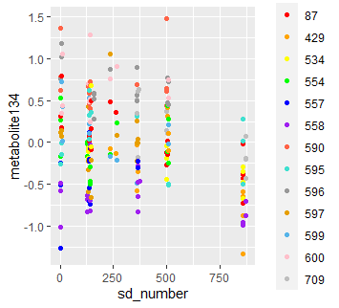
Number of days since 1/29/2010 ID

Supplementary Figure 2. The profile of plasma 3-hydroxyhippurate (normalized) repeated measurements of participants who provided more than 10 samples.
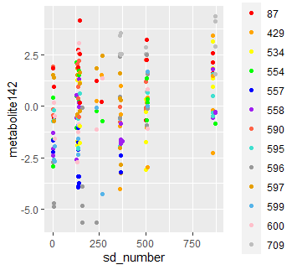
Number of days since 1/29/2010 ID

Supplementary Figure 3. The profile of plasma 4-cholesten-3-one (normalized) repeated measurements of participants who provided more than 10 samples.
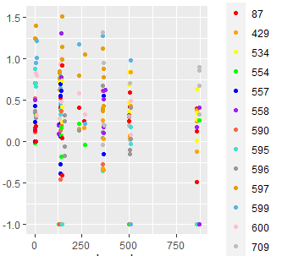
Number of days since 1/29/2010 ID

Supplementary Figure 4. The profile of plasma androstenediol (3beta,17beta) monosulfate (2) (normalized) repeated measurements of participants who provided more than 10 samples.
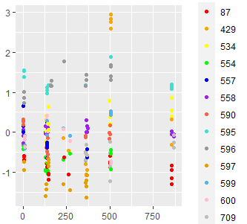
Number of days since 1/29/2010 ID

Supplementary Figure 5. The profile of plasma biliverdin (normalized) repeated measurements of participants who provided more than 10 samples.
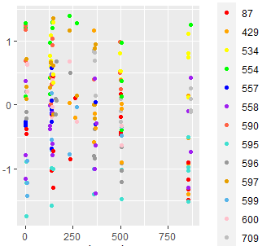
Number of days since 1/29/2010 ID

Supplementary Figure 6. The profile of plasma ectoine (normalized) repeated measurements of participants who provided more than 10 samples.
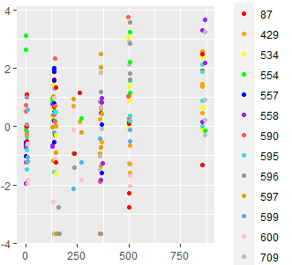
Number of days since 1/29/2010 ID

Supplementary Figure 7. The profile of plasma glycerophosphoethanolamine (normalized) repeated measurements of participants who provided more than 10 samples.
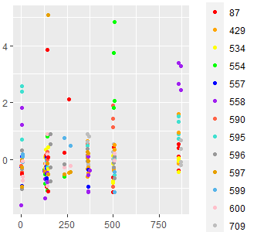
Number of days since 1/29/2010 ID

Supplementary Figure 8. The profile of plasma hypoxanthine (normalized) repeated measurements of participants who provided more than 10 samples.
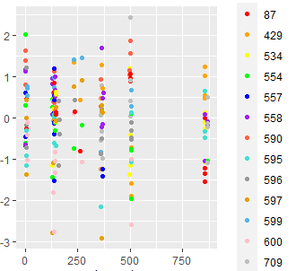
Number of days since 1/29/2010 ID

Supplementary Figure 9. The profile of plasma linoleoylcarnitine (C18:2)* (normalized) repeated measurements of participants who provided more than 10 samples.
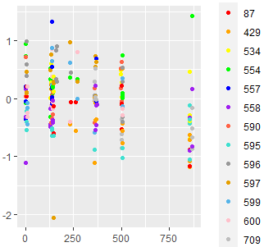
Number of days since 1/29/2010 ID

Supplementary Figure 10. The profile of plasma N-acetylglutamate (normalized) repeated measurements of participants who provided more than 10 samples.
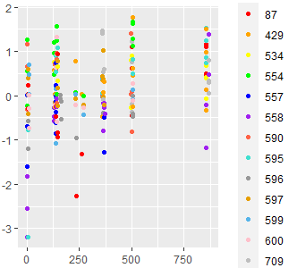
Number of days since 1/29/2010 ID

Supplementary Figure 11. The profile of plasma oleoyl ethanolamide (normalized) repeated measurements of participants who provided more than 10 samples.
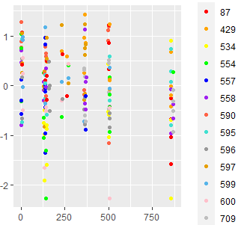
Number of days since 1/29/2010 ID

Supplementary Figure 12. The profile of plasma oleoylcarnitine (C18:1) (normalized) repeated measurements of participants who provided more than 10 samples.
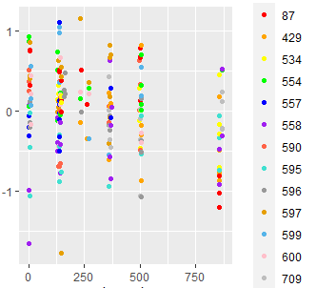
Number of days since 1/29/2010 ID

Supplementary Figure 13. The profile of plasma oleoylcarnitine (C18:1) (normalized) repeated measurements of participants who provided more than 10 samples.
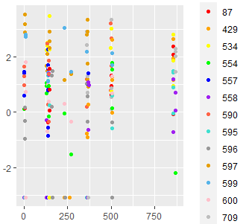
Number of days since 1/29/2010 ID

Supplementary Figure 14. The profile of plasma 1-myristoylglycerol (14:0) (normalized) repeated measurements of participants who provided more than 10 samples.
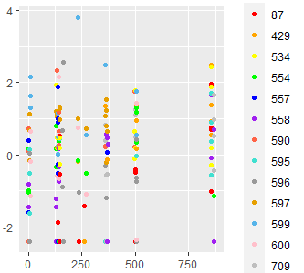
Number of days since 1/29/2010 ID

Supplementary Figure 15. The profile of plasma sphingomyelin (d18:1/20:2, d18:2/20:1, d16:1/22:2)* (normalized) repeated measurements of participants who provided more than 10 samples.
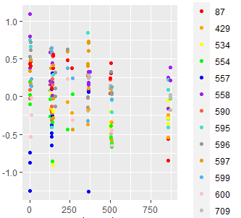
Number of days since 1/29/2010 ID

Supplementary Figure 16. The profile of plasma sphingomyelin (d18:2/18:1)* (normalized) repeated measurements of participants who provided more than 10 samples.
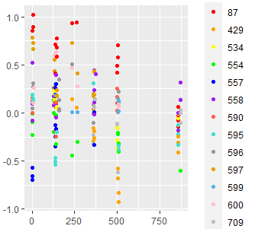
Number of days since 1/29/2010 ID

Supplementary Figure 17. The profile of plasma tartronate (hydroxymalonate) (normalized) repeated measurements of participants who provided more than 10 samples.
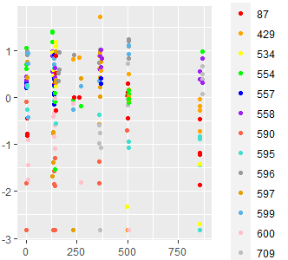
Number of days since 1/29/2010 ID

Supplementary Figure 18. The profile of plasma thymol sulfate (normalized) repeated measurements of participants who provided more than 10 samples.
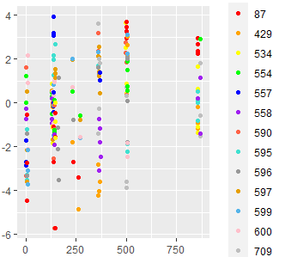
Number of days since 1/29/2010 ID

Supplementary Figure 19. The profile of urinary 8-OHdG (ng/mg creatinine) repeated measurements of participants who provided more than 10 samples.
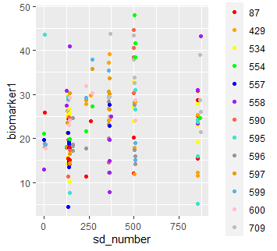
Number of days since 1/29/2010 ID

Supplementary Figure 20. The profile of urinary 8-isoprostane (pg/mg creatinine) repeated measurements of participants who provided more than 10 samples.
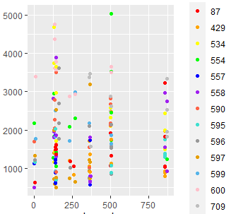
Number of days since 1/29/2010 ID

Supplementary Figure 21. The profile of plasma C-reactive protein (ng/mL) repeated measurements of participants who provided more than 10 samples.
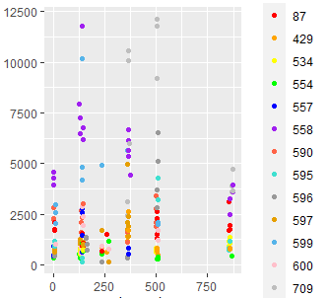
Number of days since 1/29/2010 ID

Supplementary Figure 22. The profile of plasma serum amyloid A (ng/mL) repeated measurements of participants who provided more than 10 samples.
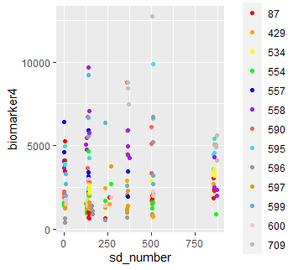
Number of days since 1/29/2010 ID

Supplementary Figure 23. The profile of plasma sICAM-1 (ng/mL) repeated measurements of participants who provided more than 10 samples.
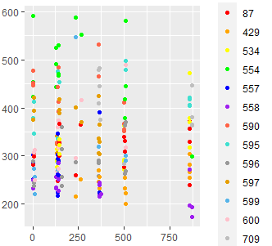
Number of days since 1/29/2010 ID

Supplementary Figure 24. The profile of plasma sVCAM-1 (ng/mL) repeated measurements of participants who provided more than 10 samples.
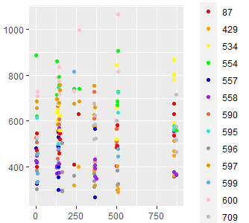
Number of days since 1/29/2010 ID

Supplementary Figure 25. The profile of plasma interleukin-1 (pg/mL) repeated measurements of participants who provided more than 10 samples.
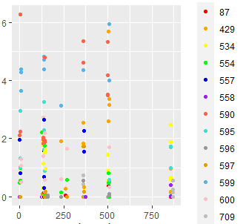
Number of days since 1/29/2010 ID

Supplementary Figure 26. The profile of plasma interleukin-2 (pg/mL) repeated measurements of participants who provided more than 10 samples.
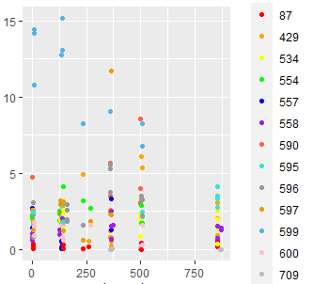
Number of days since 1/29/2010 ID

Supplementary Figure 27. The profile of plasma interleukin-6 (pg/mL) repeated measurements of participants who provided more than 10 samples.
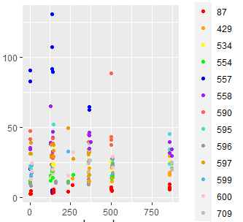
Number of days since 1/29/2010 ID

Supplementary Figure 28. The profile of plasma interleukin-8 (pg/mL) repeated measurements of participants who provided more than 10 samples.
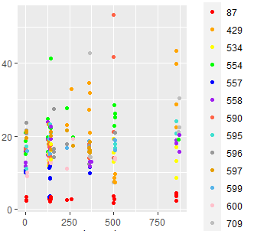
Number of days since 1/29/2010 ID

Supplementary Figure 29. The profile of plasma interleukin-10 (pg/mL) repeated measurements of participants who provided more than 10 samples.
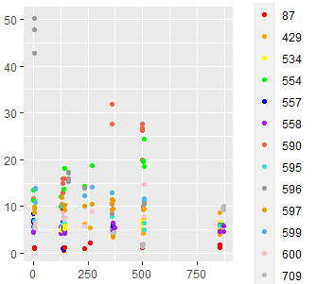
Number of days since 1/29/2010 ID

Supplementary Figure 30. The profile of plasma TNF-a (pg/mL) repeated measurements of participants who provided more than 10 samples.
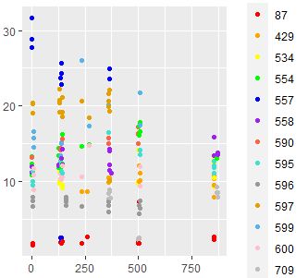
Number of days since 1/29/2010 ID

Supplementary Figure 31. The profile of plasma VEGF (pg/mL) repeated measurements of participants who provided more than 10 samples.
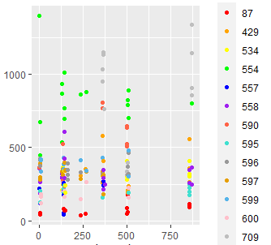
Number of days since 1/29/2010 ID

