Electronic supplementary information
Table S1. IC₅₀ of free DTX (using 1 mg/mL DTX solution in DMSO), DTX/Lipo, and DTX/AE-Lipo in MDA-MB-231 cells when exposed to a series of equivalent concentrations of DTX for 48 h.
Sample | IC₅₀ of formulations in MDA-MB-231 cells (µg/mL)
free DTX | 7.13 ± 0.51
DTX/Lipo | 8.68 ± 0.95
DTX/AE-Lipo | 4.72 ± 1.08
Abbreviations: DTX/Lipo, DTX-loaded liposomes; DTX/AE-Lipo, DTX-loaded targeting liposomes.

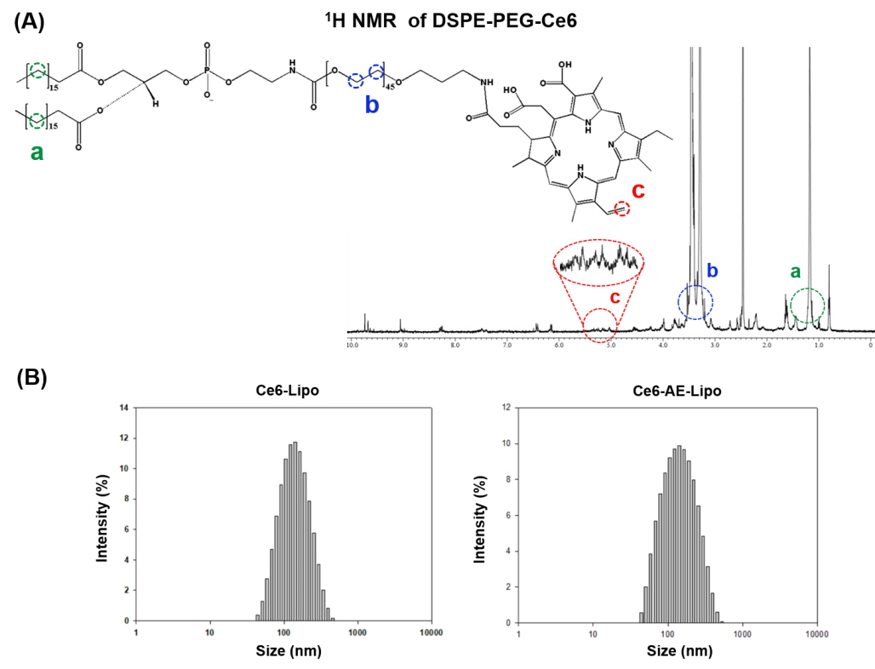
Figure S1. (A) Validation of synthesized DSPE-PEG-Ce6 by ¹H NMR and (B) size distribution of Ce6-Lipo and Ce6-AE-Lipo.
Abbreviations: Ce6-Lipo, Ce6 conjugated Lipo; Ce6-AE-Lipo, Ce6 conjugated AE-Lipo.

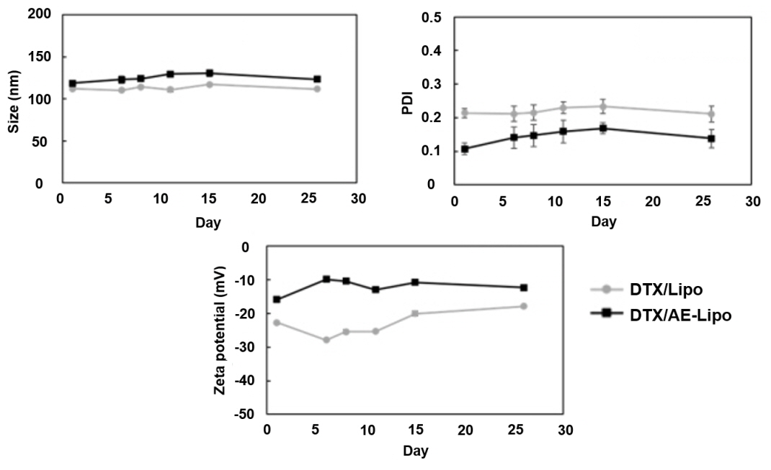
Figure S2. Stability of DTX/Lipo and DTX/AE-Lipo.
Abbreviations: DTX/Lipo, DTX-loaded liposomes; DTX/AE-Lipo, DTX-loaded targeting liposomes.

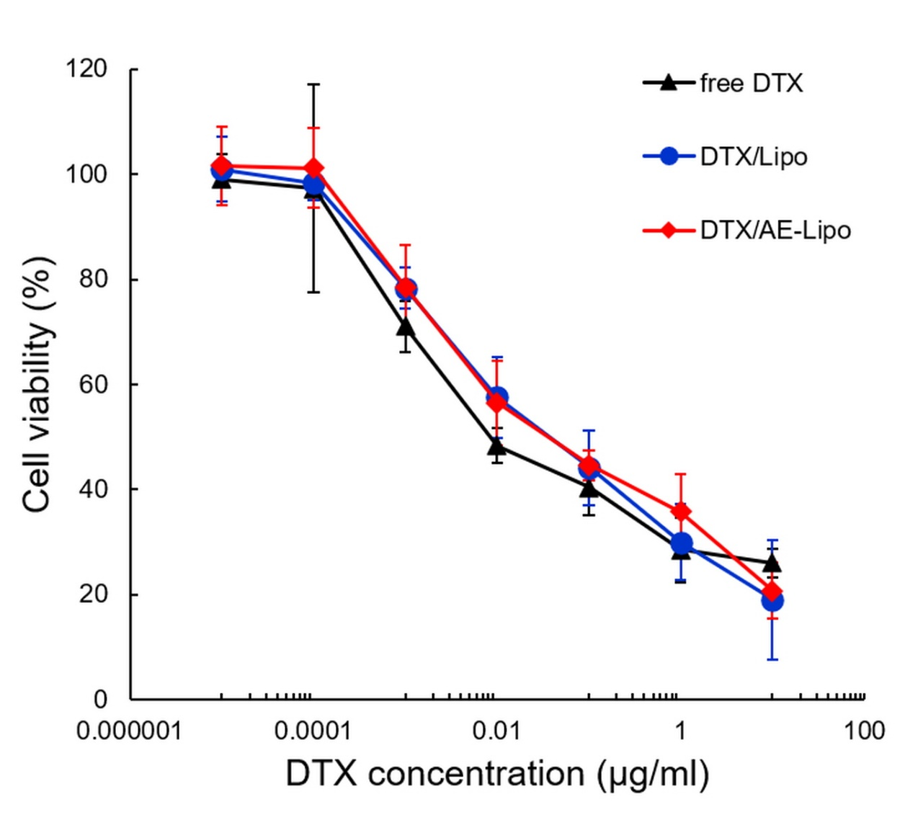
Figure S3. Cell viability of MCF-7 cells treated with free DTX (using 1 mg/mL DTX solution in DMSO), DTX/Lipo and DTX/AE-Lipo used in a series of equivalent concentrations of DTX for 48 h.
Abbreviations: DTX/Lipo, DTX-loaded liposomes; DTX/AE-Lipo, DTX-loaded targeting liposomes.

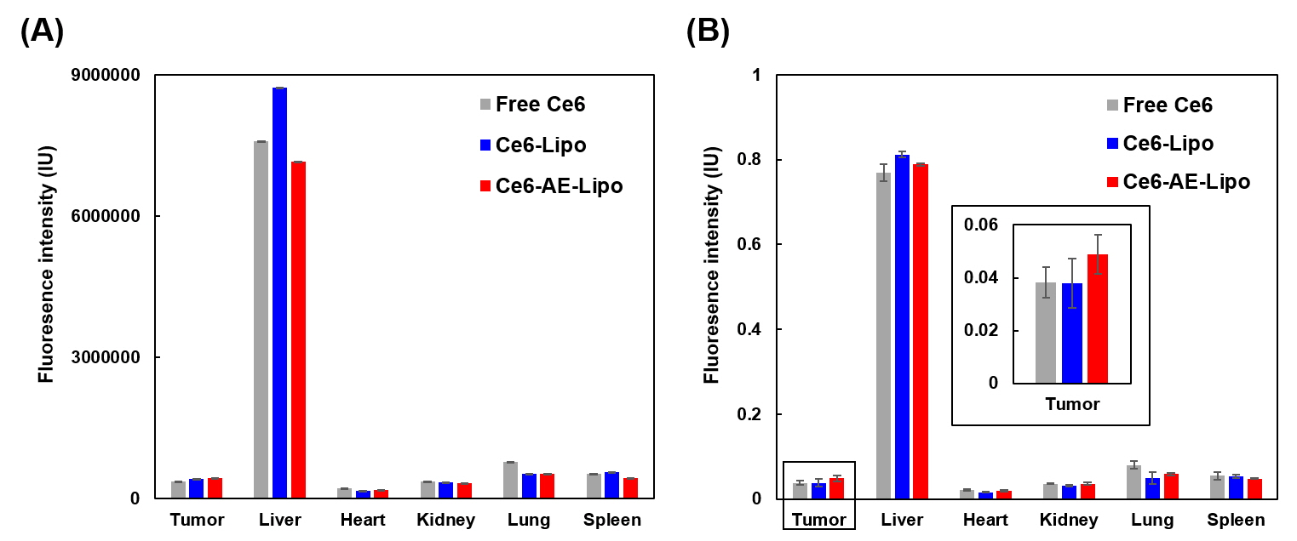
Figure S4. (A) Overall fluorescence intensity of accumulated systems in each organ and (B) the fluorescence intensity of each organ normalized by sum of total fluorescence intensity from all organs.
Abbreviations: Ce6-AE-Lipo, Ce6 conjugated AE-Lipo; Ce6-Lipo, Ce6 conjugated Lipo.

