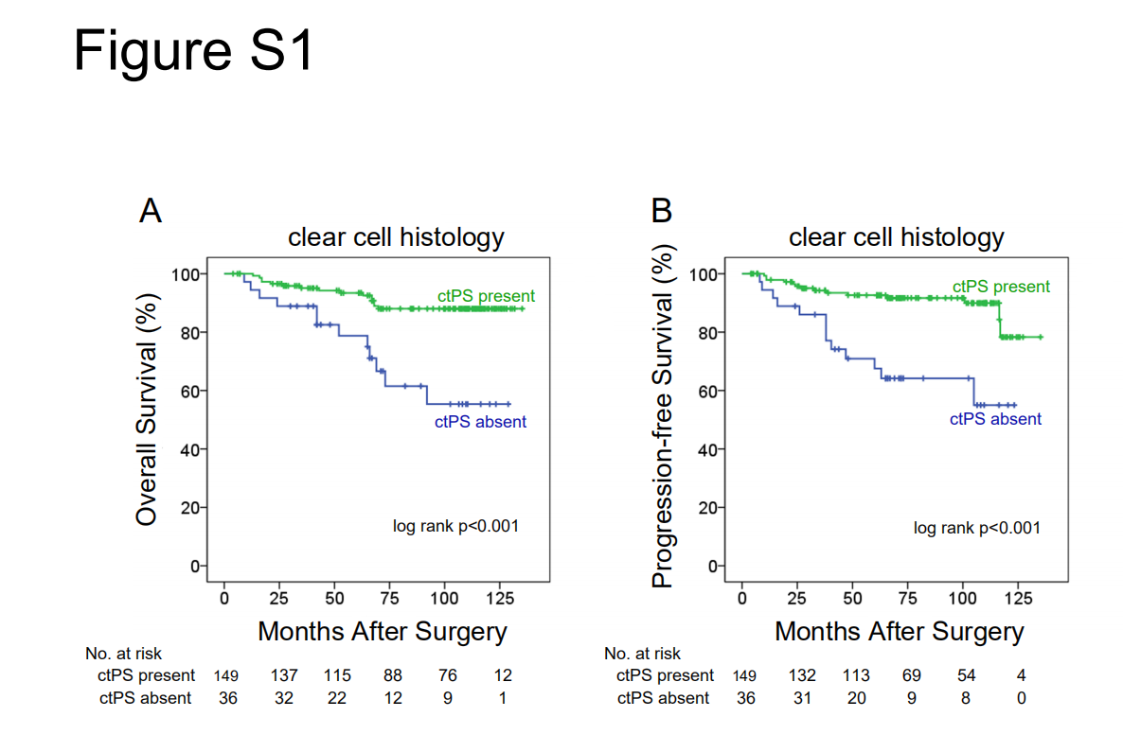

Figure S1. Kaplan-Meier OS (A) and PFS (B) curves in patients with clear cell RCC

Table S1. Comparison between ctPS presence and ctPS absence

Vaiables | ctPS absent | ctPS present | p
No. gender (%) |  |  | 0.143
male | 31 (20.5) | 120 (79.5)
female | 7 (11.9) | 52 (88.1)
Mean age±sd, yrs | 58.1±11.6 | 58.4±11.6 | 0.877
Mean tumor diameter±sd, cm | 4.0±2.5 | 4.1±2.1 | 0.781
Surgery |  |  | 0.948
radical | 19 (18.3) | 85 (81.7)
partial | 19 (17.9) | 87 (82.1)
No. TNM stage (%) |  |  | 0.964
I | 24 (17.6) | 112 (82.4)
II | 4 (20.0) | 16 (80.0)
III | 10 (18.5) | 44 (81.5)
No. Nuclear grade (%) |  |  | 0.359
G1 | 4 (14.8) | 23 (85.2)
G2 | 18 (16.4) | 92 (83.6)
G3 | 9 (17.6) | 42 (82.4)
G4 | 7 (31.8) | 15 (68.2)
No. histology (%) |  |  | 0.129
clear cell | 36 (19.5) | 149 (80.5)
non-clear cell | 2 (8.0) | 23 (92.0)
No. necrosis (%) |  |  | 0.865
with | 9 (17.3) | 43 (82.7)
without | 29 (18.4) | 129 (81.6)

