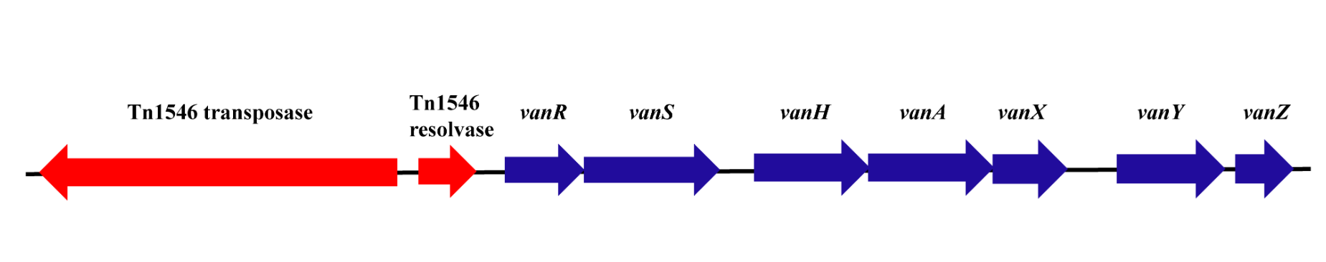
Supplemental Figure 1. The Schematic diagram of genomic island including vanZ, vanY, vanX, vanA, vanH, vanS, vanR for isolates 4942, 5734, and 9604.

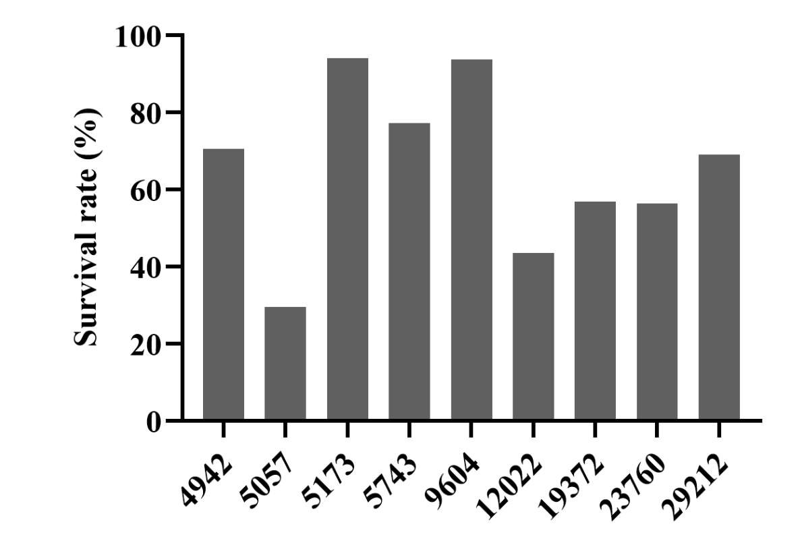

Supplemental Figure 2. The survival rate of 8 VRE isolates and ATCC 29212 during anti-complement killing test.

Supplemental Table 1. Accession of 8 VRE isolates in GenBank.
Isolates | Accession | BioSample
4942 (E. faecalis) | JACXBA000000000 | SAMN16094718
5057 (E. faecium) | JACXLB000000000 | SAMN16094885
5173 (E. faecium) | JACXLA000000000 | SAMN16094886
5743 (E. faecium) | JACXKZ000000000 | SAMN16094887
9604 (E. faecium) | JACXKY000000000 | SAMN16094888
12022 (E. faecalis) | JACXAZ000000000 | SAMN16094719
19372 (E. faecium) | JACXKX000000000 | SAMN16094889
23760 (E. faecium) | JACXKW000000000 | SAMN16094890

Supplemental Table 2. The resistance genes identified in 8 VRE isolates.
Resistance genes | 4942  (VREs) (n=18) | 5057  (VREm) (n=19) | 5173  (VREm) (n=19) | 5743  (VREm) (n=18) | 9604  (VREm) (n=17) | 12022  (VREs) (n=14) | 19372  (VREm) (n=15) | 23760  (VREm) (n=8)
AAC(6')-Ie-APH(2'')-Ia | - | + | + | + | - | + | + | +
AAC(6')-Ii | - | + | + | + | + | - | + | -
aad(6) | - | + | + | + | + | + | - | +
APH(3')-IIIa | + | + | + | + | + | + | - | +
dfrE | + | - | - | - | - | + | - | -
dfrF | - | + | + | + | + | - | - | +
dfrG | + | + | + | - | - | - | + | -
efmA | - | + | + | + | + | - | + | -
efrA | + | - | - | - | - | + | - | -
efrB | + | - | - | - | - | + | - | -
emeA | + | - | - | - | - | + | - | -
ermB | + | + | + | + | + | - | + | -
ermT | - | - | - | + | - | - | - | -
fosB3 | + | - | - | - | - | - | - | -
inuB | - | - | - | + | - | - | - | -
isaA | + | + | + | + | + | + | + | -
sat-4 | + | + | + | + | + | + | - | -
tet(K) | - | + | + | - | + | - | + | -
tet44 | + | + | + | - | + | + | + | -
vanA | + | + | + | + | + | - | + | -
vanHA | + | + | + | + | + | - | + | +
vanRA | + | + | + | + | + | + | + | +
vanSA | + | + | + | + | + | + | + | +
vanXA | + | + | + | + | + | - | + | -
vanYA | + | + | + | + | + | + | + | +
vanZA | + | + | + | + | + | + | + | -
VREm, vancomycin-resistant Enterococcus faecium; VREs, vancomycin-resistant E. faecalis.

Supplemental Table 3. The virulence genes identified in 8 VRE isolates.
Virulence genes | 4942  (VREs) (n=18) | 5057  (VREm) (n=19) | 5173  (VREm) (n=19) | 5743  (VREm) (n=18) | 9604  (VREm) (n=17) | 12022  (VREs) (n=14) | 19372  (VREm) (n=15) | 23760  (VREm) (n=8)
ace | + | - | - | - | - | - | - | -
acm | - | + | + | + | + | - | + | +
EF0485 | + | - | - | - | - | + | - | -
EF0149 | - | - | - | - | - | + | - | -
bopD | + | + | + | + | + | + | + | +
cpsA | - | - | - | - | - | + | - | -
cpsB | + | - | - | - | - | + | - | -
cpsC | + | - | - | - | - | - | - | -
cpsD | + | - | - | - | - | - | - | -
cpsE | + | - | - | - | - | - | - | -
cpsF | + | - | - | - | - | - | - | -
cpsG | + | - | - | - | - | - | - | -
cpsH | + | - | - | - | - | - | - | -
cpsI | + | - | - | - | - | - | - | -
cpsJ | + | - | - | - | - | - | - | -
cpsK | + | - | - | - | - | - | - | -
EFD32_2102 | + | - | - | - | - | - | - | -
EFAU085_01747 | - | + | + | + | + | - | + | +
uppS | - | + | + | + | + | - | + | +
cylA | + | - | - | - | - | + | - | -
cylB | + | - | - | - | - | + | - | -
cylI | + | - | - | - | - | + | - | -
cylL | + | - | - | - | - | + | - | -
cylM | + | - | - | - | - | + | - | -
cylR2 | + | - | - | - | - | + | - | -
cylS | + | - | - | - | - | + | - | -
ebpC | + | - | - | - | - | + | - | -
OG1RF_10869 | + | - | - | - | - | - | - | -
OG1RF_10870 | + | - | - | - | - | - | - | -
OG1RF_10872 | + | - | - | - | - | + | - | -
EFD32_0899 | - | - | - | - | - | + | - | -
EFD32_0900 | - | - | - | - | - | + | - | -
ecbA | - | + | + | - | - | - | - | -
efaA | + | + | + | + | + | + | + | +
esp | - | - | - | + | + | - | - | +
fss1 | + | - | - | - | - | + | - | -
fss2 | + | - | - | - | - | + | - | -
fss3 | + | + | + | + | + | + | - | +
salA | + | - | - | - | - | + | - | -
salB | + | - | - | - | - | - | - | -
fsrC | + | - | - | - | - | + | - | -
gelE | + | - | - | - | - | + | - | -
EFD32_2606 | - | - | - | - | - | + | - | -
ACI49669 | - | + | + | + | - | - | + | -
ACI49670 | - | + | + | + | - | - | + | -
ACI49672 | + | + | + | + | + | - | + | -
pilA | + | + | + | + | + | - | + | -
pilE | - | + | + | + | - | - | + | -
pilF | - | + | + | + | - | - | + | -
ACI49664 | - | - | - | + | + | - | + | +
ACI49666 | - | - | - | + | + | - | + | +
ACI49667 | - | - | - | + | + | - | + | +
pilB | - | - | - | + | + | - | + | +
EFAU085_02896 | - | + | + | + | + | - | + | +
sprE | + | - | - | - | - | + | - | -
VREm, vancomycin-resistant Enterococcus faecium; VREs, vancomycin-resistant E. faecalis.

Supplemental Table 4. The OD₅₉₀ for anti-biofilm formation of rifampin (RIF), linezolid (LNZ), fosfomycin (FM), daptomycin (DAP) alone or in combination against 8 VRE isolates and ATCC 29212.
Groups | Time | 4942 | 5057 | 5173 | 5743 | 9604 | 12022 | 19372 | 23760 | 29212
Control | 24h | 0.22±0.012 | 0.06±0.001 | 0.05±0.003 | 0.05±0.002 | 0.06±0.007 | 0.61±0.023 | 0.45±0.014 | 0.31±0.007 | 0.53±0.027
Control | 48h | 0.32±0.013 | 0.11±0.004 | 0.10±0.001 | 0.10±0.008 | 0.11±0.004 | 0.64±0.026 | 0.52±0.013 | 0.32±0.005 | 0.63±0.026
Control | 72h | 0.34±0.010 | 0.11±0.008 | 0.11±0.009 | 0.12±0.011 | 0.19±0.017 | 0.85±0.041 | 0.54±0.010 | 0.38±0.022 | 0.68±0.026
RIF (3mg/l) | 24h | 0.11±0.011 | 0.08±0.003 | 0.09±0.004 | 0.08±0.008 | 0.06±0.003 | 0.08±0.003 | 0.10±0.013 | 0.14±0.018 | 0.16±0.012
RIF (3mg/l) | 48h | 0.15±0.017 | 0.08±0.005 | 0.08±0.006 | 0.09±0.001 | 0.10±0.009 | 0.59±0.037 | 0.10±00.013 | 0.14±0.014 | 0.13±0.003
RIF (3mg/l) | 72h | 0.19±0.021 | 0.11±0.019 | 0.10±0.008 | 0.14±0.023 | 0.08±0.017 | 0.68±0.204 | 0.13±0.021 | 0.11±0.018 | 0.13±0.019
LNZ (10mg/l) | 24h | 0.10±0.004 | 0.05±0.003 | 0.06±0.002 | 0.06±0.004 | 0.04±0.003 | 0.10±0.003 | 0.05±0.003 | 0.05±0.008 | 0.14±0.023
LNZ (10mg/l) | 48h | 0.11±0.006 | 0.04±0.002 | 0.04±0.002 | 0.04±0.004 | 0.04±0.006 | 0.11±0.004 | 0.05±0.003 | 0.05±0.001 | 0.13±0.002
LNZ (10mg/l) | 72h | 0.12±0.006 | 0.06±0.001 | 0.06±0.002 | 0.06±0.002 | 0.02±0.002 | 0.11±0.009 | 0.03±0.003 | 0.02±0.003 | 0.16±0.010
FM (83mg/l) | 24h | 0.31±0.013 | 0.08±0.004 | 0.08±0.002 | 0.10±0.011 | 0.10±0.005 | 0.67±0.021 | 0.10±0.006 | 0.19±0.014 | 0.47±0.023
FM (83mg/l) | 48h | 0.39±0.012 | 0.10±0.006 | 0.09±0.001 | 0.10±0.006 | 0.11±0.009 | 0.74±0.009 | 0.20±0.034 | 0.42±0.008 | 0.51±0.049
FM (83mg/l) | 72h | 0.44±0.011 | 0.13±0.011 | 0.13±0.012 | 0.14±0.011 | 0.12±0.006 | 0.77±0.031 | 0.20±0.034 | 0.47±0.020 | 0.57±0.015
DAP (20.6mg/l) | 24h | 0.07±0.002 | 0.06±0.002 | 0.06±0.001 | 0.07±0.002 | 0.05±0.003 | 0.06±0.004 | 0.05±0.002 | 0.06±0.002 | 0.06±0.002
DAP (20.6mg/l) | 48h | 0.06±0.004 | 0.05±0.002 | 0.04±0.003 | 0.04±0.002 | 0.05±0.001 | 0.06±0.004 | 0.05±0.002 | 0.04±0.001 | 0.05±0.005
DAP (20.6mg/l) | 72h | 0.09±0.009 | 0.07±0.005 | 0.06±0.001 | 0.09±0.040 | 0.03±0.007 | 0.03±0.006 | 0.03±0.003 | 0.02±0.003 | 0.06±0.016
DAP (31.1mg/l) | 24h | 0.07±0.006 | 0.06±0.003 | 0.04±0.002 | 0.06±0.001 | 0.05±0.003 | 0.06±0.004 | 0.05±.002 | 0.05±0.005 | 0.06±0.002
DAP (31.1mg/l) | 48h | 0.07±0.001 | 0.05±0.002 | 0.04±0.004 | 0.041±0.003 | 0.06±0.002 | 0.06±0.006 | 0.04±0.002 | 0.038±0.005 | 0.05±0.004
DAP (31.1mg/l) | 72h | 0.09±0.006 | 0.07±0.004 | 0.06±0.001 | 0.08±0.024 | 0.03±0.002 | 0.03±0.001 | 0.02±0.003 | 0.02±0.002 | 0.04±0.001
DAP (47.1mg/l) | 24h | 0.07±0.005 | 0.06±0.002 | 0.05±0.003 | 0.05±0.002 | 0.04±0.002 | 0.057±0.002 | 0.05±0.001 | 0.05±0.005 | 0.06±0.001
DAP (47.1mg/l) | 48h | 0.06±0.004 | 0.04±0.003 | 0.035±0.005 | 0.04±0.003 | 0.05±0.001 | 0.05±0.001 | 0.04±0.003 | 0.04±0.004 | 0.05±0.006
DAP (47.1mg/l) | 72h | 0.08±0.003 | 0.06±0.001 | 0.05±0.001 | 0.07±0.008 | 0.02±0.006 | 0.03±0.004 | 0.02±0.002 | 0.021±0.002 | 0.02±0.004
VAN (13.3mg/l) | 24h | 0.26±0.011 | 0.26±0.035 | 0.08±0.002 | 0.07±0.001 | 0.06±0.002 | 0.6±0.018 | 0.65±0.011 | 0.23±0.012 | 0.07±0.008
VAN (13.3mg/l) | 48h | 0.43±0.010 | 0.35±0.020 | 0.16±0.013 | 0.15±0.015 | 0.12±0.002 | 0.71±0.017 | 0.80±0.011 | 0.57±0.024 | 0.08±0.002
VAN (13.3mg/l) | 72h | 0.35±0.012 | 0.31±0.013 | 0.11±0.010 | 0.10±0.004 | 0.09±0.003 | 0.72±0.026 | 0.74±0.015 | 0.56±0.007 | 0.14±0.008
FM+RIF (83mg/l+3mg/l) | 24h | 0.28±0.022 | 0.04±0.001 | 0.04±0.002 | 0.02±0.001 | 0.03±0.001 | 0.06±0.003 | 0.04±0.002 | 0.08±0.001 | 0.07±0.002
FM+RIF (83mg/l+3mg/l) | 48h | 0.24±0.017 | 0.25±0.014 | 0.07±0.005 | 0.03±0.003 | 0.03±0.009 | 0.45±0.016 | 0.07±0.002 | 0.13±0.009 | 0.09±0.001
FM+RIF (83mg/l+3mg/l) | 72h | 0.37±0.019 | 0.34±0.005 | 0.11±0.008 | 0.06±0.003 | 0.06±0.002 | 0.76±0.020 | 0.09±0.001 | 0.11±0.017 | 0.13±0.006
FM+LNZ (83mg/l+10mg/l) | 24h | 0.08±0.001 | 0.06±0.002 | 0.03±0.002 | 0.02±0.001 | 0.02±0.002 | 0.09±0.002 | 0.06±0.001 | 0.06±0.011 | 0.05±0.004
FM+LNZ (83mg/l+10mg/l) | 48h | 0.09±0.002 | 0.08±0.001 | 0.04±0.002 | 0.02±0.001 | 0.03±0.001 | 0.10±0.006 | 0.06±0.001 | 0.12±0.003 | 0.09±0.001
FM+LNZ (83mg/l+10mg/l) | 72h | 0.12±0.003 | 0.13±0.001 | 0.07±0.003 | 0.04±0.002 | 0.05±0.003 | 0.13±0.009 | 0.10±0.004 | 0.07±0.007 | 0.11±0.006
FM+DAP (83mg/l+20.6mg/l) | 24h | 0.04±0.001 | 0.03±0.001 | 0.02±0.003 | 0.02±0.001 | 0.03±0.003 | 0.04±0.001 | 0.04±0.002 | 0.08±0.007 | 0.06±0.001
FM+DAP (83mg/l+20.6mg/l) | 48h | 0.05±0.001 | 0.05±0.001 | 0.04±0.002 | 0.04±0.001 | 0.03±0.001 | 0.04±0.002 | 0.05±0.001 | 0.09±0.002 | 0.09±0.006
FM+DAP (83mg/l+20.6mg/l) | 72h | 0.07±0.001 | 0.07±0.002 | 0.06±0.002 | 0.05±0.002 | 0.04±0.004 | 0.08±0.002 | 0.07±0.002 | 0.05±0.001 | 0.09±0.002
FM+VAN (83mg/l+13.3mg/l) | 24h | 0.23±0.002 | 0.19±0.001 | 0.05±0.001 | 0.05±0.002 | 0.04±0.001 | 0.51±0.022 | 0.07±0.002 | 0.07±0.005 | 0.05±0.003
FM+VAN (83mg/l+13.3mg/l) | 48h | 0.27±0.009 | 0.27±0.020 | 0.09±0.003 | 0.09±0.002 | 0.05±0.003 | 0.57±0.006 | 0.86±0.043 | 0.12±0.008 | 0.09±0.005
FM+VAN (83mg/l+13.3mg/l) | 72h | 0.39±0.004 | 0.32±0.016 | 0.18±0.016 | 0.12±0.012 | 0.07±0.012 | 0.66±0.034 | 0.35±0.016 | 0.35±0.013 | 0.15±0.010
RIF+LNZ (3mg/l+10mg/l) | 24h | 0.05±0.001 | 0.05±0.001 | 0.04±0.002 | 0.03±0.002 | 0.03±0.001 | 0.05±0.001 | 0.08±0.002 | 0.09±0.006 | 0.06±0.001
RIF+LNZ (3mg/l+10mg/l) | 48h | 0.11±0.001 | 0.11±0.002 | 0.07±0.002 | 0.06±0.003 | 0.07±0.001 | 0.10±0.004 | 0.10±0.007 | 0.10±0.006 | 0.10±0.004
RIF+LNZ (3mg/l+10mg/l) | 72h | 0.06±0.002 | 0.07±0.001 | 0.01±0.002 | 0.01±0.003 | 0.01±0.002 | 0.05±0.002 | 0.05±0.001 | 0.04±0.002 | 0.08±0.002
RIF+DAP (3mg/l+20.6mg/l) | 24h | 0.04±0.002 | 0.06±0.001 | 0.03±0.001 | 0.03±0.002 | 0.03±0.002 | 0.04±0.002 | 0.05±0.002 | 0.01±0.002 | 0.01±0.002
RIF+DAP (3mg/l+20.6mg/l) | 48h | 0.09±0.001 | 0.10±0.004 | 0.07±0.001 | 0.07±0.001 | 0.07±0.001 | 0.11±0.011 | 0.09±0.002 | 0.08±0.001 | 0.09±0.001
RIF+DAP (3mg/l+20.6mg/l) | 72h | 0.04±0.004 | 0.04±0.003 | 0.01±0.002 | 0.01±0.002 | 0.01±0.001 | 0.05±0.001 | 0.04±0.002 | 0.04±0.003 | 0.05±0.002
RIF+VAN (3mg/l+13.3mg/l) | 24h | 0.06±0.001 | 0.05±0.003 | 0.06±0.003 | 0.04±0.003 | 0.07±0.001 | 0.06±0.003 | 0.09±0.002 | 0.02±0.016 | 0.08±0.004
RIF+VAN (3mg/l+13.3mg/l) | 48h | 0.18±0.009 | 0.15±0.018 | 0.11±0.003 | 0.10±0.002 | 0.06±0.001 | 0.15±0.014 | 0.20±0.009 | 0.23±0.016 | 0.09±0.001
RIF+VAN (3mg/l+13.3mg/l) | 72h | 0.17±0.009 | 0.25±0.015 | 0.06±0.001 | 0.05±0.002 | 0.02±0.001 | 0.27±0.011 | 0.24±0.009 | 0.18±0.008 | 0.15±0.010

