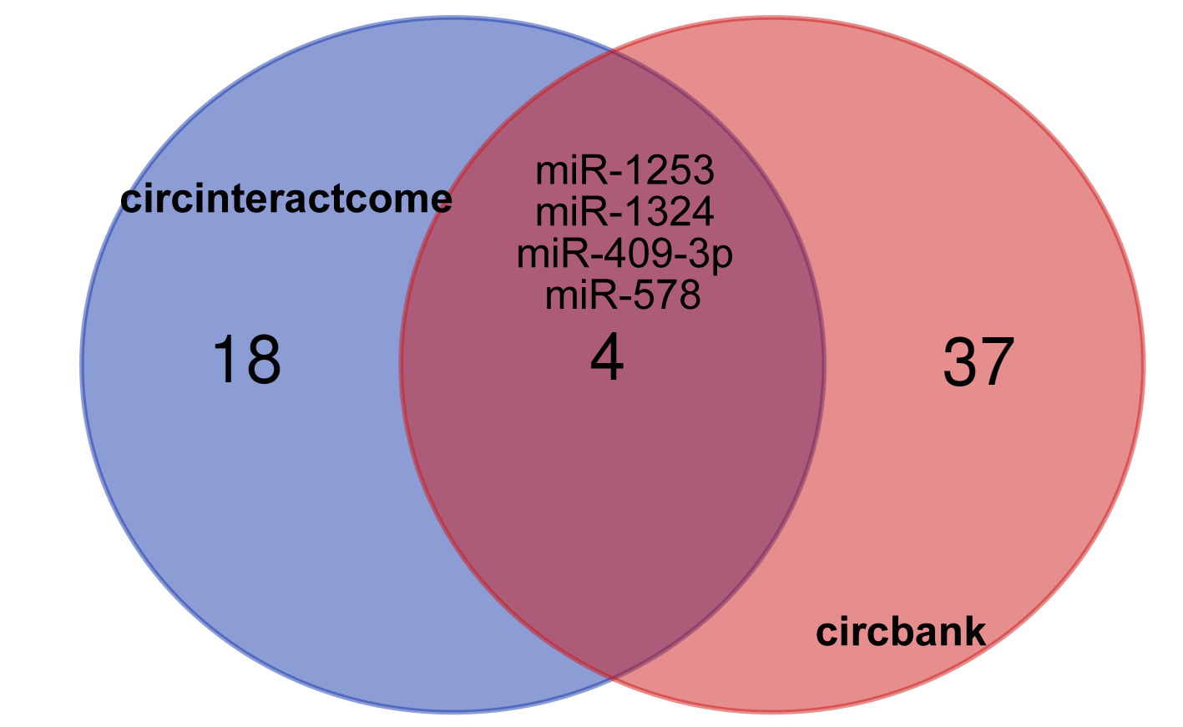
Figure S1. Venn diagram showing the miRNAs intersection of circbank and circinteractome, which predicted the binding of circ_0014715.

